* Nguyen Trung Hau - 18125129
* Nguyen Thao Ninh - 18125106
* Truong Thuy Quyen - 18125110

1. Motivation

Sometimes we want to add properties like borders or behaviors, for example, scrolling to user interface component without affecting the existing contents. Therefore, our problem here is to add responsibilities to individual objects instead of the whole class.

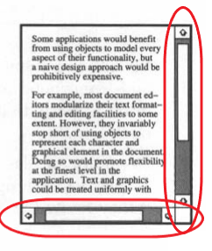

1. Solve the problem without using pattern (Inheritance)

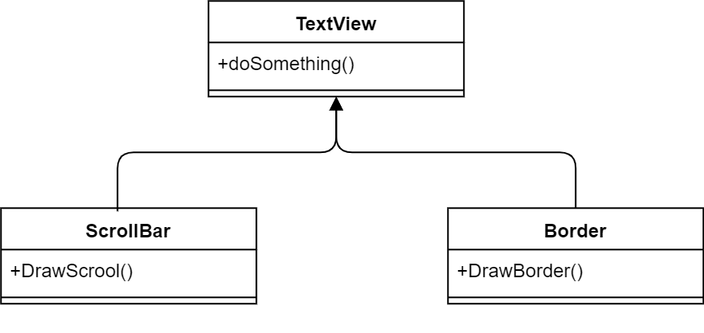

To solve problem with inheriting, we organize 2 classes ScrollBar (to create scroll bar) and Border (to create black borde) which inherit from class TextView (to print the content of subclass).

1. Disadvantages of the method above

In the inheriting method, a border and scroll are put around every subclass instance. But we sometimes do not need the border or scroll bar, in other words, they are optional. Therefore this way is inflexible as the choice of border and scroll are made statically.

We may waste time on coding due to complexity of inheritance.

1. Introduction to Decorator structural pattern

Decorator, which belongs to the structural pattern group, is frequently used to changed the object’s functionality flexibly. Decorator does not change functionality of other objects if it’s not required to do so.

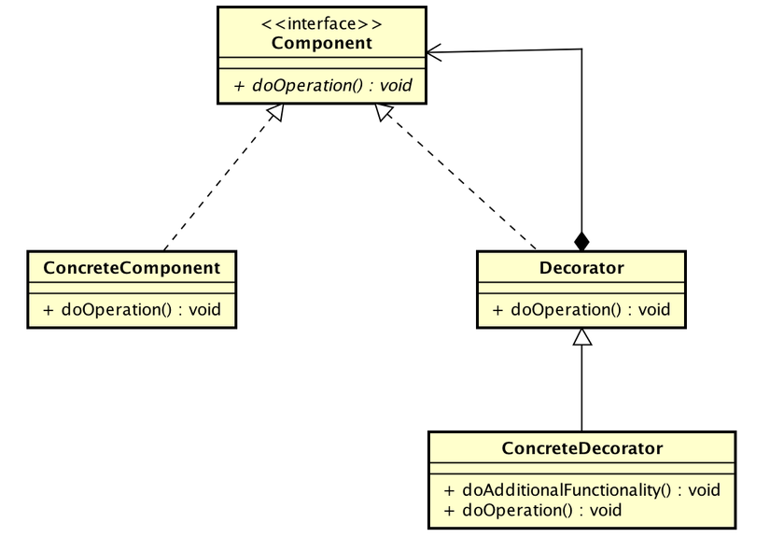

* Component is the general interface used to add responsibilities to object at run-time
* ConcreteComponent defines an instance which responsibilities can be added
* Decorator is an abstract class that maintains a reference of component object
* ConcreteDecorator: is the settings of Decorator, which adds more components to component objects

1. Solving the problem with Decorator

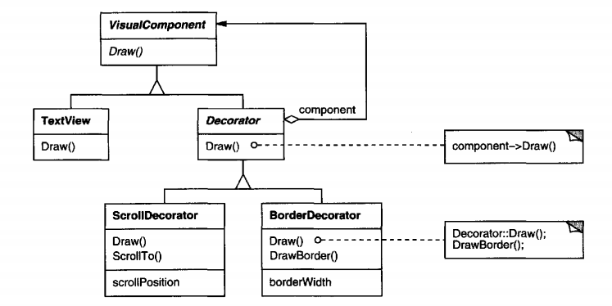

* ***Component (VisualComponent)*:** defines the interface for objects that can have responsibilities dynamically added to them.
* ***ConcreteComponent (TextView)***: defines an object to which additional responsibilities can be attached.
* ***Decorator*** : maintains a reference to a Component object and defines an interface that conforms to Component’s interface.
* ***ConcreteDecorator (BorderDecorator, ScrollDecorator)*** : adds responsibilities to the component

1. Sample Code

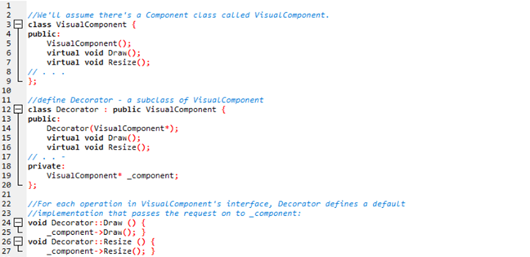

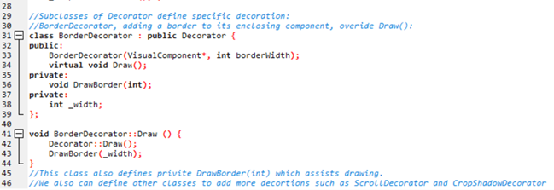

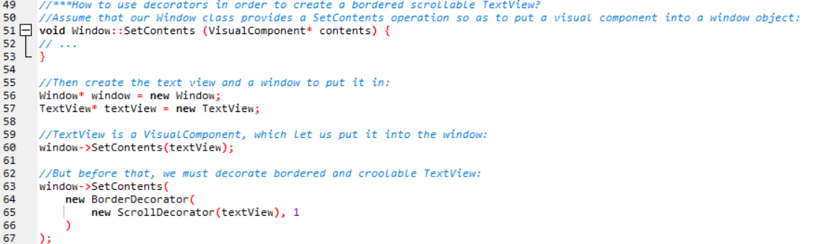

1. Some other problems of Decorator’s application

Streams are a fundamental abstraction in most I/O facilities. A stream can provide an interface for converting objects into a sequence of bytes or characters. That lets us transcribe an object to a file or to a string in memory for retrieval later. A straightforward way to do this is to define an abstractStream class with subclasses MemoryStream and FileStream. But suppose we also want to be able to do the following:

• Compress the stream data using different compression algorithms (runlength encoding, Lempel-Ziv, etc.).

• Reduce the stream data to 7-bit ASCII characterssothat it canbe transmitted over an ASCII communication channel.

The Decorator pattern gives us an elegant way to add these responsibilities to

streams. The diagram below shows one solution to the problem:

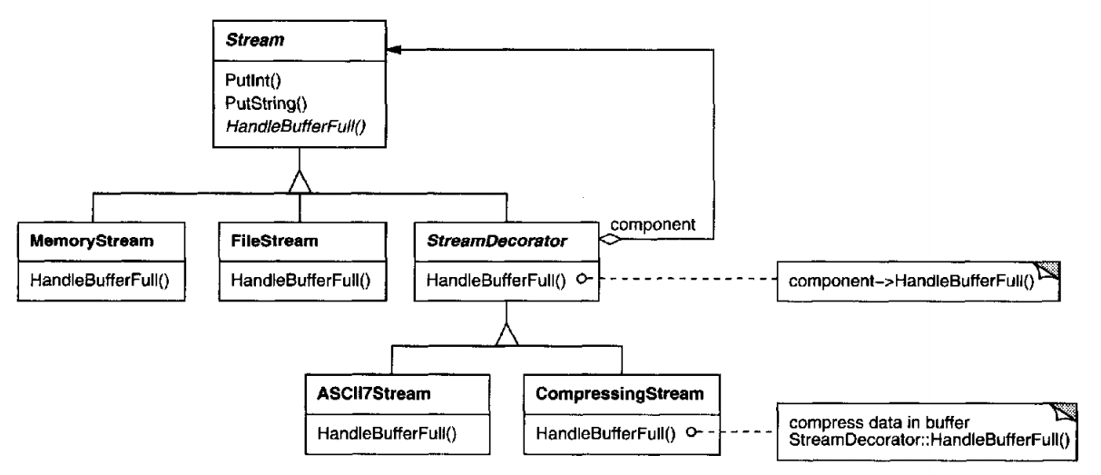

1. Advantages and disadvantages of Decorator pattern

* *Strong point:*

Decoration is more convenient for adding functionalities to objects instead of entire classes at runtime. With decoration it is also possible to remove the added functionalities dynamically.

* *Weak point:*

Decoration adds functionality to objects at runtime which would make debugging system functionality harder.

1. Multiple-choice-questions

***Question 1: How can we add more responsibilities into (all/some/an) object(s) in Object-Oriented? (Choose the best answer.)***

1. Using inheritance.
2. Using Decorator Design Pattern.
3. Both of 2 first choices.
4. Can not add.

***Question 2: Which is the way that allows us to add more responsibilities into objects but not of entire class?***

1. Using inheritance.
2. Using Decorator Pattern.
3. Using Adapter Pattern.
4. Can not add.

***Question 3: In the diagram of Decorator below, what is ConcreteComponent class used for ?***



1. Interface for objects that can have responsibilities added to them dynamically.
2. Defines an object to which additional responsibilities can be added.
3. Maintains a reference to a Component object and defines an interface that conforms to Component's interface.
4. Concrete Decorators extend the functionality of the component by adding state or adding behavior.

***Question 4: In the diagram of Decorator below, what is ConcreteDecorator class used for ?***

1. Interface for objects that can have responsibilities added to them dynamically.
2. Defines an object to which additional responsibilities can be added.
3. Maintains a reference to a Component object and defines an interface that conforms to Component's interface.
4. Concrete Decorators extend the functionality of the component by adding state or adding behavior.

***Question 5: When does Decoration add functionalities to objects ?***

1. At Compiletime.
2. At Runtime.
3. At the time codes were written.
4. At midnight.
5. Reference

Design Patterns Elements Of Reusable Object-Oriented Software [Erich Gamma, Richard Helm, Ralph Johnson, John Vlissides]

Decorator Pattern <https://www.oodesign.com/decorator-pattern.html>