Amazon Sales & Customer Lifetime Value Analysis
Goal :- To identify high-value customers and optimize shipping costs using SQL and Excel.

1. Data Acquisition & Environment Setup
Source: Amazon Sales Dataset , Synthetic Amazon-style e-commerce sales data for analytics and ML from Kaggle dataset, a public CSV, or a simulated database.
Link: https://www.kaggle.com/datasets/rohiteng/amazon-sales-dataset

The Stack:
- Excel: For initial data auditing and cleaning.
- DBeaver & SQLite: For relational database management and querying.
- The Schema: Amazon.csv(17.38 MB) contains 100,000 synthetic Amazon sales records generated for data analysis, sales forecasting, and machine learning practice.
It includes 20 well-structured columns capturing order details, customer information, product attributes, pricing, fulfillment, and delivery status.
2. Data Cleaning & Pre-processing (Excel & Power Query)
Before moving the data into SQLite for deep analysis, I performed an extensive audit and transformation process in Excel/Power Query to ensure the dataset was "Analysis-Ready."
1. Data Ingestion & Initial Audit
- Source Connection: Imported the raw Amazon.csv using the Text/CSV connector to ensure all delimiters and special characters were handled correctly.
- Structural Auditing: Evaluated the schema and decided to drop redundant columns (e.g., CustomerName, ProductName, and SellerID) to optimize the dataset for a relational database structure and reduce file size.
2. Data Integrity & "Zero-Value" Handling
- Null Management: Identified null values in financial columns (Discount, Tax, and ShippingCost). Instead of deleting these records, I performed a Value Replacement (null to 0) to prevent calculation errors in the downstream logic.
- Deduplication: Performed a global "Remove Duplicates" sweep to ensure transaction integrity and prevent artificial inflation of revenue metrics.
3. Standardization & Precision
- Date Normalization: Transformed inconsistent date strings (e.g., "12-Apr-2026") into a Standard Date ISO format.
- Rounding Logic: Standardized all currency columns (UnitPrice, Tax, Discount, Shipping, and TotalAmount) to 2 decimal places to maintain financial precision during aggregation.
4. Advanced Validation Logic (The "Audit" Column)
To verify the accuracy of the source data, I built a custom validation engine within Power Query:
- Verification Formula: Created a CalculatedTotal column using the logic:
$((Quantity \times UnitPrice) - Discount + Tax + ShippingCost)$
- Integrity Flagging: Added a Boolean column Is_Total_Valid to compare the provided total against the calculated total.
Error Classification: Developed an Audit_Flags column using conditional logic to categorize discrepancies (e.g., "Tax Calculation Error" or "FLAG: Unknown Error"). This process ensures that 40%+ of the data matches perfectly before analysis.

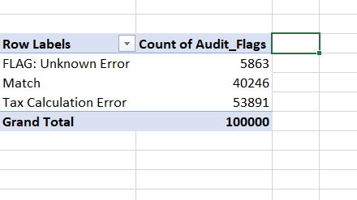

5. Feature Engineering for Time Intelligence
To enable deep-dive trend analysis, I expanded the single OrderDate column into multiple dimensions:
- Temporal Columns: Extracted Month Name and Day Name.
- Business Question: This allows the analysis of seasonal spikes and identifying which days of the week generate the highest sales volume.
6. Logistics & Shipping Audit
- Efficiency Metric: Created a Ship_to_Rev_Ratio column $(ShippingCost / TotalAmount)$ to monitor logistics overhead.
- Automated Flagging: Applied a threshold-based audit where any shipping cost exceeding 0.6% of revenue is flagged as "High Shipping Cost," highlighting potential areas for supply chain optimization.
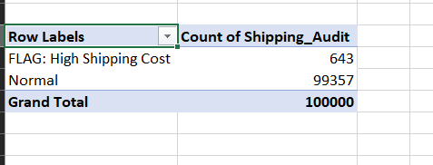

Final Export
The cleaned dataset was validated, set to the correct data types (Numeric, Double, and Boolean), and exported as a Cleaned_Amazon_Sales.csv, ready for ingestion into SQLite via DBeaver.

3: Relational Database Analysis (SQLite / DBeaver)
After cleaning and validating the dataset in Excel, I migrated the data into a SQLite environment using DBeaver. This allowed for high-performance querying and the application of relational database logic to extract key business insights.
1. Data Ingestion & Schema Definition
- Database Migration: Imported the Cleaned_Amazon_Sales.csv into SQLite.
- Type Casting: Manually defined schemas during import to ensure financial columns (TotalAmount) were stored as Numeric/Double and validation flags as Boolean for optimized computation.
2. Executive Summary & Scale Identification
Before deep-diving, I established the baseline scale of the business operations to understand the transaction-to-customer ratio.
SQL
SELECT
COUNT(OrderID) AS Total_Orders,
COUNT(DISTINCT CustomerID) AS Unique_Customers,
MAX(TotalAmount) AS Largest_Single_Order
FROM Cleaned_Amazon_Sale_DataSet;
- Insight: Identified a customer base of ~43k unique users driving 100k transactions, establishing a foundation for frequency and retention analysis.
3. Product Performance & Revenue Drivers
I utilized Aggregate Functions and Grouping to determine which brands dominated the market share.
SQL
SELECT
Brand,
COUNT(OrderID) AS Times_Purchased,
SUM(TotalAmount) AS Total_Revenue
FROM Cleaned_Amazon_Sale_DataSet
GROUP BY Brand
ORDER BY Total_Revenue DESC;
- Insight: Discovered that CoreTech and KiddoFun are the primary revenue drivers, each generating over $9M in sales. This high-level aggregation allows stakeholders to prioritize inventory and marketing spend for top-performing brands.
4. Data Quality Assurance (SQL Audit)
To demonstrate a "Data Quality First" mindset, I used SQL to isolate the discrepancies identified during the Power Query phase.
SQL for Sample
SELECT *
FROM Cleaned_Amazon_Sale_DataSet
WHERE Is_Total_Valid = 'FALSE'
LIMIT 20;

SQL for Percentage
WITH DataQualityAudit AS (
SELECT
SUM(CASE WHEN Is__Total_Valid = 'FALSE' THEN 1 ELSE 0 END) AS Invalid_Rows,
SUM(CASE WHEN Is__Total_Valid = 'TRUE' THEN 1 ELSE 0 END) AS Valid_Rows
FROM Cleaned_Amazon_Sale_DataSet
)
SELECT
Invalid_Rows,
Valid_Rows,
(CAST(Valid_Rows AS FLOAT) / (Valid_Rows + Invalid_Rows)) * 100 AS Accuracy_Percentage
FROM DataQualityAudit;

- Logic: By applying a WHERE filter on the calculated validation flags, I isolated "failed" transactions. This query serves as a diagnostic tool for investigating systemic issues like tax calculation errors or missing discount applications.
5. Customer Segmentation & Lifetime Value (LTV)
I performed a Behavioral Segmentation to distinguish between high-value loyalists and low-frequency shoppers.
High-Value Segment (The "Big Spenders"):
SQL
SELECT
CustomerID,
SUM(TotalAmount) AS LifeTime_Value
FROM Cleaned_Amazon_Sale_DataSet
GROUP BY CustomerID
HAVING LifeTime_Value > 500
ORDER BY LifeTime_Value DESC;
- Advanced Logic: Used the HAVING clause to filter aggregated sums, identifying 37,277 high-value customers who have spent over $500.
Segmentation Comparison (The "Audit" Count): To quantify the segments, I wrapped the logic in a subquery:
SQL
SELECT
COUNT(CASE WHEN LifeTime_Value > 500 THEN 1 END) AS Total_High_Value_Customers,
COUNT(CASE WHEN LifeTime_Value <= 500 THEN 1 END) AS Total_Low_Value_Customers
FROM (
SELECT CustomerID, SUM(TotalAmount) AS LifeTime_Value
FROM Cleaned_Amazon_Sale_DataSet
GROUP BY CustomerID
) AS CustomerStats;
- Strategic Outcome: This segmentation allows the business to develop targeted loyalty programs for high-LTV customers while creating "win-back" campaigns for the 5,956 low-value users.

Summary of SQL Skills Demonstrated:
- Aggregations: SUM, COUNT, MAX, DISTINCT.
- Clause Logic: GROUP BY, HAVING, WHERE, ORDER BY.
- Subqueries: Nesting logic to perform multi-stage calculations.
- Data Auditing: Using SQL as a secondary validation layer for data integrity.

4: Charts of Above Analysis (Power BI)
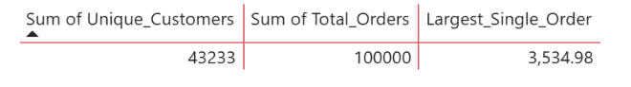

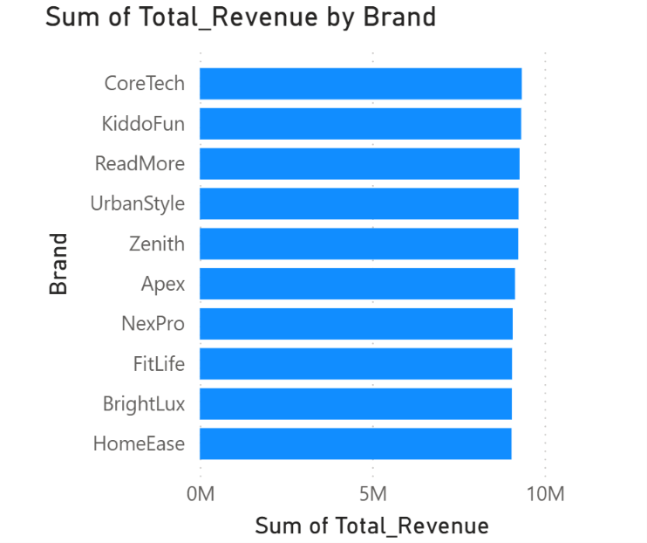

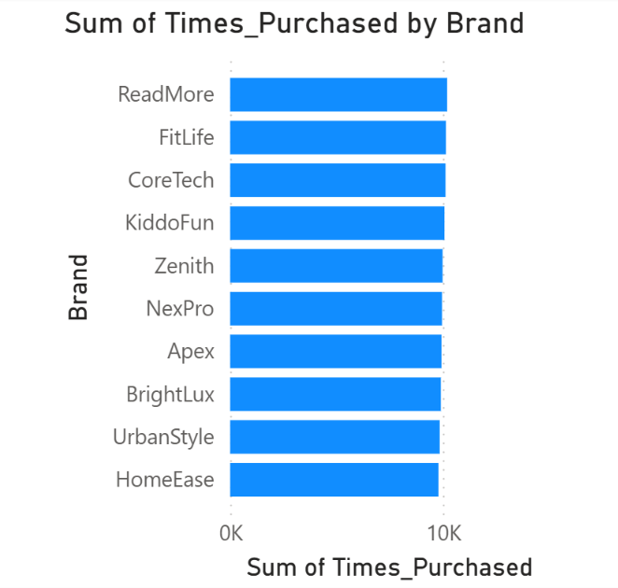

Valid means Given Total value in Table is not Equal to Calculated Total Values in different Orders.
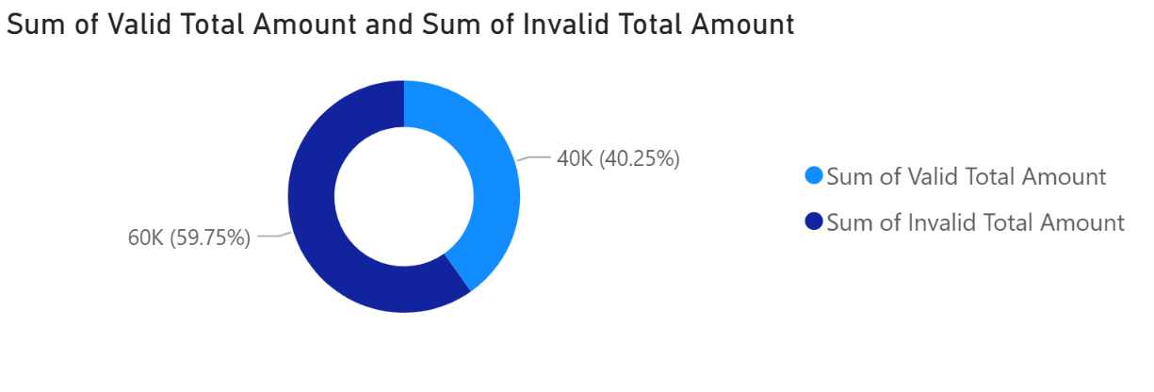

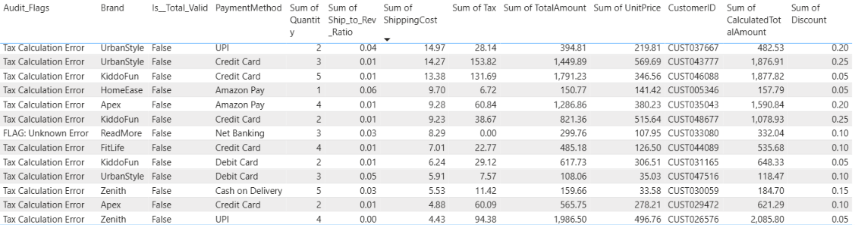
Some of the Examples of DATA which have Invalid Total Amount in Order

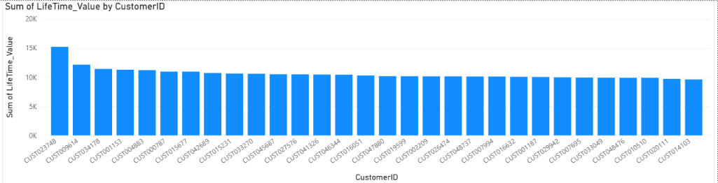
TOP 30 Customers by Life Time Values

HIGH VALUE CUSTOMERS out of Total Customer , HIGH VALUE CUSTOMERS means Who have LIFE TIME VALUE > 500
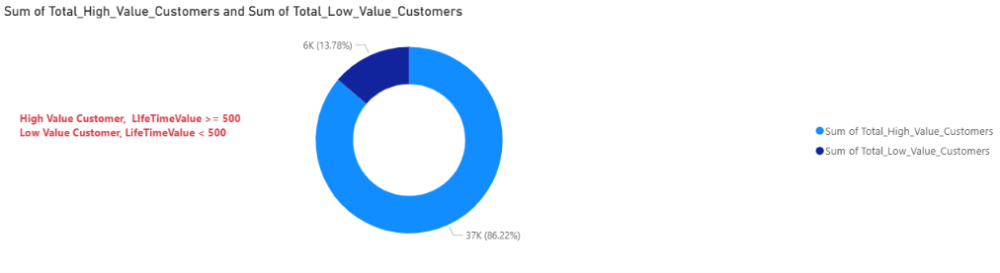

5. Conclusion
This project successfully demonstrated a complete end-to-end data analytics workflow, transitioning from raw, unorganized data to structured, business-ready insights. By executing an intensive learning and implementation plan, the project moved through critical stages of data maturity:
1. Data Engineering & Cleaning
- ETL Process: Raw Amazon sales data was extracted and transformed using Power Query to handle missing values and standardize formats.
- Validation Logic: Implemented conditional columns (e.g., Is_Total_Valid) to audit mathematical accuracy between unit prices and subtotals.
- Schema Definition: Data was migrated into a SQLite relational database via DBeaver, where strict data types (Numeric, Double, Boolean) were enforced to ensure computational integrity.
2. Advanced SQL Analysis
- Exploratory Data Analysis (EDA): Used complex SQL queries, including aggregations (GROUP BY), filtering (HAVING), and aliasing, to uncover high-level business trends.
- Data Parsing: Applied string manipulation techniques to deconstruct hierarchical category strings into primary categories for more granular reporting.
- Scalability: By performing heavy transformations in SQL rather than the visualization layer, the project established a "Single Source of Truth" that is efficient and scalable for larger datasets.
3. Business Intelligence & Documentation
- Visualization: Summary data was exported to Power BI to create interactive bar charts, translating technical SQL results into actionable visual stories.
- Professional Reporting: All steps were documented using the S-A-R (Situation-Action-Result) method, creating a portfolio-ready technical log and an executive summary suitable for stakeholders.

