|  | **OIL/GAS EXPLORATION AND PRODUCTION – PHASE 2**      ORANGE HOMEWORK TEAM 8  Karthick Krishna Balaji  Camille Carter  Margeaux Johnson  Dillard McMichael  Nish Torane    February 21, 2023 |
| --- | --- |

**Table of Content**

**Overview** **1**

**Methodology and Analysis** **1**

**Data Used** **1**

**Dry Well Estimation** **1**

**Net Present Value** **1**

**Initial Costs** **1**

**Net Revenue** **1**

**Variable Costs** **2**

**Final Net Present Value** **2**

**Results and Recommendations** **2**

**Results** **2**

**Recommendations** **2**

**Conclusion** **2**

**Appendix** **2**

**Oil/Gas Exploration and Production – Phase 2**

# **Overview**

Compagnie Pétrolière et Gazière (hereafter the “Company”) has tasked Orange Homework Team 8 (hereafter the “Analysts”) to simulate the total cost of a single dry well and the net present value of a single wet well. The Company has provided two datasets containing historical drilling costs from 1960 to 2007 and projected costs from 2023 to 2050.

After obtaining the 2023 drilling cost distribution in Phase 1 of the project, the Analysts proceeded to estimate the total cost of a dry well by simulating the sum of lease, seismic, labor and drilling cost, each of which came from their own independent distributions. The resulting distribution indicated the most frequently occurring total cost is $5MM.

The Analysts also estimated the net present value of the wet well by summing the total cost to drill and complete a wet well and net revenues from production over the years, discounted by the weighted average cost of capital (WACC). The production rates were simulated using a lognormal distribution for IP rates and a uniform distribution for decline rates, both of which had a correlation coefficient of 0.64. The revenue risk was modeled using forecasted oil prices from the World Bank of EIA and also took into account the net revenue interest, which followed a normal distribution. Finally, the operating costs were modeled using a normal distribution and a fixed state severance tax of 4.6% was applied after the net revenue interest. The resulting NPV distribution indicated that the most frequently occurring NPV is between $1M-1.5M.

# **Methodology and Analysis**

## Data Used

The Company provided the Analysts with two datasets. The first dataset contains historical Drilling Cost data from 1960 to 2007. This dataset includes the cost of drilling crude oil, natural gas, and dry wells in thousands of dollars. The dataset also provided arithmetic returns for each year and each drilling method. As suggested by the Company, the Analysts only used data between 1990 and 2006. The Analysts converted the character variables to numeric and calculated the average annual cost and return as two new variables. The second dataset contains the projected minimum, maximum, and AEO2021 reference prices of drilling costs from 2023 to 2050.

## Dry Well Estimation

The Analysts simulated 10,000 future values to estimate the cost of a single dry well. Producing a dry well includes leasing, seismic, labor, and drilling costs. A report detailing leasing costs follows a normal distribution with a mean of 600 and a standard deviation of 50 acres at $960 an acre. Similarly, seismic costs follow a normal distribution with a mean of 3 and a standard deviation of 0.35 sections at $43,000 per section. Labor costs were on average $215,000 with a minimum of $172,000 and a maximum of $279,000. Given this information, the Analysts used two normal distributions to estimate leasing and seismic costs, and the triangle distribution to estimate labor costs. Drilling costs were simulated using the normal distribution method from Phase I.

## Net Present Value

The Analysts also simulated 10,000 future values to estimate the Net Present Value(NPV) of a wet well. This valuation requires information about initial costs (seismic and lease costs), net revenues, and variable costs (labor, drilling, and operating costs).

### Initial Costs

Initial costs were calculated similarly to the dry well estimation but had the addition of completion costs. A report detailing leasing costs follows a normal distribution with a mean of 600 and a standard deviation of 50 acres at $960 an acre. Similarly, seismic costs follow a normal distribution with a mean of 3 and a standard deviation of 0.35 sections at $43,000 per section. Completion costs also follow a normal distribution with a mean of $390,000 and a standard deviation of $50,000. The Analysts used three normal distributions to estimate leasing, seismic, and completion costs. Drilling costs were simulated using the normal distribution method from Phase I.

### Net Revenue

To calculate net revenue the Analysts simulated the annual production of an individual well. Previous research found that the initial production rate follows a lognormal distribution with a mean of 420 and a standard deviation of 120 BOPD. The subsequent pump decline rate was found to follow a uniform distribution bounded between 15 and 32%. The initial production and decline rates have a correlation coefficient of 0.64. The Analysts simulated 10,000 initial production and decline rates from the respective distributions and correlated the data using the Cholesky decomposition. With information on initial and decline rates, the Analysts were able to calculate the projected volume of oil produced for the next 15 years. The future yearly projections were simulated with a triangle distribution using the minimum, maximum, and AEO2021 Average Reference and multiplied with the yearly oil production.

Before the Company can fully realize revenue, it must pay severance taxes to the state and net revenue interest to mineral interest holders. Severance taxes are set at a constant value of 4.6%. Net revenue interest was assumed to be normally distributed with a mean of 75% and a standard deviation of 2%. The analyst used a normal distribution to simulate net revenue interest and deducted that fee as well as the severance tax from the total revenue.

### Variable Costs

Additionally, there were recurring annual fees including labor and operating costs that needed to be considered. Labor costs follow a triangle distribution with an average of $215,000, a minimum of $172,000, and a maximum of $279,000. Operating costs follow a normal distribution with a mean of #2.25 and a standard deviation of $0.30. A triangle distribution and normal distribution were used to simulate these costs, respectively.

### Final Net Present Value

Finally, the Analysts subtracted variable costs from the final revenue to compute the final net revenue for each year, discounted at the weighted average cost of capital of 10%, summed across years, and subtracted initial cost to compute the forecast of NPV. This process was repeated 10,000 times to create a distribution of NPV.

# **Results and Recommendations**

## Results

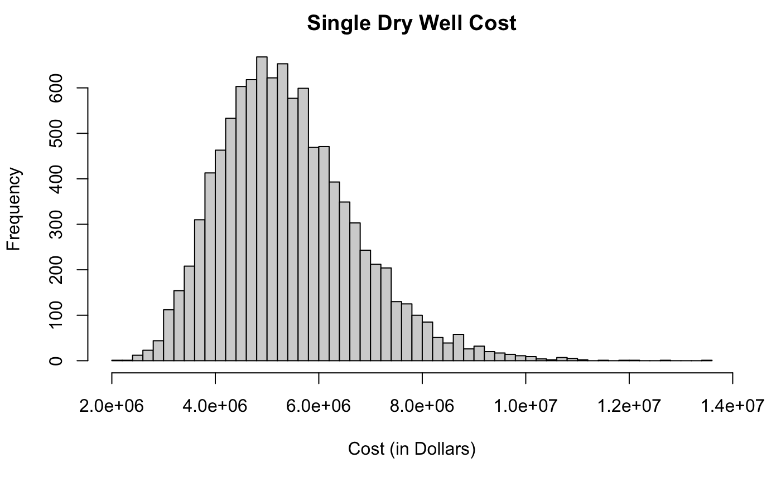

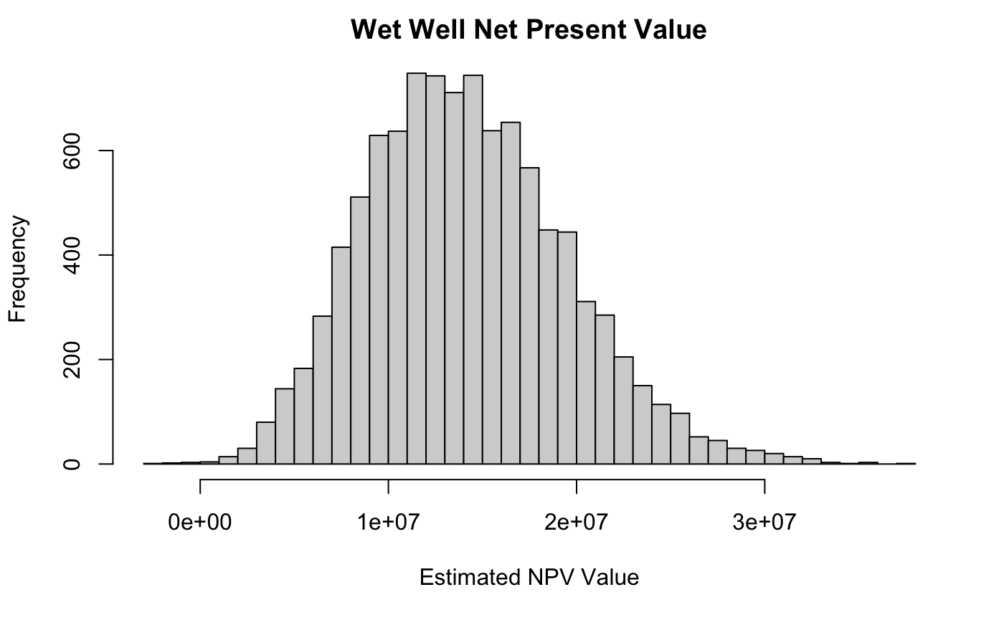

**Table 1: Summary Statistics for Simulated Dry Well and Wet Well NPV**

|  | **Minimum** | **1st Quartile** | **Median** | **Mean** | **3rd Quartile** | **Maximum** |
| --- | --- | --- | --- | --- | --- | --- |
| **Dry Well** | 2,167,907 | 4,478,047 | 5,274,242 | 5,411,996 | 6,175,156 | 13,588,292 |
| **NPV Wet Well** | -2,681,283 | 10,370,276 | 13,815,193 | 14,163,100 | 17,568,719 | 37,527,104 |

## Recommendations

# **Conclusion**

# **Appendix**

**Figure 3: 2023 Drilling Cost Under Kernel Density Estimate for 2006-2012**

**Figure 4: 2023 Drilling Cost Under Normality Assumption for 2006-2012**

**Homework Report Checklist**

The team member(s) responsible for checking each item should enter their initials in the field next to each question. All items should be addressed before submitting the assignment with the initial checklist attached.

**Sections & Structure**

**Overview**

|  | Is the overview concise? |
| --- | --- |
|  | Does it provide context about the business problem? <Content> |
|  | Does it briefly address your team’s work, quantifiable results, and recommendations? <Action> |
|  | Does it offer audience-centered reasons for recommendations? <Context> |

**Body Sections**

|  | Does the report body include information on methods, analysis, quantifiable results, and  recommendations? |
| --- | --- |
|  | Is content grouped into appropriate sections (methodology, analysis, results, recommendations)? |

**Conclusion**

|  | Does the report have a conclusion? |
| --- | --- |
|  | Does the conclusion sum up the report and emphasize relevant takeaways? |

**Structure**

|  | Does each major section have a heading? |
| --- | --- |
|  | Are sections, subsections, and paragraphs organized logically for easy navigation? |

# 

**Visuals**

**Introduction, Discussion, and Captions**

|  | Is each visual introduced in the text before it appears? |
| --- | --- |
|  | Is each visual close to where it is introduced? |
|  | Does each visual include a title with the following information: type (table or figure), number, and a descriptive caption? |
|  | Is each visual discussed and interpreted in the text? |
|  | Are figures and tables numbered separately? |
|  | Are table captions above the table? Are figure captions below the figure? |

**Visual Design**

|  | Do figures/tables use audience-friendly labels rather than variable names? |
| --- | --- |
|  | Are the visuals easy to interpret? |
|  | Are the visuals appropriately sized? |
|  | Do tables appear on one page (not split between 2 pages)? |
|  | Are legends and axis labels included for figures? |
|  | Are numbers in tables right aligned? |
|  | Are the visuals designed well (ex: re-created in Word or Excel, not blurry or stretched,…)? |

**Document Design**

**Title Page Design**

|  | Does it include a descriptive title? |
| --- | --- |
|  | Does it state the team name, team members’ names, and the submission date? |

**Table of Contents Design**

|  | Does it list all the major sections of the report with corresponding page numbers? |
| --- | --- |
|  | Do the page numbers and sections in the Table of Contents match the report? |

**Document Design for Entire Report**

|  | Is a standard typeface (Calibri, Arial, etc.) used? |
| --- | --- |
|  | Is the size of the body text between 10-12 pt.? |
|  | Are headings and subheadings used to organize information? |
|  | Are distinctive text styles (bold, italic, etc.) used to distinguish between heading levels? |
|  | Are text styles for headings used consistently (ex: all level-one headings are bold)? |
|  | Are all paragraphs an appropriate length (fewer than 12 lines)? |
|  | Is white space used to indicate paragraph breaks? |
|  | Are bullet lists used for a series of items and numbered lists to show a hierarchy? |

# 

**Writing Style and Mechanics**

**Spelling and Capitalization**

|  | Are spelling errors located and corrected? |
| --- | --- |
|  | Is spelling consistent throughout (no switching between acceptable spellings)? |
|  | Is capitalization used appropriately (proper nouns, etc.)? |
|  | Is capitalization of words consistent throughout the report? |

**Grammar and Punctuation**

|  | Are verb tenses used appropriately? |
| --- | --- |
|  | Are marks of punctuation used appropriately? |
|  | Is subject-verb agreement used in every sentence? |
|  | Is the grammar checker updated and are underlined grammar issues addressed? |

**Writing Style**

|  | Are all sentences in the report easy for your audience to understand quickly? |
| --- | --- |
|  | Are most sentences written in active voice? |
|  | Are idioms and vague words eliminated from the report? |
|  | Are acronyms introduced before being used? |
|  | Are well-written topic sentences included at the beginning of each paragraph? |
|  | Are lists parallel? |
|  | Is the appropriate point of view used when addressing your audience or describing team actions? |