The program Open CANalysis it is an open source program and give you the ability to read and write data on a CAN bus. It's new and need more support from developers from all around the World. This is a little tutorial about how to start if you want to test some on your CAN bus.
You need a HARDWARE to be connected with the CAN bus physical layer. I use the AT90CAN128 8 bit uE from Atmel and i bought a development board from Olimex.
https://www.olimex.com/Products/AVR/Development/AVR-CAN/ Schematic
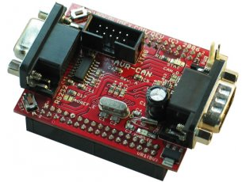
- A firmware for this uE is at the GITHUB under this link firmware
- You can download a hex file to burn it direct to the uE. HEX file for a crystal 16 MHZ and 19200 Baudrate
- I burn the firmware with this programmer from Olimex and the AVARICE. Link to Programmer
- I use this command: avarice -1 -j /dev/ttyUSB2 -e -P at90can128 -f AT90CAN128_CANinteruptSecondTry.hex -p -v
- The above board has a chip for USB-to-RS232 Serial, but i use also this one from Ebay.
- If you want to change the baudrate of the Uart, you can change the function uart0_init() of the file uart.c. the code is the following

/* 1 M-bit with 16 MHZ Crystal
UCSR0A = (1<< U2X0);
UBRR0H = 0; // set baud rate
UBRR0L = 1; */
// UBRR0L = 0; 2 MBIT
UBRR0H = 0;
UBRR0L = 51; //19200 baudrate optional for testing

How to use the GUI to start a session of your CAN bus.
Click the button with number 1 and the you can see the dialog window with the settings of the Serial connection. Set the properly Port at number 2, set the baud-rate at number 3 and click apply to save the settings. At the end click the button number 5 to connect with the usb device. Let all the other settings like this picture, if you know what you do then you can change the settings, if not then your connection will don't work properly.
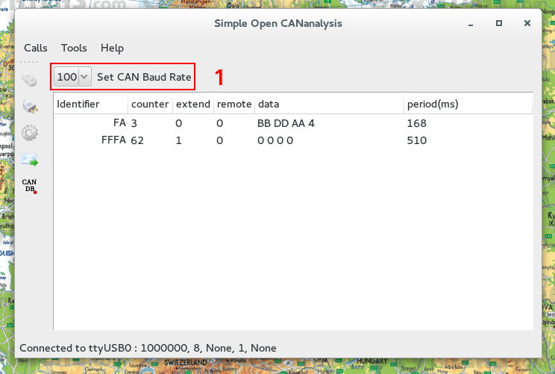
You can select the baud-rate of the CAN bus, the program supports 100, 250, 500 KBAUD and 1 MBAUD. You have to know the baud-rate of your CAN bus. After the change of the CAN baud-rate the hardware make a hard reset itself.
The field identifier has the ID of the incoming data frame, the counter shows the number of the arrived messages, the field extended shows if the frame has a extended or a standard format. 1 means extended. The remote fields shows if the frame is a remote or a data frame. The field Data has all the data values of the frame, ATTENTION all the values are in HEX dec format and the field period shows the period of the frame in ms, if it is a cyclic message.

