1. Identify the type (class) of the components shown in the window below. The component named menu contains all the beverage names in one component.
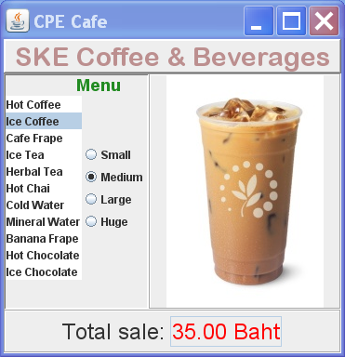
mainTitle
menuTitle
menu
size1
size2
size3
size4
description
totalBox
image

2. How would you create this layout using Java's Layout Managers?
Draw a diagram of how you can layout the space using layout managers, and which Layout Managers you would use.

3. How would you layout this? Draw a diagram of what layout manager(s) you would use, and how you'd partition the space.
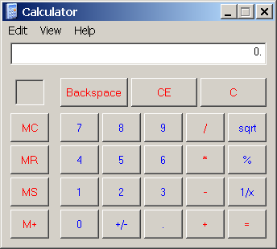

4. This is a demo of the open-source JCalendar program. Can you figure out how they did it?
If not, you can download the source code from http://toedter.com/jcalendar and read the code.
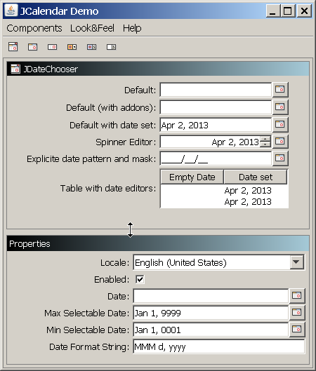
You can resize the top part by dragging the center line.

6. Other useful graphical components you can download:

JCalendar - JavaBean for calendar, date, and time choosers
JGoodies - layout managers and components (the above example uses a Form Layout)
JFreeChart - draws many kinds of graphs and charts, can handle multiple data sets.

