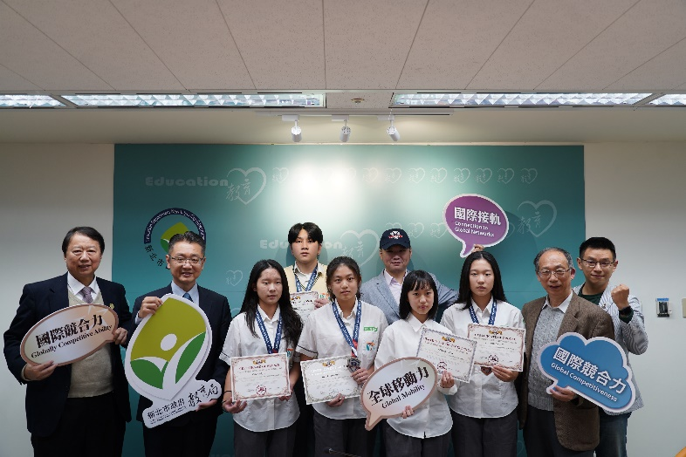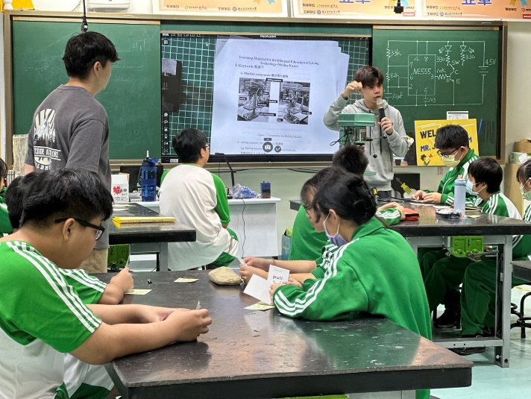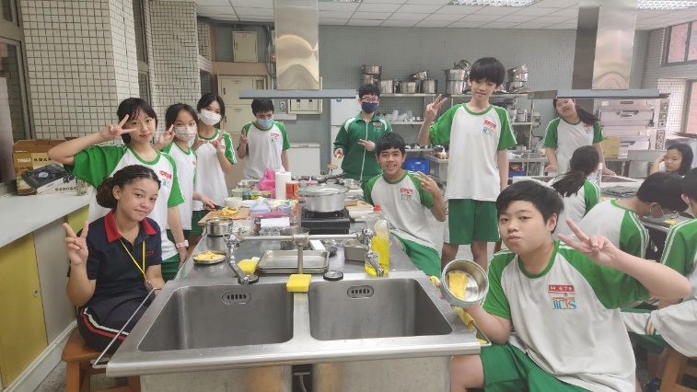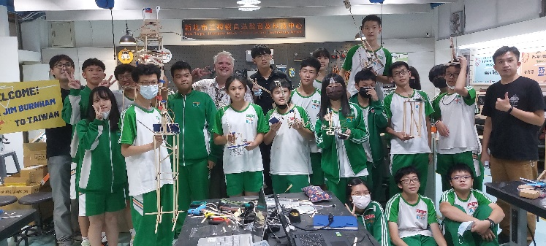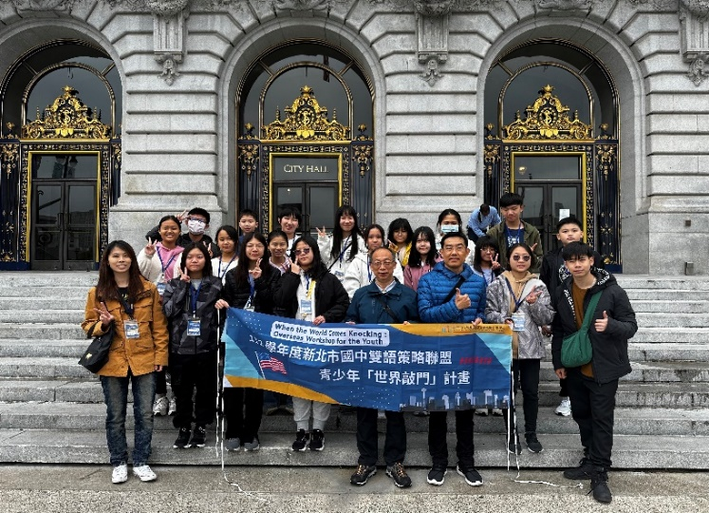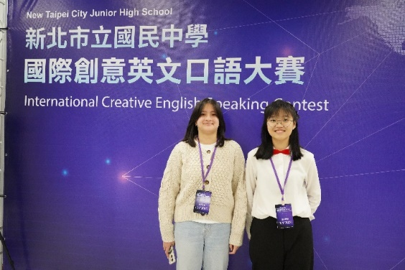

Inviting Metro ED’s instructor to teach Arduino Throwing Hand

Conducting lively and engaging bilingual practical courses

Foreign students joining classes with our school

The first overseas study tour for junior high students to expand their vision

Hold an annual International Creative English Speaking Contest

Having excellent results in the Ivy Cup International English Contest, receiving an award from the city government