1) development environment and how to build dependencies

+) ubuntu-18.04.4-desktop-amd64.iso (Linux OS)

+) gcc/g++ 7.5.0 (with std::tr1 support for function, bind, shared_from_this, ...)

+) pthread (multi thread)

+) glog (debug logging)

+) gtest (googletest unit test)

+) valgrind (memory leak)

+) exprtk (c++ mathematical expression library)

a) step 1: update ubuntu with command line:

sudo apt update

b) step 2: install gcc/g++ with command line:

sudo apt install gcc g++

c) step 3: libpthread.so is available in ubuntu 18.04.4 with path “/usr/lib/x86_64-linux-gnu”

d) step 4: install glog with command line:

sudo apt install autoconf libtool make

tar xvf glog-0.4.0.tar.gz

cd glog-0.4.0/

./autogen.sh

./configure --prefix=$HOME/CocCoc/glog-0.4.0

make

make install

e) step 5: install gtest with command line:

sudo apt install cmake

tar xvf googletest-release-1.8.1.tar.gz

cd googletest-release-1.8.1/

mkdir mybuild

cd mybuild/

cmake ../ -DCMAKE_INSTALL_PREFIX=$HOME/CocCoc/googletest-release-1.8.1

make

make install

f) step 6: install valgrind with command line:

sudo apt install valgrind

2) how to build unit test (googletest) using makefile

+ step 1: clean all with command line as follow:

make clean

+ step 2: build eventmanager test with command line as follow:

make eventmanager_test

+ step 3: build iobuffer test with command line as follow:

make iobuffer_test

+ step 4: build tcp test with command line as follow:

make tcp_test

3) how to run unit test (googletest) and memory leak (valgrind) using makefile

+ step 1: run eventmanager test with command line as follow:

make eventmanager_valgrind

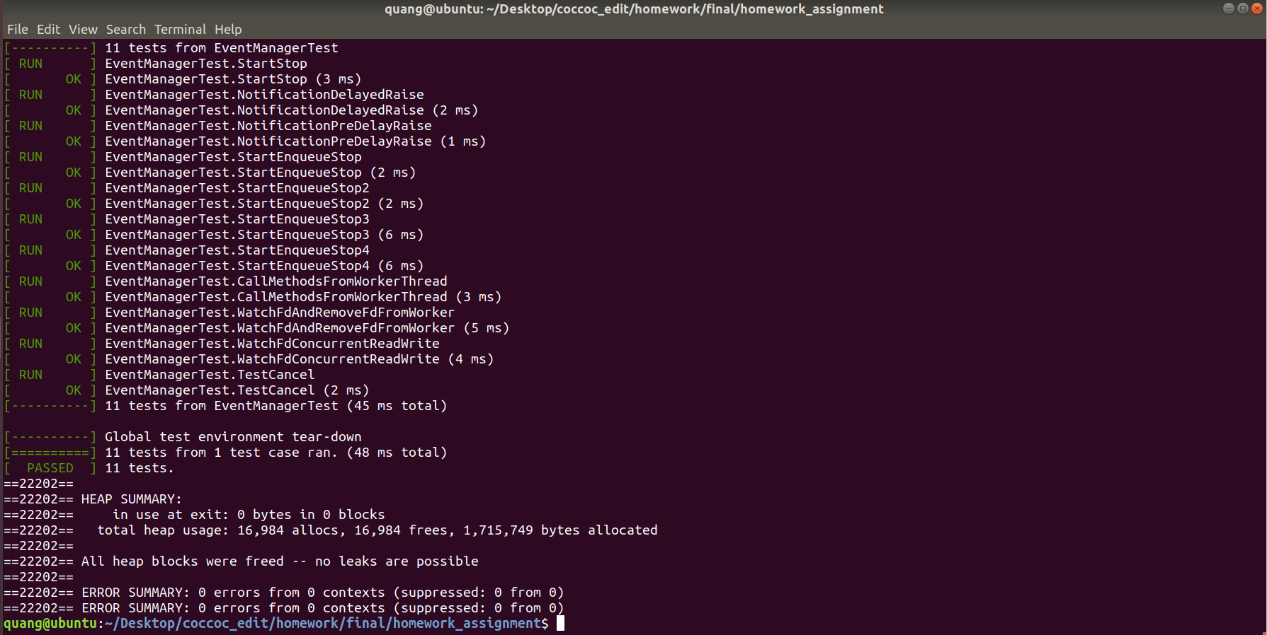

+ step 2: run iobuffer test with command line as follow:

make iobuffer_valgrind

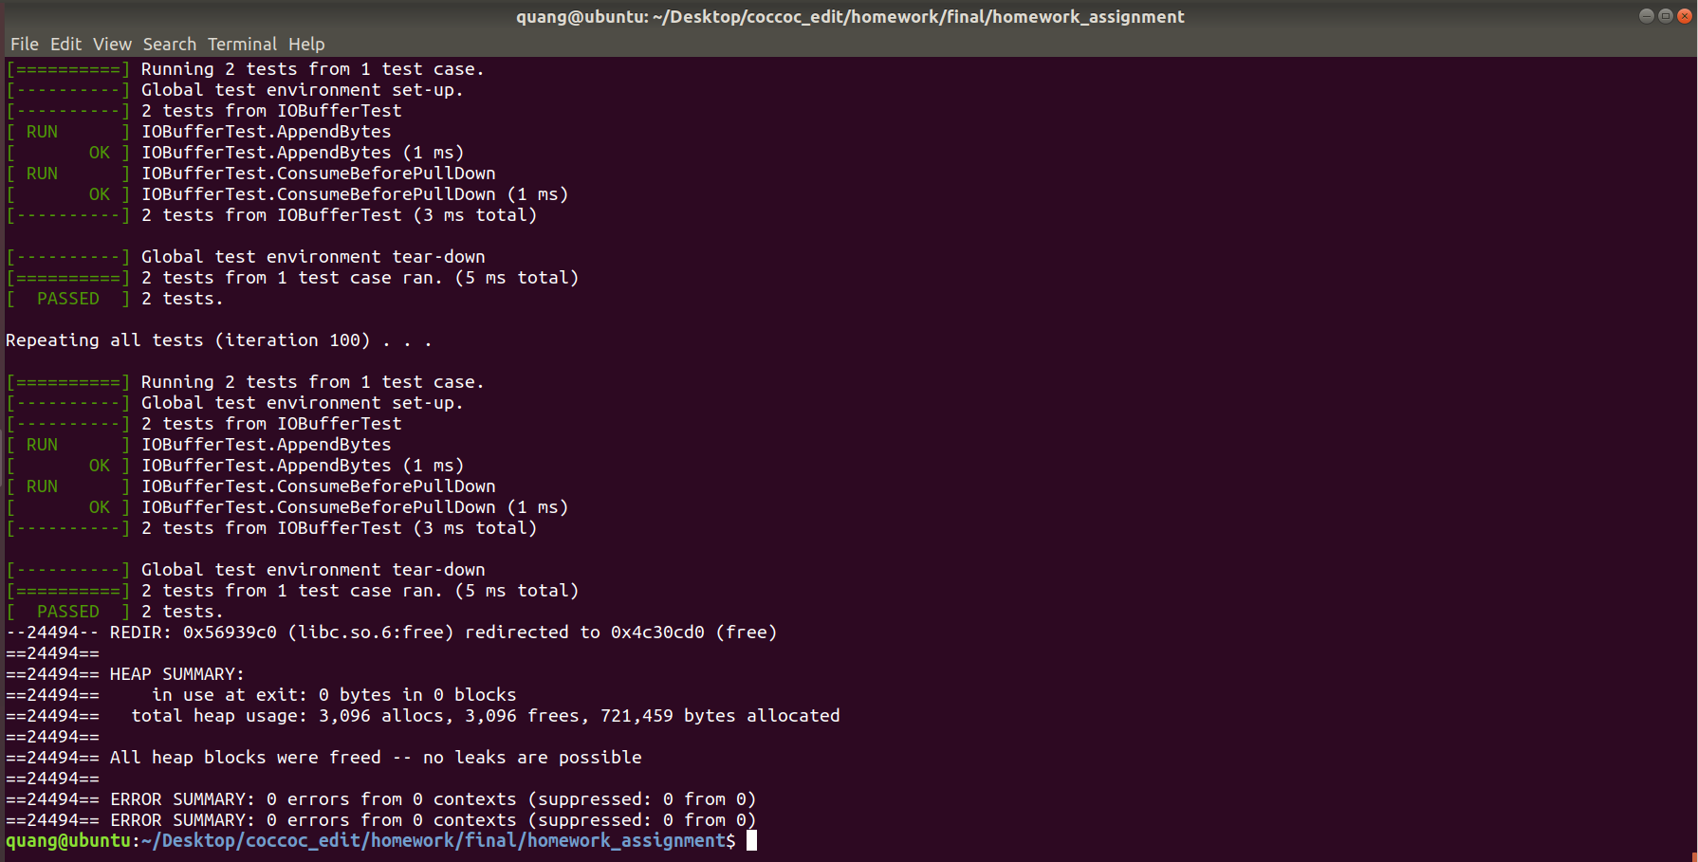

+ step 3: rum tcp test with command line as follow:

make tcp_valgrind

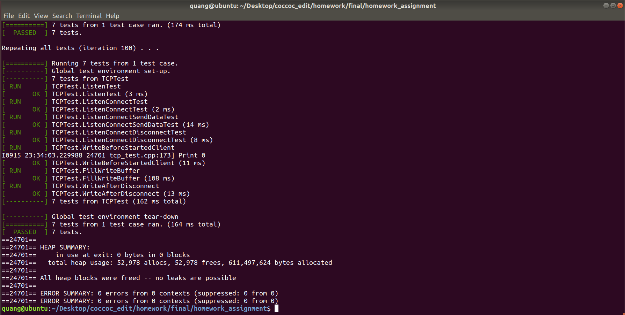

4) how to build socket (server and client) using makefile

+ step 1: build server with command line as follow:

make server

+ step 2: build client with command line as follow:

make client

5) how to test communication between server and client via tcp socket

+ Server is running on 5007 port: run command line as follow:

./server

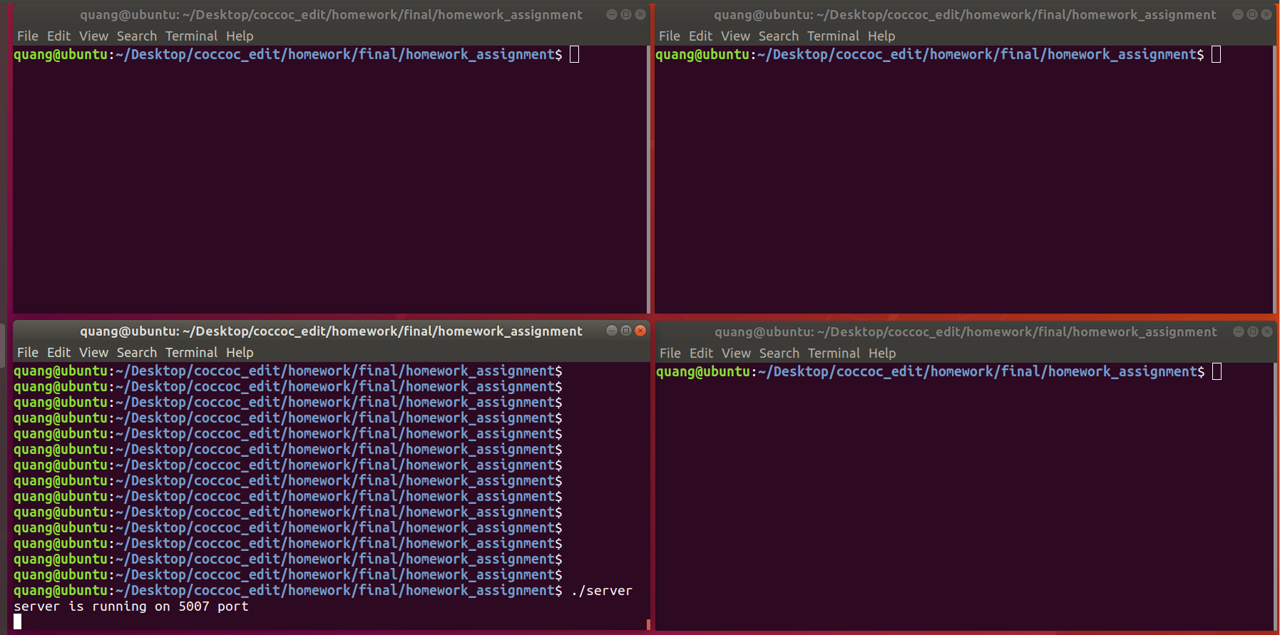

+ Client connected to server on localhost address and 5007 port: run command line as follow:

./client

