1) how to build socket (server and client) using makefile

+ step 1: build server with command line as follow:

make server

+ step 2: build client with command line as follow:

make client

2) how to test communication between server and client via tcp socket

+ Server is running on 5007 port: run command line as follow:

./server

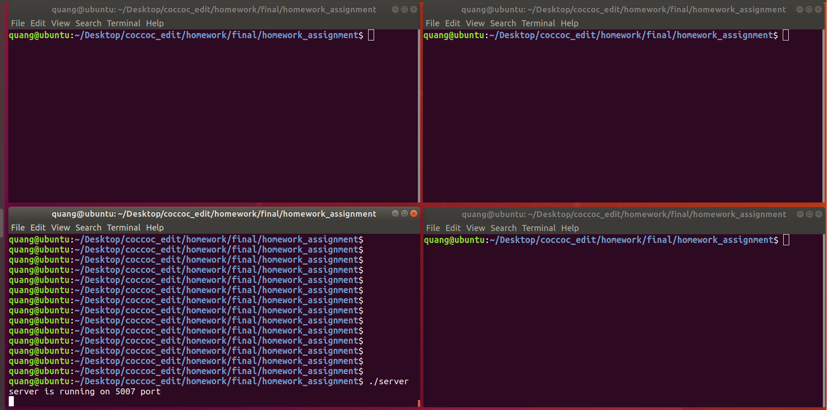

+ Client connected to server on localhost address and 5007 port: run command line as follow:

./client

