1) how to build unit test (googletest) using makefile

+ step 1: clean all with command line as follow:

make clean

+ step 2: build eventmanager test with command line as follow:

make eventmanager_test

+ step 3: build iobuffer test with command line as follow:

make iobuffer_test

+ step 4: build tcp test with command line as follow:

make tcp_test

2) how to run unit test (googletest) and memory leak (valgrind) using makefile

+ step 1: run eventmanager test with command line as follow:

make eventmanager_valgrind

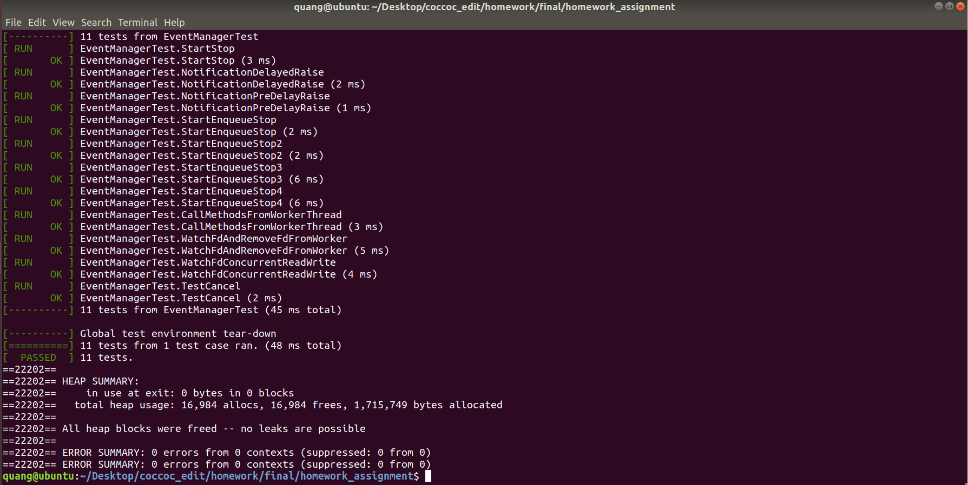

+ step 2: run iobuffer test with command line as follow:

make iobuffer_valgrind

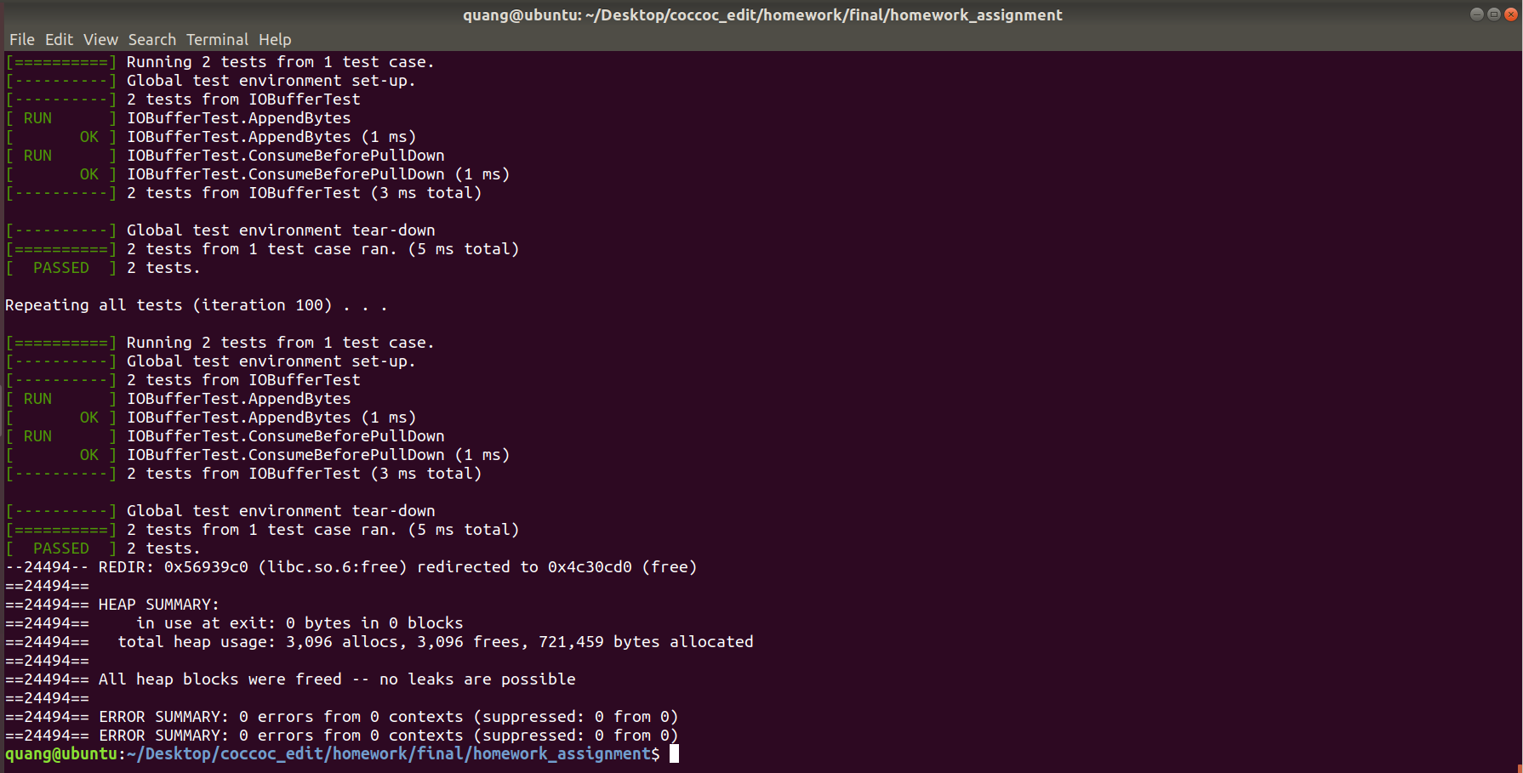

+ step 3: rum tcp test with command line as follow:

make tcp_valgrind

