**Exercise 1 – Hero Name Recognition**

Predict the hero names on the left side of the message bar.

|  |  |
| --- | --- |
| Image | Hero name |
|  | Ahri |
|  | Ashe |

Solution:

2 modules:

* Preprocess: (OpenCV)

Crop to get hero image on the left side.

Detect circle include hero face (remove background or circle/square detect)

Result:

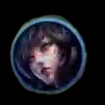 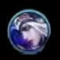 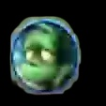 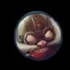 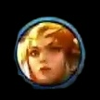

* Classification:

2 solutions:

* First, use Image Processing (Template Matching / SIFT or … ) because the image has no feature change, and data just have 98 images => Accuracy is relatively stable, running time is faster than using neural network and do not need GPU.

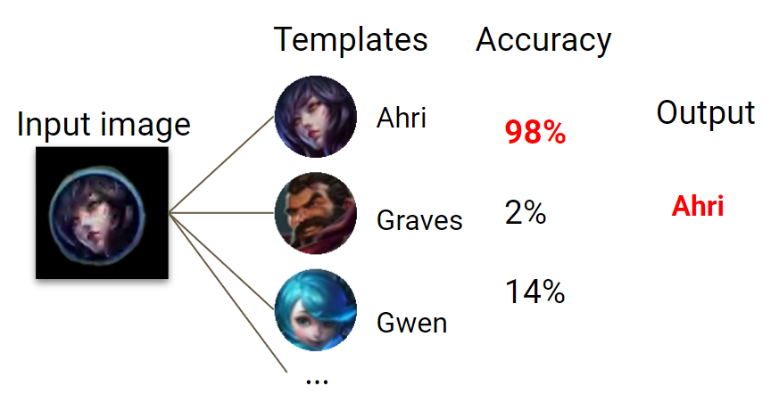

* Second, use Deep Learning (YOLO or <https://paperswithcode.com/sota/image-classification-on-imagenet>) if we have more images to classify => Accuracy is higher using image processing, but running time is slower.

**Exercise 2 – Highlight Moment Detection System**

Capturing goal moment in FIFA23:

* Processing in audio:

Use audio detection for key word such as (wow, bravo, yeah… or loud sound, scream high frequency). Create a break point for 5-10s to highlight.

Problem: Noise, audience voice)

* Processing in image frame in video:
* Detect the goal score box  and check score change. Get highlight 5-10s.

Problem: goal score box is covered by commend and disappear too fast

* Detect the ball through line of goal.

= > Solution for the above problem: consider combining two methods (audio detect + goal score box), using denoise technique for audio detection, using contour detect, denoise to enhance getting goal score box and using a strong model to training.