Type of the Paper (Article, Review, Communication, etc.)
Deep Reinforcement Learning Control for Path Following and Static Obstacle Avoidance for Autonomous Surface Vessels
Nam H. Tran ¹, Hung D. Nguyen¹, Peter King^{1*}, Minh Tran^{1, 2}
Academic Editor: Firstname Lastname
Received: date
Revised: date
Accepted: date
Published: date
Copyright: © 2026 by the authors. Submitted for possible open access publication under the terms and conditions of the Creative Commons Attribution (CC BY) license.
¹ Australian Maritime College, University of Tasmania, Maritime Way, Newnham, Tasmania 7250, Australia; hoangnam.tran@utas.edu.au (N.H.T.); h.d.nguyen@utas.edu.au (H.D.N.); p.d.king@utas.edu.au (P.K.)
² RMIT University Vietnam, 702 Nguyen Van Linh, HCMC 700000, Vietnam; minh.tranquang@rmit.edu.au (M.T.)
* Correspondence: p.d.king@utas.edu.au
Highlights
What are the main findings?
- A LiDAR-based deep reinforcement learning policy (Soft Actor-Critic) enables an underactuated ASV to follow a reference path while avoiding static obstacles in a narrow environment, validated in both simulation and model-scale field experiments.
- A feasibility-inspired LiDAR sector pooling design provides compact obstacle features for policy input and supports evaluation of LiDAR configuration.
What are the implications of the main findings?
- The study provides a practical baseline for ASV navigation using local SLAM pose and LiDAR sensing, suitable for constrained waterways.
- The sim-to-field evaluation protocol and modular observation design can be extended towards dynamic obstacle avoidance and COLREG-based decision-making in future work.
Abstract
Autonomous surface vessels (ASVs) operating in narrow and restricted waterways must follow a planned path while avoiding nearby static hazards and maintaining safe clearance from boundaries. This paper presents a LiDAR-based deep reinforcement learning framework for path following and static obstacle avoidance of an underactuated ASV. The vessel receives local pose information from a localization system and surrounding environment through a 2D LiDAR scan, which is converted into compact sector features using feasibility-inspired pooling method. A Soft Actor-Critic (SAC) policy is trained in simulation to output continuous rudder and propulsion commands, based on LiDAR features, estimated motion states, and path-relative errors. The policy is evaluated over 500 randomized simulation episodes ranging from 0-4 obstacles. The trained policy achieved an overall success rate of 94%, with an average cross-track error of 0.80 m. Obstacle and border collision rates are both 3%, indicating that the policy can balance path tracking and collision avoidance in constrained layouts. Field experiments using the model-scale Bluefin vessel show that the learned policy can transfer to the physical platform and avoid static obstacles in fixed test scenarios, with minimum obstacle clearances of 0.50-1.17 m. However, the field trajectories exhibit larger oscillations and longer path lengths than simulation, with an average RMS cross-track error of 1.14 m compared to 0.69 m in simulation. These results demonstrate feasible transfer while highlighting the need for improved vessel dynamics modeling and sim-to-field refinement.
Keywords: autonomous surface vessel; LiDAR; deep reinforcement learning; Soft Actor-Critic; path following; collision avoidance; restricted waterways; field experiments

1. Introduction
Autonomous Surface Vessels (ASVs) are increasingly deployed for monitoring, inspection, and logistics in coastal and inland waters. Many practical missions take place in confined or restricted waterways, such as harbors, canals and narrow channels, where available maneuvering space is limited and small navigation errors can quickly lead to collision with quay walls or grounding. Recent work on autonomous navigation in confined waters emphasizes that boundary constraints and nearby static structures change the decision-making problem compared with open-water operation, motivating specific methods to narrow environments [1, 2]. In restricted waterways, static obstacle avoidance is not simply a local detour problem. Because the available clearance is limited, avoiding an obstacle can immediately increase the risk of boundary contact or excessive deviation from the survey path. Therefore, path following, obstacle avoidance, and boundary clearance must be treated as a coupled control problem rather than independent modules. This motivates the present focus on static-obstacle navigation in narrow environments as a necessary step toward reliable ASV autonomy before introducing dynamic obstacle encounters.
Surveys of ASV autonomy consistently highlight that collision avoidance and motion planning remain as central bottlenecks, emphasizing that practical solutions must be robust, real-time, and compatible with marine vehicle dynamics and sensing limitations [3-5]. Recent literature on marine collision avoidance is driven by dynamic encounters and COLREGs compliance, where an autonomous vessel must navigate among multiple moving targets and rule-based behaviors [6]. This focus is well justified for open-water autonomy, however, for many restricted-water missions, the most frequent and immediate risk is collision with static obstacles, such as quay walls or narrow channel boundaries, where even small tracking errors can lead to contact. Static-obstacle navigation is also a practical foundation: a system that cannot reliably avoid fixed hazards in confined corridors is unlikely to be dependable once multi-vessel reasoning is added.
Classical ASV navigation methods combine model-based guidance laws with local planners or reactive avoidance layers. Marine guidance and control references, such as line-of-sight (LOS), offer convergence properties for path following, but they rely on a controller that can realize the commanded course and speed changes under hydrodynamics and actuator constraints [7]. When obstacles are introduced, an additional layer is often required to select avoidance maneuvers while maintaining progress along a reference path. Implementations in confined waters often utilize onboard ranging sensors to construct a local obstacle representation and then integrate path following with collision avoidance logic. For example, Villa et al. demonstrated path following with LiDAR-based obstacle avoidance for a surface vessel operating under harbor conditions, using a structured guidance formulation and sensor-driven safety logic [8]. More optimization-based pipelines integrate collision constraints directly into the control problem: Gonzales-Garcia et al. formulated a nonlinear model predictive control (NMPC) strategy that simultaneously tracks a path and enforces obstacle clearance using LiDAR measurements [9]. Experimental studies using 2-dimensional LiDAR further illustrate practical issues, such as spurious returns or partial occlusions, that can dominate the performance gap between simulation and field deployment [10]. While these methods can be effective, they also expose recurring limitations, including reliance on accurate models and tuning, and low adaptability in dense environments [4, 5, 8].
Machine learning-based methods offer another route where the control policy is learned from data rather than manually tuned parameters. Deep reinforcement learning (DRL) provides a direct way to treat navigation and control as a sequential decision problem: the policy selects control actions that balance between progress, tracking accuracy, and safety [11]. In marine robotics, DRL has shown promise in both path-following control and collision avoidance. Woo et al. demonstrated a DRL controller for USV path following using an actor-critic continuous-control algorithm, known as deep deterministic policy gradient (DDPG), framing path following as a closed-loop control policy learned through interaction rather than explicit controller tuning [12]. Subsequent work has refined state design and training structure for underactuated marine vehicles, including DRL path-following formulations targeting robustness and smoother convergence. Qu et al. proposed a DRL-based path-following control scheme for an underactuated autonomous marine vehicle under uncertainty, illustrating how detailed reward shaping and state construction can stabilize learning and improve tracking behavior [13].
Obstacle avoidance in marine settings is harder than in many ground-robot cases because yaw response is slow, stopping distance is large, and feasible actions are constrained by rudder and thrust limits. Early DRL work on marine vessels showed that a learned policy can produce avoidance actions under disturbances when the reward encourages both safety and progress. Cheng and Zhang proposed a concise DRL approach for obstacle avoidance in underactuated unmanned marine vessels, focusing on usable policies without complex control laws [14]. Meyer et al. trained an agent, using proximal policy optimization (PPO), for an underactuated ASV to follow a known path while avoiding static obstacles, using multiple rangefinder sensors as perception [15]. Their study demonstrates that the combined objective between path tracking and collision avoidance can be achieved when observations and rewards are designed carefully.
Woo and Kim targeted the decision-making stage of USV collision avoidance and proposed a DRL approach that uses a grid-map representation of encounter situations [16]. They designed a semi-Markov decision process and a neural network architecture tailored to collision avoidance, then evaluated the trained network in both simulations and collision avoidance experiments. This work shows the value of structured spatial inputs when the environment geometry is complex. More recent works also use spatial encodings to improve learning in crowded settings. Teitgen et al. proposed a collision-grid representation for dense environments with multiple obstacles, illustrating the broader trend of using geometry-aware inputs rather than raw state vectors [17]. In restricted waters, PPO variants have been explored to improve stability and decision-making quality. Hao et al. introduced an improved PPO-based strategy for USV collision avoidance in restricted waters, using a recurrent network (GRU) to improve convergence compared with standard feed-forward structures [18].
Beyond pure simulation training, recent work increasingly targets robustness and transfer from simulation to field validation. Slawik et al. studied domain randomization for DRL path-following control of an ASV by training over a distribution of dynamics and sensing parameters rather than a single model, and compared popular DRL algorithms, including DDPG, PPO, and Soft Actor-Critic (SAC), to improve sim-to-real readiness [19]. Cross-domain training has been proposed as another way to reduce the data burden and improve generalization when marine data are expensive. Lambert et al. reported a ground-to-water cross-domain DRL approach for ASV navigation to address training sparsity in marine environments [20].
Despite this progress, two gaps remain relevant to static obstacle avoidance in narrow waterways. First, while most ML-based marine literature targets dynamic obstacles and COLREGs compliance, fewer studies isolate and deeply evaluate the static-hazard problem in constrained environments. Second, sim-to-real transfer continues to be a practical bottleneck for DRL marine autonomy, motivating cross-domain training and domain randomization strategies. The paper addresses these gaps by developing and validating DRL-based navigation and control system for an ASV operating in a narrow environment, focusing on path following with static obstacle avoidance.
Built from our prior simulation study, this paper addresses a different and more deployment-oriented problem. The previous work established the algorithmic baseline by comparing PPO and SAC for ASV path following and static obstacle avoidance in randomized situations, and robustness under varied obstacle layouts [21]. In contrast, the present work focuses on translating this algorithmic baseline into a field-deployable navigation framework for restricted waterways, where local pose, LiDAR sector observations, underactuated vessel dynamics, propulsion and rudder constraints, and boundary clearance must be considered together. The main contributions of this paper are:
- A deployable DRL navigation framework for an underactuated ASV in restricted waterways.
- A LiDAR observation design that converts raw range measurements into compact sensor features suitable for real-time policy execution.
- An SAC-based continuous-control policy that outputs rudder and propulsion commands, selected based on prior PPO/SAC comparison and adapted here to the combined path following, obstacle avoidance, and boundary clearance tasks.
- A simulation and field validation protocol that evaluates the trained policy under various obstacle densities and matched model-scale scenarios, allowing both statistical evaluation and qualitative sim-to-field comparison.
The remainder of the paper is organized as follows. Section 2 describes the materials and methods for reproducibility. Section 3 presents the results and discussion, covering simulation study and field experiments. Section 4 concludes the paper and discusses future extensions.

2. Materials and Methods

2.1. System model and problem setup
The ASV operates in a two-dimensional bounded workspace representing a narrow operating area. The environment contains static obstacles that remain fixed during an episode. A collision is declared when the ASV footprint intersects an obstacle or the workspace boundary. During operation, the platform provides a local pose estimate $\left(x,y,ψ\right)$ in a resettable SLAM/localization frame, together with a 2D LiDAR scan. A reference path from start to destination point is assumed available from a global path planner. The controller is not provided with the full path as a map. Instead, it receives compact path-relative quantities computed from the local pose and path geometry, including cross-track error, course error, and look-ahead course error. These terms provide a low-dimensional representation of tracking performance and are used to guide the learned policy toward smooth convergence back to the reference path after avoidance maneuvers.
The control policy outputs rudder and propulsion commands at a fixed control period. The commanded actions are constrained by actuator limits and mapped into feasible setpoints before being applied to the vessel. Episodes are finite and truncated after a maximum duration if neither the goal nor a collision event occurs. The objective is to reach the goal region while tracking the reference path and maintaining safe clearance from obstacles and boundaries.
Fig. 1 illustrates the proposed navigation and control framework as a closed-loop pipeline that maps onboard sensing to continuous rudder and propulsion commands.
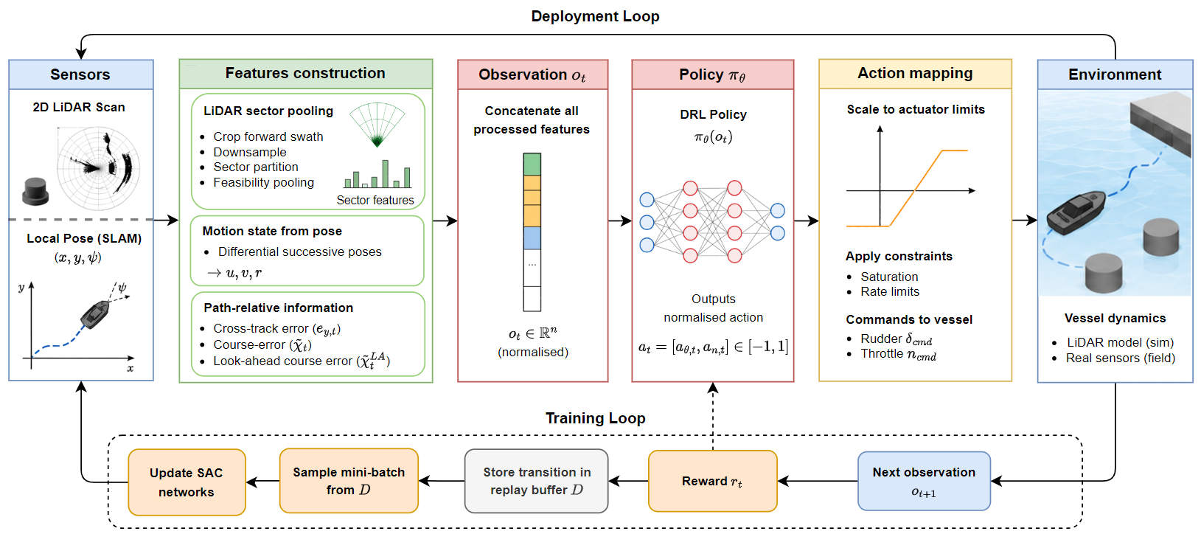
Figure 1. ASV navigation and control workflow
During training, the environment produces a scalar reward $r_{t}$ based on the reward function. The transition $\left(o_{t},a_{t},r_{t},o_{t+1}\right)$ is stored in a replay buffer to support off-policy SAC updates. For evaluation and field trials, the same closed-loop pipeline is executed, except for learning updates and replay-buffer storage as only the trained policy is used for decision making.

2.2. Vessel model and control
The autonomous surface vessel is represented by a physics-informed maneuvering model with three degrees of freedom (3-DOF): surge, sway, and yaw. This formulation is widely used for low-speed surface vessel guidance and collision avoidance, where motion is dominated by the horizontal plane and the effects of heave, roll, and pitch can be neglected without compromising the local navigation objective [22]. The model combines a rigid-body formulation with calibrated hydrodynamic terms so that it remains computationally efficient for RL simulations, while still reproducing the measured speed and turning behavior of the Bluefin vessel.
Let the vessel pose in the local earth-fixed frame be
$$η={\left[x, y, ψ\right]}^{⊤},$$ | (1)
where $x$ and $y$ denote the planar position and $ψ$ is the heading angle. The body-fixed velocity vector is written as
$$ν={\left[u, v, r\right]}^{⊤},$$ | (2)
where $u$ is the surge velocity, $v$ the sway velocity, and $r$ the yaw rate. The kinematic transformation between body-fixed motion and earth-fixed motion is written as
$$\dot{η}=R\left(ψ\right)ν, R\left(ψ\right)=\left[\begin{matrix}\cos{ψ} & -\sin{ψ} & 0 \\ \sin{ψ} & \cos{ψ} & 0 \\ 0 & 0 & 1\end{matrix}\right].$$ | (3)

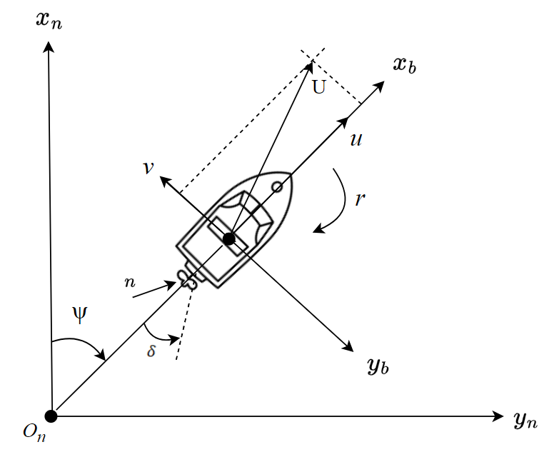
Figure 2. Local earth-fixed frame {n} and body-fixed frame {b} for the 3-DOF vessel maneuvering model
The 3-DOF dynamics are expressed as
$$M\dot{v}+C\left(v\right)v+D\left(v\right)v=τ\left(δ,n\right),$$ | (4)
where $M$ is the effective inertia matrix, $C\left(v\right)$ contains Coriolis and centripetal terms, and $D(v)$ represents hydrodynamic damping. The generalized force/moment vector $τ={\left[X,Y,N\right]}^{⊤}$ is generated by the propeller and rudder, which is commonly decomposed as
$$τ=τ_{H}\left(v\right)+τ_{P}\left(u,n\right)+τ_{R}\left(v,δ,n\right),$$ | (5)
corresponding to hull, propeller, and rudder contributions [22]. The commanded control inputs are rudder angle $δ$ and propeller speed $n$, while lateral force $Y$ and yaw moment $N$ arise through hydrodynamic interaction. Actuator commands are bounded by $δ∈\left[-δ_{max},δ_{max}\right]$ and $n∈\left[n_{min},n_{max}\right]$. To avoid aggressive maneuvers during simulation rollouts, the rudder and propulsion commands are limited to the allowable range. The equations of motion are integrated with a fixed-step 4th order Runge-Kutta method using the control period $Δt$. Model parameters are calibrated against straight-line and turning-circle maneuvers of the model-scale vessel such that the surge speed build-up and turning performance in simulation reflect the experimental platform.

2.3. LiDAR observation design
To enable local path following and static obstacle avoidance in a narrow area, the ASV relies on a forward-looking 2D scanning LiDAR to provide surrounding geometric data without requiring a pre-built map. LiDAR-based mapless policies are widely used in DRL navigation because they offer a compact and meaningful observation that reduces dependency on global localization accuracy [23, 24]. Moreover, they can transfer more robustly across simulation and deployment domains when compared to map-dependent planners.

2.3.1. LiDAR configuration
At time step $t$, the LiDAR returns a raw scan vector
$$d_{t}={\left[d_{t,1}, d_{t,2},…,d_{t,N}\right]}^{⊤},$$ | (6)
where $d_{t,i}∈\left[D_{min},D_{max}\right]$ is the measured range of beam $i$ and $N$ is the number of raw beams. The physical LiDAR has a valid sensing interval bounded by a measurable range $\left[D_{min},D_{max}\right]$. Measurements outside of this range are treated as invalid and replaced by $D_{max}$ before sector pooling. This configuration follows the practical constraint that the forward sector contains the most relevant collision information for local obstacle collision avoidance in limited environments, while still providing sufficient lateral coverage to detect corridor-like structures [25].
Let $α_{i}∈\left[-\frac{Φ}{2},\frac{Φ}{2}\right]$ denote the bearing angle of beam $i$ expressed in the ASV body frame, measured relative to the forward axis. In the simulation, each $d_{t,1}$ is computed by ray-casting against obstacle polygons and boundary segments, then clipped to $\left[0,D_{max}\right]$.

2.3.2. Sector pooling
Directly feeding the raw scan vector into the policy increases input dimension and can make learning less stable, particularly when the training distribution includes varied obstacle layouts and narrow passages. Therefore, the raw scan is compressed into a fixed number of angular sectors:
$$S_{1},S_{2},…,S_{M}, M=25,$$ | (7)
where each sector $S_{j}$ is an adjacent set of beam indices spanning a constant angular interval. The pooled sector distance is written as
$$D_{t,j}=Pool\left(\left\{d_{t,i} | i∈S_{j}\right\}\right), j=1, 2,…,M.$$ | (8)
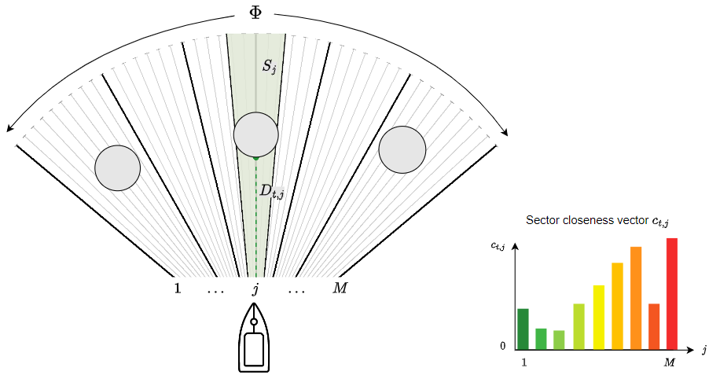
Figure 3. LiDAR sector pooling and closeness vector
Instead of using minimum or maximum pooling, feasibility-inspired pooling principle is adopted so that each sector feature reflects not only the nearest return, but also whether the sector can accommodate the vessel’s footprint at increasing distances. The intuition is that a single short return, such as a corner or a thin obstacle, should not automatically dominate the entire sector if there exists a sufficiently wide free area in a neighboring direction. Similar motivations appear in low-dimensional range representations for DRL navigation, where sparse or compressed scans are designed to preserve actionable structure while reducing learning complexity [26].
Algorithm 1 describes the feasibility sector pooling used to compress a raw LiDAR scan into fixed-length sector features. For each sector, candidate range levels are examined in ascending order. At each candidate level, beams farther than the candidate range are treated as free, while beams at or nearer than the candidate range close the current opening. The pooled distance $D_{t,j}$ is the first candidate range at which no opening wider than the safety-adjusted vessel width $W_{s}$ remains. If all candidate levels remain feasible, the pooled distance is set to the farthest measured range in the sector. The pooled distance is then normalized into the bounded closeness feature $c_{t,j}$.

Algorithm 1. Feasibility sector pooling for LiDAR
Require:
$W_{s}$: safety-adjusted vessel width
$Φ$: LiDAR swath (FOV)
$D_{max}$: maximum LiDAR range
$N$: total number of LiDAR beams
$M$: number of sectors
$x_{t}$: raw LiDAR scan at time $t$, $x_{t}=\left\{x_{t,1}, …,x_{t,N}\right\}$
$S_{j}$: sector partitions, $j=1…M$
Ensure:
$D_{t}=\{D_{t,1},…,D_{t,M}\}$: pooled sector distances
$c_{t}=\{c_{t,1},…,c_{t,M}\}$: sector closeness vector
Function: SectorPooling($d_{t}$)
$θ←\frac{Φ}{N-1}$
for each sector $S_{j}$ do
$x←$ raw beam ranges in $S_{j}$
$I←$ indices of $x$ sorted in ascending range
$D_{t,j}←max⁡(x)$
for $i$ in $I$ do
$x_{i}←x\left[i\right]$
if $x_{i}≤0$ then
continue
$d_{i}←θx_{i}$
$y←0.5 d_{i}$
opening_found $←$ false
for each beam range $x_{k}$ in $x$, traversed in angular order do
if $x_{k}>x_{i}$ then
$y←y+d_{i}$
if $y>W_{s}$ then
opening_found $←$ true
break
else
$y←y+0.5 d_{i}$
if $y>W_{s}$ then
opening_found $←$ true
break
$y←0$
if opening_found is false then
$D_{t,j}←x_{i}$
break
$c_{t,j}←clip\left(1-D_{t,j}/D_{max}, 0, 1\right)$
return $D_{t}$ and $c_{t}$

2.3.3. Boundary visibility
A key sim-to-field consideration in narrow environments is that the boundary may not appear symmetrically in the LiDAR scan due to sensor placement and platform geometry, where one wall is visible while the opposite wall is partially occluded. To emulate this and prevent policies from overfitting to a single boundary sensing, the environment supports different border visibility modes for the observation LiDAR scan. However, the true collision boundary is still enforced geometrically for termination and safety penalties. This separation of what the policy sees versus what counts as collision is consistent with sensor-level mapless USV navigation studies that emphasize realism in perception while maintaining strict safety evaluation [26, 27].
In addition, when shaping the obstacle avoidance reward, the obstacle proximity term is computed from a LiDAR scan that excludes borders, ensuring that obstacle avoidance learning is not dominated by persistent wall returns. Boundary interactions are instead handled by a border-clearance penalty term, using the minimum geometric distance between the vessel and the map boundary.

2.4. MDP elements for DRL guidance navigation and control

2.4.1. Reinforcement learning algorithm
To formalize the closed-loop interaction, the navigation task is modelled as a partially observable Markov decision process (MDP) $〈S, A, P, R, γ〉$, where $S$ is the state space, $A$ is the action space, $P$ is the transition model, $R$ is the reward function, and $γ∈(0, 1]$ is a discount factor [9]. The underlying state $s_{t}$ captures the vessel motion and surrounding obstacle configuration, while the agent receives an observation $o_{t}$ constructed from processed LiDAR features, estimated motion variables and path-relative errors. At each time step $t$, the policy $π_{θ}\left(a_{t} | o_{t}\right)$ selects a continuous action $a_{t}∈A$. The environment transitions according to $P\left(s_{t+1} | s_{t},a_{t}\right)$ and returns a scalar reward $r_{t}=r\left(s_{t},a_{t},s_{t+1}\right)$. The discounted return from time $t$ is defined as
$$G_{t}=\sum_{k=0}^{T-t-1}{γ^{k}r_{t+k+1}},$$ | (9)
where $γ∈\left(0, 1\right]$ is the discount factor and $T$ is the episode horizon determined by success, collision, or timeout. The learning objective is to find policy parameters $θ$ that maximise the expected return $J\left(π_{θ}\right)=E\left[G_{0}\right]$.
For continuous-control problems, DRL commonly represents the policy and value functions using function approximation, leading to policy-gradient and actor-critic formulations that can handle high-dimensional observations and continuous actions [28]. A widely adopted strategy is to learn a critic alongside the actor to reduce gradient variance and stabilize training. Practical deep actor-critic implementations often use parallelized data collection to improve stability [29]. In on-policy actor-critic methods, generalized advantage estimation (GAE) is frequently used to balance bias and variance in the advantage signal and improve learning stability [30]. While these approaches provide important foundations, the navigation task involves long horizons and continuous actuation.
In this work, an off-policy actor-critic algorithm, Soft Actor-Critic (SAC), is selected for two reasons. First, the ASV navigation problem considered here has a continuous action space, where the policy must regulate rudder and propulsion commands rather than choosing from a set of discrete maneuvers. SAC directly learns a stochastic continuous control policy, which is suitable for this control interface. Second, the training environment contains randomized start/goal positions and obstacle layouts so sample efficiency and exploration are important. SAC is off-policy and reuses stored transitions through a replay buffer, which improves data efficiency compared to on-policy methods, while its entropy-regularized objective encourages exploration and reduces premature convergence to a narrow avoidance strategy [31]. This choice is also supported by our previous study, where SAC outperformed PPO in success rate, cross-track error, trajectory smoothness, and robustness across varied static-obstacle layouts [21]. Therefore, SAC is used as the final algorithm in this paper, while present study focuses on deployment-oriented observation design, restricted-waterway evaluation, and field validation.
SAC learns a stochastic policy $π_{θ}$ for continuous control using a maximum-entropy objective, which encourages exploration and improve robustness [32]. The objective is
$$J\left(π\right)=\sum_{t=0}^{T}{E_{(s_{t},a_{t})\sim ρ_{π}}[r\left(s_{t},a_{t}\right)+α H(π(⋅|s_{t}))]},$$ | (10)
where $α$ is a temperature parameter. SAC is trained off-policy using a replay buffer of transitions $\left(o_{t},a_{t},r_{t},o_{t+1}\right)$. In a standard implementation, two critics $Q_{ϕ_{1}}$ and $Q_{ϕ_{2}}$ are used and the target uses the minimum to reduce overestimation bias. The critic target can be written as
$$y_{t}=r_{t}+γ\left(\min_{i∈\left\{1,2\right\}}{Q_{{\overline{ϕ}}_{i}}\left(s_{t+1},a_{t+1}\right)}-α\log{π_{θ}\left(a_{t+1} | s_{t+1}\right)}\right), a_{t+1}\sim π_{θ}(⋅|s_{t+1}),$$ | (11)

and the policy update maximizes expected soft value
$$J_{π}\left(θ\right)=E_{s_{t}\sim D,a_{t}\sim π_{θ}}\left[α\log{π_{θ}\left(a_{t} | s_{t}\right)}-\min_{i∈\left\{1,2\right\}}{Q_{ϕ_{i}}\left(s_{t},a_{t}\right)}\right].$$ | (12)
In our implementation, the entropy temperature $α$ is tuned automatically to match a target entropy, reducing sensitivity to continuous action scaling.

2.4.2. Observation vector
The policy input is constructed as a compact observation vector
$$o_{t}=\left[c_{t},u_{t},v_{t},r_{t},e_{y,t},{\tilde{χ}}_{t},{\tilde{χ}}_{t}^{LA}\right],$$ | (13)
where:
- $c_{t}∈R^{M}$ is the LiDAR sector closeness vector.
- $u_{t}$ and $v_{t}$ are the surge and sway velocities in the body frame.
- $r_{t}$ is the yaw rate.
- $e_{y,t}$ is the cross-track error (CTE), signed lateral deviation from the closest point on the reference path.
- ${\tilde{χ}}_{t}$ is the course or heading error relative to the local path tangent.
- ${\tilde{χ}}_{t}^{LA}$ is the look-ahead course error relative to a forward point on the path, used to encourage smoother convergence and reduce oscillations.
Let $p\left(s\right)$ denote the reference path parameterised by arc length $s$, $p\left(s_{c}\right)$ be the closest point on the path to the vessel position $p_{xy}={\left[x,y\right]}^{⊤}$, and $t_{c}$ is the unit tangent at $s_{c}$. The signed cross-track error is defined as
$$e_{y}=sign\left(t_{c}×\left(p_{xy}-p\left(s_{c}\right)\right)\right){\left|\left|p_{xy}-p\left(s_{c}\right)\right|\right|}_{2}.$$ | (14)
This error definition is consistent with standard path following guidance formulations that penalize lateral deviation from the desired track [5]. The course error ${\tilde{χ}}_{t}$ measures alignment between the vessel’s direction of motion and the local path direction, while a look-ahead course error ${\tilde{χ}}_{t}^{LA}$ provides anticipative steering toward a forward point on the path. Let $p_{t}^{LA}$ be a path point located ahead of $p(s_{c})$ by a look-ahead distance $D_{LA}$. We adopt a path-length-proportional look-ahead:
$$D_{LA}=\max{(D_{min},κL_{path})},$$ | (15)
where $L_{path}$ is the current path length, $D_{min}>0$ prevents degeneracy on short paths, and $κ>0$ is the tuning coefficient. Then ${\tilde{χ}}_{t}^{LA}$ is the angular difference between the vessel’s course and the bearing angle from $p_{t}$ to $p_{t}^{LA}$. These path-relative error signals are common in marine path following guidance because they encode task progress and convergence geometry in low dimension [32]. The geometric interpretation of the path-relative quantities is illustrated in Fig. 4.
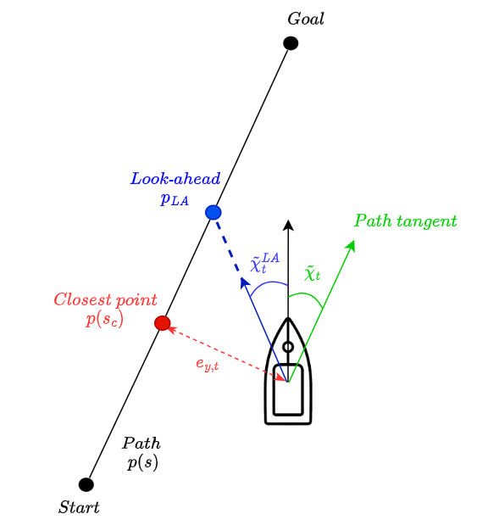
Figure 4. Path-relative tracking quantities

2.4.3. Action space
The agent outputs a continuous action corresponding to rudder and propulsion commands (Eq. 16).
$$a_{t}={\left[a_{δ,t},a_{n,t}\right]}^{⊤}, a_{δ,t},a_{n,t}∈\left[-1,1\right]$$ | (16)
The rudder command is mapped linearly to a bounded physical rudder angle (Eq. 17).
$$δ_{t}=δ_{max}a_{δ,t}$$ | (17)
For propulsion, two operating modes are supported:
- Fixed-speed mode is used to stabilize early learning. The propeller speed is held constant $n_{t}=n_{c}$ and $a_{n,t}$ is ignored.
- Speed-control mode outputs a residual throttle around a nominal cruise RPM (Eq. 18)
$$n_{t}=clip\left(n_{c}+Δn a_{n,t}, n_{min}, n_{max}\right),$$ | (18)
where $n_{c}$ is the cruise RPM, $Δn$ is the maximum residual authority, and $\left[n_{min},n_{max}\right]$ bounds the actuation. This residual parameterisation keeps the action bounded, avoids requiring the policy to rediscover a nominal cruising point from scratch, and improves training stability in continuous control settings.

2.4.4. Reward function
The reward is shaped to encode the two coupled objectives of this work: (i) follow the reference path with small tracking error and stable steering, and (ii) avoid collisions with static obstacles and boundaries, while preventing stationary behaviors such as stopping or circling without progress. The total step reward combines path tracking, heading alignment, obstacle proximity, boundary clearance, and progress/speed shaping terms:
$$r_{t}=λ g_{u,t} r_{pf,t}+\left(1-λ\right)r_{oa,t}+w_{χ}g_{u,t}r_{χ,t}+r_{exist}+r_{border,t}+r_{spd,t}+r_{term,t}.$$ | (19)
This type of reward design is common in DRL-based ASV navigation, where the policy must learn a practical balance between safety and task completion efficiency rather than optimizing only a single objective [15]. In the present configuration intended for field deployment, the weighting coefficient $λ=0.5$ is fixed to provide a consistent balance between path following and obstacle avoidance [21].
Path tracking terms
The path following component penalizes lateral deviation from the reference path using an exponential penalty on the cross-track error (Eq. 20).
$$r_{pf,t}=\exp\left(-γ_{e}\left|e_{y,t}\right|\right)$$ | (20)
This choice provides a smooth learning signal near the path while reducing reward for large deviations, discouraging wide detours in narrow corridors. The sensitivity parameter $γ_{e}$ controls how tightly the policy tracks the path: larger $γ_{e}$ enforces stricter tracking, while smaller $γ_{e}$ allows the vessel to temporarily deviate when obstacle avoidance requires it.
A common failure mode in safety-shaped rewards is that the agent may stand still to avoid collisions. To resolve this, the tracking and heading terms are multiplied by a speed gate (Eq. 21).
$$g_{u,t}=clip\left(\frac{\max\left(u_{t},0\right)}{U_{ref}},0,1\right).$$ | (21)
When the vessel is not moving forward ($u_{t}≤0$), the gated terms contribute little to the return, which encourages the agent to achieve safety through feasible motion rather than stopping indefinitely. $U_{ref}$ is a reference surge speed used for normalisation.
In addition to minimizing CTE, the reward encourages heading alignment to reduce oscillations and promote smooth steering. A combined heading error is formed using the instantaneous course error ${\tilde{χ}}_{t}$ and a look-ahead course error ${\tilde{χ}}_{t}^{LA}$ (Eq. 22).
$${\tilde{χ}}_{t}^{*}=ω_{LA} {\tilde{χ}}_{t}^{LA}+\left(1-ω_{LA}\right) {\tilde{χ}}_{t}, r_{χ,t}={\cos{(\tilde{χ}}}_{t}^{i}),$$ | (22)
where $ω_{LA}∈\left[0, 1\right]$ weights the look-ahead course error relative to the instantaneous course error. The alignment term is scaled by $w_{χ}$ and gated by forward speed through $g_{u,t}$. The look-ahead component provides anticipation when approaching corners or tight passages and helps reduce high-frequency corrections that can occur when minimising CTE alone [32].
Safety terms
Obstacle proximity is penalized using a LiDAR scan that excludes border returns, preventing persistent wall measurements from dominating the learning signal. The obstacle penalty is computed using the raw beam distances to preserve directional sensitivity and to provide a smooth gradient for learning (Eq. 23).
$$r_{oa,t}=-\frac{1}{N}\sum_{i=1}^{N}{\frac{w_{i}}{\max\left(d_{t,i},d_{min}\right)}}, w_{i}=\frac{1}{1+\left|α_{i}\right|}.$$ | (23)
Here, $d_{t,i}$ is the range of beam $i$, $α_{i}$ is its bearing angle relative to the forward direction, and $d_{min}$ prevents numerical blow-up for very small ranges. The weighting $w_{i}$ emphasizes forward-facing beams, reflecting the fact that collision risk is dominated by obstacles ahead of the vessel.
Since boundary sensing can be asymmetric in the observation scan due to sensor placement, boundary safety is enforced separately through a geometric clearance penalty computed from the true map boundary (Eq. 24).
$$r_{border,t}=-K_{b}{\left[\max\left(0,1-\frac{d_{b,t}}{d_{safe}}\right)\right]}^{2},$$ | (24)
$d_{b,t}$ is the minimum distance from the vessel to the boundary, $d_{safe}$ is a soft safety distance, and $K_{b}>0$ controls penalty strength. This squared hinge form yields zero penalty when clearance is sufficient and increases smoothly as the vessel approaches the boundary.
Efficiency terms
A constant living penalty $r_{exist}<0$ encourages efficient completion and further discourages wandering. Terminal rewards enforce a clear separation between success and failure:
- if the vessel reaches destination point, a terminal bonus $R_{goal}>0$ is applied;
- if a collision occurs or the episode ends due to timeout, a terminal penalty $R_{collision}<0$ is applied.
$$r_{term,t}=\left\{\begin{aligned}R_{goal}>0, if reach goal \\ R_{collision}<0, if collision/timeout\end{aligned}\right.$$ | (25)
When propulsion is controlled by the policy, extra speed shaping encourages progress and prevents persistent stalling or unnecessary thruster variation (Eq. 26).
$$r_{spd,t}=K_{p}\left(d_{g,t-1}-d_{g,t}\right)-K_{s}\max\left(0,U_{min}-\max\left(u_{t},0\right)\right)-K_{n}\frac{\left|n_{t}-n_{c}\right|}{Δn},$$ | (26)
The first term rewards progress (or reduction in distance-to-goal), the second penalizes low forward speed below $U_{min}$, and the third regularises the propulsion command around a nominal cruise RPM $n_{c}$ with authority $Δn$. These terms are only active in speed-control mode and can be omitted when the propulsion is fixed.
Overall, the reward is structured so that safety-related terms always remain active, while tracking and heading rewards are emphasized only when the vessel makes forward progress. Specifically, the obstacle avoidance and border clearance penalties discourage unsafe proximity to obstacles and boundaries regardless of speed, whereas the speed gate $g_{u,t}$ prevents a trivial strategy of stopping to avoid collisions. The cross-track term encourages the vessel to remain close to the reference path in corridor-like environments, and the combined heading term with a look-ahead component reduces oscillatory steering and promotes anticipatory turning when approaching narrow passages. A constant living penalty promotes efficient solutions and discourages aimless wandering. Finally, terminal rewards dominate the return at success or failure, ensuring that reaching the goal and avoiding collisions remain the primary objectives. The speed-shaping terms are enabled only when speed control is part of the action space.

3. Results and Discussion
This section presents the simulation and field results used to validate the proposed DRL framework in a restricted operating area. First, the simulation training configuration and evaluation protocol is described, followed by quantitative simulation results. Then, the model-scale field experiments conducted under predefined obstacle layouts are presented. Finally, the consistency and differences between simulations and real-world performance are discussed.

3.1. Training configuration and parameters
The SAC policy is trained in the simulation using the Stable-Baselines3 (SB3) implementation of Soft Actor-Critic [33]. The environment is constructed as a Gymnasium interface with a dictionary observation space (MultiInputPolicy), continuous actions, and scalar rewards. Parallel rollout collection is performed using a vectorized environment (SubprocVecEnv) with $N_{env}$ worker processes to improve sample throughput and stabilize off-policy data collection.
The training environment randomizes the start/goal positions and static obstacle layouts within a bounded narrow workspace. During training, the obstacle count is sampled from a predefined distribution of 0 to 4 obstacles. This distribution exposes the agent to both obstacle-free path-following and obstacle-avoidance scenarios, so the learned policy does not overfit to either pure path tracking or constant off-track avoidance. Obstacles are generated near the path to ensure that they create meaningful local planning challenges.
The policy is trained for 1 million timesteps. The first 700,000 timesteps are used for fixed-speed training, allowing the agent to first learn stable steering, path-following, and obstacle-avoidance behavior without simultaneously adapting propulsion. The remaining 300,000 timesteps introduce speed control in three stages of 100,000 steps each. In these stages, the propulsion command is represented as a residual action around a nominal cruise setting:
$$n=clip\left(n_{c}+Δn{ a}_{n}, n_{min},n_{max}\right),$$ | (27)
where $a_{n}∈\left[-1,1\right]$ is the normalized propulsion action, $n_{c}$ is the cruise command, and $Δn$ defines the allowable residual authority. The speed-control range is gradually widened from a narrow band around cruise speed to a final range corresponding to 25%-75% of the maximum propulsion command. The full propulsion range is not used because near-zero propulsion can lead to ineffective steering or standing-still behavior, while full-speed operation is less reliable in narrow waterways due to larger turning radius and increased overshoot. The staged residual formulation therefore allows the vessel to accelerate and decelerate around a safe cruise region without learning degenerate behaviors or overly aggressive high-speed maneuvers.
Table 1 summarizes the parameters used throughout training and evaluation. The same observation construction and action mapping are used consistently during training, simulation evaluation, and field deployment to minimize implementation gaps.
Table 1. Training configuration and parameters
Category | Parameter | Notation | Value
LiDAR | Measurable range | $$\left[D_{min}, D_{max}\right]$$ | [1, 16] m
 | Field of view/Swath | $$ϕ$$ | 270$°$
 | Number of beams | $$N$$ | 225
 | Number of sectors | $$M$$ | 25
Reward | Collision penalty | $$R_{collision}$$ | -1000
 | Timeout penalty | $$R_{timeout}$$ | -1000
 | Goal bonus | $$R_{goal}$$ | 50
 | Step penalty | $$r_{exist}$$ | -0.5
 | Path tracking sensitivity | $$γ_{e}$$ | 0.05
 | Speed gate reference | $$U_{ref}$$ | 0.8 m/s
 | Weighting parameter | $$λ$$ | 0.5
 | Heading mix | $$ω_{LA}$$ | 0.7
 | Heading multiplier | $$ω_{χ}$$ | 0.35
 | Border soft penalty | $$K_{b}, { d}_{safe}$$ | 0.25, 0.7 m
 | Progress reward weight | $$K_{p}$$ | 0.7
 | Look-ahead coefficient | $$κ$$ | 0.25
Training configuration | Total timesteps | $$N_{steps}$$ | 1,000,000
 | Parallel environments | $$N_{env}$$ | 8
 | Learning rate | $$η$$ | 5 x 10⁻⁵
 | Batch size | $$B$$ | 512
 | Discount factor | $$γ$$ | 0.99
 | Replay buffer size | $$D$$ | 1,000,000
 | Training frequency | $$f_{train}$$ | 1
 | Gradient steps | $$G$$ | 1
 | Entropy coefficient | $$α$$ | auto
Speed-control curriculum | Cruise propulsion | $$n_{c}$$ | 50% of max. speed
 | Stage 1 propulsion range | $$\left[{n_{1}}_{min},{n_{1}}_{max}\right]$$ | [37.5%, 62.5%]
 | Stage 2 propulsion range | $$\left[{n_{2}}_{min},{n_{2}}_{max}\right]$$ | [33.3%, 66.6%]
 | Stage 3 propulsion range | $$\left[{n_{3}}_{min},{n_{3}}_{max}\right]$$ | [25.0%, 75.0%]
 | Residual propulsion | $$Δn_{1},Δn_{2},Δn_{3}$$ | 12.5%, 16.5%, 25.0%

3.2. Evaluation metrics
To quantify navigation performance, task-level outcomes and path-following quality are reported. The success rate is defined as the fraction of episodes in which the ASV reaches the goal region within the episode horizon. Path tracking performance is measured by the mean and standard deviation of cross-track error, which reflect tracking accuracy and oscillatory behavior. Efficiency is reported through the elapsed time of each successful episode.
Because navigation in restricted waters involves both obstacle avoidance and boundary clearance, it is informative to report collision outcomes separately as obstacle collision rate and border collision rate. These rates help diagnose whether failures are dominated by obstacle interaction or boundary contact. These collision-rate metrics are recommended for interpreting failure modes in this study.

3.3. Simulation evaluation

3.3.1. Training process
To visualize learning progress, fig. 5 plots the mean evaluation rewards versus training timesteps. The solid line represents the mean episode reward at each evaluation checkpoint, while the shaded region indicates one standard deviation across evaluation episodes. Since the training environment randomizes the start/goal positions and obstacle layouts, the reward variance is expected to remain relatively large, especially during early training when the policy has not yet learned consistent avoidance behavior.
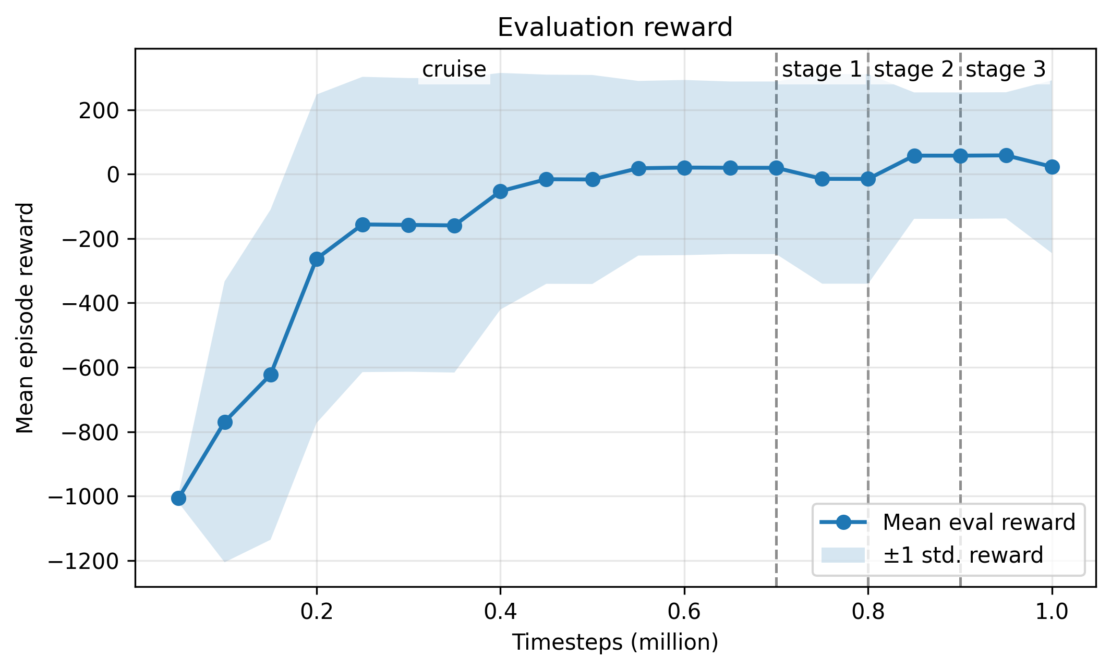
Figure 5. Mean evaluation reward versus timesteps
The learning curve shows a rapid improvement during the initial phase of training, where the mean reward increases from large negative values to near-zero values. This indicates that the policy first learns basic goal-directed motion and begins to reduce terminal failure events such as collision or timeout. After approximately the middle stage of training, the reward curve reaches a plateau and fluctuates around a small positive value, suggesting that the policy has converged to a stable behavior under the sampled training distribution. The remaining reward variation is attributed to differences in obstacle number and placement across evaluation episodes.

3.3.2. Quantitative evaluation across obstacle density
In our previous study, both PPO and SAC were trained and evaluated over 1000 randomized episodes [21]. Across various weighting coefficients $λ$ settings, PPO achieved success rates between 49.4% and 67.4%, whereas SAC achieved success rates between 90.0% and 95.5%. Under the same comparison, SAC yielded higher efficiency with average completion time and lower average cross-track errors. These results established SAC as the most suitable learning algorithm for this navigation and control problem, which is why the present paper focuses on the selected SAC policy and evaluates it under a more deployment-oriented formulation.
In this work, we conduct $N_{eval}=500$ evaluation episodes, evenly distributed across 0 to 4 obstacles. Table 2 summarizes the simulation evaluation results. Reporting results by obstacle count provides a compact and interpretable representation of robustness: as obstacle density increases, the policy must trade off tracking precision against avoidance maneuvers, which may increase cross-track deviations and elapsed time while maintaining a high success rate if avoidance remains reliable.
Table 2. Simulation evaluation of the trained SAC policy over 500 randomly generated episodes
Number of obstacles | Success rate | Avg. cross-track error | Std. cross-track error | Avg. time elapsed | Obstacle  collision rate | Border  collision rate
0 | 100% | 0.24 m | 0.33 m | 18.20 s | 0% | 0%
1 | 92% | 0.63 m | 0.82 m | 21.75 s | 8% | 0%
2 | 92% | 0.89 m | 0.88 m | 21.74 s | 6% | 2%
3 | 95% | 1.05 m | 0.86 m | 21.18 s | 0% | 5%
4 | 91% | 1.17 m | 0.91 m | 21.03 s | 1% | 8%
Overall | 94% | 0.80 m | 0.76 m | 20.78 s | 3% | 3%
The trained SAC policy achieves an overall success rate of 94% across the 500 evaluation episodes. In the obstacle-free case, the policy reaches the destination in all episodes and maintains the smallest average cross-track error, which confirms that the learned controller can perform the basic path-following task. When obstacles are introduced, the average cross-track error increases from 0.24 m in obstacle-free scenarios to 1.17 m in the four-obstacle cases. This trend is expected because successful avoidance in a narrow environment requires temporary deviations from the reference path.
Despite the increasing obstacle density, the success rate remains above 90% for all tested obstacle counts. The average elapsed time increases once obstacles are present but remain within a narrow range. This suggests that the policy does not rely on excessive waiting behavior to avoid obstacles. Instead, it performs avoidance maneuvers while continuing to make progress toward the goal.
The collision-rate breakdown also provides useful information about the failure modes. Obstacle collisions are most noticeable in single and two-obstacle cases, while border collisions become more prominent as the number of obstacles increases. This indicates that in denser layouts, the policy is able to avoid obstacles, but avoidance maneuvers can push the vessel closer to the workspace boundary. Overall, the simulation results show that the proposed observation design and reward formulation lead to robust path-following and static obstacle avoidance across a range of randomly generated environments.
From this perspective, the 94% success rate obtained in the present study is significant for two reasons. First, the result is evaluated over 500 randomized episodes spanning from 0 to 4 obstacles, which reflects generalization across obstacle density and spatial arrangement. Second, the task setting is more restrictive than an open-water avoidance problem because obstacle avoidance and boundary clearance are coupled. This is reflected in the separate reporting of obstacle and border collision rates, both of which remain at 3% overall. The policy therefore does not simply avoid obstacles at the cost of drifting into the boundary; instead, it maintains a useful balance between path tracking, static obstacle avoidance, and boundary clearance in confined waterways.

3.4. Field experiments

3.4.1. Experiment setup
Field experiments are conducted using a model-scaled Bluefin vessel equipped with a 2D LiDAR sensor and a SLAM-based localization system. The trained SAC policy is executed on an offboard computer, while the vessel provides real-time telemetry containing local pose, heading, and LiDAR range measurements. The field implementation follows the same observation and action interface used in simulation: LiDAR sector features, motion states and path-relative errors. The trained policy outputs continuous rudder and propulsion actions. Table 3 specifies the dimensions of the Bluefin vessel and the LiDAR sensor package used in this experiment.
Table 3. Technical details of the Bluefin vessel and LiDAR sensor
Component | Parameter | Value
Bluefin Vessel | Mass | 64.55 kg
 | Length Over All | 1.73 m
 | Length Between Perpendicular | 1.57 m
 | Breadth | 0.50 m
 | Draft | 0.19 m
 | Inertia Moment | 10.45 kg
LiDAR | LiDAR Model | RPLidar C1
 | Navigation | ROS2 package rf2o_laser odometry
Communication between the vessel and the offboard computer is implemented through UDP protocol. At the start of a trial, the offboard computer sends a message to initiate telemetry streaming and receives LiDAR and localization data from the vessel. For each valid telemetry frame, the computer constructs the observation vector and evaluates the trained policy deterministically. The policy output is mapped to physical command values before transmission to the vessel. The rudder action is converted into a bounded rudder command and rate limiting applied to match the real actuator. The propulsion action is mapped using the same residual cruise-speed formulation in the simulation. Commands are sent back to the vessel through UDP at 10 Hz control rate.

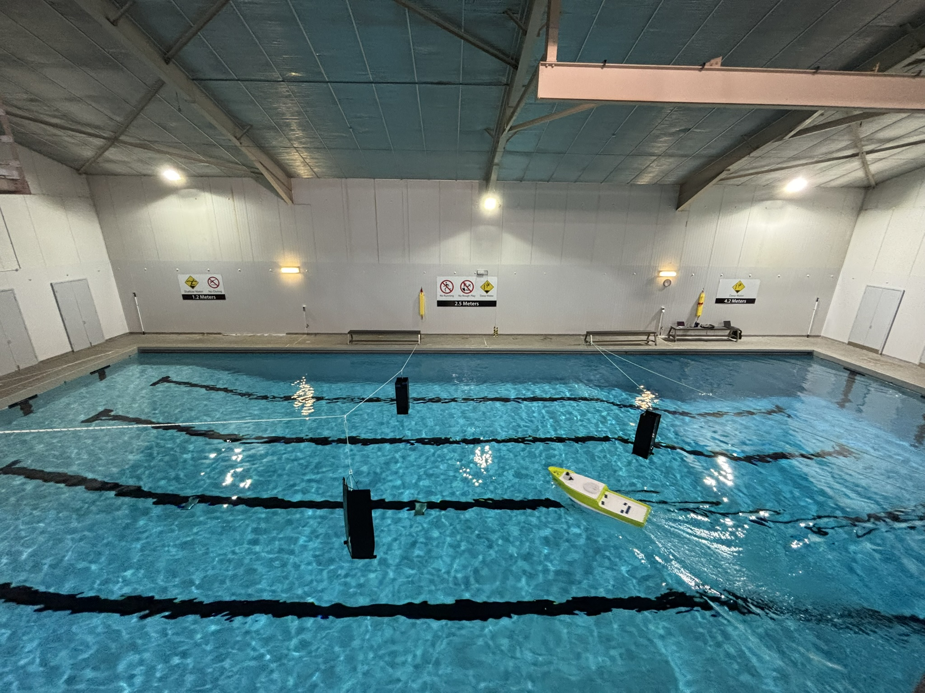
Figure 6. Model-scale Bluefin vessel operating in the test basin with three static obstacles.
To enable direct comparison between simulation and field behavior, three test scenarios are defined with three obstacles arranged in a confined waterway layout as shown in Fig. 6. The same scenario settings are reproduced in simulation for trajectory overlay comparison.

3.4.2. Comparison between simulation and field
Fig. 7 overlays the trajectories obtained in simulation and field trials for three scenarios. Table 4 provides the corresponding trajectory-based metrics. The purpose of this comparison is not to obtain identical trajectories, but to determine whether the policy trained in simulation can reproduce the same task-level behavior on the Bluefin vessel.
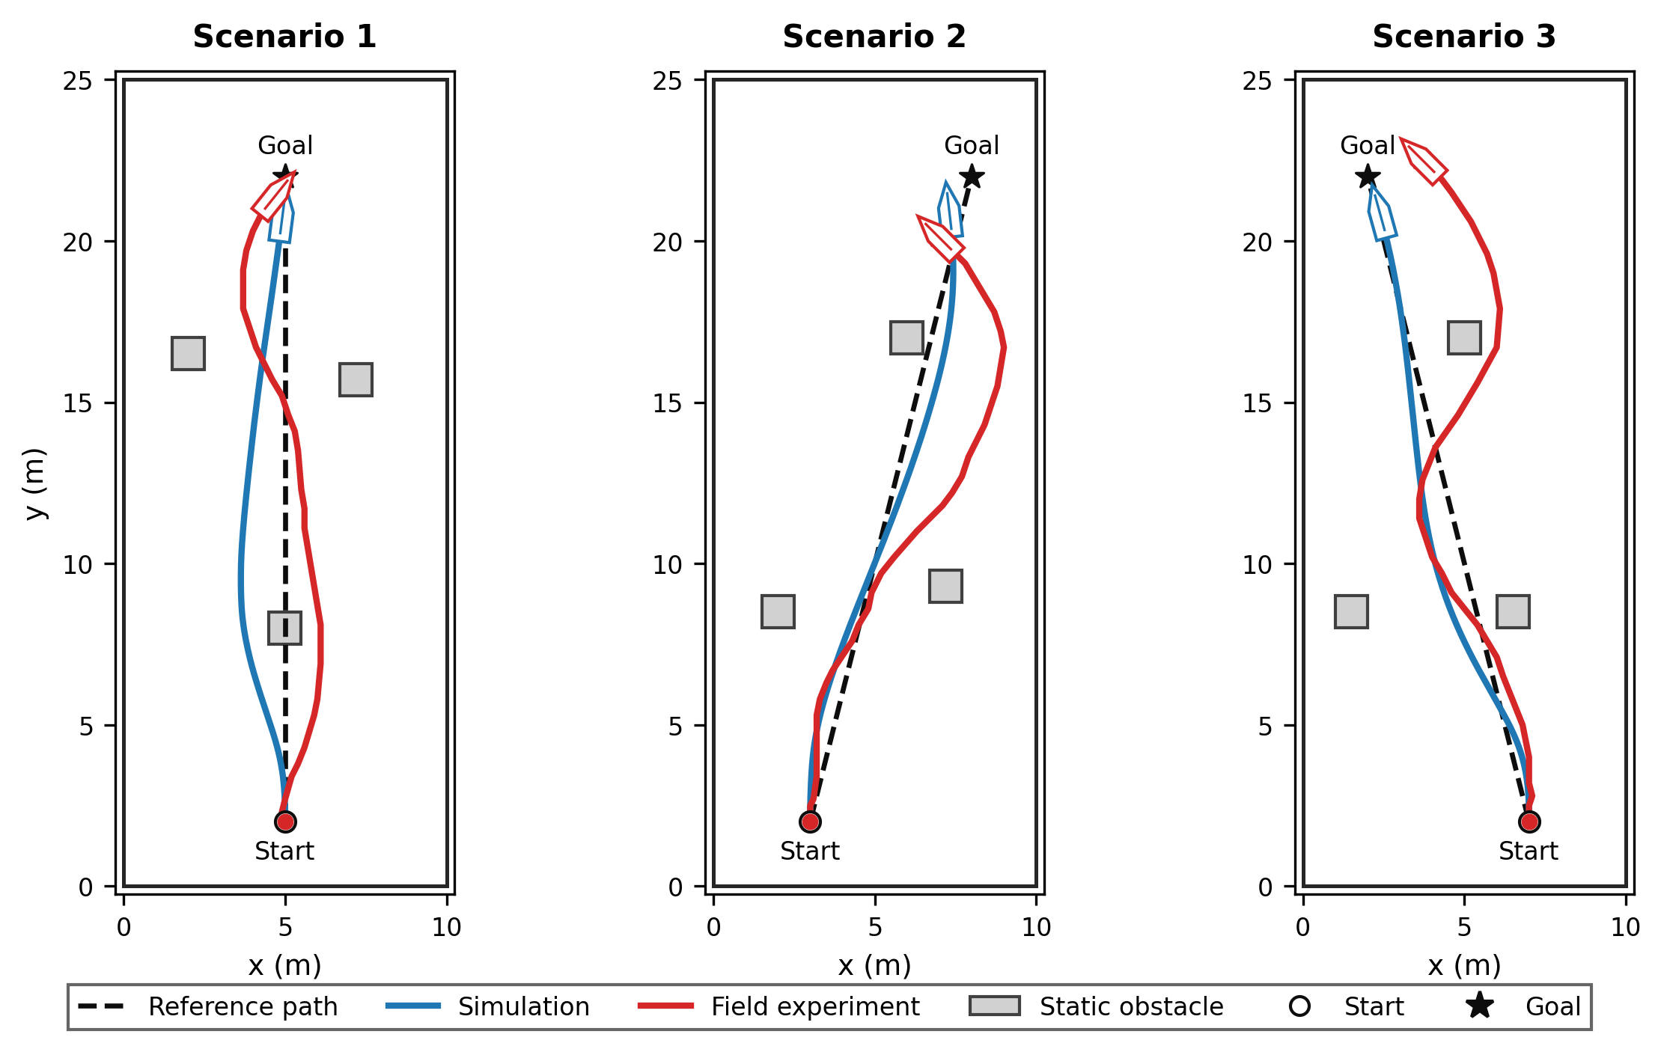
Figure 7. Simulated and field trajectories for three test scenarios.
Overall, the field results show successful task-level transfer of the trained SAC policy. In all three scenarios, the field trajectory avoids static obstacles and progresses toward the goal. The minimum obstacle clearance and boundary clearance in the field trials remain positive in all cases, which indicates that the policy is able to maintain collision-free motion in the tested environment. At the same time, the field trajectories show stronger oscillation and wider recovery maneuvers than the simulated trajectories. Averaged over the three scenarios, the field RMS cross-track error is 1.14 m, compared to 0.69 m in simulation. The field trajectories are also longer, with an average path length of 21.11 m over 19.49 m in simulation. This confirms the visual observation in fig. 7, where the real vessel generally follows the same direction as the simulated vessel, but requires additional correction and larger deviations.
Table 4. Trajectory-based comparison between simulation and field experiments
Scenario | Platform | Std. cross-track error | RMS cross-track error | Path length | Min. obstacle clearance | Min. border clearance
1 | Simulation | 0.50 m | 0.81 m | 19.00 m | 0.68 m | 2.00 m
 | Field | 0.72 m | 0.73 m | 20.26 m | 0.54 m | 2.00 m
2 | Simulation | 0.61 m | 0.79 m | 19.88 m | 0.52 m | 2.00 m
 | Field | 1.02 m | 1.17 m | 20.38 m | 1.17 m | 1.00 m
3 | Simulation | 0.39 m | 0.46 m | 19.60 m | 1.09 m | 2.00 m
 | Field | 1.30 m | 1.53 m | 22.69 m | 0.50 m | 2.00 m
Overall | Simulation | 0.50 m | 0.69 m | 19.49 m | 0.76 m | 2.00 m
 | Field | 1.01 m | 1.14 m | 21.11 m | 0.74 m | 1.67 m

In the first scenario, the field result is close to the simulation result in terms of cross-track error. This suggests that the vessel completed the same avoidance task but with more corrective motion. In the second scenario, the field trajectory shows a larger tracking deviation than simulation. The RMS cross-track error increases from 0.79 m in simulation to 1.17 m in the field deployment, and the standard deviation of cross-track error increases from 0.61 m to 1.02 m. This shows that the deployed vessel adopted the same avoidance strategy as simulated with higher overshoot, resulting in a larger path deviation and closer to the boundary. The sim-to-field gap is more noticeable in the final test scenario, where the field RMS cross-track error is 1.53 m and path length increases to 22.69 m. This test case highlights the main limitation observed in the field experiments: the learned policy achieves the task, but the real vessel response is more oscillatory and less smooth than the simulated response.
The comparison suggests that the main limitation is not the decision-making of the policy, but the mismatch between the simulated and real vessel responses. The field trajectories preserve the intended behavior of path following, obstacle avoidance, and boundary clearance, but with larger oscillations and wider turns. These differences are caused by unmodelled hydrodynamic effects, actuator response delay, localization noise, LiDAR measurement variation, and water disturbances. Since the ASV is underactuated, small discrepancies in heading response or propulsion mapping can produce visible differences in cross-track error, especially in narrow waterways where clearance is limited.

3.5. Discussion and limitations
The simulation and field results together demonstrate that the proposed LiDAR-based SAC framework can produce feasible navigation behavior in a restricted environment, simultaneously tracking a reference path and avoiding static obstacles. Simulation evaluation over randomized episodes provides evidence of robustness across varying obstacle densities, while the three field scenarios validate that the learned policy transfers to a real platform under constrained testing conditions.
The separate reporting of obstacle and border collisions is important in restricted waterways. In open-water settings, the main failure mode is often collision with another object; however, in a narrow channel environment, a successful avoidance maneuver can still fail if it pushes the vessel towards the boundary. The simulation results show that as obstacle density increases, cross-track error increases and border collisions become more frequent. This supports the central motivation of the paper: static obstacle avoidance in confined waterways must be evaluated together with path-tracking and boundary-clearance performance.
The field experiments also reveal the main limitation of the current framework. Although the policy transfers successfully at the task level, the field trajectories are less smooth than the simulated trajectories, with larger cross-track variation and longer path lengths. This suggests that the primary sim-to-field gap is not the high-level decision-making module, but the mismatch in dynamic responses. Likely causes include unmodelled hydrodynamic effects, actuator delay, localization jitter, and water disturbances. These effects are amplified in narrow waterways, where small heading or actuation errors can quickly produce larger lateral deviations.
Therefore, future work will focus on reducing this simulation-to-field gap by refining the vessel dynamics model through additional system identification, improving actuator and propulsion modeling, and introducing disturbance variations during training. Furthermore, the method will be extended toward dynamic obstacle avoidance and COLREG-compliant navigation. This staged deployment is necessary because reliable path recovery and static obstacle avoidance in restricted waterways provide the foundation for more complex multi-vessel encounter scenarios.

4. Conclusions
This paper presented a LiDAR-based Soft Actor-Critic guidance navigation control framework for path following and static obstacle avoidance of an underactuated ASV in narrow waterways. The proposed method differs from conventional modular approaches by learning a unified observation-to-action policy that combines LiDAR sector features, local motion estimates, and path-relative errors to generate continuous rudder and propulsion commands. This is important in restricted environments, where path following, static obstacle avoidance, and boundary clearance must be handled together rather than as independent objectives.
In simulation, the trained policy achieved a 94% success rate over 500 randomized episodes, with obstacle and border collision rates of 3% each. These results show that the policy can generalize across different obstacle densities while balancing path tracking and avoidance behavior. Field experiments on the model-scaled Bluefin vessel confirmed task-level transfer: the vessel avoided static obstacles and maintained positive obstacles and boundary clearance in the tested scenarios. However, field trajectories showed larger oscillations and longer paths than simulation, with average RMS cross-track error increasing from 0.69 m to 1.14 m.
The results demonstrate that the proposed framework can perform path following and static obstacle avoidance under restricted-waterway conditions, but also reveal that the current simulation model does not fully capture the real vessel response. Future work will refine the vessel dynamics and actuator models through further system identification, incorporate sensing and disturbance variations during training, and extend the framework toward dynamic obstacle avoidance and COLREG-compliant navigation.

References
- Hansen, P.N.; Enevoldsen, T.T.; Papageorgiou, D.; Blanke, M. Autonomous Navigation in Confined Waters - A COLREGs Rule 9 Compliant Framework. IFAC-PapersOnLine 2022, 55, 222–228, doi: https://doi.org/10.1016/j.ifacol.2022.10.435.
- Enevoldsen, T.T.; Galeazzi, R. Grounding-aware RRT⁎ for Path Planning and Safe Navigation of Marine Crafts in Confined Waters. IFAC-PapersOnLine 2021, 54, 195–201, doi: https://doi.org/10.1016/j.ifacol.2021.10.093.
- Qiao, Y.; Yin, J.; Wang, W.; Duarte, F.; Yang, J.; Ratti, C. Survey of Deep Learning for Autonomous Surface Vehicles in Marine Environments. IEEE Transactions on Intelligent Transportation Systems 2023, 24, 3678–3701, doi: 10.1109/TITS.2023.3235911.
- Vagale, A.; Oucheikh, R.; Bye, R.T.; Osen, O.L.; Fossen, T.I. Path planning and collision avoidance for autonomous surface vehicles I: a review. Journal of Marine Science and Technology 2021, 26, 1292–1306, doi: 10.1007/s00773-020-00787-6.
- Burmeister, H.-C.; Constapel, M. Autonomous Collision Avoidance at Sea: A Survey. Frontiers in Robotics and AI 2021, Volume 8 - 2021.
- Hu, L.; Hu, H.; Naeem, W.; Wang, Z. A review on COLREGs-compliant navigation of autonomous surface vehicles: From traditional to learning-based approaches. Journal of Automation and Intelligence 2022, 1, 100003, doi: https://doi.org/10.1016/j.jai.2022.100003.
- Fossen, T.I. Handbook of marine craft hydrodynamics and motion control; John wiley & sons: 2011.
- Villa, J.; Aaltonen, J.; Koskinen, K.T. Path-Following With LiDAR-Based Obstacle Avoidance of an Unmanned Surface Vehicle in Harbor Conditions. IEEE/ASME Transactions on Mechatronics 2020, 25, 1812–1820, doi: 10.1109/TMECH.2020.2997970.
- Gonzalez-Garcia, A.; Collado-Gonzalez, I.; Cuan-Urquizo, R.; Sotelo, C.; Sotelo, D.; Castañeda, H. Path-following and LiDAR-based obstacle avoidance via NMPC for an autonomous surface vehicle. Ocean Engineering 2022, 266, 112900, doi: https://doi.org/10.1016/j.oceaneng.2022.112900.
- Kim, J.-S.; Lee, D.-H.; Kim, D.-W.; Park, H.; Paik, K.-J.; Kim, S. A numerical and experimental study on the obstacle collision avoidance system using a 2D LiDAR sensor for an autonomous surface vehicle. Ocean Engineering 2022, 257, 111508, doi: https://doi.org/10.1016/j.oceaneng.2022.111508.
- Sutton, R.S.; Barto, A.G. Reinforcement learning: An introduction 2nd ed. MIT press Cambridge 2018, 1, 25.
- Woo, J.; Yu, C.; Kim, N. Deep reinforcement learning-based controller for path following of an unmanned surface vehicle. Ocean Engineering 2019, 183, 155–166, doi :https://doi.org/10.1016/j.oceaneng.2019.04.099.
- Qu, X.; Jiang, Y.; Zhang, R.; Long, F. A Deep Reinforcement Learning-Based Path-Following Control Scheme for an Uncertain Under-Actuated Autonomous Marine Vehicle. Journal of Marine Science and Engineering 2023, 11, 1762, doi: 10.3390/jmse11091762.
- Cheng, Y.; Zhang, W. Concise deep reinforcement learning obstacle avoidance for underactuated unmanned marine vessels. Neurocomputing 2018, 272, 63–73, doi: https://doi.org/10.1016/j.neucom.2017.06.066.
- Meyer, E.; Robinson, H.; Rasheed, A.; San, O. Taming an Autonomous Surface Vehicle for Path Following and Collision Avoidance Using Deep Reinforcement Learning. IEEE Access 2020, 8, 41466–41481, doi: 10.1109/ACCESS.2020.2976586.
- Woo, J.; Kim, N. Collision avoidance for an unmanned surface vehicle using deep reinforcement learning. Ocean Engineering 2020, 199, 107001, doi: https://doi.org/10.1016/j.oceaneng.2020.107001.
- Teitgen, R.; Monsuez, B.; Kukla, R.; Pasquier, R.; Foinet, G. Dynamic trajectory planning for ships in dense environment using collision grid with deep reinforcement learning. Ocean Engineering 2023, 281, 114807, doi: https://doi.org/10.1016/j.oceaneng.2023.114807.
- Hao, S.; Guan, W.; Cui, Z.; Lu, J. USV Collision Avoidance Decision-Making Based on the Improved PPO Algorithm in Restricted Waters. Journal of Marine Science and Engineering 2024, 12, 1428, doi: 10.3390/jmse12081428.
- Slawik, T.; Wehbe, B.; Christensen, L.; Kirchner, F. Deep Reinforcement Learning for Path-Following Control of an Autonomous Surface Vehicle using Domain Randomization. IFAC-PapersOnLine 2024, 58, 21–26, doi: https://doi.org/10.1016/j.ifacol.2024.10.027.
- Lambert, R.; Li, J.; Wu, L.-F.; Mahmoudian, N. Robust ASV Navigation Through Ground to Water Cross-Domain Deep Reinforcement Learning. Frontiers in Robotics and AI 2021, Volume 8 - 2021.
- Tran, N.H.; Nguyen, H.D.; King, P.; Tran, M. Autonomous Surface Vessels Path Following and Static Obstacle Collision Avoidance using Deep Reinforcement Learning. In Proceedings of the 2026 4th International Conference on Mechatronics, Control and Robotics (ICMCR), 20–22 March 2026, 2026; pp. 81–87.
- Fossen, T.I. Marine control system-guidance, navigation and control of ships, rigs and underwater vehicles. Marine Cybernetics 2002.
- Wang, N.; Wang, Y.; Zhao, Y.; Wang, Y.; Li, Z. Sim-to-Real: Mapless Navigation for USVs Using Deep Reinforcement Learning. Journal of Marine Science and Engineering 2022, 10, 895, doi: 10.3390/jmse10070895.
- Wu, X.; Wei, C.; Guan, D.; Ji, Z. Risk-aware deep reinforcement learning for mapless navigation of unmanned surface vehicles in uncertain and congested environments. Ocean Engineering 2025, 322, 120446, doi: https://doi.org/10.1016/j.oceaneng.2025.120446.
- Choi, J.; Park, K.; Kim, M.; Seok, S. Deep Reinforcement Learning of Navigation in a Complex and Crowded Environment with a Limited Field of View. In Proceedings of the 2019 International Conference on Robotics and Automation (ICRA), 20–24 May 2019, 2019; pp. 5993–6000.
- Meyer, E.; Heiberg, A.; Rasheed, A.; San, O. COLREG-Compliant Collision Avoidance for Unmanned Surface Vehicle Using Deep Reinforcement Learning. IEEE Access 2020, 8, 165344–165364, doi: 10.1109/ACCESS.2020.3022600.
- Sutton, R.S.; McAllester, D.; Singh, S.; Mansour, Y. Policy gradient methods for reinforcement learning with function approximation. Advances in neural information processing systems 1999, 12.
- Mnih, V.; Badia, A.P.; Mirza, M.; Graves, A.; Lillicrap, T.; Harley, T.; Silver, D.; Kavukcuoglu, K. Asynchronous methods for deep reinforcement learning. 2016, 2016; pp. 1928–1937.
- Schulman, J.; Moritz, P.; Levine, S.; Jordan, M.; Abbeel, P. High-dimensional continuous control using generalized advantage estimation. arXiv preprint arXiv:1506.02438 2015.
- Haarnoja, T.; Zhou, A.; Hartikainen, K.; Tucker, G.; Ha, S.; Tan, J.; Kumar, V.; Zhu, H.; Gupta, A.; Abbeel, P. Soft actor-critic algorithms and applications. arXiv preprint arXiv:1812.05905 2018.
- Haarnoja, T.; Zhou, A.; Abbeel, P.; Levine, S. Soft actor-critic: Off-policy maximum entropy deep reinforcement learning with a stochastic actor. 2018, 2018; pp. 1861–1870.
- Breivik, M.; Fossen, T.I. Path following for marine surface vessels. 2004, 2004; pp. 2282–2289.
- Raffin, A.; Hill, A.; Gleave, A.; Kanervisto, A.; Ernestus, M.; Dormann, N. Stable-baselines3: Reliable reinforcement learning implementations. Journal of machine learning research 2021, 22, 1–8.
Disclaimer/Publisher’s Note: The statements, opinions and data contained in all publications are solely those of the individual author(s) and contributor(s) and not of MDPI and/or the editor(s). MDPI and/or the editor(s) disclaim responsibility for any injury to people or property resulting from any ideas, methods, instructions or products referred to in the content.

