**Description**

***WELCOME TO MVQuiz***

This app contains puzzles about popular movies in theater. Do you want to test your knowledge about movies? Try figure it out.

*HOW TO PLAY*

Player has to guess the movie by typing the name of the movie from the movie scene.

*GAMEPLAY*

* + A lot of movie puzzles - Easy to play.
  + Have great fun with knowledge test.

IT IS FREE. NO REGISTRATION REQUIRED. NO PURCHASES

*MORE UPDATES*

Update Frequently, add new movie puzzles. Your interest never ends.

*PLAY AND SHARE WITH FRIENDS*

You got stuck? Use HINT

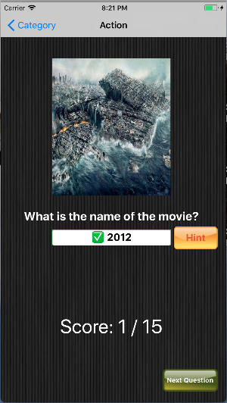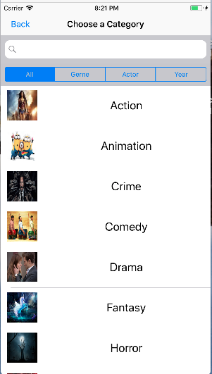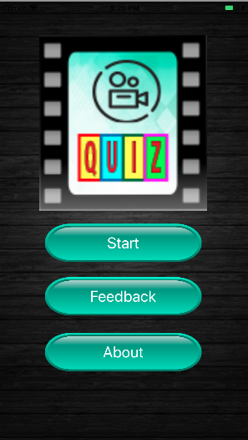**Screenshot**

**Technology (Chapters from the book)**

* + Chapter 4
  + Chapter 5
  + Chapter 10
  + Chapter 12
  + Chapter 13
  + Chapter 14

**Information on seller**

Nguyen Tran – Undergraduate student at Cal State University of Fullerton