**Name:** Wajahat Raza Zakir

**Roll No:** 17P-6011

**Course:** Theory of Automata

**Instructor:** Sir Shakirullah Shah

**1) Starts with a and has even number of letters.**

a(a+b)((a+b)(a+b))*

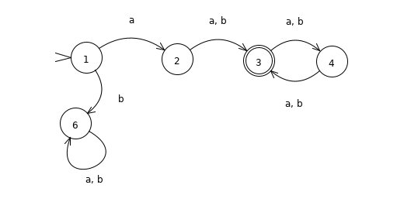

**2) Starts with b and has odd number of letters.**

b((a+b)(a+b))*

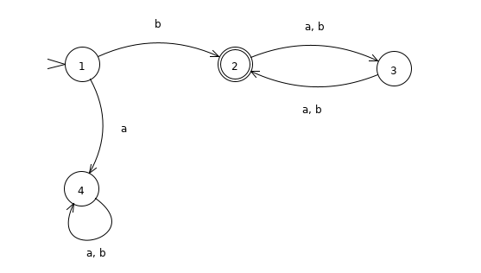

**3) Contains aa.**

(a+b)*aa(a+b)*

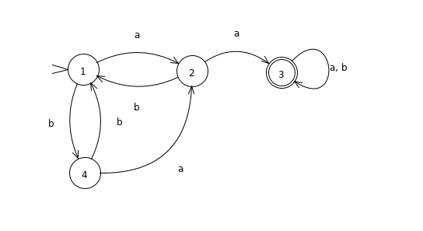

**4) Does not contain bba.**

a*(baa*)b+a*(baa*)*bbb*

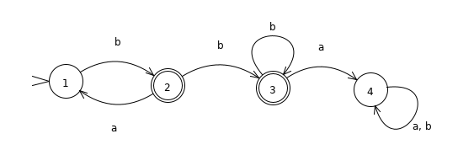

**5) Does not contain ab.**

b* + b*aa*

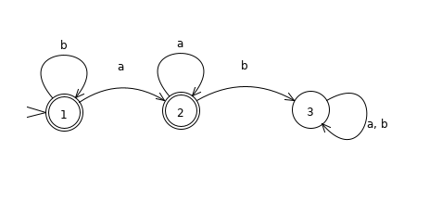

**6) Does not contain aba.**

b*a(bbb*a)*(a(bbb*a)*)*(b+bbb*)+b**\***

