**1914626_Nguyễn Trung Nguyên – Bài tập tuần 2**

* **Hiển thị danh sách nhóm món ăn ở Panel**

**Code:**

private void AdminForm_Load(object sender, EventArgs e)

{

LoadTableToLvDetail();

LoadCategoryToPanel();

}

private void CreateButton(int id, string name, int yPos)

{

var btn = new Button();

btn.Text = name;

btn.BackColor = Color.Aquamarine;

btn.Height = 33;

btn.Width = 245;

btn.Location = new Point(0, yPos);

btn.Tag = id;

btn.Click += CategoryButton_Click;

pnGroupFood.Controls.Add(btn);

}

private void LoadCategoryToPanel()

{

var yPos = 0;

CreateButton(0, "Tất cả", yPos);

foreach (var cat in WorkingContext.CategoryList)

{

yPos += 35;

CreateButton(cat.Id, cat.Name, yPos);

}

}

**Kết quả:**

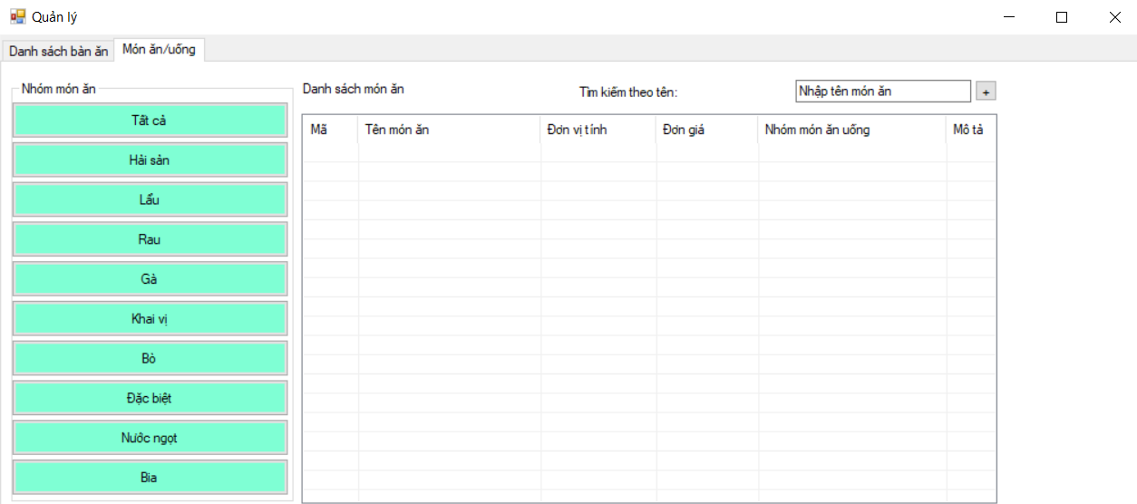

* **Xử lý sự kiện click vào nhóm món ăn, hiển thị ở Listview**

Code:

private int _currentCategoryID = 0;

private void AdminForm_Load(object sender, EventArgs e)

{

LoadTableToLvDetail();

LoadCategoryToPanel();

LoadFoodToLvDetail(WorkingContext.FoodList);

}

private void CategoryButton_Click(object sender, EventArgs e)

{

_currentCategoryId = Convert.ToInt32((sender as Button).Tag);

var foods = WorkingContext.FoodList;

if (_currentCategoryId > 0)

{

foods = foods.Where(f => f.CategoryId == _currentCategoryId).ToList();

}

LoadFoodToLvDetail(foods);

}

private void LoadFoodToLvDetails(List<Food> list)

{

lvFoodsList.Items.Clear();

foreach (var food in list)

{

AddFoodToLV(food);

}

}

private void AddFoodToLV(Food food)

{

ListViewItem item = new ListViewItem(food.Id.ToString());

item.SubItems.Add(food.Name);

item.SubItems.Add(food.Unit);

item.SubItems.Add(food.UnitPrice.ToString());

item.SubItems.Add(food.CategoryId.ToString());

item.SubItems.Add(food.Description);

item.SubItems.Add(food.ImageLink);

lvFoodsList.Items.Add(item);

}

**Kết quả:**

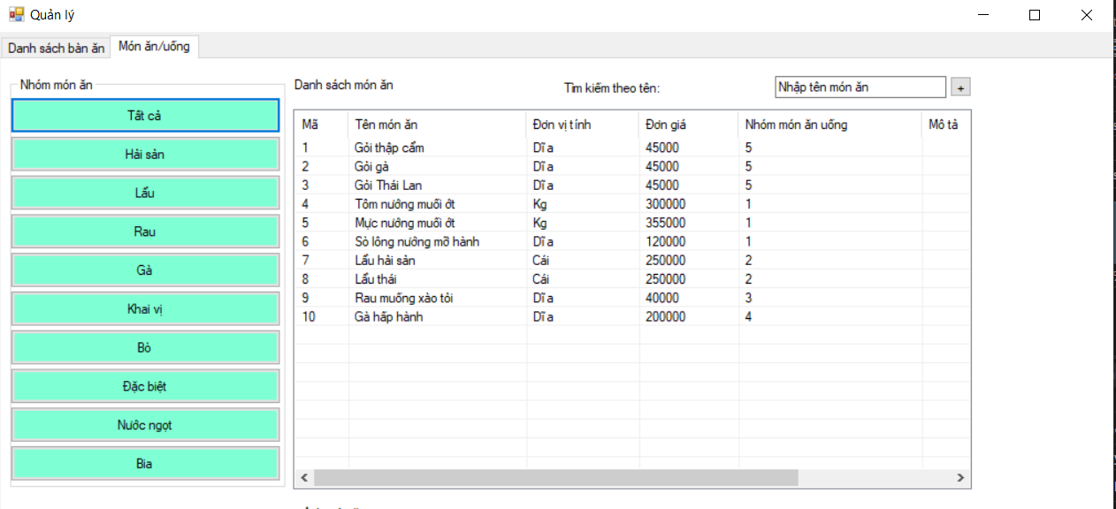

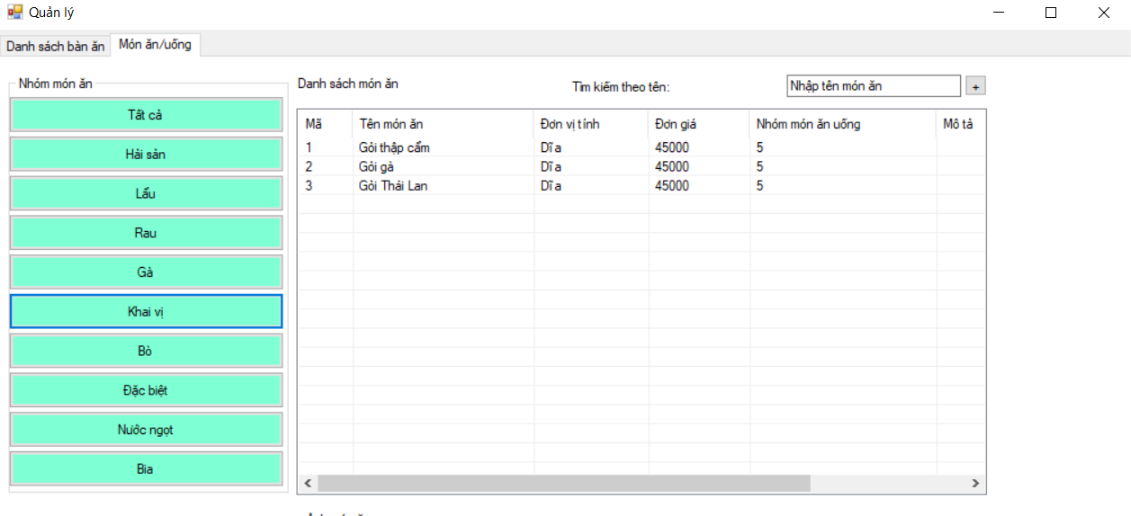

* **Tạo place holder text cho ô tìm kiếm**

Code:

private const string _placeHolderText = "Nhập tên món ăn";

private void AdminForm_Load(object sender, EventArgs e)

{

LoadTableToLvDetail();

LoadCategoryToPN();

LoadFoodToLvDetails(WorkingContext.FoodList);

SetUpSearchInputText();

}

private void SetUpSearchInputText()

{

txtSearch.Text = _placeHolderText;

txtSearch.GotFocus += RemovePlaceHolderText;

txtSearch.LostFocus += ShowPlaceHolderText;

}

private void ShowPlaceHolderText(object sender, EventArgs e)

{

if (string.IsNullOrWhiteSpace(txtSearch.Text))

txtSearch.Text = _placeHolderText;

}

private void RemovePlaceHolderText(object sender, EventArgs e)

{

if (txtSearch.Text == _placeHolderText)

txtSearch.Text = "";

}

**Kết quả:**





* **Xử lý sự kiện cho nút Thêm món ăn**

**Code:**

private void btnAddFood_Click(object sender, EventArgs e)

{

var dialog = new InformationFoodForm();

if (dialog.ShowDialog() == DialogResult.OK)

{

var food = dialog.ReturnedFood;

AddFoodToLV(food);

}

}

**Kết quả:**

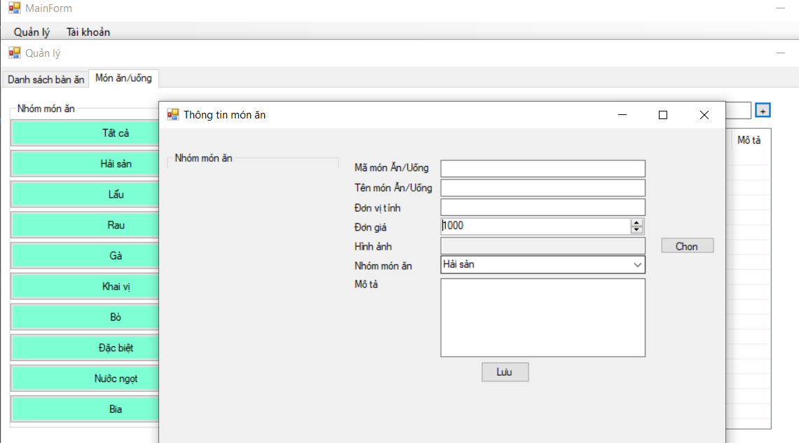

* **Xử lý sự kiện tải danh sách nhóm món ăn cho combo box bên FoodForm**

**Code:**

private void InformationFoodForm_Load(object sender, EventArgs e)

{

cbbGroupFood.DataSource = WorkingContext.CategoryList;

cbbGroupFood.DisplayMember = "Name";

cbbGroupFood.ValueMember = "Id";

}

**Kết quả:**

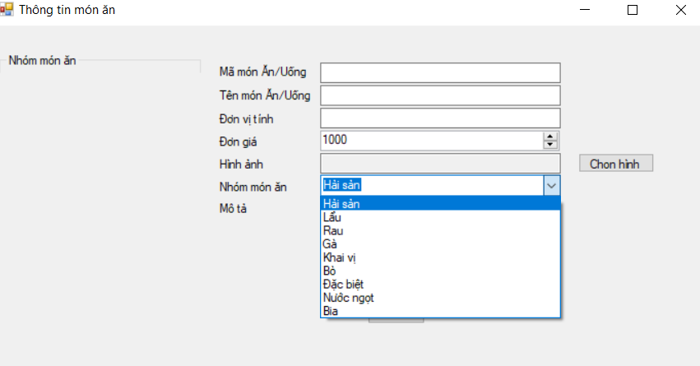

* **Xử lý sự kiện khi click nút "Chọn hình"**

**Code:**

private void btnChoosePicture_Click(object sender, EventArgs e)

{

OpenFileDialog dlg = new OpenFileDialog();

dlg.Title = "Open Dialog";// "Add Photos";

dlg.Multiselect = true;

dlg.Filter = "Image Files (JPEG, GIF, BMP, etc.)|"

+ "*.jpg;*.jpeg;*.gif;*.bmp;"

+ "*.tif;*.tiff;*.png|"

+ "JPEG files (*.jpg;*.jpeg)|*.jpg;*.jpeg|"

+ "GIF files (*.gif)|*.gif|"

+ "BMP files (*.bmp)|*.bmp|"

+ "TIFF files (*.tif;*.tiff)|*.tif;*.tiff|"

+ "PNG files (*.png)|*.png|"

+ "All files (*.*)|*.*";

dlg.InitialDirectory = Environment.CurrentDirectory;

if (dlg.ShowDialog() == DialogResult.OK)

{

var filename = dlg.FileName;

txtPicture.Text = filename;

ptbPicture.Load(filename);

}

}

**Kết quả:**

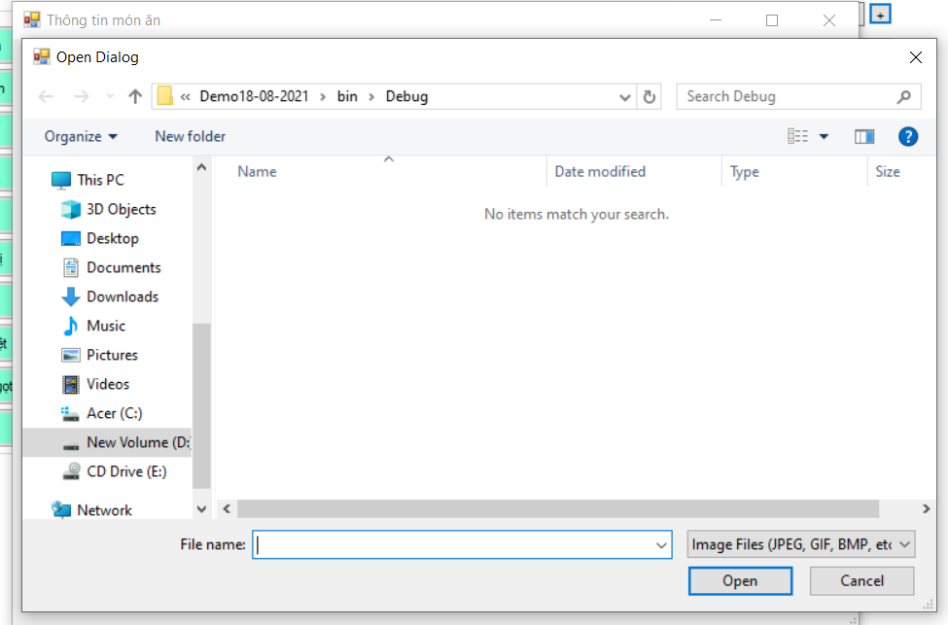

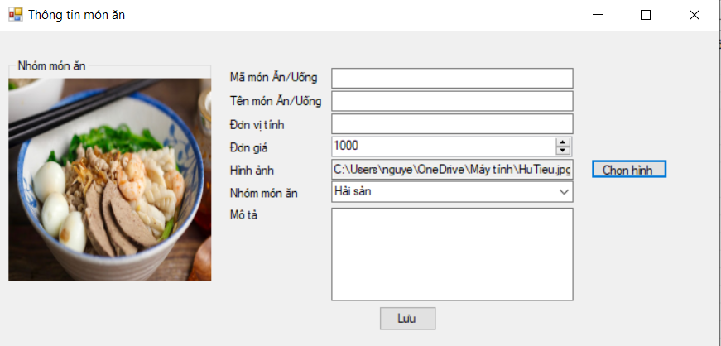

* **Xử lý sự kiện khi nhấn nút Lưu (thêm mới món ăn) và xử lý thêm món ăn vừa được thêm vào Listview ở AdminForm**

**Code:**

**InformationFoodForm**

private void btnSave_Click(object sender, EventArgs e)

{

var name = txtNameFoodDrink.Text;

var unit = txtUnitCalc.Text;

var description = txtDescription.Text;

var link = txtPicture.Text;

var price = Convert.ToInt32(nudUnitPrice.Value);

var categoryId = Convert.ToInt32(cbbGroupFood.SelectedValue);

if (_foodId ==0)

{

int id = WorkingContext.FoodList.Any() ? WorkingContext.FoodList.Max(f => f.Id) + 1 : 1;

ReturnedFood = new Food(id, name, unit, price, description, link, categoryId);

WorkingContext.FoodList.Add(ReturnedFood);

}

else

{

}

DialogResult = DialogResult.OK;

}

**AdminForm**

private void btnAddFood_Click(object sender, EventArgs e)

{

var dialog = new InformationFoodForm();

if (dialog.ShowDialog() == DialogResult.OK)

{

var food = dialog.ReturnedFood;

AddFoodToLV(food);

}

}

**Kết quả:**

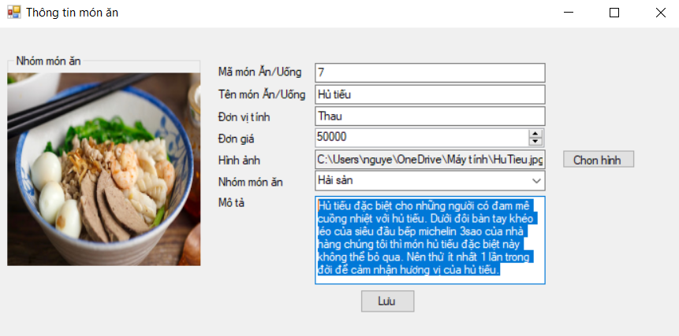

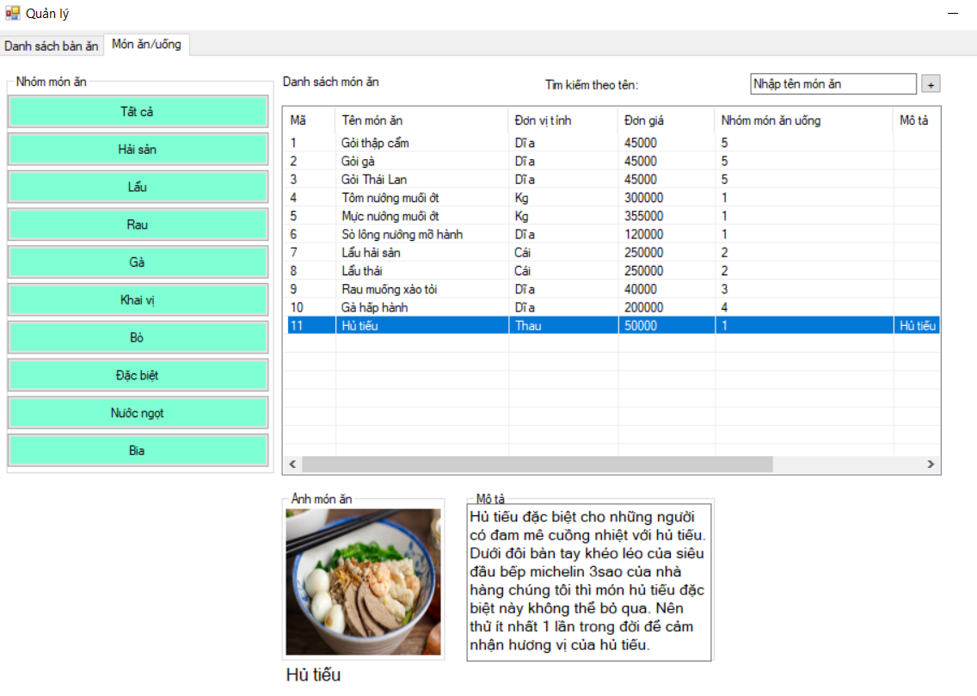

* **Xử lý sự kiện click đôi vào item mở form cập nhật.**

**Code:**

**AdminForm**

private void lvFood_DoubleClick(object sender, EventArgs e)

{

InformationFoodForm DoubleClick = new InformationFoodForm(1);

int categoryID = 0;

int count = lvFood.SelectedItems.Count;

if (count > 0)

{

int id = int.Parse(lvFood.SelectedItems[0].SubItems[0].Text);

string name = lvFood.SelectedItems[0].SubItems[1].Text;

string unit = lvFood.SelectedItems[0].SubItems[2].Text;

var price = Convert.ToInt32(lvFood.SelectedItems[0].SubItems[3].Text);

categoryID = int.Parse(lvFood.SelectedItems[0].SubItems[4].Text);

string decription = lvFood.SelectedItems[0].SubItems[5].Text;

string path = lvFood.SelectedItems[0].SubItems[6].Text;

DoubleClick.ReturnedFood = new Food(id, name, unit, price, decription, path, categoryID - 1);

}

if (DoubleClick.ShowDialog() == DialogResult.OK)

{

var foods = WorkingContext.FoodList;

if (DoubleClick.ReturnedFood.CategoryId > 0)

{

foods = foods.Where(f => f.CategoryId == DoubleClick.ReturnedFood.CategoryId).ToList();

}

LoadFoodToLvDetail(foods);

}

}

**InformationForm**

private void InformationFoodForm_Load(object sender, EventArgs e)

{

cbbGroupFood.DataSource = WorkingContext.CategoryList;

cbbGroupFood.DisplayMember = "Name";

cbbGroupFood.ValueMember = "Id";

if (_foodId > 0)

{

txtCodeFoodDrink.Text = ReturnedFood.Id.ToString();

txtNameFoodDrink.Text = ReturnedFood.Name;

txtUnitCalc.Text = ReturnedFood.Unit;

nudUnitPrice.Value = ReturnedFood.UnitPrice;

cbbGroupFood.SelectedIndex = ReturnedFood.CategoryId;

txtPicture.Text = ReturnedFood.ImageLink;

txtDescription.Text = ReturnedFood.Description;

try

{

ptbPicture.SizeMode = PictureBoxSizeMode.StretchImage;

ptbPicture.Load(txtPicture.Text);

}

catch (Exception)

{

}

}

}

**Kết quả:**

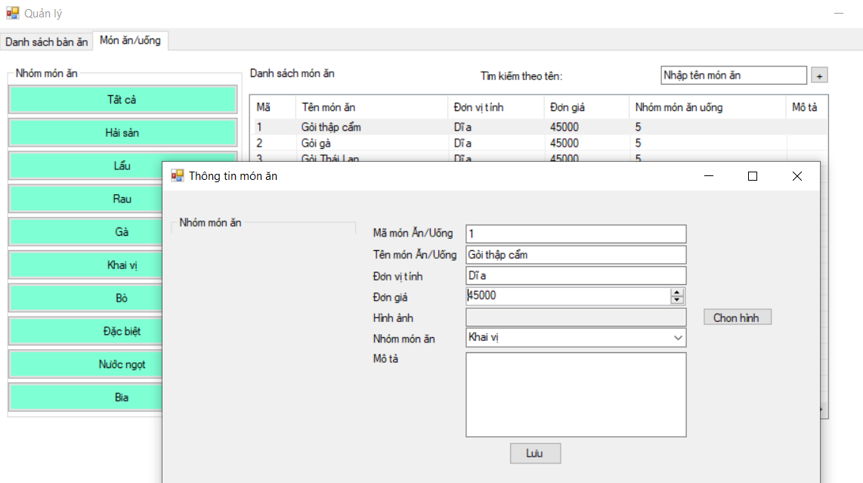

* **Xử lý sự kiện tìm kiếm theo tên món ăn**

**Code:**

private void txtSearchFood_TextChanged(object sender, EventArgs e)

{

var foods = WorkingContext.FoodList;

lvFood.Items.Clear();

foreach (var item in foods)

{

if (item.Name.ToLower().StartsWith(txtSearchFood.Text.ToLower()))

{

AddFoodToLV(item);

}

}

}

**Kết quả:**

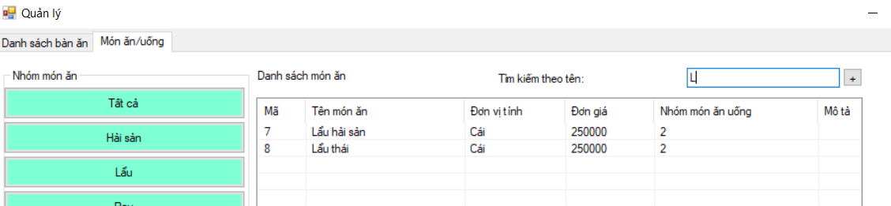

* **Hiển thị hình và tên món ăn ở phần bên dưới form khi chọn một một ăn trong danh sách**

**Code:**

private void lvFood_Click(object sender, EventArgs e)

{

lblNameFood.Text = lvFood.SelectedItems[0].SubItems[1].Text;

txtDescription.Text = lvFood.SelectedItems[0].SubItems[5].Text;

try

{

ptbViewPictureFood.SizeMode = PictureBoxSizeMode.StretchImage;

ptbViewPictureFood.Load(lvFood.SelectedItems[0].SubItems[6].Text);

}

catch (Exception)

{

}

}

**Kết quả:**

