SLA Performance Dashboard
Work Scope — Development Brief

Prepared for | Vivian Truong
Version | 1.0
Date | 19 March 2026
Status | Ready for Development

Purpose
Build a live SLA Performance Dashboard that pulls real-time data from So Ezy and displays task volumes, turnaround times, SLA compliance rates, and overdue items across six operational teams. The dashboard must auto-refresh and allow managers to drill into individual team task lists from a single screen.

Teams & SLA Targets
The following six teams must be represented on the dashboard. SLA targets (turnaround time) are defined per team and must be configurable:

Team | Example TAT Target | Primary Task Type
Data Entry | 4 hours (To be confirmed) | Loan application entry
Valuations | 4 hours (To be confirmed) | Valuation ordering
Assessments | 4 hours (To be confirmed) | Loan assessments
QA | 4 hours (To be confirmed) | File quality checks
Funder Submission | 4 hours (To be confirmed) | Funder lodgements
Settlements | 4 hours (To be confirmed) | Settlement processing

Feature Scope

Global KPI Strip (Top of Dashboard)

Four summary tiles displayed permanently at the top of the screen, fed live from So Ezy:
    - Total Active Tasks — count of all open tasks across all teams
    - Overall SLA % — percentage of tasks completed within SLA target
    - Average Turnaround Time — mean TAT in hours/days across all teams
    - Overdue / Breached Items — count of tasks past their SLA deadline
Each tile must show a directional change indicator (e.g. +47 since yesterday) compared to the previous business day.

Team Cards (Main Grid)

Six cards arranged in a 3-column grid — one per team. Each card must display:
    - Team name and department label
    - SLA compliance badge (colour-coded: green ≥90%, amber 75–89%, red <75%)
    - Volume — total number of active tasks for that team
    - Average TAT — mean turnaround time; displayed in hours or days depending on the team target; highlighted red if currently over target
    - Overdue count — number of tasks past SLA deadline; red if any exist
    - SLA compliance progress bar — visual bar filling left to right, colour-coded to match badge

    - Overdue summary line — e.g. "⚠ 6 overdue" or "✓ No overdue items"
    - SLA target reminder — e.g. "Target: 4h" shown bottom right of card All six cards must be clickable and open the Task Detail modal (see 3.3).

Task Detail Modal (Drill-Down)

Clicking any team card opens a modal overlay showing the top 10 active tasks for that team pulled live from So Ezy. The modal must include:

Modal Header
    - Team name, department, total volume, and SLA target
    - Four mini KPI chips: SLA %, Volume, Avg TAT, Overdue count

Task Table (10 rows)
Each row in the task table must display the following columns:

Column | So Ezy Field | Format | Colour Logic | Notes
Task ID | Task/case reference | Monospace text | — | Unique identifier from So Ezy
Description | Task title / type | Text + client sub-label | — | Client name shown below
Status | Task status field | Pill badge | Green / Amber / Red | On Track, At Risk, Overdue
TAT vs Target | Created date vs now | Progress bar + hours/days | Green → Amber  → Red | Red when past target
Priority | Priority field | Dot + label | Red / Amber / Green | High / Med / Low

Overdue rows must have a light red background; At Risk rows a light amber background. The modal must close on clicking outside it or pressing Escape.

7-Day Trend Chart

A line chart displayed below the team cards showing each team's SLA compliance percentage across the last 7 calendar days. Requirements:
    - One line per team, each in a distinct colour
    - Y-axis: 60%–100%, with percentage labels
    - X-axis: Day labels (Mon–Sun or rolling dates)
    - Tooltip on hover showing team name and exact % for that day
    - Custom colour legend beneath the chart title

Active Alerts Panel

A sidebar panel displayed alongside the trend chart, showing the top 5 active alerts requiring immediate attention. Each alert must include:
    - Severity icon (critical = red, warning = amber)
    - Alert title and brief description pulled from So Ezy breach/flag logic
    - Time since alert was triggered (e.g. "3h ago")
    - Alert count badge in the panel header

Live Feed & Auto-Refresh

    - The dashboard must display a "Live Feed" indicator with an animated green dot
    - All data must refresh automatically every 5 minutes from So Ezy
    - A live clock (AEST) must be displayed in the top bar
    - Refresh must be non-disruptive — no full page reload

So Ezy Integration

Overview

All data displayed on the dashboard must be sourced live from So Ezy. No mock data should be used in the production build. The development team will need to confirm the available API or data export method with the So Ezy platform.

Concept idea
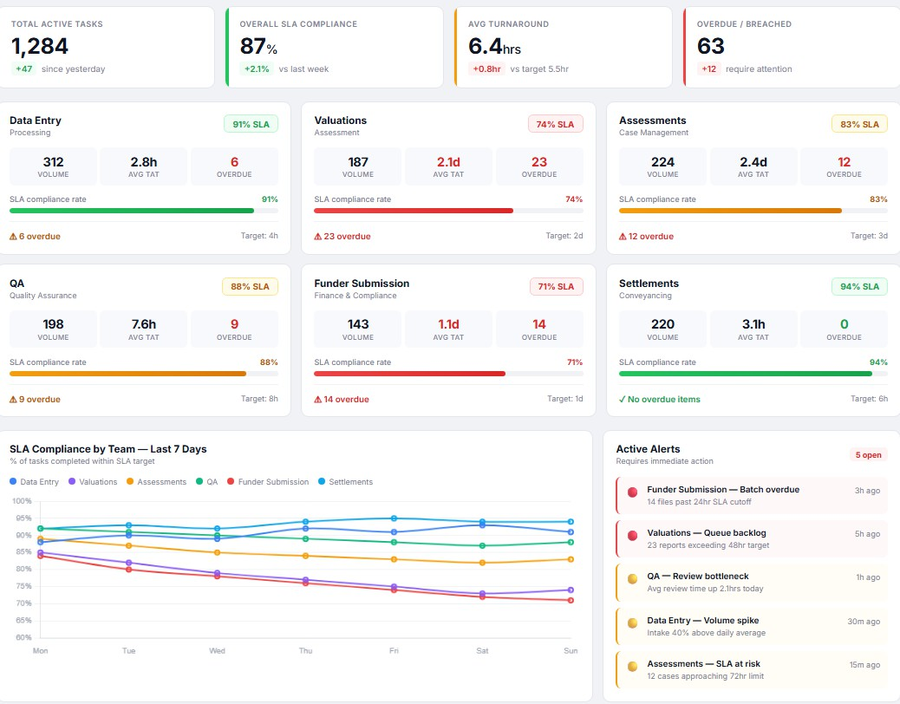

  - Integration Method (To Be Confirmed)

The development team must establish the available integration method with So Ezy. Expected options include:
    - REST API — preferred. Polling endpoint every 5 minutes. Requires API key / OAuth credentials from So Ezy.
    - Webhook — So Ezy pushes updates to the dashboard backend on task state changes.

    - Database view / SQL query — if So Ezy allows direct read access to the underlying database.
The development team should confirm with the So Ezy vendor which method is available and what authentication is required before commencing backend build.

SLA Calculation Logic

The following calculation logic must be implemented in the dashboard backend (not reliant on So Ezy computing these values):
    - Turnaround Time (TAT) = Current timestamp minus task Created date-time (for open tasks), or Completed minus Created (for closed tasks)
    - SLA Compliance % = (Tasks completed within target TAT ÷ Total tasks completed) × 100, calculated per team per day
    - Overdue = Any open task where TAT has exceeded the team's configured SLA target
    - At Risk = Any open task where TAT has exceeded 85% of the team's SLA target

Technical Requirements

Platform

    - Web-based dashboard — accessible via browser on desktop and large-format display screens
    - No mobile optimisation required in v1
    - Must render correctly in Chrome and Edge

Refresh & Performance

    - Data must refresh every 5 minutes without a full page reload
    - Initial page load must complete within 3 seconds on a standard office network
    - Modal drill-down must open within 1 second of clicking a team card

Configurable Settings

The following values must be configurable without a code deployment (ideally via an admin config file or settings panel):
    - SLA target (TAT) per team
    - Data refresh interval
    - Alert thresholds (At Risk % threshold, currently 85% of target)
    - Number of tasks shown in drill-down modal (currently 10)

Hosting

To be confirmed by the development team. The dashboard should be hostable on the organisation's existing internal infrastructure or a cloud environment accessible to operations staff.

Out of Scope (v1)
- Mobile / tablet responsive layout
- User login or role-based access control
- Editing or updating tasks from within the dashboard
- Email or push notifications
- Historical reporting beyond the 7-day trend chart
- Integration with any system other than So Ezy

Deliverables

Deliverable | Description
Live dashboard (web app) | Fully functional browser-based dashboard connected to So Ezy

Deliverable | Description
So Ezy integration layer | Backend service / API connector pulling and caching So Ezy data
SLA calculation engine | Logic computing TAT, compliance %, overdue, and at-risk flags
Configuration file | Admin-editable file for SLA targets and refresh settings
Deployment instructions | Step-by-step guide to deploy and host the dashboard internally

- Assumptions & Dependencies
- So Ezy provides an accessible API or data export method that can return the required fields listed in Section 4.2
- The development team will liaise directly with So Ezy to obtain API credentials and confirm the integration method
- SLA target values per team (listed in Section 2) are confirmed by operations management prior to build commencing
- The dashboard will be accessed on a network with reliable connectivity to the So Ezy platform
- Operations management will provide UAT sign-off before go-live

