School Management System

Theme
A school database designed to organize student details, subjects, exam schedules, and marks. The system uses MySQL queries to retrieve academic records and analyze student performance.

Modules
- Students
- Subjects
- Exams
- Marks

Entity Relationship (ER) Diagram
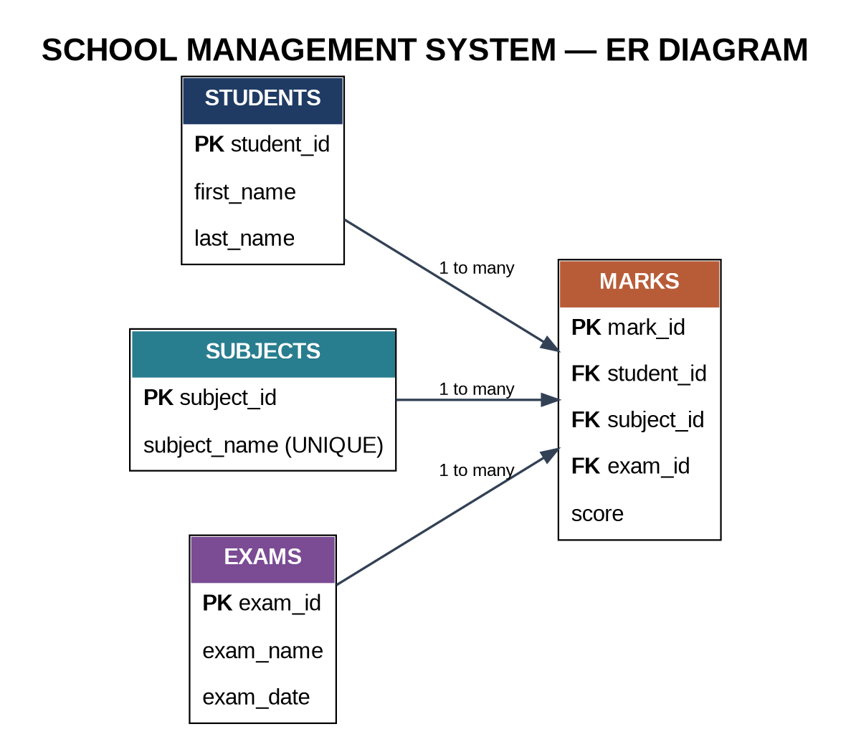
Sample Data
The following table screenshots present the sample records used in the School Management System project. The database contains 7 students, 4 subjects, 3 exams, and 26 marks records.
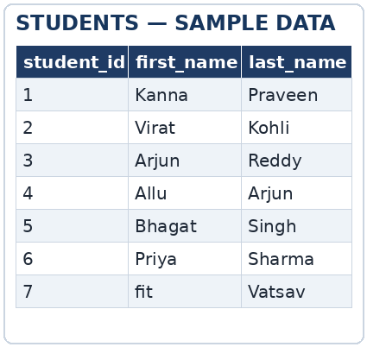
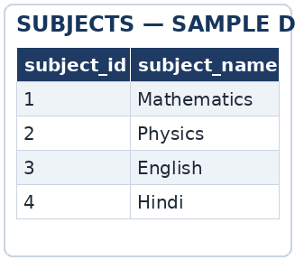
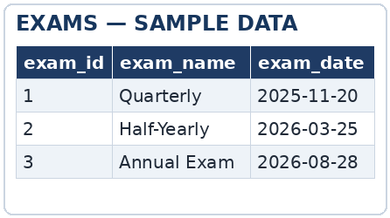
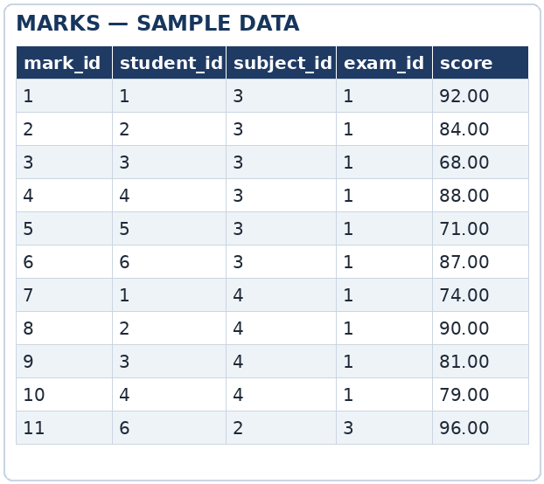

Queries

1. Display all students
SELECT first_name, last_name
FROM Students;

2. Find marks above 80
SELECT *
FROM Marks
WHERE score > 80;

3. Sort exams by date, newest first
SELECT exam_name, exam_date
FROM Exams
ORDER BY exam_date DESC;

4. Display student name, subject, and score
SELECT s.first_name, sub.subject_name, m.score
FROM Marks m
JOIN Students s ON m.student_id = s.student_id
JOIN Subjects sub ON m.subject_id = sub.subject_id;

5. Calculate average score by subject
SELECT sub.subject_name, ROUND(AVG(m.score), 2) AS average_score
FROM Subjects sub
JOIN Marks m ON sub.subject_id = m.subject_id
GROUP BY sub.subject_id, sub.subject_name;

6. Count marks recorded for Priya Sharma
SELECT COUNT(m.mark_id) AS marks_recorded
FROM Students s
JOIN Marks m ON s.student_id = m.student_id
WHERE s.first_name = 'Priya' AND s.last_name = 'Sharma';

7. Find the highest score and the student who earned it
SELECT s.first_name, s.last_name, m.score
FROM Students s
JOIN Marks m ON s.student_id = m.student_id
WHERE m.score = (SELECT MAX(score) FROM Marks);

8. Find exams whose total marks exceed 250
SELECT e.exam_name, SUM(m.score) AS total_score
FROM Exams e
JOIN Marks m ON e.exam_id = m.exam_id
GROUP BY e.exam_id, e.exam_name
HAVING SUM(m.score) > 250;

9. Generate a Pass / Fail report (70 is the pass mark)
SELECT CONCAT(s.first_name, ' ', s.last_name) AS student_name,
sub.subject_name, m.score,
CASE WHEN m.score >= 70 THEN 'Pass' ELSE 'Fail' END AS status
FROM Marks m
JOIN Students s ON m.student_id = s.student_id
JOIN Subjects sub ON m.subject_id = sub.subject_id;

Conclusion
The School Management System demonstrates relational database design and core SQL skills, including filtering, sorting, joins, aggregate functions, subqueries, GROUP BY, HAVING, and CASE expressions.
Prepared by Akshith

