**Microsoft Excel Homework Report – Nico Santoso**

This report will summarize the findings about 4000 past Kickstarter campaigns pertaining to the entertainment industry.

1. Given the data, campaigns that were under the “Theater” category had the most successful campaigns – these campaigns can be defined as those that have raised more capital than their campaign goal. It could be inferred that more people on the platform were willing to pledge for these campaigns than any other campaign, however, out of the 4000, “Theater” held the highest proportion of total campaigns. Thus, this parameter might not be a good indication of whether starting a campaign under the “Theater” category guarantees success.

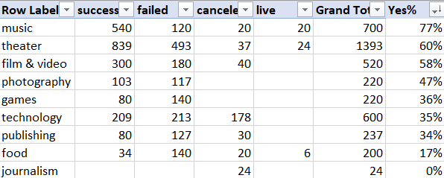

By calculating the percentage of successful outcomes relative to the total campaigns of each category, it can be distinguished that most “Music” campaigns were more successful – exceeding “Theater” campaigns by 17%. Hence, a random “Music” campaign on Kickstarter has a higher chance of being successful than a “Theater” campaign that could have more competition because of having more campaigns on the platform.

2. From the first conclusion, it can also be deduced that “Plays” are the most popular sub-category of campaigns that exceeded their campaign goals. Based on the second pivot table that segmented each category into sub-categories, it can also be seen that “Plays” take up to 25% of the total campaigns - a higher proportion of the data could lead to more chances of campaigns having success. However, it can also be said that many pledgers had similar interests in terms of entertainment which led to the results shown by the pivot.

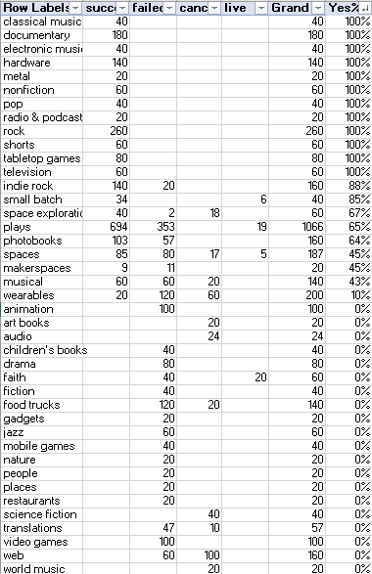

Conducting the same procedure in the first conclusion, it can now be seen that many more sub-categories have a 100% chance of being successful than “Plays”. The data shows a different outlook because it expanded the variety of sub-categories with similar chances of being successful on Kickstarter.

3. Judging how successful a campaign could be by its Category or Sub-Category may not always give the right prediction, the period in which a campaign is uploaded to the platform could also provide different results. By creating a line chart to see which campaigns had succeeded, could give an idea of the spending trends pledgers have throughout the year.

Based on the chart, there is a peak that occurs in May and a low in December for “successful’ campaigns indicating that there is a somewhat downward trend in which as the year passes, pledgers would be less likely to support a campaign. One plausible reason for this could be as it approaches the end of the year, consumers would shift their spending habits as a result of holidays, celebrations, and promotions from retail stores that entices spending elsewhere.

Even though there is volatility amongst “failed” and “canceled” campaigns throughout the year, there is no trend that shows which period campaigns could avoid failure.

These conclusions are limited to the amount of data and is subjected to confounding variables that would affect a campaign’s chances of success. The only information given about the campaign starters is found under the “blurb” column which gives less room to analyze how many “faithful” pledgers a campaign has. A well-established company may use Kickstarter as a source of funding and that would usually attract more pledgers that can lead to a higher chance of success. Meanwhile, newborn campaigns may receive less attention therefore possibly leading to failures.

Due to this reason, a table or graph could be shown to dissect the impact of the “spotlight” column which seems to be Kickstarter’s form of promoting certain campaigns on their website to gain more visibility to users of the platform. By doing such analysis, the data can identify the impact of this variable to a campaign’s success. Whether or not this independent variable is significant enough could give an idea to other externalities that could cause the derived conclusions to be biased one way or another.