For a **Python Developer in Quantitative Analytics Engineering (Vice President)** role at BlackRock, you can expect questions covering:

### **1. Python Programming**

* Explain Python’s memory management.Python’s memory management involves: ✔ **Automatic memory allocation and deallocation**  
   ✔ **Reference counting and garbage collection**  
   ✔ **Optimization through PyMalloc and generational GC**
  + For efficient memory usage, avoid unnecessary references, use generators, and leverage gc.collect() when needed.
* What are Python’s built-in data structures?
  + 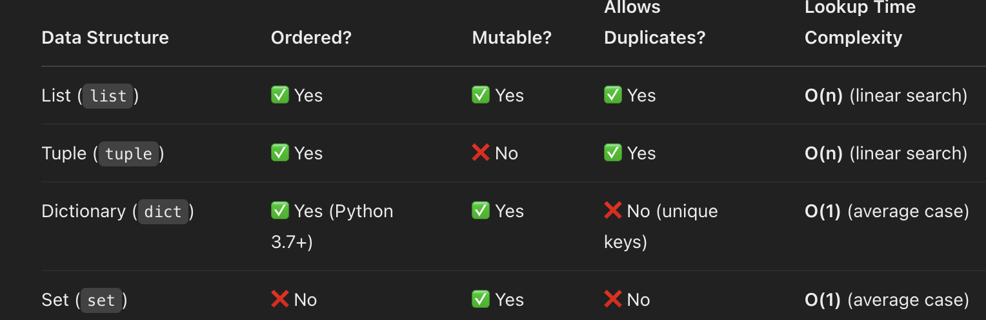
* How does Python handle multithreading and multiprocessing?
  + 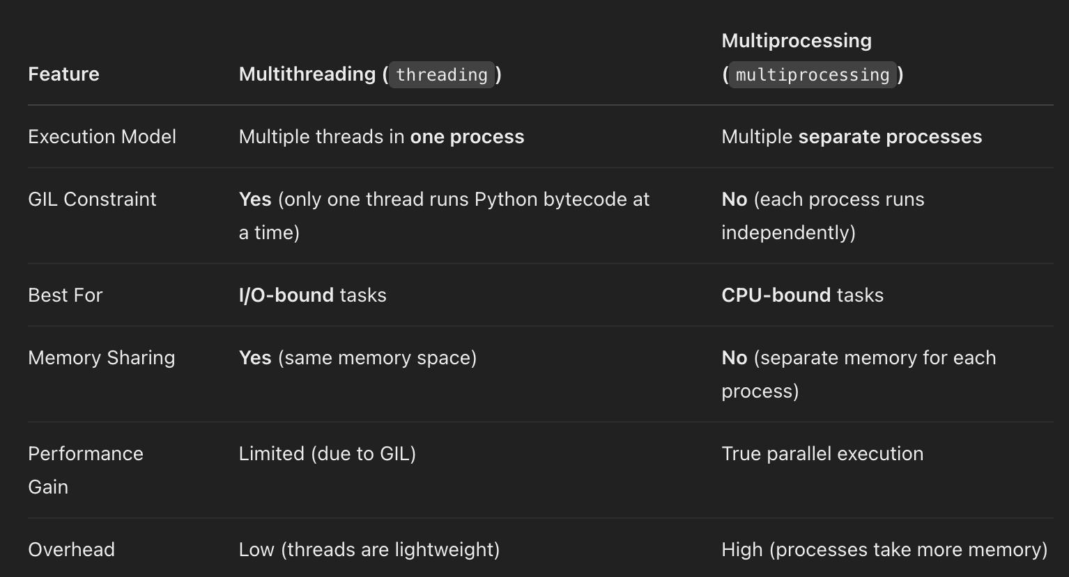
* Explain list comprehension and generator expressions.
  + 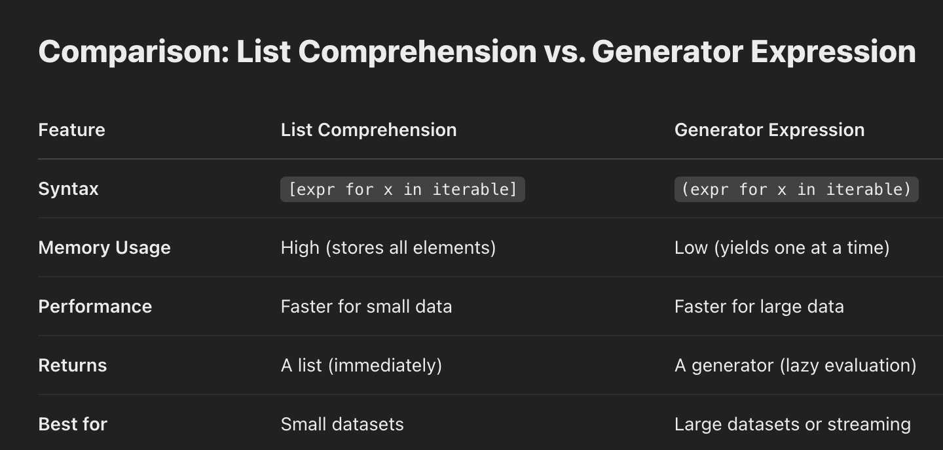
* Difference between deepcopy() and copy().
  + 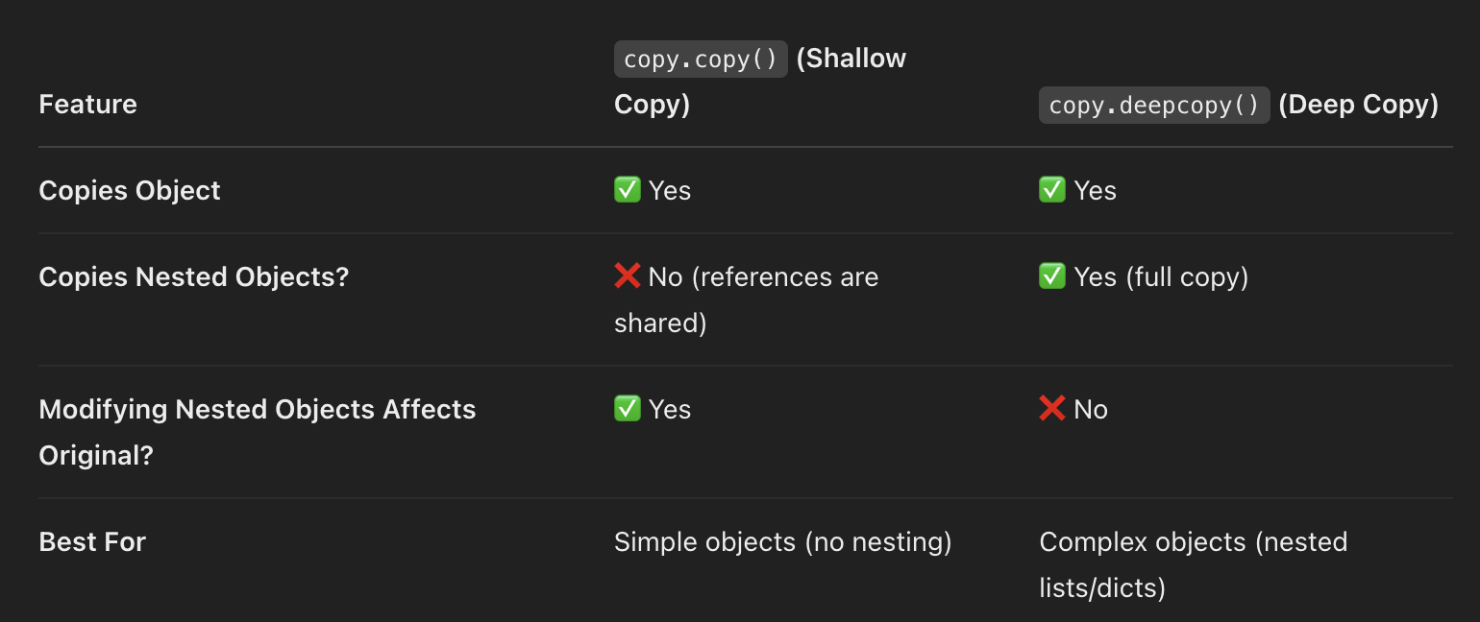
* What is the Global Interpreter Lock (GIL), and how does it impact concurrency?
  + 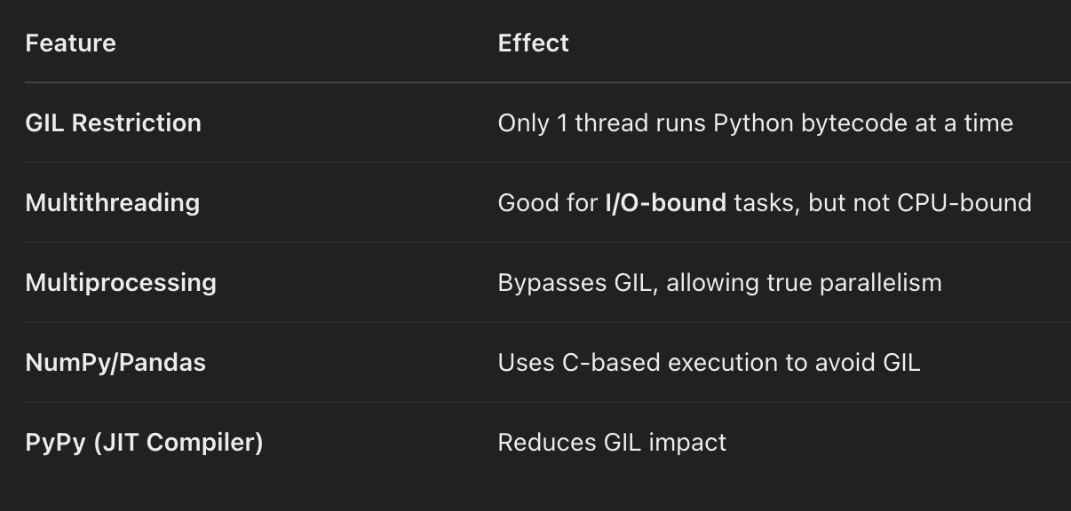
* How do you optimize performance in Python?
  + **. Use Efficient Data Structures (Built-in & Collections)**
  + ✔ Prefer **lists** over linked lists (Python lists are dynamic arrays).  
     ✔ Use **sets** for **fast lookups** instead of lists.  
     ✔ Use **tuples** over lists when data is immutable (faster).  
     ✔ Use **collections** module for optimized data structures:
  + ✔ Use **defaultdict** for missing keys in dictionaries:
  + ✔ List comprehensions are **faster than for loops**:
  + ✔ Use **generator expressions** for memory efficiency:
  + **🔹 3. Avoid Unnecessary Loops & Use map(), filter(), zip()**
  + ✔ Use **zip()** for parallel iteration:
  + ✔ Use **join()** instead of string concatenation:
  + ✔ **Built-in functions** (like sum(), max(), min(), sorted()) are faster than loops.
  + ✔ Use **NumPy** for numerical operations:
  + ✔ Use **enumerate()** instead of manual indexing:
  + ✔ Use **dictionary lookups** instead of if-elif chains:
  + **Use Cython or PyPy for Speed**
  + ✔ **Cython**: Compiles Python to C for performance.
  + ✔ **PyPy**: JIT-compiled Python, much faster for CPU-heavy tasks.
  + ✔ **Multiprocessing** for CPU-bound tasks:
  + ✔ Use **memoization** to speed up function calls:
  + ✔ Use **timeit** to measure execution time:
  + ✔ Use **cProfile** to find slow parts:
* Explain @staticmethod vs. @classmethod vs. instance methods.
  + 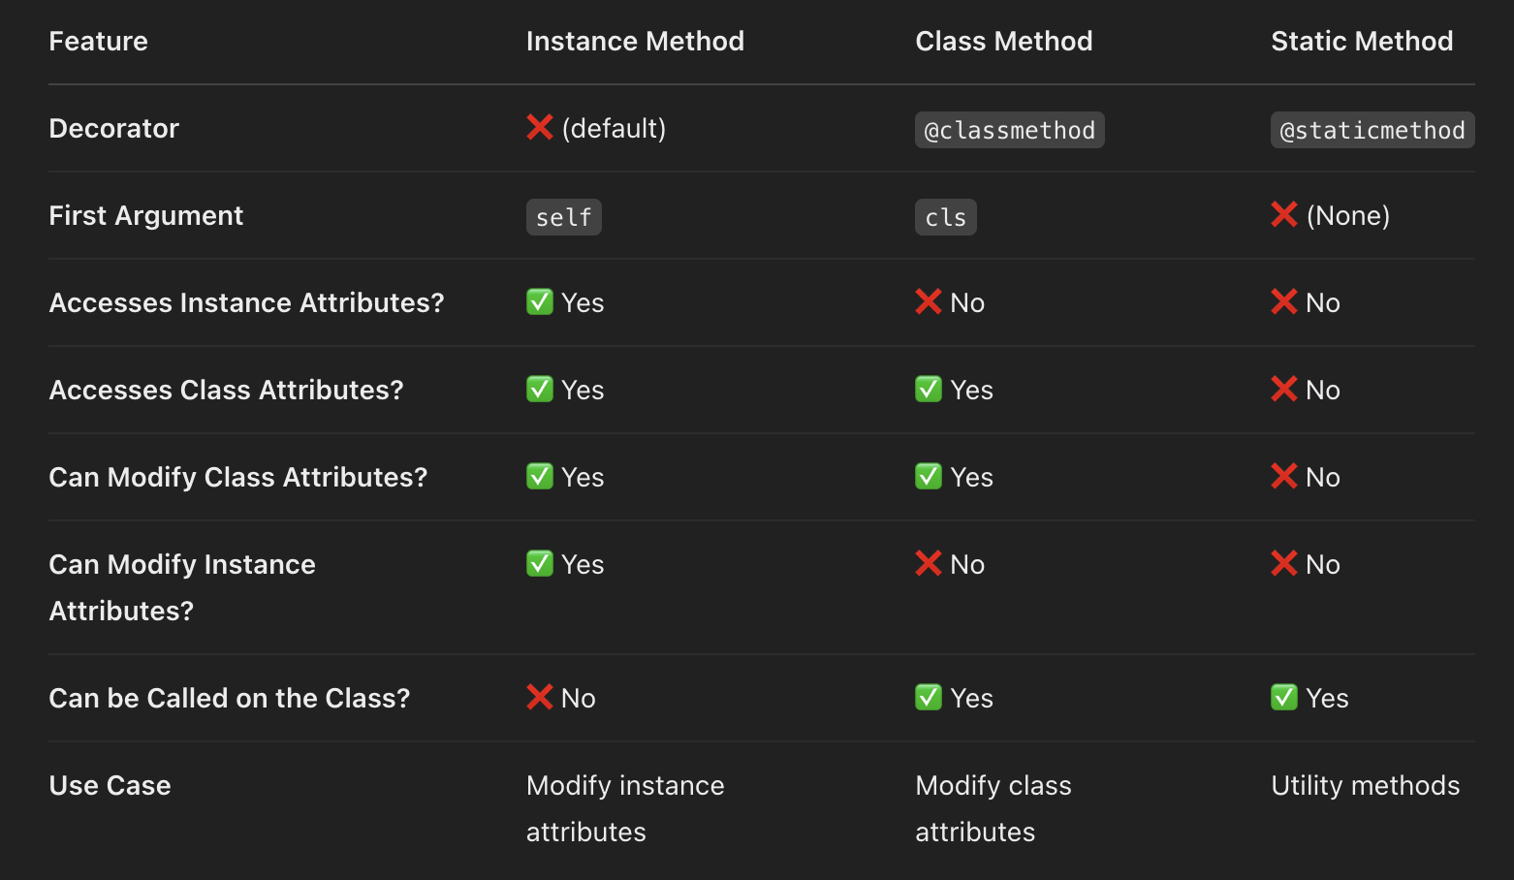
* How does Python handle exceptions? Can you customize them?
  + 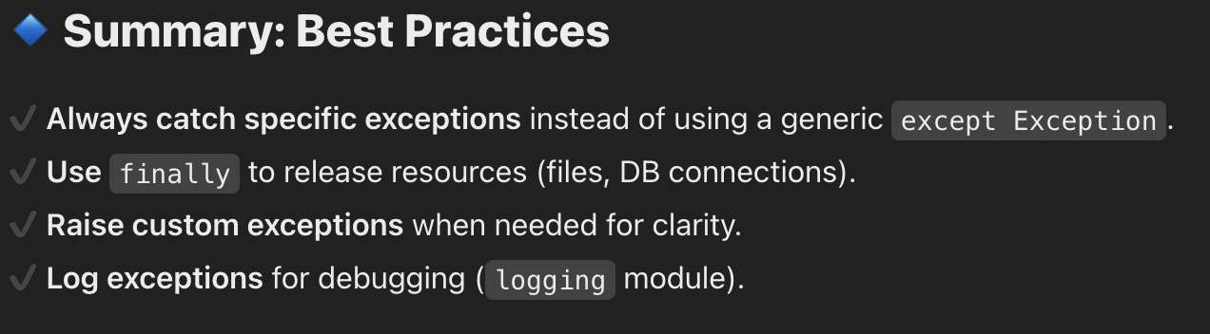

### **2. Algorithms & Data Structures**

* Implement quicksort, merge sort, or any sorting algorithm.
* Find the median of two sorted arrays.
* Explain and implement binary search.
* How do you find the shortest path in a weighted graph?
* Explain hash tables and their applications.
* How does dynamic programming work? Implement a Fibonacci function using DP.
* Find the longest increasing subsequence in an array.
* Detect cycles in a linked list.

### **3. Quantitative Finance & Math**

* What is Monte Carlo simulation? How would you implement it in Python?
* How do you calculate VaR (Value at Risk)?
  + 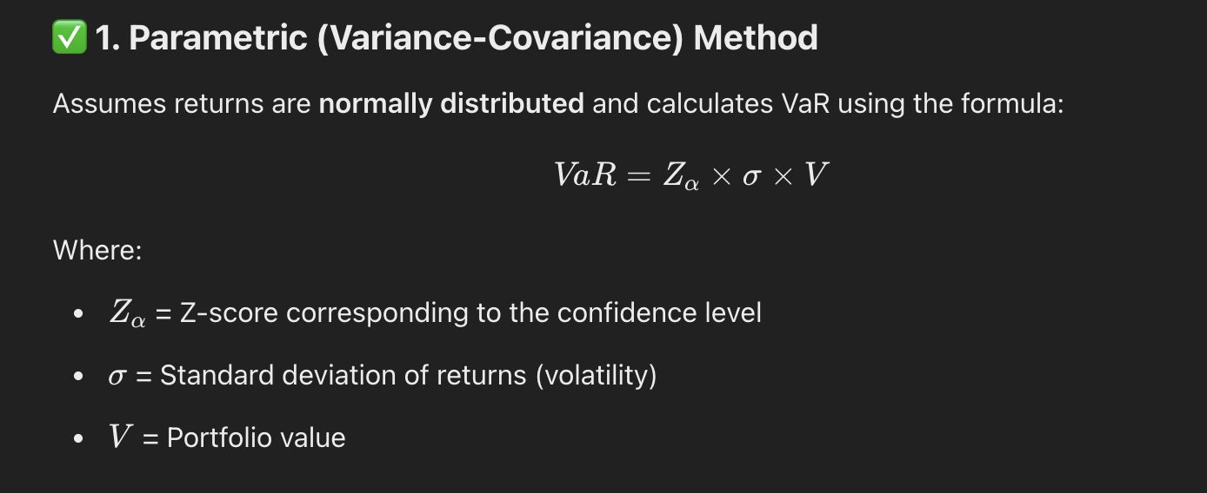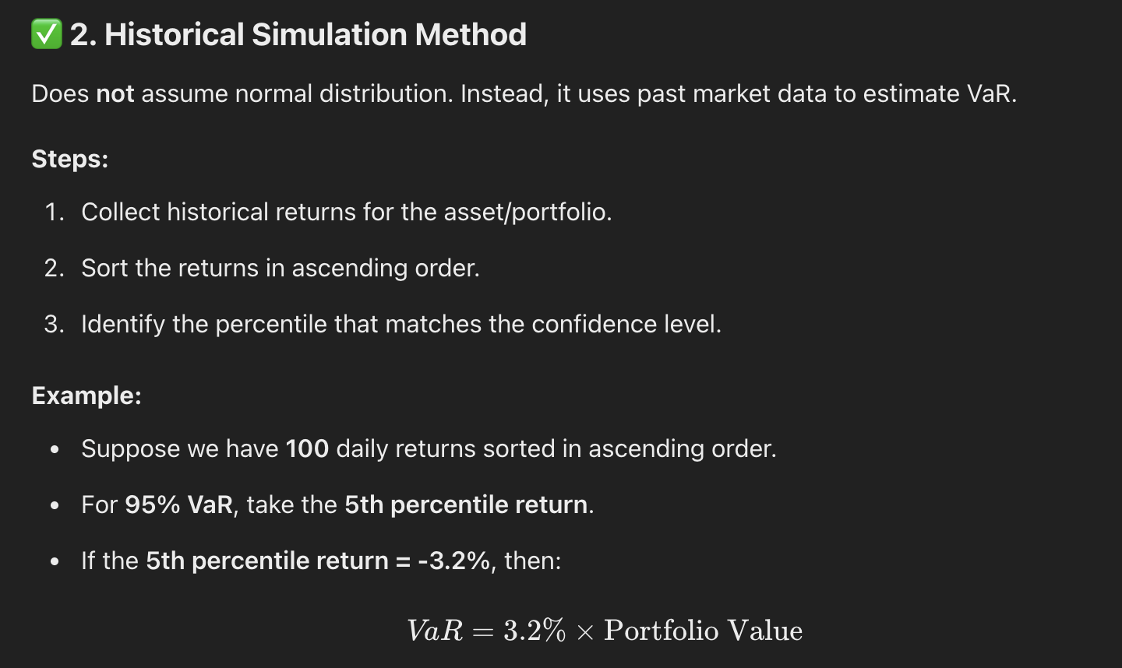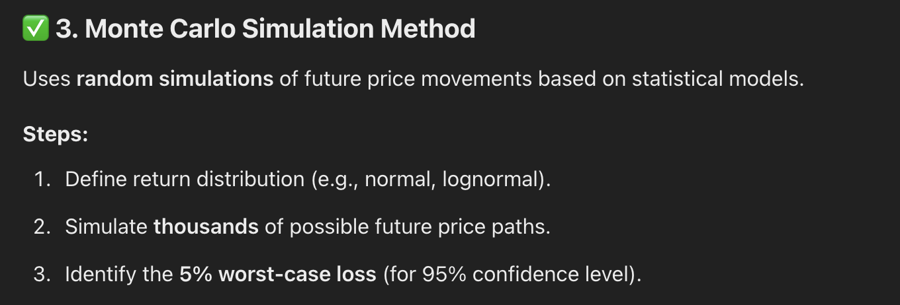
* Explain Black-Scholes and how to implement it.
* What is stochastic calculus, and how is it used in quant finance?
* Implement a pricing model for options using Python.
* What are different risk metrics used in portfolio management?
  + 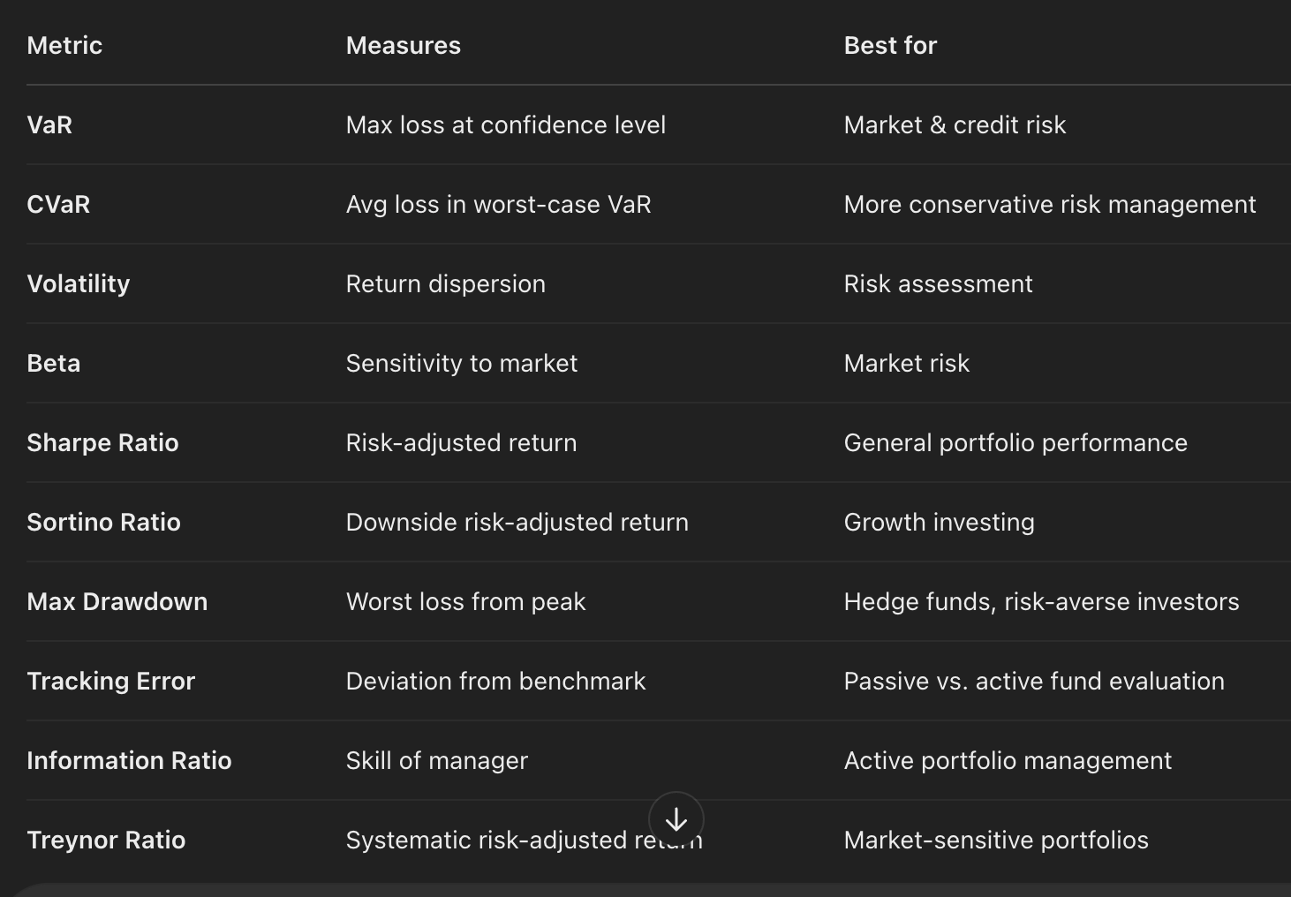
* How do you handle large-scale data computation in Python?
  + 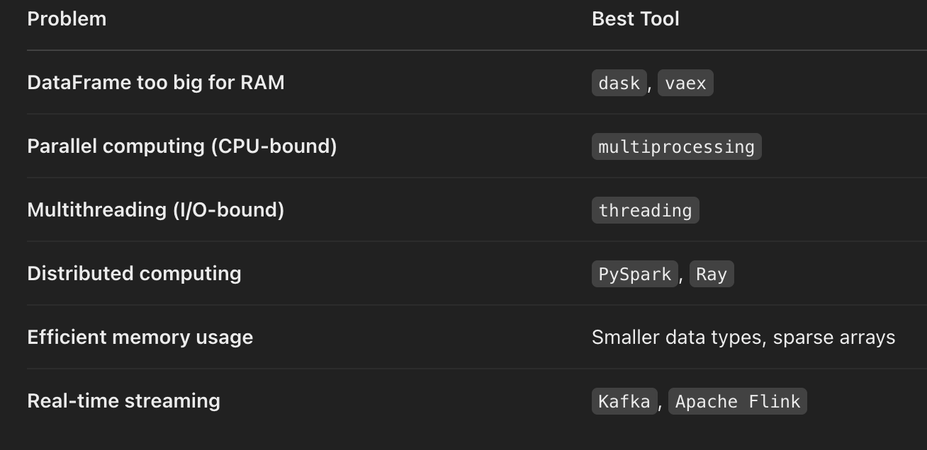
* How do you implement a linear regression model?
  + 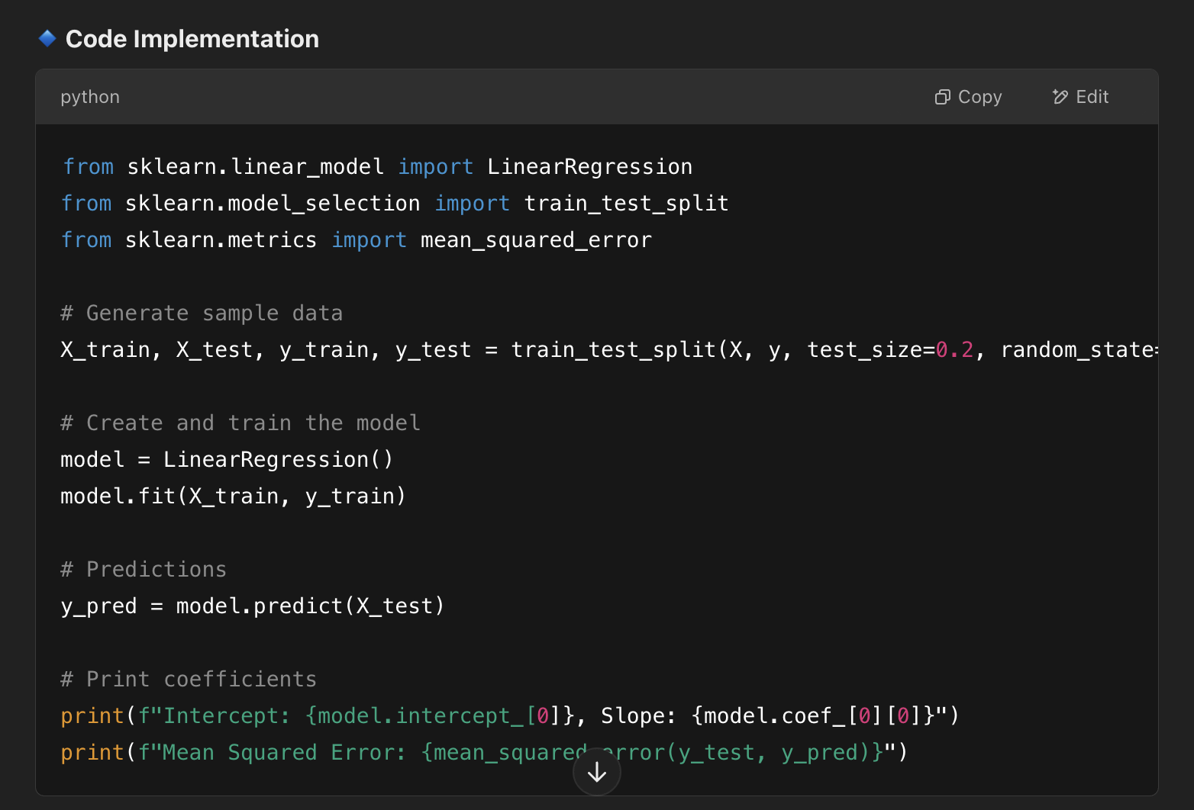

### **4. Data Analysis & Pandas**

* How do you handle missing data in Pandas?
  + 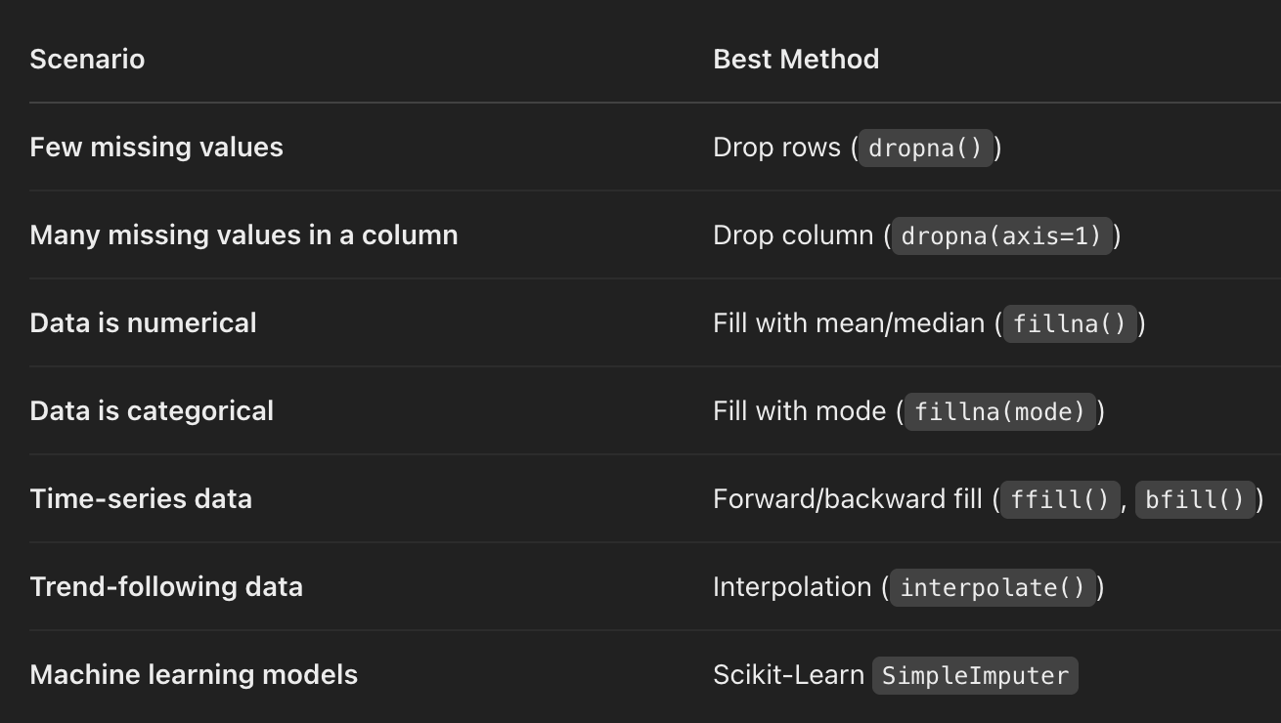
* What are vectorized operations in NumPy?
  + 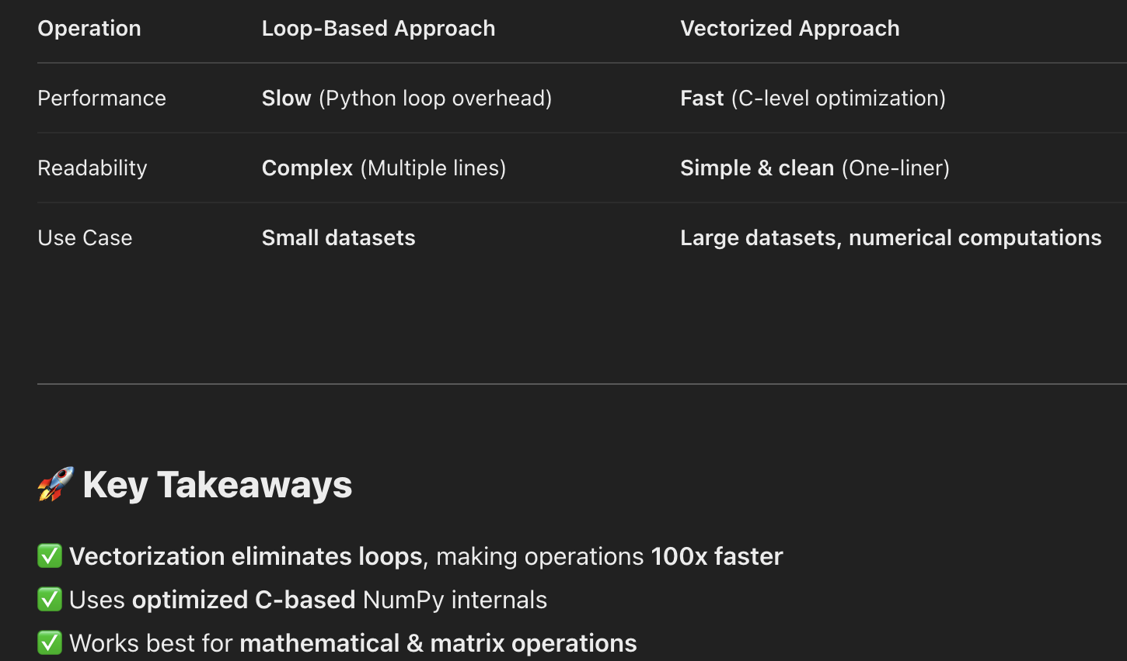
* Explain the difference between apply(), map(), and vectorized functions.
  + 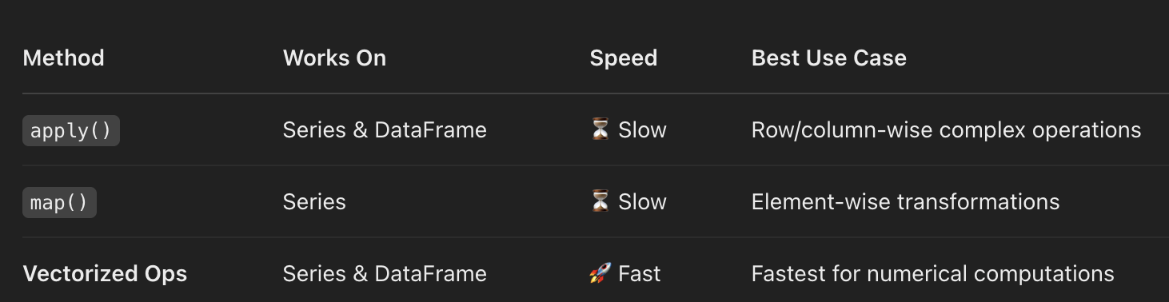
* How do you merge two large datasets efficiently?
  + 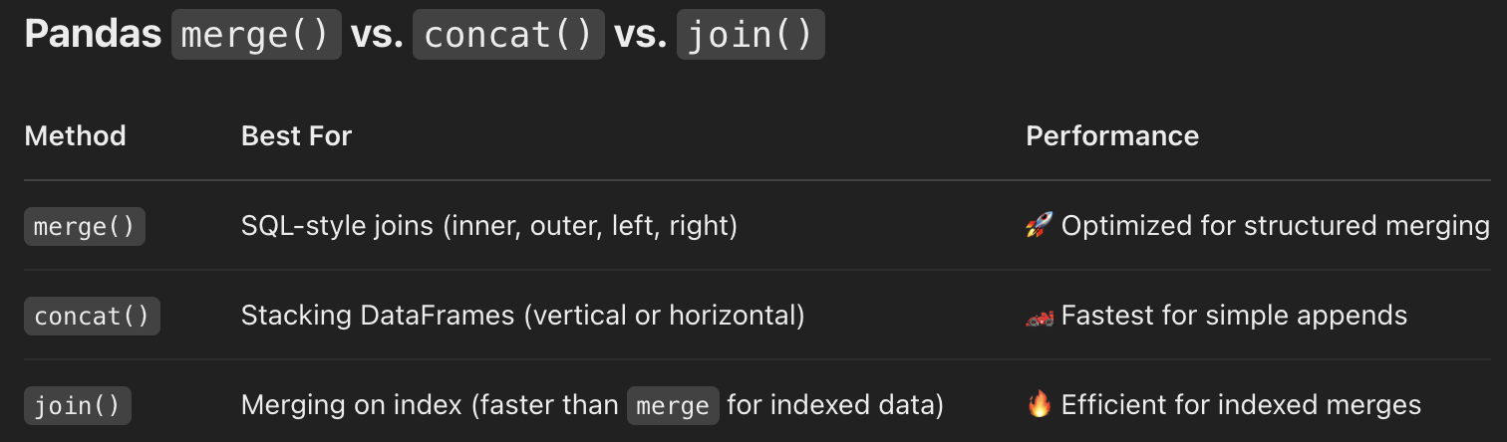
* What is the difference between a Pandas DataFrame and a NumPy array?
  + 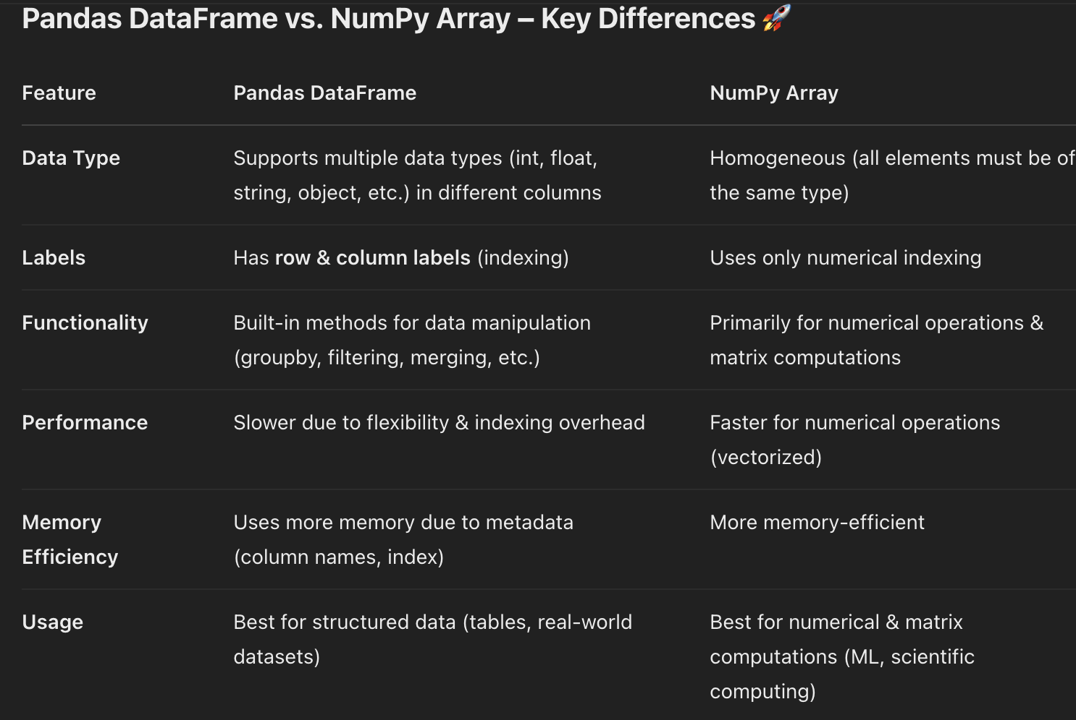

### **5. SQL & Databases**

* Write a query to get the second-highest salary from a table.

SELECT DISTINCT salary FROM employees ORDER BY salary DESC LIMIT 1 OFFSET 1;

* How do you optimize queries for large datasets?
  + Indexing - speed up lookups
  + Select only the required cols to reduce data transfer
  + Before optimizing check what slowing your query. Use Explain Analyze
  + slow Join without indexexing
  + use inner join over outer join if possible
  + use partition for huge tables
  + optimize order by and group by
  + use limit & offset for pagination
  + avoid distinct when possible
    - select distinct departments from employees
    - select department from employee group by department
  + use union all instead of union. union removes duplicate which is slow
* Explain indexing in SQL and how it works.
  + 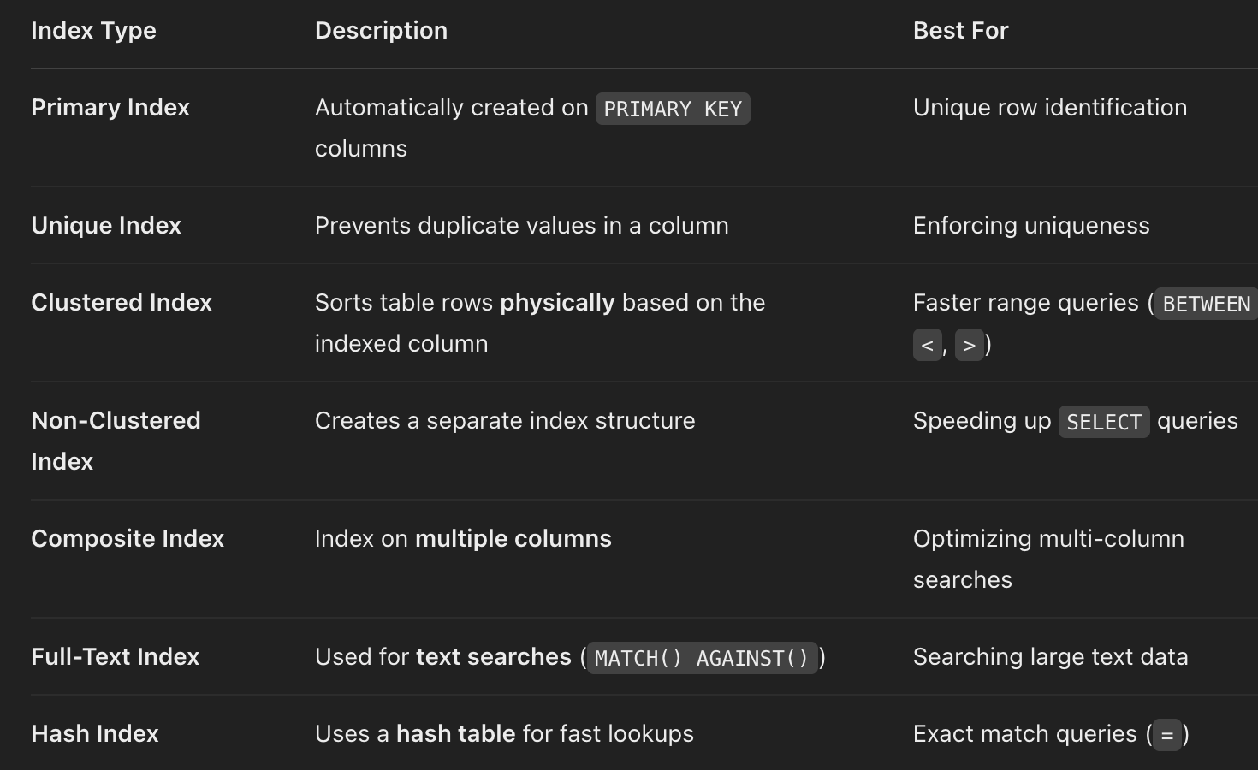
* What is normalization? When do you denormalize a database?
  + Normalization is the **process of organizing data in a database** to:  
     ✅ **Reduce redundancy** (avoid duplicate data)  
     ✅ **Improve data integrity** (eliminate anomalies)  
     ✅ **Ensure efficient data retrieval**
  + It involves **dividing a database into smaller, related tables** and defining relationships between them.
* Difference between SQL joins (INNER, LEFT, RIGHT, FULL).
  + 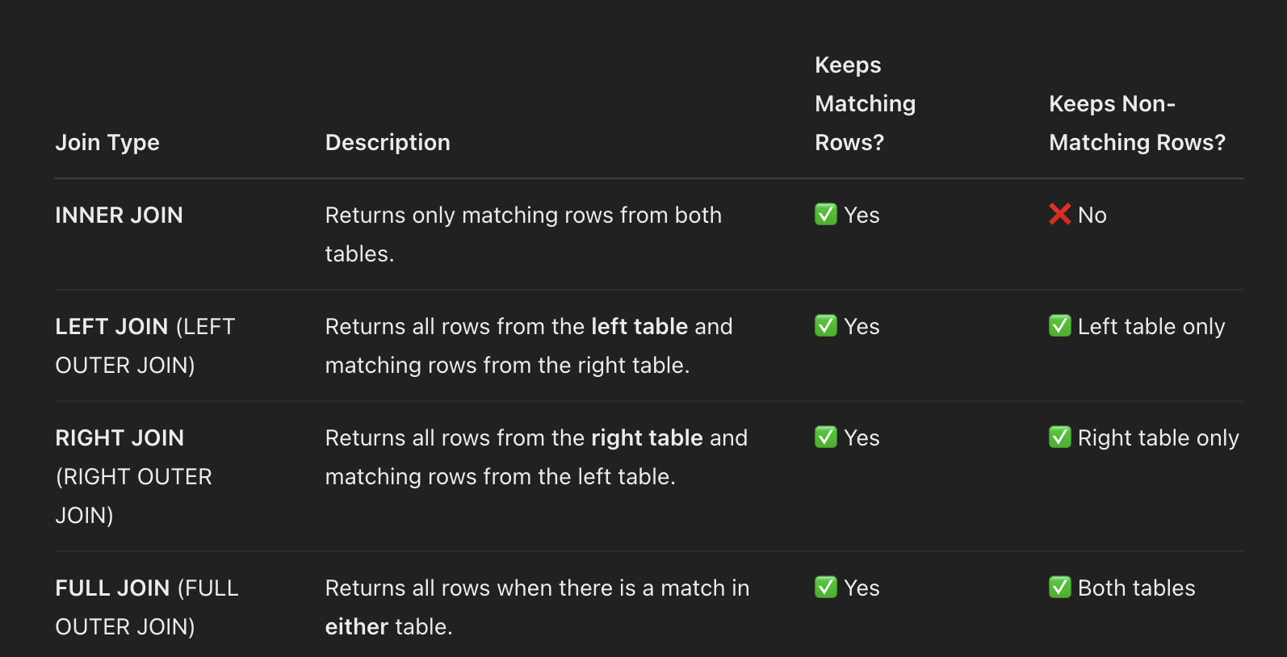

### **6. System Design & Architecture**

* How would you design a real-time trading system?
* How do you handle large-scale data processing in Python?
* What are the trade-offs between SQL and NoSQL databases?
* How do you design a distributed computing system for financial calculations?
* Explain message queues and their use in financial applications.

### **7. Object-Oriented & Functional Programming**

* How do you implement design patterns like Singleton, Factory, or Observer in Python?
* What are first-class functions and closures in Python?
  + 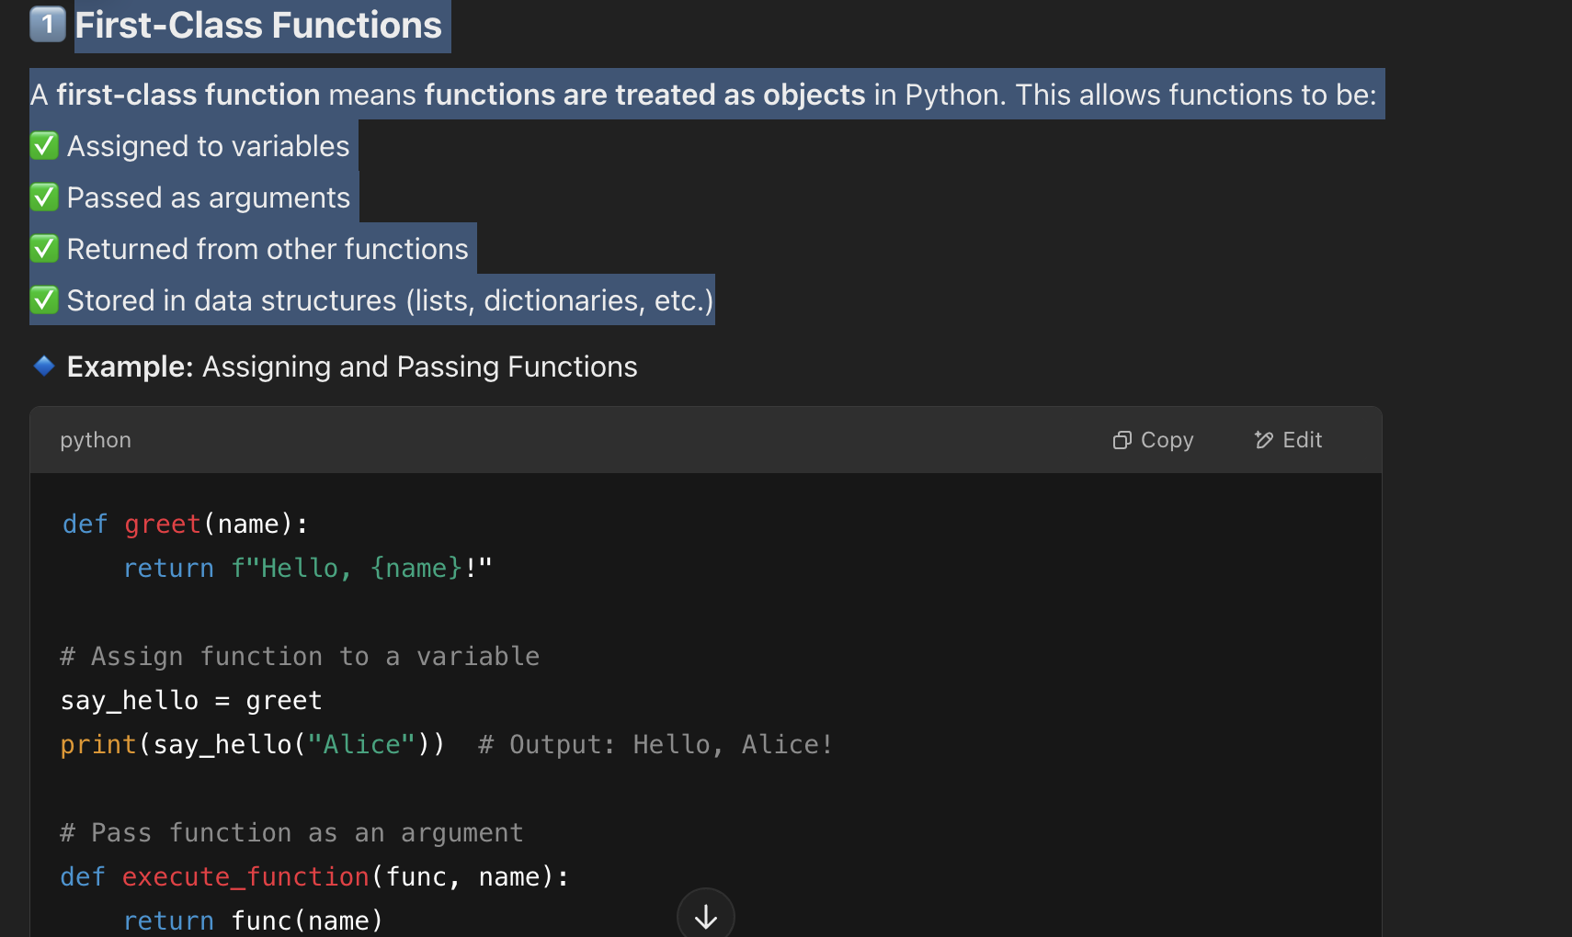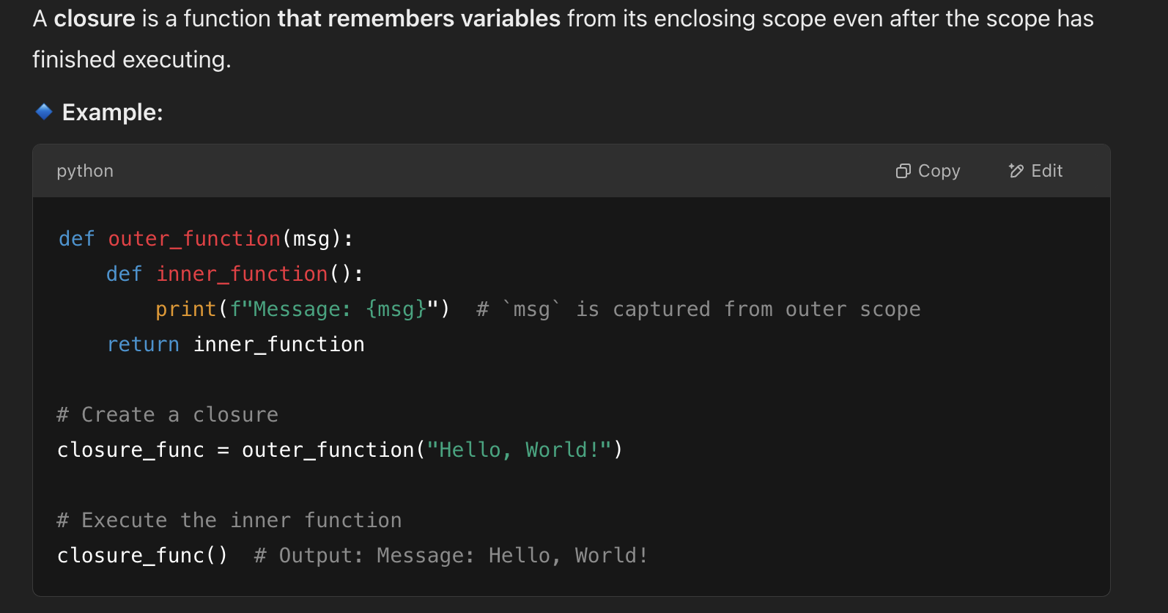
* Explain the SOLID principles in Python.
  + 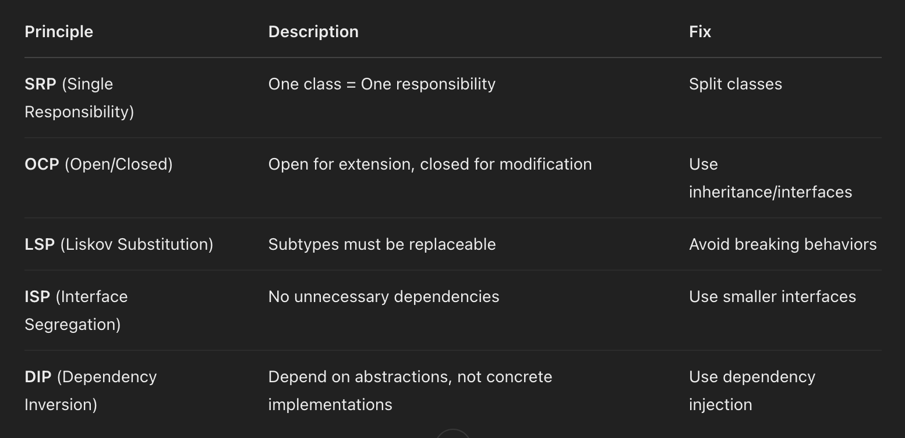

### **8. Behavioral Questions**

* Why do you want to work at BlackRock?
  + "BlackRock’s leadership in asset management, technology-driven approach through Aladdin, and commitment to sustainability make it an exciting place to work. Given my background in finance, technology, and risk analytics, I am eager to contribute to BlackRock’s data-driven investment strategies. Additionally, I value continuous learning and collaboration, which aligns with BlackRock’s culture of innovation and excellence. Working at BlackRock would provide the perfect opportunity for me to grow while making an impact in the financial industry."
* Describe a time when you solved a complex problem using Python.
* How do you handle conflicts in a team setting?
* Tell me about a project where you worked with large datasets.

Would you like me to help with coding problems or mock interviews?

Based on the job description, your interview will likely focus on:

### **1. Python Development (Core & Advanced)**

* Writing modular and scalable Python applications
* Best practices in Python software design
* Debugging and optimizing Python code for performance
* Working with large-scale data processing pipelines
* Python testing frameworks (unittest, pytest)
  + 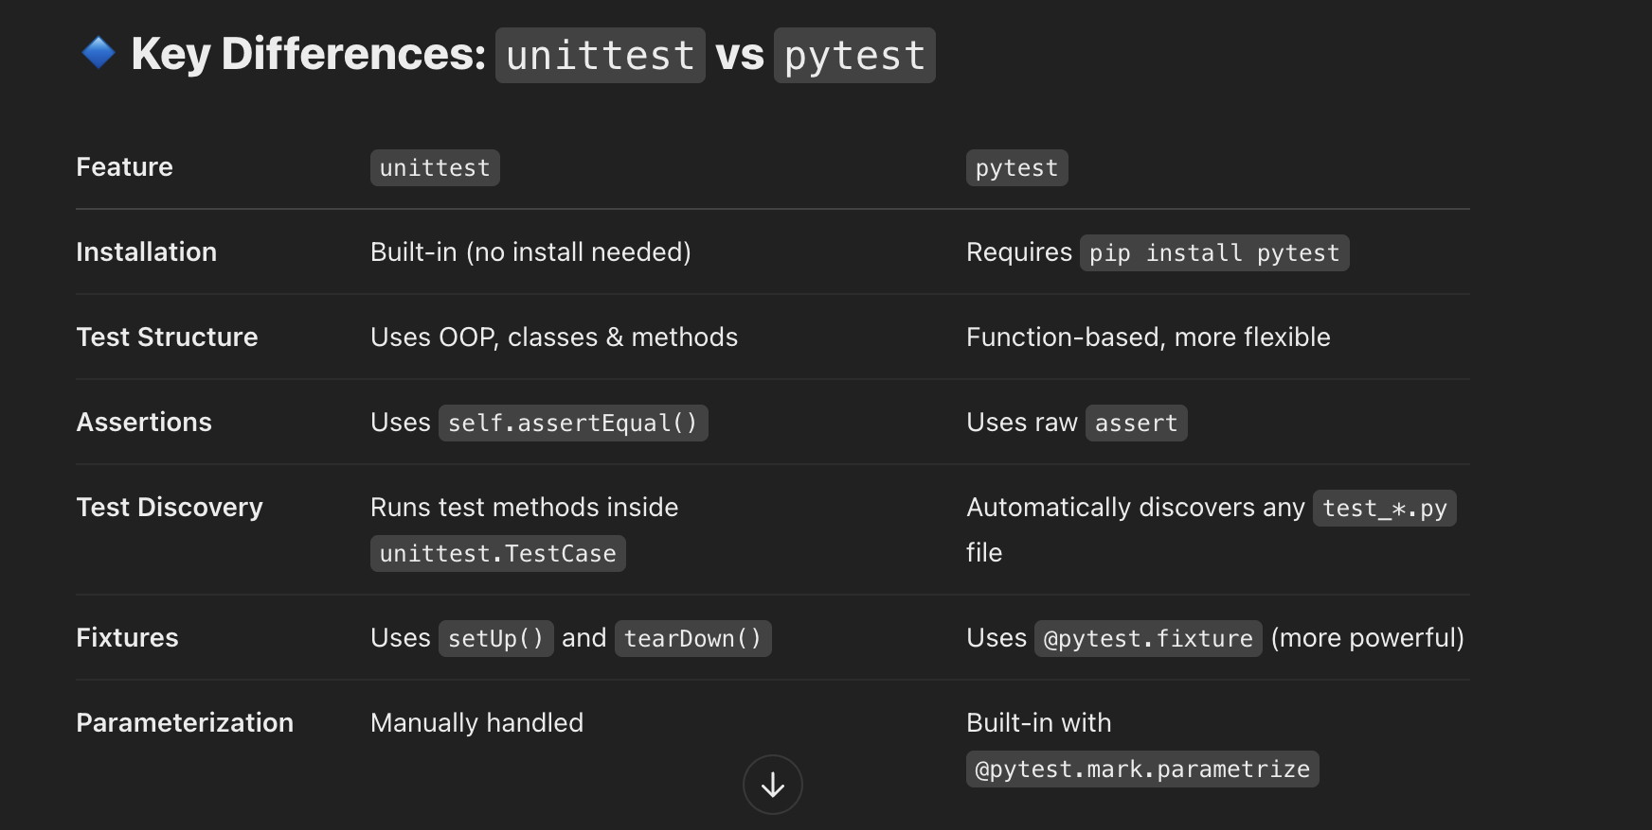
* Python concurrency (threads, multiprocessing, asyncio)
  + 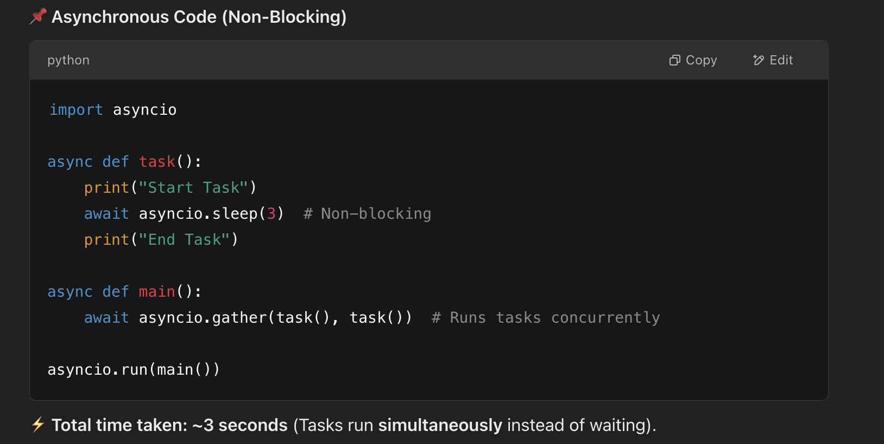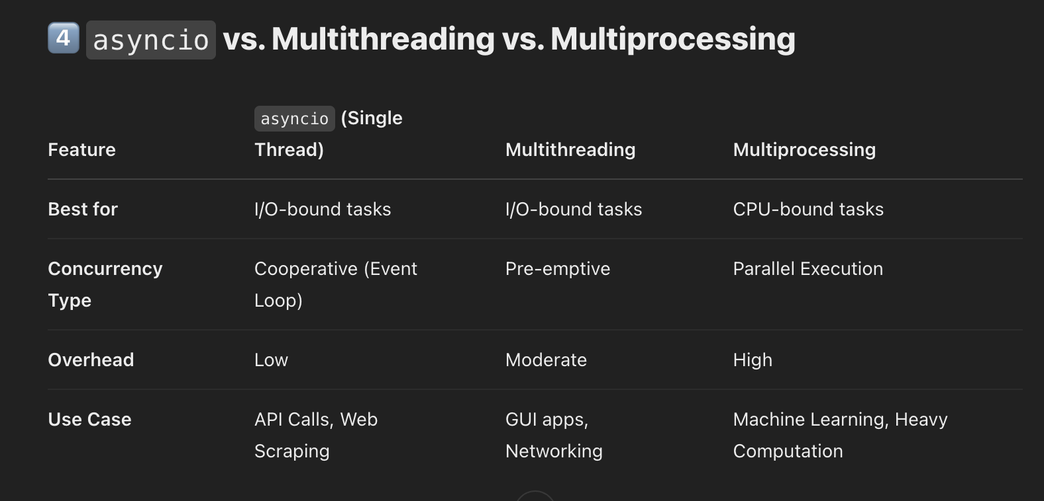

### **2. Quantitative & Financial Modeling**

* Implementing financial risk models in Python
* Working with time series data (Pandas, NumPy)
* Portfolio risk analytics concepts (VaR, stress testing)
* High-performance computing for quantitative finance
* Understanding investment management processes

### **3. System Design & Scalability**

* Building distributed systems for financial data
* Experience with cloud platforms (Azure, AWS, etc.)
* CI/CD and DevOps principles
* Designing resilient, high-performance applications

### **4. Agile & Collaboration**

* Working in Agile/Scrum environments
* Using Git, CI/CD pipelines
* Collaborating with quantitative analysts and modelers

Would you like help with mock coding problems or system design scenarios?

Great! Here are some **mock coding problems** tailored to your role:

### **1. Python Core & Data Structures**

#### **Problem: Stock Price Tracker**

You are given a stream of stock prices as they arrive. Implement a class that supports:

* update(timestamp: int, price: float) -> None: Updates the stock price for a given timestamp.
* current() -> float: Returns the latest stock price.
* maximum() -> float: Returns the highest stock price seen so far.
* minimum() -> float: Returns the lowest stock price seen so far.

Example:

tracker = StockPriceTracker()  
tracker.update(1, 100)  
tracker.update(2, 105)  
tracker.update(3, 98)  
print(tracker.current()) # 98  
print(tracker.maximum()) # 105  
print(tracker.minimum()) # 98

### **2. Quantitative Finance & Risk Analytics**

#### **Problem: Value at Risk (VaR) Calculation**

Write a function to compute the **95% Value at Risk (VaR)** using the **historical simulation** method.

* Assume you have an array of past daily returns.
* Return the 5th percentile of the distribution.

Example:

returns = [-0.02, 0.01, -0.015, 0.005, -0.025, 0.02, -0.01]  
print(compute_var(returns)) # Should return a negative number

### **3. High-Performance Computing**

#### **Problem: Parallel Monte Carlo Simulation**

Implement a Monte Carlo simulation to estimate the value of **π** using **multiprocessing**.

* Generate random points inside a unit square and count how many fall inside the unit circle.
* Use **multiple processes** to speed up computation.

Example:

print(estimate_pi(num_samples=1000000, num_processes=4))

### **4. System Design & Large-Scale Data Processing**

#### **Problem: Streaming Moving Average**

Design a system to process a stream of financial data and compute a **moving average of the last N values** efficiently.

* Use an O(1) approach to update the moving average.
* Assume the input is a continuous stream of numbers.

Example:

ma = MovingAverage(3)  
ma.add(10)   
ma.add(20)   
ma.add(30)   
print(ma.average()) # 20.0  
ma.add(40)   
print(ma.average()) # 30.0

Would you like to implement any of these, or should I provide solutions and explanations? 🚀

