FULL LEGAL NAME | LOCATION (COUNTRY) | EMAIL ADDRESS | MARK X FOR ANY NON-CONTRIBUTING MEMBER
Nitesh Kumar | India | Niteshkr2209@gmail.com
Yang Liu | Canada
Sheik Allieu | Sierra Leone

*Remember: Any group members who did not contribute to the project should be given all zero (0) points for the collaboration grade on the GWP submission page.

Statement of integrity: By typing the names of all group members in the text boxes below, you confirm that the assignment submitted is original work produced by the group (excluding any non-contributing members identified with an “X” above).
Team member 1 | Nitesh Kumar
Team member 2 | Yang Liu
Team member 3 | Sheik Allieu

Use the box below to explain any attempts to reach out to a non-contributing member. Type (N/A) if all members contributed.
Note: You may be required to provide proof of your outreach to non-contributing members upon request.

1. Introduction and data
A portfolio manager wants to build a portfolio for a client from ten large US stocks: Tesla (TSLA), Walmart (WMT), Bank of America (BAC), Goldman Sachs (GS), Eli Lilly (LLY), Merck (MRK), Alphabet class C (GOOG), Meta (META), Apple (AAPL) and ExxonMobil (XOM). In this report we work through four questions the manager asked us. First, what the optimal mean-variance mix is, with and without a cap on any single stock. Second, which style factors drive the capped portfolio. Third, whether random simulation can stand in for proper optimisation. Fourth, how the allocation changes once we add our own market views with the Black–Litterman approach.
We used daily closing prices, adjusted for splits, from 1 September 2023 to 30 September 2025 (521 daily returns) to estimate mean returns and the covariance matrix. The following quarter, 1 October to 31 December 2025 (64 trading days), was kept aside for out-of-sample testing. We chose daily over weekly data because two years of weekly data gives only about 105 observations for a 10×10 covariance matrix (55 parameters), while daily data gives five times as many and still covers the same market regime. Returns are simple daily returns and are annualised with 252 days. The risk-free rate is the daily one-month T-bill rate from the Kenneth French Data Library (French), the same source as the five factors used in Part 2, so every excess return in the report is measured against the same benchmark. Its average over the sample was 5.04% a year. S&P 500 constituent weights on 30 September 2025 were used to build the market portfolio in Part 4
Table 1. In-sample return statistics, 1 Sep 2023 – 30 Sep 2025
Stock | Mean return (ann.) | Volatility (ann.) | Sharpe ratio
TSLA | 45.8% | 62.9% | 0.65
WMT | 33.3% | 21.1% | 1.34
BAC | 31.7% | 25.6% | 1.04
GS | 46.9% | 28.3% | 1.48
LLY | 21.7% | 35.2% | 0.47
MRK | -9.7% | 24.2% | -0.61
GOOG | 32.1% | 29.6% | 0.91
META | 50.4% | 36.2% | 1.25
AAPL | 18.5% | 27.7% | 0.49
XOM | 3.1% | 22.2% | -0.09

Table 1 shows how uneven the period was. META, GS and TSLA returned more than 45% a year, while Merck lost almost 10% and Exxon barely beat cash. Any optimiser fed these numbers will chase the winners, which is the main issue we keep coming back to below (Michaud)

2. Technical report

2.1 Part 1 – Standard mean-variance optimisation (Steps 1–4)
Method Following Markowitz, we look for the portfolio with the highest Sharpe ratio (Sharpe), i.e. the tangency portfolio, by solving the constrained problem below directly with a sequential quadratic programming solver. We used several starting points to make sure we were finding the global optimum and not a local one. No simulation was used in this part.
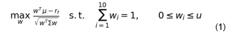
Here mu is the vector of mean daily returns, Sigma the sample covariance matrix and r_f the average daily risk-free rate. In Step 1 the upper bound is u = 1 (long-only). For Step 2 the brief gives the client limit as 15% in one sentence and as 0.18 in the next, so we solved both cases. We treat 15% as the binding mandate because it is what the client actually asked for, and a 15% portfolio automatically satisfies an 18% limit as well. The 15% portfolio is the one carried into Parts 2 and 4.
Table 2. Optimal (maximum Sharpe ratio) weights and in-sample statistics

Stock | Step 1: long-only | Step 2: max 15% | Step 2: max 18%
TSLA | 0.0% | 1.6% | 0.0%
WMT | 43.7% | 15.0% | 18.0%
BAC | 0.0% | 15.0% | 18.0%
GS | 34.7% | 15.0% | 18.0%
LLY | 0.0% | 14.4% | 10.0%
MRK | 0.0% | 0.0% | 0.0%
GOOG | 4.9% | 15.0% | 18.0%
META | 16.7% | 15.0% | 18.0%
AAPL | 0.0% | 4.1% | 0.0%
XOM | 0.0% | 4.9% | 0.0%
Exp. return | 40.8% | 34.0% | 37.2%
Volatility | 19.2% | 18.4% | 19.1%
Sharpe ratio | 1.86 | 1.57 | 1.69
Stocks held | 4 | 9 | 6

Step 1 and Step 2 results
Without a cap, the optimiser holds only four names: Walmart (43.7%), Goldman Sachs (34.7%), Meta (16.7%) and a small amount of Alphabet (5.0%). This is the classic "error-maximising" behaviour of mean-variance optimisation. It loads up on the stocks with the best past Sharpe ratios that are not too correlated with each other, and Walmart is attractive because of its low volatility (21%) and low correlation with the tech and bank names. The in-sample Sharpe ratio is 1.86.
With the 15% cap the money has to be spread over nine stocks. Five positions sit exactly at the 15% limit (WMT, BAC, GS, GOOG and META), Lilly takes 14.4%, and the remaining 10% or so goes to XOM, AAPL and TSLA. Only Merck is left out. The Sharpe ratio falls to 1.57, so on paper the cap costs about 0.29 units of Sharpe ratio. The 18% version holds six names and sits in between at 1.69.
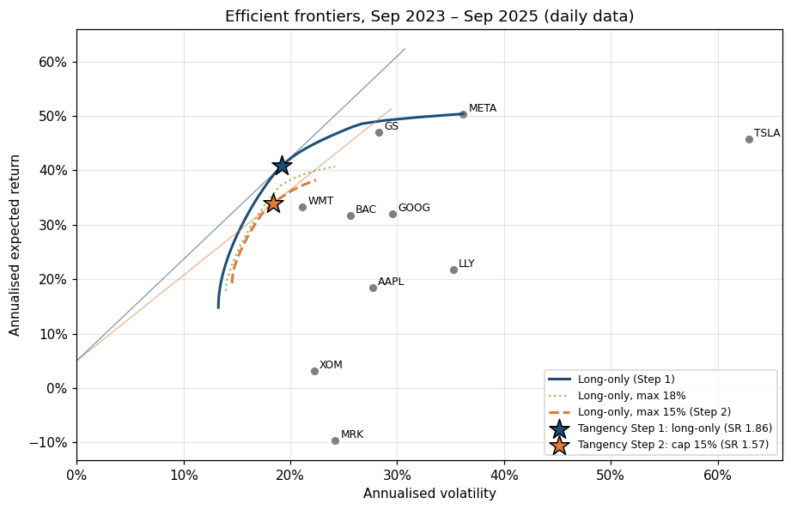Figure 1. Efficient frontiers (long-only, 18% cap and 15% cap) with tangency portfolios and capital market lines

Step 3 – Comparing the efficient frontiers
Figure 1 plots both frontiers on the same axes. The main difference is that the capped frontier is much shorter and lies inside the unconstrained one. At the top, the long-only frontier runs up to 50.4% expected return (100% in Meta), while with the cap the best feasible portfolio reaches only 38.2%, since at most 15% can go to any one high-return stock. At the bottom, the minimum-variance point moves right, from 13.3% to 14.6% volatility, because the low-risk names (WMT, XOM, MRK) cannot be overweighted either. The curves are close only in the middle section, where the unconstrained efficient portfolios already respect the 15% limit. Every extra constraint can only shrink the feasible set, so the capped frontier can never lie above the original one. The cost shows up as a flatter capital market line and a lower maximum Sharpe ratio.

Step 4 – Out-of-sample performance (Oct–Dec 2025)
Each portfolio was bought at the 30 September 2025 close and held without rebalancing until 31 December 2025. We measured the cumulative return, the annualised Sharpe ratio from daily excess returns, and the maximum drawdown (largest fall from a previous peak).
Table 3. Out-of-sample performance, 1 Oct – 31 Dec 2025 (buy-and-hold)
Portfolio | Cumulative return | Sharpe ratio (ann.) | Max drawdown | Volatility (ann.)
Step 1: long-only | 6.87% | 1.51 | -5.02% | 14.7%
Step 2: cap 15% | 13.09% | 3.42 | -2.97% | 12.9%
Step 2: cap 18% | 11.97% | 2.95 | -2.91% | 13.7%
Equal weight (1/10) | 12.47% | 3.15 | -3.61% | 13.4%
S&P 500 | 2.35 % | 0.39 | -5.11% | 12.6%

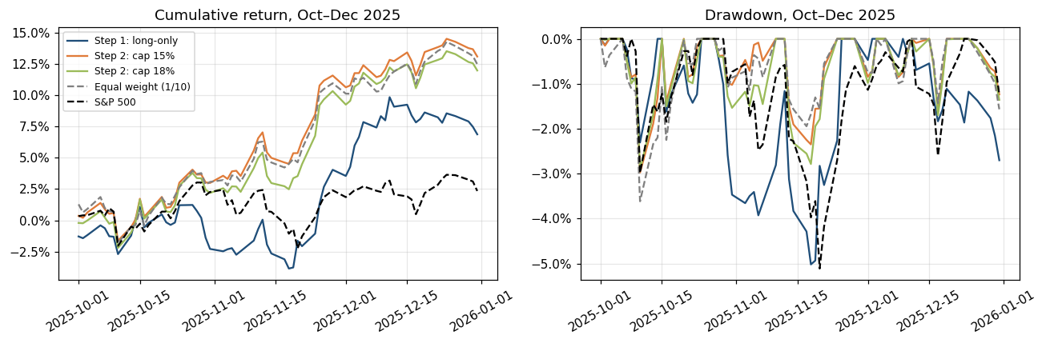 Figure 2. Out-of-sample cumulative return and drawdown
The ranking out of sample is the reverse of the in-sample one. The capped portfolio returned 13.1% in three months with a Sharpe ratio of 3.42 and a maximum drawdown of only –3.0%. The unconstrained portfolio made 6.9%, with a Sharpe ratio of 1.51 and a deeper drawdown of –5.0%. Both beat the S&P 500 (+2.3%), but the gap between them is almost entirely explained by what the concentrated portfolio did not hold. Lilly rose 41%, Merck 25% and Alphabet 29% in the quarter, while Meta, its third-largest position, fell 10%. Notably, the naive 1/N portfolio (12.5%) also did better than the “optimal” unconstrained mix. This fits the evidence that weight caps act like shrinkage on a noisy covariance and mean estimate and tend to help out of sample (Jagannathan and Ma). One quarter is a short window and we would not read the Sharpe ratios too literally, but the direction of the result is what theory predicts.

2.2 Part 2 – Fama–French five-factor exposure of the capped portfolio (Steps 4–6)

Step 4 – The five factors and their correlations
We estimate the Fama and French five-factor model for the daily excess return of the Step 2 portfolio, holding the weights constant:
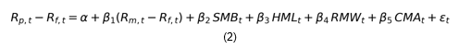
- Market risk premium (R_m - R_f): the return of the value-weighted US market over T-bills. Its beta measures how much the portfolio moves with the overall market. This is the systematic risk that cannot be diversified away.
- SMB (Small Minus Big): small-cap stocks minus large-cap stocks. A positive beta means a small-cap tilt; a negative beta means the portfolio behaves like large caps.
- HML (High Minus Low): high book-to-market (value) stocks minus low book-to-market (growth) stocks. A positive beta is a value tilt.
- RMW (Robust Minus Weak): firms with high operating profitability minus firms with weak profitability. A positive beta means exposure to high-quality, profitable companies.
- CMA (Conservative Minus Aggressive): firms that invest conservatively (slow asset growth) minus firms that invest aggressively. A negative beta means the portfolio leans towards companies that are expanding their asset base quickly.
Table 4. Correlation matrix of daily factor returns, Sep 2023 – Sep 2025

Factor | Mkt-RF | SMB | HML | RMW | CMA
Mkt-RF | 1.00 | 0.21 | -0.26 | -0.38 | 0.02
SMB | 0.21 | 1.00 | 0.39 | -0.40 | 0.15
HML | -0.26 | 0.39 | 1.00 | 0.19 | 0.10
RMW | -0.38 | -0.40 | 0.19 | 1.00 | -0.11
CMA | 0.02 | 0.15 | 0.10 | -0.11 | 1.00

The correlations are moderate. The largest in absolute value are SMB with RMW (–0.40), SMB with HML (0.39) and the market with RMW (–0.38). The negative market–RMW link fits the period: the rally was led by a few mega-cap tech stocks, and on strong market days small, weakly profitable firms also tended to rally, which pushed RMW down. CMA is almost uncorrelated with everything else, and the market factor is only weakly correlated with SMB and HML. The variance inflation factors are all below 1.8, so multicollinearity is not a concern and each beta can be read separately.

Step 5 – OLS and robust regression; training and testing split
How we split the data. Because this is a time series, we split chronologically instead of randomly, since a random split would let the model learn from days that come after the ones it is tested on. The training set is 1 September 2023 to 30 September 2025 (521 days), which is the same window used to choose the portfolio weights. The testing set is the out-of-sample quarter, 1 October to 31 December 2025 (64 days). The coefficients are estimated on the training data only. We then use them with the realised test-period factor returns to predict the portfolio’s excess returns and compare these with what actually happened. As a robustness check we also re-ran everything on an 80/20 chronological split inside the training window (train Sep 2023 – Apr 2025, test May – Sep 2025).
Models. (i) Ordinary least squares, with Newey–West standard errors (5 lags) so that inference is valid with the heteroskedasticity and mild autocorrelation found in daily returns (Newey and West). (ii) A robust M-estimator with Huber’s loss function and tuning constant 1.345 (Huber). This model treats small residuals like OLS but gives less weight to large ones, so a handful of earnings-day jumps (for example Tesla or Meta moving 10% in a day) cannot drive the betas. About 22% of training days received a weight below one.
Table 5. Five-factor regression of the capped portfolio’s daily excess return (training set)
Factor | OLS coef. | OLS t (HAC) | OLS p | Huber coef. | Huber t | Huber p
Alpha (ann.) | 0.073 | 1.38 | 0.169 | 0.086 | 1.73 | 0.083
Mkt-RF | 1.046 | 40.43 | 0.000 | 1.041 | 48.39 | 0.000
SMB | -0.157 | -3.86 | 0.000 | -0.150 | -4.56 | 0.000
HML | 0.202 | 4.46 | 0.000 | 0.190 | 5.57 | 0.000
RMW | -0.095 | -1.64 | 0.102 | -0.069 | -1.52 | 0.128
CMA | -0.335 | -4.54 | 0.000 | -0.276 | -6.03 | 0.000

Table 6. In-sample and out-of-sample fit (RMSE of daily excess returns)
Model | Train R2 | Test R2 | Train RMSE | Test RMSE | Test correlation
OLS | 0.819 | 0.475 | 0.492% | 0.578% | 0.787
Huber robust | 0.819 | 0.513 | 0.493% | 0.556% | 0.792

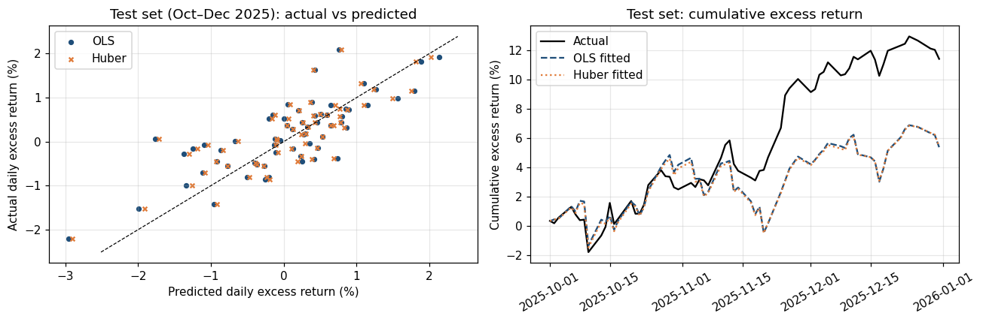Figure 3. Test set (Oct–Dec 2025): actual vs predicted daily excess returns and cumulative excess return

Step 6 – Which factors explain the portfolio, and how
The two estimators tell the same story, which gives us confidence that the results are not caused by a few extreme days.
- Market : By far the most important factor. The portfolio carries roughly the same market risk as the index, a little more because of Tesla, Meta and the two banks. On its own the market explains most of the 82% {R}^2.
- Size : A clear large-cap tilt, which is expected since all ten stocks are mega caps. In a period when small caps lagged (SMB averaged –8% a year), this tilt added about 1.3% a year to returns.
- Value : A moderate value tilt, mainly from Bank of America, Goldman Sachs, Exxon and Walmart. This partly offsets the growth character of the tech names.
- Investment : The portfolio behaves like companies that invest aggressively. That is what we would expect from Alphabet, Meta and Lilly, which are spending heavily on AI data centres and new manufacturing capacity. The Huber estimate is a bit smaller, so some of this loading comes from big move days.
- Profitability : Even though most of the holdings are very profitable, the RMW loading is small and statistically insignificant. Part of the profitability effect is probably already captured through the market factor, given the –0.38 correlation.
- Alpha: 7.3% a year under OLS ($p = 0.17$) and 8.6% under Huber ($p = 0.08$). Neither is significant at 5%, so we cannot claim real stock-picking skill. Most of the excess return is explained by factor exposure.
Table 7. Return attribution of the capped portfolio (training set)
Factor | Beta (OLS) | Avg factor return (ann.) | Contribution (ann.)
Mkt-RF | 1.046 | 17.0% | 17.81%
SMB | -0.157 | -8.1% | 1.26%
HML | 0.202 | 2.4% | 0.49%
RMW | -0.095 | -2.6% | 0.25%
CMA | -0.335 | -5.4% | 1.82%
Alpha | — | — | 7.28%
Total |  |  | 28.92%

Table 7 splits the 28.9% average annual excess return into its sources. The market accounts for 17.8 points. Size (+1.3), investment (+1.8), value (+0.5) and profitability (+0.3) add about 4 points together, and the remaining 7.3 points are unexplained alpha. Interestingly, the negative betas on SMB and CMA helped because those factors themselves had negative returns. A small-cap rebound or a return of “conservative” stocks would hurt the portfolio relative to the market.
Out of sample, the model explains about half of the daily variation (test {R}^2 of 0.47 for OLS and 0.51 for Huber; correlation between predicted and actual returns of about 0.79). The fall from 0.82 is mainly because the portfolio’s big winner in Q4 was healthcare (Lilly and Merck), and its jump was stock-specific rather than factor-driven. Huber does slightly better in the test set, which supports using the robust estimates for risk reporting. On the 80/20 split inside the training window the betas were almost identical and the test {R}^2 was 0.68 for both models, so the factor profile is stable over time.

2.3 Part 3 – Can simulation replace optimisation? (Steps 7–8)
We picked five stocks from five different sectors so the problem is not trivial: GOOG (communication services), LLY (health care), WMT (consumer staples), GS (financials) and XOM (energy). The objective is again the maximum Sharpe ratio with weights summing to one and no short sales. Step 8 adds the cap w_i 0.30.
Simulation design. We draw weights uniformly over the simplex using a Dirichlet distribution with all parameters equal to one, so every long-only fully-invested portfolio is equally likely to be drawn. (The common shortcut of drawing uniform numbers and dividing by their sum is biased towards equal weights and covers the corners poorly, and the optimum is often at a corner.) For each sample size $N$ we keep the simulated portfolio with the best Sharpe ratio and measure the largest absolute gap between its weights and the optimiser’s. Each N is repeated 30 times with different random seeds (10 times for N e 500,000), because a single run can be lucky or unlucky.
For Step 8 the cap makes simulation harder, because a random draw is usable only if all five weights are at or below 0.30. For a uniform draw on the 5-asset simplex the probability of this is:
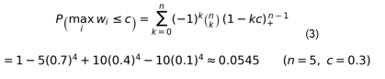
So only about 1 draw in 18 is admissible (we measured 5.49% empirically). We used rejection sampling: draw from the simplex, then throw away any draw that breaks a box constraint. The surviving draws are uniform on the capped region, so Steps 7 and 8 are compared like for like, with NNN counting only feasible portfolios.
Table 8. Optimal weights: optimisation vs best of 1,000,000 simulated portfolios
Stock | Step 7 optimiser | Step 7 simulation | Step 8 optimiser | Step 8 simulation
GOOG | 12.5% | 10.5% | 29.1% | 27.7%
LLY | 0.6% | 1.3% | 10.9% | 12.0%
WMT | 47.5% | 48.8% | 30.0% | 29.9%
GS | 39.3% | 39.3% | 30.0% | 29.7%
XOM | 0.0% | 0.1% | 0.0% | 0.7%
Sharpe ratio | 1.798 | 1.797 | 1.684 | 1.680

Table 9. Convergence of simulation to the optimiser (average over repeated runs)
N (feasible) | Step 7: max weight error | Step 7: Sharpe gap | Step 8: max weight error | Step 8: Sharpe gap | Step 8: raw draws
100 | 13.18% | 0.0760 | 8.87% | 0.0739 | 2,036
500 | 9.42% | 0.0373 | 5.98% | 0.0381 | 10,010
1,000 | 7.08% | 0.0240 | 5.25% | 0.0281 | 20,010
5,000 | 4.83% | 0.0123 | 3.89% | 0.0172 | 100,010
10,000 | 4.31% | 0.0092 | 3.30% | 0.0142 | 200,000
50,000 | 2.93% | 0.0044 | 2.04% | 0.0074 | 928,540
100,000 | 2.64% | 0.0033 | 1.55% | 0.0056 | 1,839,195
500,000 | 2.47% | 0.0020 | 1.15% | 0.0032 | 9,190,413
1,000,000 | 1.81% | 0.0015 | 1.44% | 0.0028 | 18,356,586

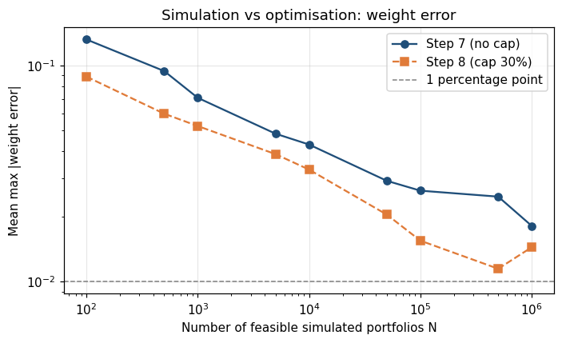
Figure 4. Average largest weight error vs number of simulated portfolios (log–log scale)
Step 7 result. The optimiser puts 47.5% in WMT, 39.3% in GS, 12.5% in GOOG, 0.6% in LLY and nothing in XOM. The Sharpe ratio of the best simulated portfolio gets close quickly (within 0.01 after about 10,000 draws), but the weights converge very slowly. The error shrinks only slowly, roughly in proportion to N^{-0.2}: about 13 percentage points at 100 draws, 4–5 pp at 5,000–10,000, and still 1.8 pp on average at one million. This happens because the Sharpe ratio surface is very flat near the top, so many quite different portfolios score almost the same. In our runs about one million simulations were needed before all five weights were reliably within about 2 pp of the optimiser, and even then only some runs landed within 1 pp.
Step 8 result. With the 30% cap, WMT and GS are both held at exactly 30% and the freed-up weight goes to GOOG (29.1%) and LLY (10.9%). XOM is still zero. Measured per feasible portfolio, the capped problem converges about as fast or slightly faster, because the feasible region is smaller and two weights are pinned at the boundary. But each feasible portfolio costs about 18 raw draws. Getting to roughly 1–1.5 pp accuracy required 500,000 to 1,000,000 feasible portfolios, which is 9 to 18 million random draws. The optimiser gets the exact answer in a fraction of a second. Our conclusion is that simulation is a useful picture of the opportunity set and a sanity check, but it is not a replacement for optimisation. This is especially true with box constraints, where the number of wasted draws grows quickly with the number of assets and the tightness of the cap.

2.4 Part 4 – Black–Litterman (Step 9)

(a) Market portfolio and its Sharpe ratio
Ten stocks are not a market, so we followed the synthetic composite approach. The market is the S&P 500. Our ten stocks enter with their actual index weights on 30 September 2025 (for Alphabet we use only the class C line, since GOOG is the share we hold), and an 11th asset, “REST”, represents the other roughly 490 constituents with weight 1 - sum w_i = 82.2%. The daily return of REST is backed out from the index return:
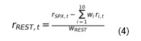
The covariance matrix Sigma is then estimated on all eleven assets. As a check, w^\top \Sigma w reproduces the S&P 500 variance exactly (0.02496 annualised). One limitation is that we hold the September 2025 weights fixed over the whole two years, although index weights drift. Over the sample the S&P 500 earned an excess return of 15.3% a year with 15.8% volatility, so the market Sharpe ratio is 0.97. From this, the risk-aversion coefficient is delta = (E[R_m] - R_f)/\sigma_m^2 = \text{SR}/\sigma_m = 6.13, and the implied equilibrium excess returns are found by reverse optimisation (Black and Litterman; He and Litterman):
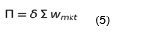
Table 10. Market weights (30 Sep 2025) and equilibrium vs historical excess returns (annualised)
Asset | Market weight | Implied excess return Π | Historical excess return
TSLA | 2.19% | 35.5% | 40.8%
WMT | 0.80% | 8.2% | 28.3%
BAC | 0.63% | 15.1% | 26.7%
GS | 0.43% | 20.1% | 41.9%
LLY | 1.02% | 11.9% | 16.7%
MRK | 0.35% | 4.7% | -14.7%
GOOG | 2.01% | 17.2% | 27.0%
META | 2.84% | 22.5% | 45.4%
AAPL | 6.65% | 18.3% | 13.5%
XOM | 0.86% | 6.4% | -1.9%
REST | 82.24% | 14.4% | 13.4%

The implied returns are much more sensible as forecasts than the historical averages. Merck and Exxon get small positive premia instead of negative ones, and Meta, Goldman and Walmart are pulled down to what their risk justifies. Tesla gets the highest prior (35.5%) only because its beta is very high. Our delta of 6.1 is above the usual 2.5–3.5 range because the 2023–2025 market Sharpe ratio was unusually high. We kept it so that the prior is internally consistent with the data, but note that it makes the implied premia relatively generous.

(b) Choice of tau
tau measures how uncertain we are about the equilibrium mean, through Pi sim N(mu, tau \Sigma). If means are estimated from $T$ observations, the covariance of the sample mean is \Sigma, so we set tau = 1/T = 1/521 = 0.00192$. This choice is consistent with the data frequency. With daily data, tau Sigma is the variance of an estimated daily mean. A value like 0.025–0.05, often quoted for monthly or annual data (Walters), would be far too large here and would make the prior almost meaningless. All inputs (Pi, Q,Omega) are kept in daily units and only annualised for presentation.

(c) Views: P, Q and Omega
We took the role of the portfolio manager on 30 September 2025 and wrote four views:
- View 1 (relative, high confidence): LLY will outperform MRK by 8% a year. Lilly’s GLP-1 drugs (Mounjaro, Zepbound) are still growing very fast, while Merck faces the loss of exclusivity on Keytruda from 2028.
- View 2 (absolute, medium confidence): XOM will earn 0% over cash. OPEC+ has been unwinding production cuts through 2025 and Brent is trading in the mid-$60s, which squeezes upstream earnings.
- View 3 (relative, medium confidence): GOOG will outperform META by 5% a year. The September 2025 search antitrust remedy turned out much milder than feared (no forced sale of Chrome), and Google Cloud and Gemini are monetising AI, while Meta keeps raising its capex guidance without a matching revenue line.
- View 4 (relative, low confidence): an equal-weighted pair of BAC and GS will outperform the rest of the market by 3% a year. This rests on a steeper yield curve, lighter capital rules (the proposed eSLR changes) and a recovery in M&A and IPO activity.
Table 11. Pick matrix P (columns with non-zero entries; all other assets are 0)
View | BAC | GS | LLY | MRK | GOOG | META | XOM | REST
V1: LLY - MRK | 0 | 0 | 1 | -1 | 0 | 0 | 0 | 0
V2: XOM | 0 | 0 | 0 | 0 | 0 | 0 | 1 | 0
V3: GOOG - META | 0 | 0 | 0 | 0 | 1 | -1 | 0 | 0
V4: Banks - REST | 0.5 | 0.5 | 0 | 0 | 0 | 0 | 0 | -1

Each row of P is one view, and every asset not shown in the table has a zero in that row. The view vector is:
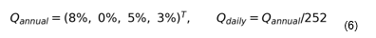
Uncertainty Omega. We start from He and Litterman’s rule, which sets each view's variance equal to the prior variance of the same portfolio, and then scale it by a confidence multiplier c_k: 0.5 for high confidence (half the variance), 1 for medium and 2 for low. Omega is diagonal, so the views are treated as independent.
Table 12. Views, the equilibrium value of each view, and view uncertainty
View | Q (ann.) | Prior PΠ (ann.) | ck | Ωkk (daily) | View st. dev. (ann.)
V1: LLY - MRK | 8.0% | 7.2% | 0.5 | 4.89e-07 | 17.6%
V2: XOM | 0.0% | 6.4% | 1.0 | 3.76e-07 | 15.5%
V3: GOOG - META | 5.0% | -5.3% | 1.0 | 8.94e-07 | 23.8%
V4: Banks - REST | 3.0% | 3.2% | 2.0 | 4.84e-07 | 17.5%

(d) Posterior mu_{BL} and Sigma_{BL}
Using the canonical Black–Litterman formulas (Walters):
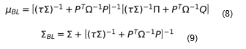
Table 13. Prior and posterior expected excess returns and volatilities (annualised)
Asset | Prior Π | μBL | Change | σ prior | σ posterior
TSLA | 35.54% | 34.79% | -0.74% | 62.91% | 62.97%
WMT | 8.23% | 7.72% | -0.51% | 21.15% | 21.17%
BAC | 15.14% | 13.73% | -1.41% | 25.60% | 25.62%
GS | 20.10% | 18.63% | -1.47% | 28.31% | 28.33%
LLY | 11.90% | 11.46% | -0.44% | 35.23% | 35.25%
MRK | 4.74% | 3.99% | -0.75% | 24.20% | 24.22%
GOOG | 17.17% | 18.68% | 1.50% | 29.57% | 29.60%
META | 22.51% | 18.84% | -3.67% | 36.18% | 36.20%
AAPL | 18.34% | 17.50% | -0.84% | 27.71% | 27.74%
XOM | 6.36% | 3.15% | -3.21% | 22.22% | 22.23%
REST | 14.44% | 13.57% | -0.87% | 15.10% | 15.12%

Table 14. Posterior covariance matrix Sigma_{BL} (annualised, times 100$)
 | TSLA | WMT | BAC | GS | LLY | MRK | GOOG | META | AAPL | XOM | REST
TSLA | 39.65 | 3.45 | 5.67 | 7.71 | 3.04 | 0.64 | 7.15 | 7.69 | 7.70 | 1.29 | 4.78
WMT | 3.45 | 4.48 | 1.45 | 1.67 | 1.43 | 0.53 | 1.07 | 1.97 | 1.78 | 0.34 | 1.22
BAC | 5.67 | 1.45 | 6.57 | 5.61 | 1.38 | 0.75 | 1.92 | 2.69 | 2.42 | 2.11 | 2.39
GS | 7.71 | 1.67 | 5.61 | 8.02 | 2.03 | 0.78 | 3.01 | 3.97 | 3.19 | 2.15 | 3.17
LLY | 3.04 | 1.43 | 1.38 | 2.03 | 12.43 | 2.72 | 1.34 | 3.52 | 1.62 | 0.44 | 1.79
MRK | 0.64 | 0.53 | 0.75 | 0.78 | 2.72 | 5.87 | 0.11 | 0.34 | 1.03 | 0.62 | 0.75
GOOG | 7.15 | 1.07 | 1.92 | 3.01 | 1.34 | 0.11 | 8.76 | 5.06 | 3.74 | 0.35 | 2.47
META | 7.69 | 1.97 | 2.69 | 3.97 | 3.52 | 0.34 | 5.06 | 13.11 | 4.08 | 0.62 | 3.25
AAPL | 7.70 | 1.78 | 2.42 | 3.19 | 1.62 | 1.03 | 3.74 | 4.08 | 7.70 | 1.19 | 2.50
XOM | 1.29 | 0.34 | 2.11 | 2.15 | 0.44 | 0.62 | 0.35 | 0.62 | 1.19 | 4.94 | 1.01
REST | 4.78 | 1.22 | 2.39 | 3.17 | 1.79 | 0.75 | 2.47 | 3.25 | 2.50 | 1.01 | 2.29

The posterior moves most where our views disagree with equilibrium. The market-implied GOOG – META spread is –5.3%, and our +5% view pulls it to about –0.2%: Alphabet’s expected excess return rises by 1.5 points and Meta’s falls by 3.7 points. The XOM view cuts Exxon’s premium from 6.4% to 3.2%. Views 1 and 4 hardly move anything, because the market was already pricing roughly what we believed (7.2% for LLY – MRK and 3.2% for banks vs the rest). This is a useful property of the model: a view only changes the answer if it is actually different from what the market already implies. Because tau is small, Sigma_{BL} is only slightly larger than Sigma (volatilities rise by 0.02–0.06 pp).

Optimal Black–Litterman weights
We computed the optimal weights in two ways. (i) The unconstrained BL portfolio over all 11 assets, $w^* = (delta Sigma_{BL})^{-1} mu_{BL}, normalised to sum to one. This shows the pure tilts the views create relative to the market. (ii) The maximum-Sharpe portfolio on the ten investable stocks using $mu_{BL}$ and $Sigma_{BL}$, under the same constraints as Part 1 (long-only, and long-only with the 15% cap). For reference, we also show the “prior-only” portfolio (Pi, no views), which separates the effect of the equilibrium prior from the effect of our views.

Table 15. Unconstrained Black–Litterman weights over the 11-asset market
Asset | Market weight | BL unconstrained | Tilt vs market
TSLA | 2.19% | 2.44% | 0.25%
WMT | 0.80% | 0.89% | 0.09%
BAC | 0.63% | 1.25% | 0.63%
GS | 0.43% | 1.03% | 0.60%
LLY | 1.02% | 2.65% | 1.63%
MRK | 0.35% | -1.13% | -1.48%
GOOG | 2.01% | 10.25% | 8.24%
META | 2.84% | -4.84% | -7.68%
AAPL | 6.65% | 7.42% | 0.77%
XOM | 0.86% | -10.64% | -11.49%
REST | 82.24% | 90.67% | 8.43%

Table 16. Constrained weights. Left: long-only. Right: long-only with 15% cap
Stock | Part 1 Step 1 | Prior only | BL | Part 1 Step 2 | Prior only | BL
TSLA | 0.0% | 4.5% | 5.1% | 1.6% | 4.9% | 6.5%
WMT | 43.7% | 7.2% | 8.1% | 15.0% | 8.5% | 12.1%
BAC | 0.0% | 5.8% | 5.1% | 15.0% | 10.6% | 13.6%
GS | 34.7% | 22.2% | 23.4% | 15.0% | 15.0% | 15.0%
LLY | 0.0% | 5.7% | 8.2% | 14.4% | 5.8% | 8.3%
MRK | 0.0% | 5.2% | 3.1% | 0.0% | 6.0% | 6.2%
GOOG | 4.9% | 12.2% | 23.9% | 15.0% | 13.5% | 15.0%
META | 16.7% | 12.9% | 3.8% | 15.0% | 13.3% | 8.3%
AAPL | 0.0% | 18.6% | 19.2% | 4.1% | 15.0% | 15.0%
XOM | 0.0% | 5.7% | 0.0% | 4.9% | 7.4% | 0.0%

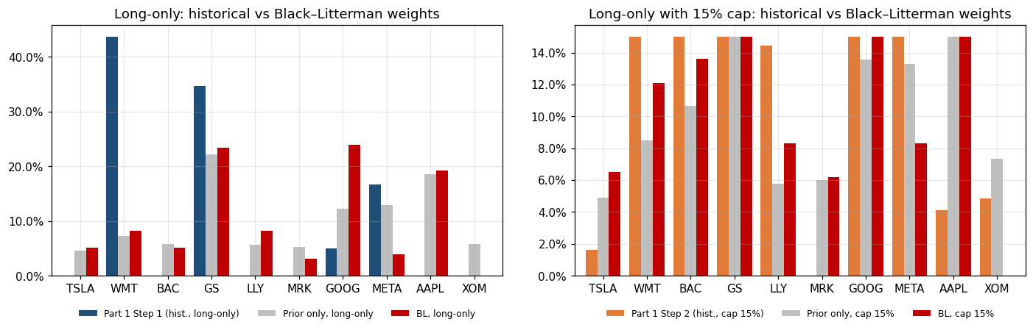Figure 5. Historical (Part 1), prior-only and Black–Litterman weights

(e) Black–Litterman vs Part 1
The differences are large. The Part 1 long-only portfolio was 78% in two stocks (WMT and GS), while the BL long-only portfolio holds nine names, with the largest positions in Alphabet (23.9%), Goldman (23.4%) and Apple (19.2%). Most of this change comes from replacing noisy historical means with equilibrium returns, not from our views: the total absolute weight change between Part 1 and BL is 1.19 (long-only), but between the prior-only portfolio and BL it is only 0.35. The views still matter where they disagreed with the market. View 3 had the biggest effect, doubling GOOG (12.2% ->23.9%) and cutting META from 12.9% to 3.8%. View 2 removed Exxon completely (5.7% -> 0%). View 1 moved LLY up (5.7% ->8.2%) and MRK down (5.2% -> 3.1%), while View 4 had almost no impact because it agreed with the prior. In the unconstrained 11-asset solution (Table 15), the views show up as clean long/short tilts around the market weights: +8.2 pp GOOG against –7.7 pp META, –11.5 pp XOM, and +1.6 pp LLY against –1.5 pp MRK.
Do weights change more or less with constraints? Less. With the 15% cap, the total weight change caused by the views falls from 0.35 to 0.25, and the change versus Part 1 falls from 1.19 to 0.44. The cap is already binding for GS, GOOG and AAPL in the BL portfolio, so the extra conviction in Alphabet cannot be expressed beyond 15%, and the optimiser has to spread the remaining weight elsewhere. Constraints therefore make the final portfolio more robust but also hide part of the manager’s views. With no constraints at all, the views are expressed in full, including short positions in META, MRK and XOM. Under the BL inputs, both BL portfolios have a higher expected Sharpe ratio (0.85 and 0.84) than the Part 1 portfolios evaluated on the same inputs (0.72 and 0.80).
Table 17. Out-of-sample check including the BL portfolios, Oct–Dec 2025
Portfolio | Cumulative return | Sharpe ratio (ann.) | Max drawdown
Part 1 Step 1: long-only | 6.87% | 1.51 | -5.02%
Part 1 Step 2: cap 15% | 13.09% | 3.42 | -2.97%
BL long-only | 15.43% | 3.38 | -4.09%
BL cap 15% | 12.98% | 3.16 | -3.69%
S&P 500 | 2.35% | 0.39 | -5.11%

As an extra check, we ran the BL portfolios through the same out-of-sample quarter. The BL long-only portfolio returned 15.4% (Sharpe 3.38), the best of all, helped by being overweight Alphabet and underweight Meta, exactly as View 3 intended. The capped BL portfolio returned 13.0%, almost the same as the Part 1 capped portfolio. The Exxon view was wrong in this quarter (XOM rose 6.7%), but the position was small, so it did little damage.

2.5 Summary of key results and recommended course of action
- The unconstrained mean-variance portfolio is concentrated (four stocks, 78% in WMT and GS) and has the best in-sample Sharpe ratio (1.86), but it under-performed out of sample (6.9% vs 13.1% for the capped portfolio).
- The 15% cap shortens the efficient frontier and lowers the in-sample Sharpe ratio to 1.57, but it diversifies estimation risk and was the better portfolio in the test quarter (Sharpe 3.42, drawdown –3.0%).
- The capped portfolio is a market-like (beta approx 1.05) large-cap portfolio with a value tilt and an aggressive-investment tilt. Alpha is not significant, so its excess return is mostly explained by factors.
- Simulation reaches the optimal Sharpe ratio quickly but the optimal weights only very slowly (about $10^6$ portfolios for ~2 pp accuracy, and 18 times more raw draws with a 30% cap). Optimisation should be used.
- Black–Litterman produces diversified, intuitive weights and lets the manager express views in a controlled way. Constraints dampen the effect of views.
Recommendation. We recommend that the client hold the Black–Litterman portfolio with the 15% cap, or, if the manager prefers not to rely on views, the Part 1 capped portfolio, which is very close. It respects the client’s limit, holds nine of the ten stocks, has better-grounded expected returns than the purely historical portfolio, and expresses the GOOG-over-META and underweight-energy views in moderate size. The concentrated unconstrained portfolio should not be used. The portfolio should be reviewed quarterly: re-estimate Sigma, update the market weights and revisit each view, and in particular the Exxon view, which did not work in Q4 2025. Factor exposures should be monitored as well, especially the negative size and investment loadings, which would hurt if small caps or low-investment “value” stocks start to lead.

3. Non-technical report

What we found
We were asked to build the best mix of ten large US companies for the client, using their performance between September 2023 and September 2025, and then to check how it held up in the last three months of 2025.
If we simply chase the best past results, the recommended mix puts almost 80% of the money into just two companies, Walmart and Goldman Sachs. On paper this looked like the best trade-off between return and risk. But it is fragile: it depends heavily on two years of past returns repeating, and they rarely do. When the client asked that no company make up more than 15% of the portfolio, the money was spread across nine companies. On past data this looked slightly less attractive. In the following three months, however, the spread-out portfolio gained about 13%, almost double the concentrated one (about 7%), and its worst dip was only 3% compared with 5%. Over the same period the S&P 500 rose only about 2%. The concentrated portfolio missed the big gains in Eli Lilly, Merck and Alphabet and was hurt by a fall in Meta.
We also checked what really drives the client’s portfolio. Most of its ups and downs follow the overall stock market, slightly more than one-for-one. Beyond that, it behaves like a portfolio of very large companies, with a mild preference for cheaper “value” companies such as the banks, and a tilt towards companies that are investing heavily in growth, such as the tech firms building AI infrastructure. After accounting for these drivers, there is no reliable evidence of extra return beyond what the market and these styles explain.
Finally, we combined the market’s own pricing with a few of our own opinions: Eli Lilly should do better than Merck, oil companies will struggle with weak oil prices, Alphabet should do better than Meta, and the big banks should do slightly better than the market. This produced a balanced portfolio that leans more towards Alphabet and less towards Meta and Exxon, without making any big bets. In the test quarter this approach also performed well.

What we recommend
- Invest in the diversified portfolio that respects the 15% limit, adjusted for our market views. In practice this is roughly 15% each in Goldman Sachs, Alphabet and Apple, 12–14% in Walmart and Bank of America, about 8% in each of Eli Lilly and Meta, 6–7% in Tesla and Merck, and no Exxon.
- Avoid the concentrated two-stock portfolio. It looked best on past data but it is the most exposed to a single disappointment.
- Review the portfolio every quarter, and revise our views when the facts change. For example, if oil prices recover, the zero weight in Exxon should be reconsidered.

What will drive each portfolio
- All portfolios: the direction of the overall US stock market is the dominant risk. A 10% market fall would be expected to cost the portfolio about 10–11%.
- Concentrated portfolio (Part 1, no limit): the fortunes of Walmart (consumer spending, tariffs on imported goods) and Goldman Sachs (deal-making and trading activity, interest rates). A setback at either company would hit the whole portfolio.
- 15%-limit portfolio: a broad mix of drivers. Bank profits and interest rates (BAC, GS), technology and AI spending (GOOG, META), drug approvals and pricing (LLY), and consumer demand (WMT). It would underperform if smaller companies, or companies that invest less, start to lead the market.
- Views-based portfolio: in addition to the above, it is sensitive to how Alphabet's AI and cloud business performs relative to Meta's, to oil prices (through the decision not to hold Exxon), and to the regulatory backdrop for banks.

4. Conclusion
This project showed us, with real numbers, how sensitive mean-variance optimisation is to its inputs. The “best” historical portfolio was the most concentrated and the least robust. A simple weight cap traded a little in-sample efficiency for a lot of out-of-sample stability. The factor regression confirmed that the client is mostly buying market exposure with a large-cap, value and high-investment flavour, and that the robust and OLS estimates agree. Random simulation can approximate the optimum only at great computational cost, and much more so with box constraints, so it is best used as an illustration. Black–Litterman gave the most usable framework: it starts from the market, changes only what our views genuinely disagree with, and stays well diversified, particularly under the client's 15% limit. Two practical takeaways stand out. Estimation error, more than the choice of model, is the real enemy, so diversification constraints are worth their cost. And views should be few, clearly argued and sized according to confidence.

References
Black, Fischer, and Robert Litterman. “Global Portfolio Optimization.” Financial Analysts Journal, vol. 48, no. 5, 1992, pp. 28–43.
Fama, Eugene F., and Kenneth R. French. “A Five-Factor Asset Pricing Model.” Journal of Financial Economics, vol. 116, no. 1, 2015, pp. 1–22.
French, Kenneth R. “Data Library: Fama/French 5 Factors (2x3) [Daily].” Tuck School of Business at Dartmouth, mba.tuck.dartmouth.edu/pages/faculty/ken.french/data_library.html. Accessed 30 Oct. 2026.
He, Guangliang, and Robert Litterman. “The Intuition Behind Black-Litterman Model Portfolios.” Goldman Sachs Investment Management Research, 1999.
Huber, Peter J. “Robust Estimation of a Location Parameter.” The Annals of Mathematical Statistics, vol. 35, no. 1, 1964, pp. 73–101.
Jagannathan, Ravi, and Tongshu Ma. “Risk Reduction in Large Portfolios: Why Imposing the Wrong Constraints Helps.” The Journal of Finance, vol. 58, no. 4, 2003, pp. 1651–1683.
Markowitz, Harry. “Portfolio Selection.” The Journal of Finance, vol. 7, no. 1, 1952, pp. 77–91.
Michaud, Richard O. “The Markowitz Optimization Enigma: Is ‘Optimized’ Optimal?” Financial Analysts Journal, vol. 45, no. 1, 1989, pp. 31–42.
Newey, Whitney K., and Kenneth D. West. “A Simple, Positive Semi-Definite, Heteroskedasticity and Autocorrelation Consistent Covariance Matrix.” Econometrica, vol. 55, no. 3, 1987, pp. 703–708.
Sharpe, William F. “Mutual Fund Performance.” The Journal of Business, vol. 39, no. 1, 1966, pp. 119–138.
Walters, Jay. “The Black-Litterman Model in Detail.” SSRN Electronic Journal, revised 20 June 2014, ssrn.com/abstract=1314585.

