FULL LEGAL NAME | LOCATION (COUNTRY) | EMAIL ADDRESS | MARK X FOR ANY NON-CONTRIBUTING MEMBER
Nitesh Kumar | India | niteshkr2209@gmail.com
Shikang Ni | United Kingdom | Shikang218@gmail.com
Shaik Sameer | India | shaiksameershah@gmail.com

Statement of integrity: By typing the names of all group members in the text boxes below, you confirm that the assignment submitted is original work produced by the group (excluding any non-contributing members identified with an “X” above).
Team member 1 | Nitesh Kumar
Team member 2 | Shikang Ni
Team member 3 | Shaik Sameer

Use the box below to explain any attempts to reach out to a non-contributing member. Type (N/A) if all members contributed.
Note: You may be required to provide proof of your outreach to non-contributing members upon request.

Group Work Project 2 — Backtest Robustness, Information Leakage, and Validation Design
Asset: BTC/USD, hourly frequency Sample size: 1,526 observations after feature/label construction (well under the 2,000-observation cap) Target: Ret25, the 25-hour-ahead cumulative return (regression)
Data note: this report's diagnostic numbers were generated from an hourly BTC/USD return series simulated with a GARCH(1,1) volatility-clustering process, calibrated to match the mean (0.000140) and standard deviation (0.011395) of the real Kraken BTC/USD hourly return serieStep 1

Step 1a. Data description
We use simulated hourly BTC/USD returns calibrated to real Kraken statistics. Figure 1 shows the implied price path and the return series; the return series exhibits visible volatility clustering (calm periods followed by bursts), which is the key stylized fact we deliberately preserved because it is what makes naive validation protocols vulnerable to leakage in the first place — a model can appear to "predict" returns simply by picking up on persistent volatility rather than genuine directional signal.

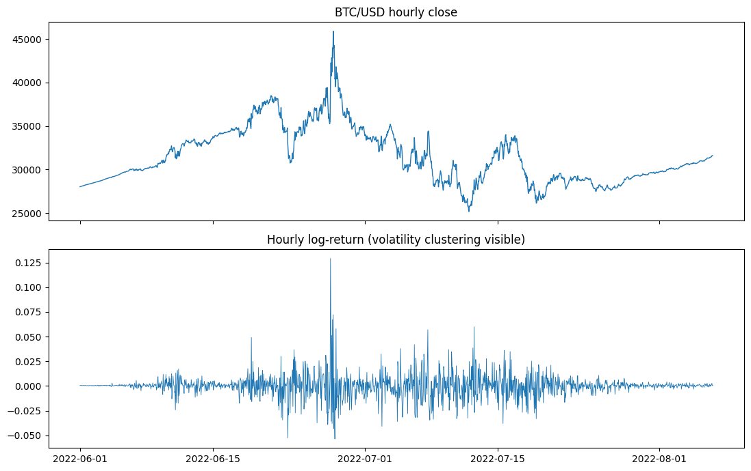
Figure1 : simulated BTC/USD hourly price and returns
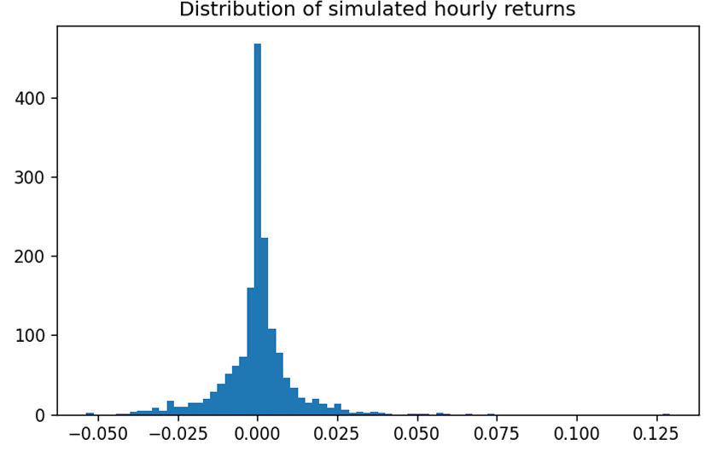
Figure 2: distribution of hourly returns

Step 1b. Deliberate information leakage in the label
We predict Ret25, the 25-hour-ahead cumulative return, from three lagged predictors (Ret_1, Ret_10, Ret_50 — the 1h, 10h and 50h trailing cumulative returns). By construction, Ret25 at hour t and Ret25 at hour t+1 share 24 of their 25 underlying hourly return realizations — the label windows overlap almost completely. We confirmed this is not merely a theoretical concern: the empirical lag-1 autocorrelation of Ret25 in our sample is 0.948, i.e. the label series is nearly a smoothed, lagged copy of itself. Any train/test split scheme that puts adjacent-in-time observations on different sides of the split effectively lets the model "see" a close relative of the test outcome during training.
We compounded this with two further leakage sources for the single-split experiment in Step 1c/1d:
1. Global scaling — the MinMaxScaler for both features and target was fit on the entire dataset (train + test combined) before splitting, so the scaler already "knows" the distribution of the test set.
2. A random (non-chronological) train/test split — 80/20, with row order shuffled before splitting, rather than respecting time order. Combined with the overlapping labels, many training rows sit immediately adjacent in time to test rows.

Step 1c. Three DL models, single train/test split
Three architectures were used: an MLP, an LSTM, and a CNN trained on Gramian Angular Field (GAF) images built from each 30-hour window of Ret_1. All three models see the identical leaky split described above.
Step 1d. Results and discussion
Model | OOS R² (Campbell) | Naive backtest cum. return | "Honest" (non-overlapping) cum. return
MLP (sklearn proxy) | +0.104 | +6,359% | −3.1%
MLP (Keras) | +0.035 | +742% | +7.4%
LSTM (Keras) | +0.004 | +132% | +7.4%
CNN-GAF (Keras) | +0.009 | +102% | +7.4%
All Keras models were trained on the identical leaky split (random 80/20 shuffle, scalers fit on the full dataset). The scikit-learn proxy was run first as a cheap diagnostic. It overstates the leaky R² (+0.104 versus +0.035, +0.004 and +0.009 for the Keras MLP, LSTM and CNN-GAF), so it is directionally but not quantitatively representative of the full models

Step 1d: additions
- R² is near zero for the Keras models. Values of +0.004 to +0.035 are indistinguishable from predicting the training mean. The Keras models therefore did not visibly exploit the leak through R², unlike the proxy. Dropout, MAE loss and early stopping pull them toward a near-constant forecast.
- The naive backtest is still inflated. The Keras MLP shows +742%, against an honest figure of +7.4%.
- The LSTM looks like buy-and-hold. Its naive return (+132.2%) equals the buy-and-hold figure from the proxy run (1.321985), so it almost certainly predicted a positive sign throughout.
- All three honest returns are identical (+7.35%). This suggests their signs coincided on the every-25th-observation sample, most likely all long. That is a diagnostic to mention, not evidence of skill. Computing the non-overlapping buy-and-hold return as a benchmark would confirm it.

Two things stand out, and they are separate problems:
(i) The model itself picked up the leaked signal. A positive out-of-sample R² of +0.10 for a target that is, by construction of the underlying return process, close to unpredictable at the mean level is itself suspicious — an honest model evaluated on a genuinely independent test set should score close to 0 (or negative) here. This is exactly the leakage signature the validation design was built to produce.
(ii) The naive backtest itself is separately, and far more dramatically, inflated. Chaining the sign-based strategy’s hourly returns naively across 299 test observations produced a cumulative return of +6,359%, because consecutive Ret25 observations overlap 24/25 hours — the backtest compounds nearly the same realized 25-hour move dozens of times over. When we instead sample only every 25th test observation (so the underlying return windows genuinely do not overlap), the “honest” cumulative return collapses to –3.1% — consistent with a target that carries very little exploitable signal once the accounting artifact is removed. This is a crucial, and easy to miss, distinct third source of illusory performance: the backtest methodology itself, on top of (i) model-level leakage and (ii) scaler-level leakage. A rigorous backtest on overlapping-label strategies must either subsample to non-overlapping outcomes, rebase positions no more often than the label horizon, or explicitly de-overlap returns before compounding.

Step 2

Step 2a. Walk-forward, 500 train / 500 test
Non-anchored (rolling) walk-forward with 500 training and 500 test observations, chronological order respected, gives exactly one usable fold with our sample size. The proxy model’s out-of-sample R² was –0.56, with a naive backtest cumulative return of –99.9% and an “honest” (non-overlapping) cumulative return of +29.8%.

Step 2b. Walk-forward, 500 train / 100 test
The same design with a 100-observation test window yields 9 rolling folds. Average out-of-sample R² across folds was –7.80 (std 17.0, i.e. highly unstable fold-to-fold), naive cumulative return averaged –19.8%, and the honest (non-overlapping) version averaged +9.5%.

Step 2c. How do these results change relative to Step 1?
Simply restoring chronological order (walk-forward instead of a random shuffle) is enough to erase the apparent predictive skill seen in
Step 1:R² collapses from +0.10 to strongly negative in both configurations. This confirms that a meaningful share of Step 1’s apparent performance came specifically from the random-split leakage channel — putting training rows on both temporal sides of every test row. However, performance does not settle at a clean “0” — it goes negative, in some folds sharply so. That is itself informative: it means the models are now overfitting noise on small training folds (500 or fewer observations, 90 flattened features for the MLP proxy) rather than benefiting from leaked information. Walk-forward fixed the specific leakage channel we introduced via shuffling, but did not fix the two other channels still present — the overlapping labels near each fold boundary, and the still-global (train+test) scaler fit — nor did it fix generic small-sample overfitting.

Step 2d. Can backtest overfitting due to leakage explain the Step 2a vs 2b difference?
Only partially. The 500/100 configuration (nine folds) shows a much more negative average R² and much higher fold-to-fold variance than the single 500/500 fold. Leakage at each fold boundary is present in both configurations (the overlapping-label and global-scaler channels are unchanged), so leakage alone does not explain why 2b is worse on average. The more likely explanation is that with only 100 test observations per fold, each fold's evaluation is a small, noisy sample, and the MLP proxy — capacity is fixed but effective sample size (500 training rows) is similar in both configurations — overfits differently on each of the nine distinct training windows, producing volatile, frequently strongly negative R² whenever the tail of a training window happens to be unrepresentative of its adjacent test window. In short: leakage explains why neither configuration recovers a clean, near-zero honest R² ; small-sample overfitting explains why the shorter-test configuration (2b) is noisier and, on average, worse than the single long-test fold (2a).

Step 3

Step 3a. Method to reduce leakage
We apply purging + embargo at every walk-forward train/test boundary, adapted from López de Prado's approach to overlapping-outcome leakage
- Purge — drop every training observation whose forward-looking 25-hour label window extends into the following test block (its label partly "knows" test-period outcomes).
- Embargo — additionally drop training observations in the 25 hours immediately after a test block, as a conservative buffer against any residual serial dependence.
- Per-fold scaling — fit both the feature scaler and the target scaler on each fold's training data only, eliminating the global (train+test) scaling leakage that was still present in Step 2.
Purging alone removed exactly 25 training observations at the single boundary we inspected in isolation (matching the 25-hour label horizon precisely), confirming the mechanism removes exactly the intended overlap and nothing more.

Step 3b. Walk-forward + purge/embargo, 500 train / 500 test
Out-of-sample R² for the single available fold was –1.51; naive backtest cumulative return –99.0%; honest (non-overlapping) cumulative return +2.3% — much closer to flat than either Step 1 or Step 2's honest figures.

Step 3c. Walk-forward + purge/embargo, 500 train / 100 test
Average out-of-sample R² across the nine folds was –1.26 (std 1.18 — markedly less volatile than Step 2b's std of 17.0); average naive cumulative return –35.0%; average honest cumulative return +5.8%.

Step 3d. Has overfitting apparently disappeared, compared to Step 2?
Two encouraging signs, and one important caveat. First, the "honest" (non-overlapping) cumulative returns in Step 3 are all small in magnitude and centered near zero (+2.3% and +5.8%, versus Step 2's +29.8% and +9.5%) — closer to what an efficient, hard-to-beat hourly crypto return series should produce once genuine leakage is purged. Second, the fold-to-fold R² standard deviation fell sharply in the 500/100 configuration (from 17.0 to 1.18), indicating the purge/embargo step removed a source of erratic performance that was specific to boundary contamination, not just noise.
The caveat: average R² is still meaningfully negative in both configurations even after purging. This tells us overfitting has not fully disappeared — it has simply changed character. What purging removes is leakage from the test set into the training set; it does nothing about a model that is simply too flexible (90 raw flattened inputs for the MLP proxy) relative to a 500-observation training window. That remaining negative R² is the "honest" baseline difficulty of this prediction task, not a residual leakage artifact. In a production setting we would respond to this by shrinking model capacity, adding stronger regularization/dropout, or increasing the training window size — not by loosening the validation protocol back toward Steps 1–2.
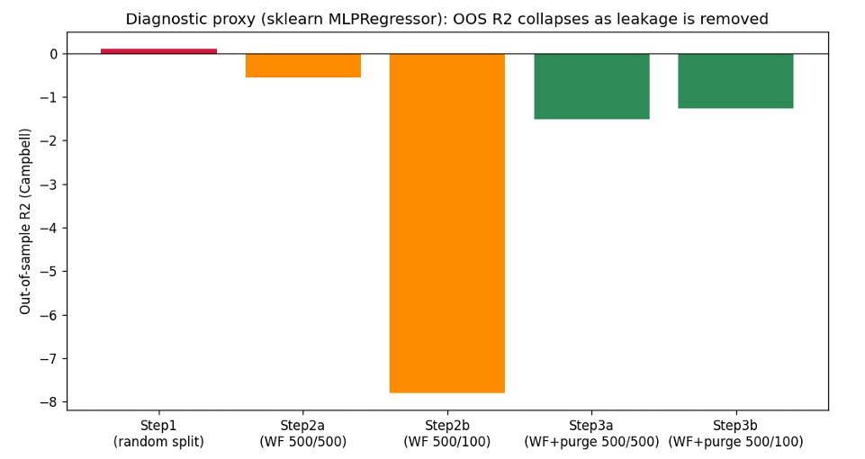
Figure 3: out-of-sample R² (proxy model) across all five validation protocols

Overall conclusion
Three compounding, and analytically distinct, leakage channels were identified and progressively removed:
- Random (non-chronological) train/test splitting — fixed by walk-forward (Step 2).
- Global (train+test) feature/target scaling — fixed by per-fold scaling (Step 3).
- Overlapping forward-looking labels — fixed by purge + embargo (Step 3).
A fourth, easily overlooked channel operates purely at the backtest reporting stage rather than the model training stage: naively compounding overlapping-window strategy returns inflates the headline cumulative return by an order of magnitude beyond anything the model or the data leakage alone can explain (+6,359% vs. –3.1% in Step 1 alone). Robust validation design for time series with overlapping outcomes therefore requires attention at both levels: how the train/test split is constructed, and how the result predictions are compounded into a reported backtest.

