1. INTRODUCTION

**1.1 MOTIVATION**

The inspiration for this project came from the existing Google Fitness Tracker that user can use to track his/her daily physical activities and food intake to maintain a healthy life.

**1.2 PROBLEM STATEMENT**

For this project we make a program that gives user access to his/her current fitness state as well as track his/her daily intake of calories in order to maintain a healthy life. It also provides an interface for calculating BMI and provide related websites and ways to get into proper shape.

**1.3 OBJECTIVES**

With this program we hope to provide an easy and convenient interface to track and manage user daily calorie intake and daily food habits. It also helps the user to plan a diet according to his present state in order to get to a proper healthy body shape by giving information about the required intake or reduction of calories.

**1.4 BASIC FEATURES**

This project is basically divided into three parts:

* User’s personal information
* BMI Calculator
* Calorie tracker
* Result and related websites

While the user can perform various operations based on the choice of input given, the security of the data is ensured. Access to any of the operation is granted only proper input is given.

The source code is well organized as it is divided into multiple modules. Comments have been used to make the objective of the code clear to the user.

1. SYSTEM ANALYSIS

**2.1 EXISTING SYSTEM**

The idea behind our project originated from the currently existing Google Fitness Tracker, in which the user can check his day to day activity. But, in the existing system there is no suggestions on how to get to desired body shape and it does not maintain a daily calorie intake record.

* 1. **PROPOSED SYSTEM**

1. In our proposed application of fitness tracking software, we have proposed some added functionality related to calorie intake.
2. In our application, user can calculate his/her BMI and get to the desired body shape.
3. User can also calculate the daily calorie intake using the calorie chart per serving.
4. The result is displayed and the required reduction or intake of calories is displayed along with the websites which are helpful to get to a required body state.
5. REQUIREMENT SPECIFICATIONS
   1. **SOFTWARE REQUIREMENTS**

**3.1.1. NetBeans:**

NetBeans is a software development platform written in Java. The NetBeans Platform allows applications to be developed from a set of modular software components called modules. Applications based on the NetBeans Platform, including the NetBeans integrated development environment (IDE), can be extended by third party developers.

The NetBeans IDE is primarily intended for development in Java, but also supports other languages, in particular PHP, C/C++ and HTML5. NetBeans is cross-platform and runs on Microsoft Windows, macOS, Linux, Solaris and other platforms supporting a compatible JVM. The editor supports many languages from Java, C/C++, XML and HTML, to PHP, Groovy, Javadoc, JavaScript and JSP. Because the editor is extensible, you can plug in support for many other languages.

**3.1.2. Text Editor:**

A text editor is a type of program used for editing plain text files. Such programs are sometimes known as "notepad" software, following the Microsoft Notepad.

Text editors are provided with operating systems and software development packages, and can be used to change configuration files, documentation files and programming language source code.

* 1. **HARDWARE REQUIREMENTS**

1. 8GB DDR4 RAM
2. 50GB free HDD space
3. 7th gen i5 CPU
4. Necessary Input and Output Devices

**4.SYSTEM IMPLIMENTATION**

**4.1 Jpalette implimentation:**

**4.1.1 Personal Information:**

Personal Information: This lets the user to input his personal information.

It has six input fields and 2 buttons:

Fields and Text Fields:

**1**. **Name**:

It takes the user’s name as input.

**2. Age**:

It takes user’s age as input.

**3**.**Male/Female**:

It contains 2 radio buttons from which the user needs to select his/her gender.

**4**.**Email Id**:

It takes user’s e-mail id as input.

**5**.**Occupation**:

It takes user’s occupation as input.

**6**.**Address**:

It takes user’s address as input.

**4.1.2 BMI Calculator:**

BMI calculator calculates the BMI of the user, using the details about height and weight by using the formula BMI=(weight)/(height*height)

It has three fields:

1. **Weight:**

It takes user’s weight as input.

1. **Height:**

It takes user’s height as input.

1. **BMI:**

It displays the calculated BMI.

**4.1.3 Calorie Tracker:**

Calorie Tracker is the Jplaette which displays the calorie chart for daily meals and calculate the daily calorie intake.

1. **Meals of the day (JPalette):**

It displays the various meals of the day in the form of Radio Buttons and when selected displays the calorie chart per serving for the selected meal.

1. **Calorie intake per item:**

It takes the calorie per serving as the input.

1. **No of items:**

It takes the no. of servings.

1. **Total Calories:**

It displays the total calorie of the day.

* + 1. **Result:**

Result displays the present body state and the calorie intake or reduction. It also displays the related websites.

It consists of one JPalette:

1.**Related Websites:**

It consists of three checkboxes which contains the link to the selected activity i.e. Workout, Planned Diet and yoga.

* + 1. **Your Information:**

It consists of a JTextArea which displays the saved data.

* 1. **JButton implimentation:**
     1. **Result:**

It calculates the result by taking various JPalette’s information and displays the result in the Result JPalette.

* + 1. **Clear:**

It clears all the fields and text areas present in the frame.

* + 1. **Save Data:**

It saves all the data entered by the user in a file which is present in the project folder.

* + 1. **Display:**

It displays the saved data entered by the user in a file which is present in the project folder.

* + 1. **Exit:**

It displays a dialog box which asks the user whether he/she wants to exit. If yes, then it exits from the application else keeps the user active.

**5.RESULTS**

**The results obtained from the application are:**

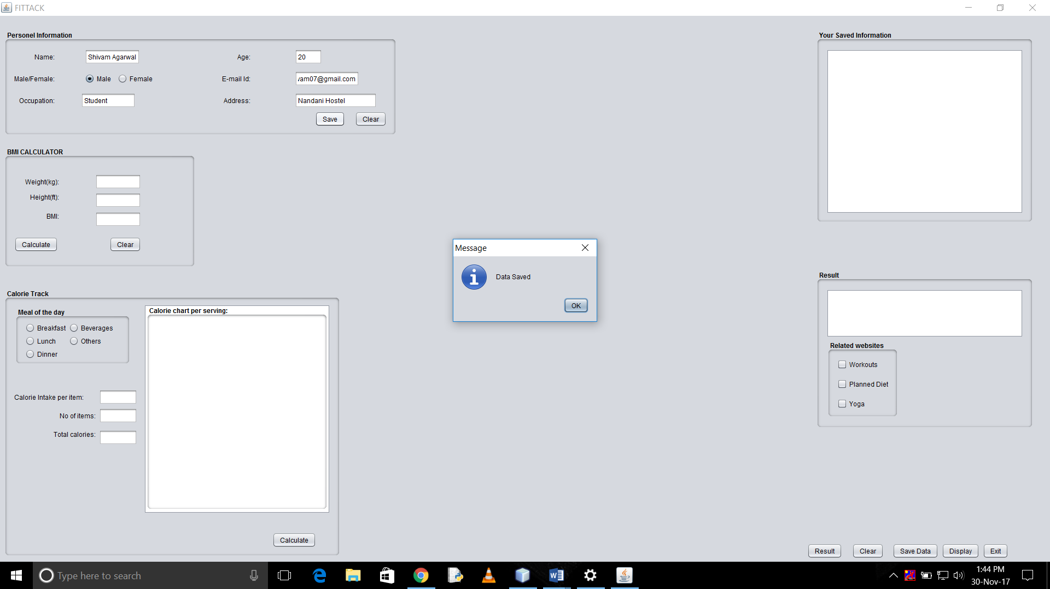

* The user has given the input of his/her personal details.

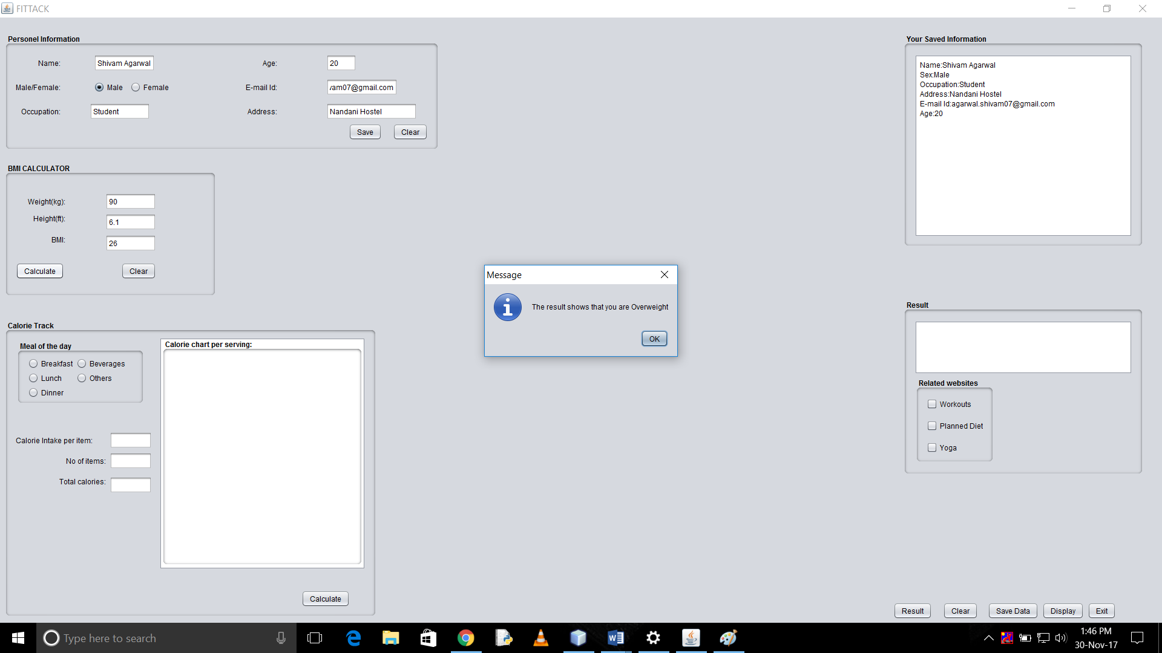

* Inputs and result of BMI calculator.

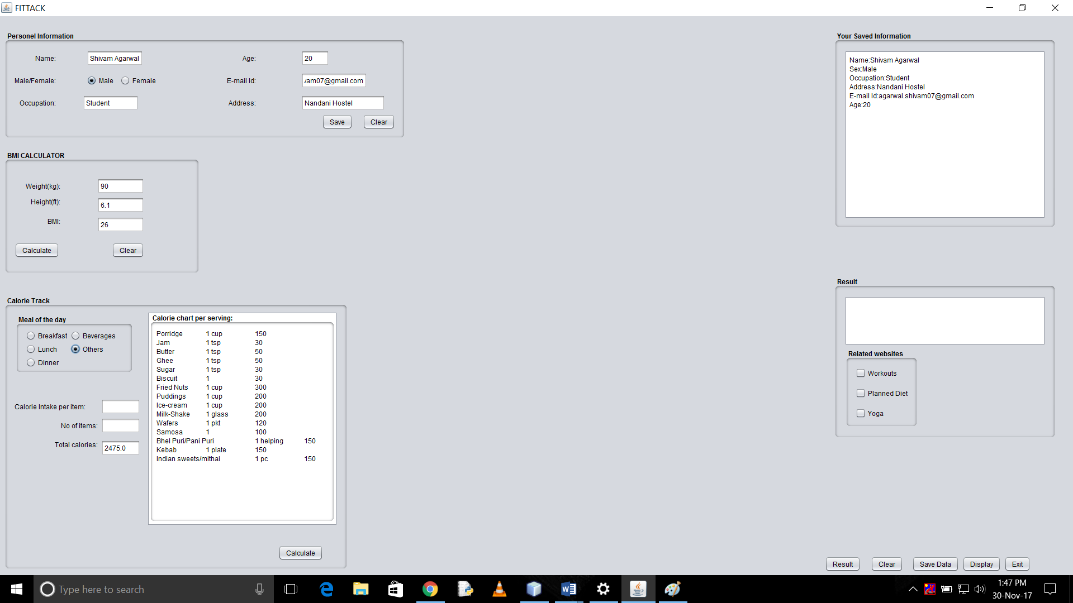

* The calorie chart for the “other” jRadioButton selection. And calculation of total calorie intake.

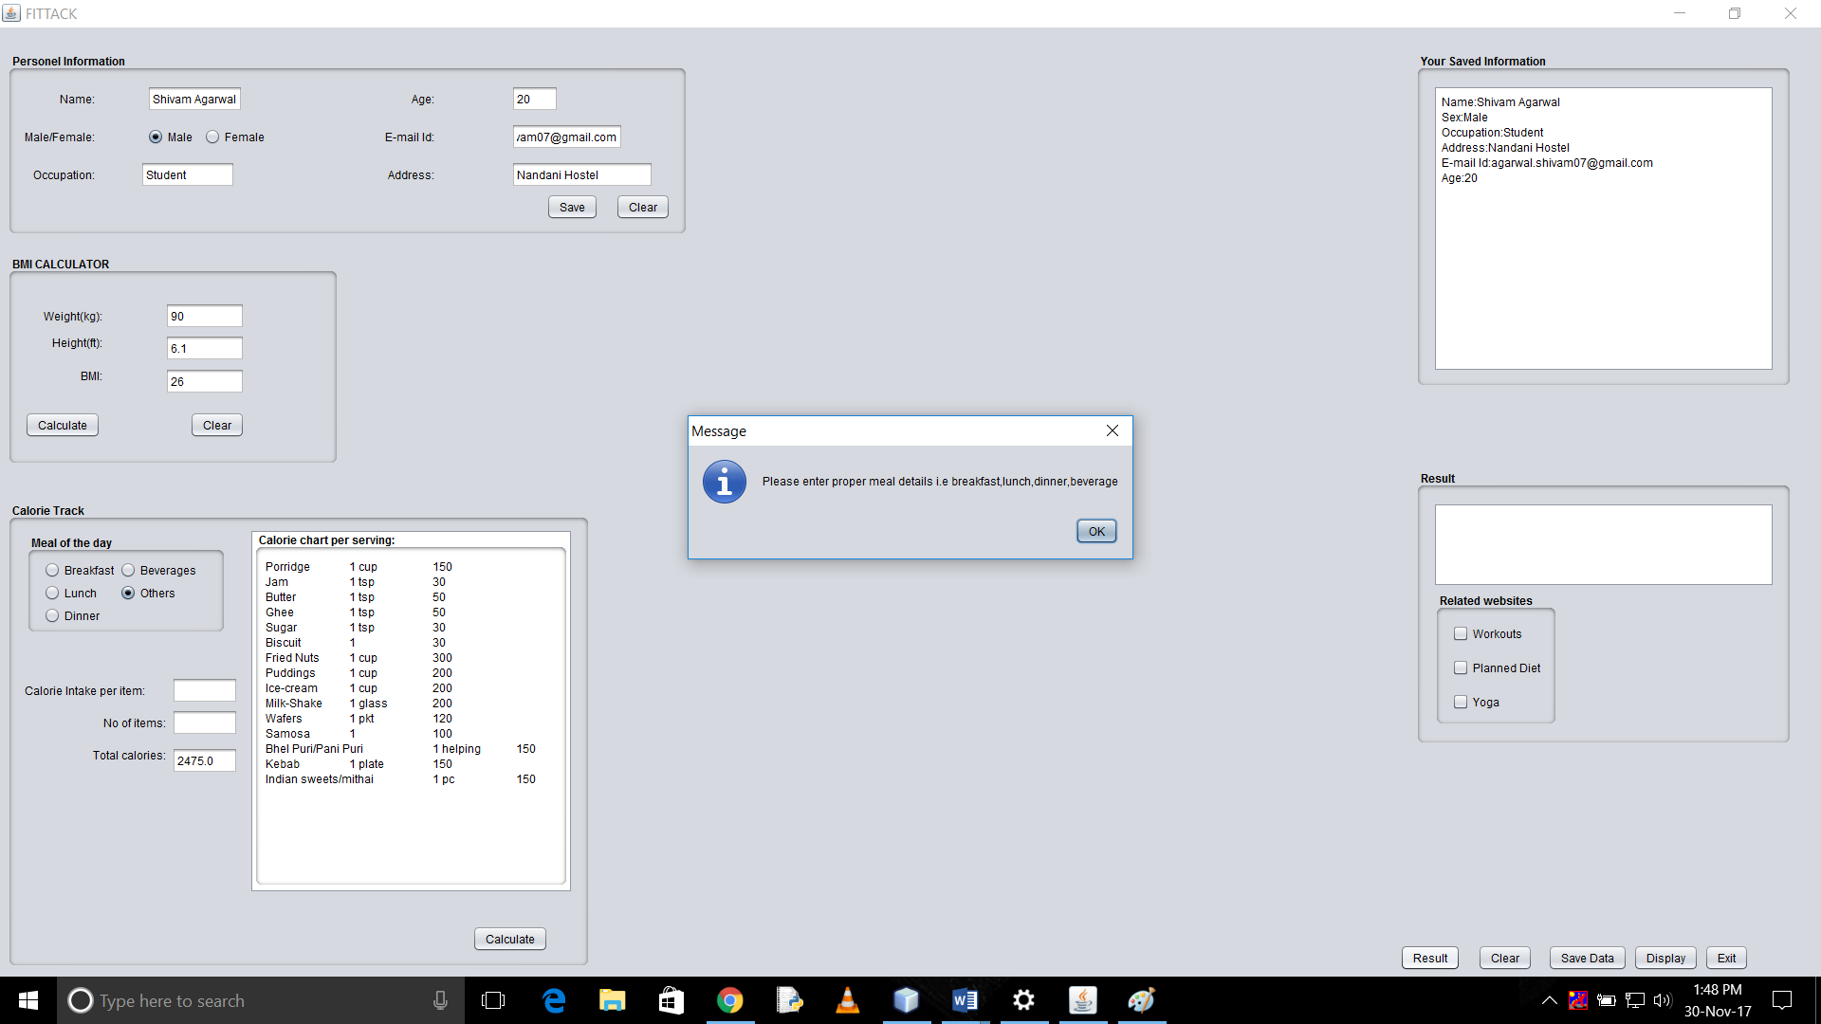

* If the user hasn’t given proper meal input.

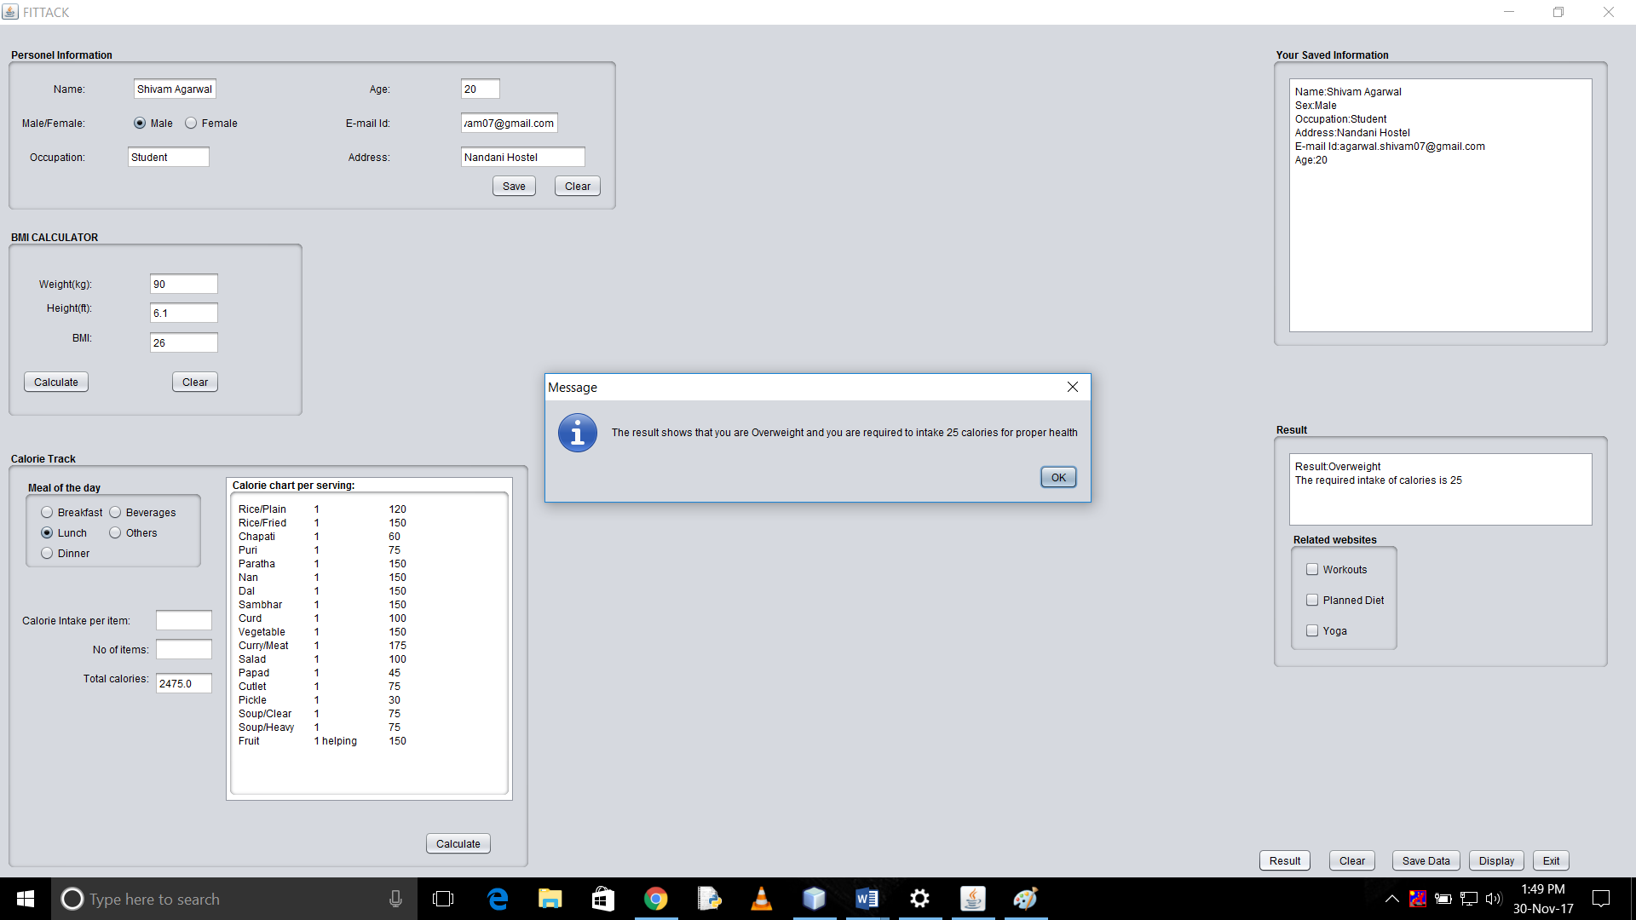

* The calculated result.

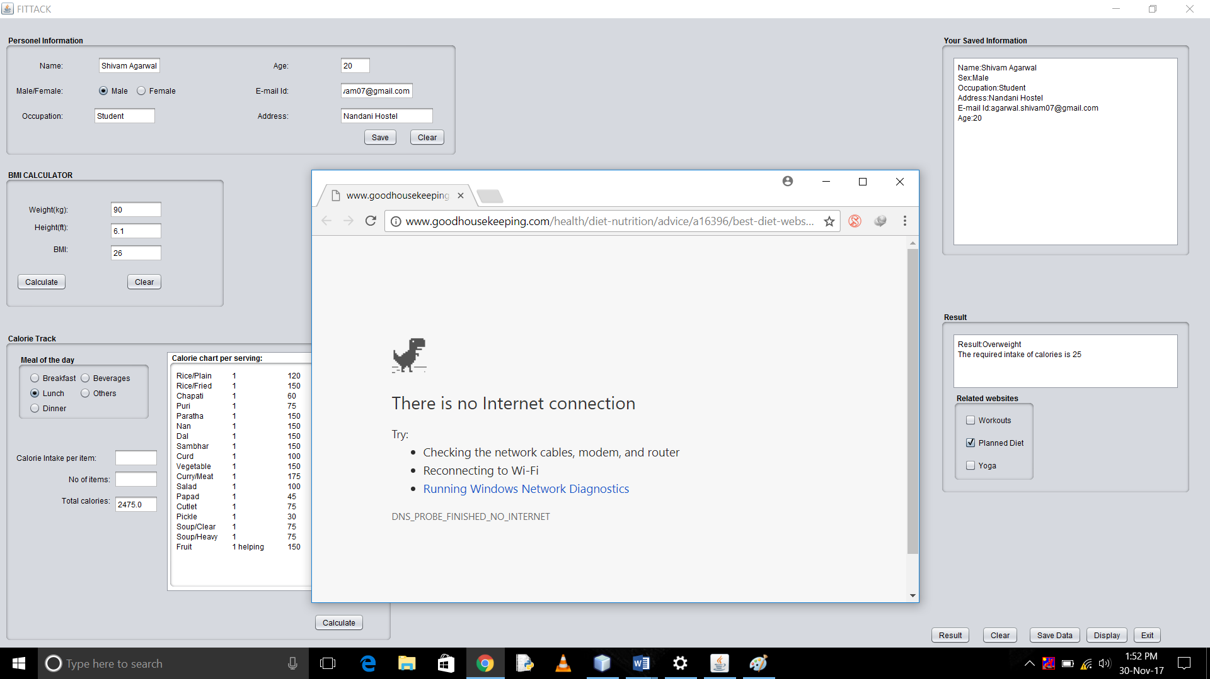

* Link to the related website when checkbox is selected.

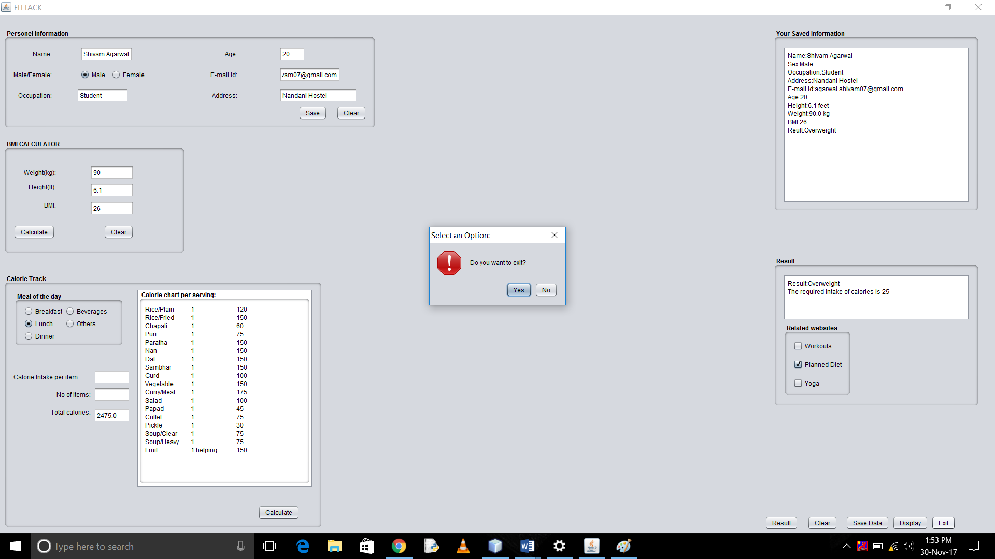

* Dialog Box appearing when exit button is selected to exit.

**6.CONCLUSION**

Use of this application helps the user to get details about his present body state. It also provides the user with the details of calorie he/she need to reduce or intake per day for getting a healthy life. This application also provides the user with the related websites which will help the user achieving his desired body state.

**7.REFERENCES**

1. **Google Fitness Tracker**
2. **Netbeans Forum- https://forums.netbeans.org/ntopic22529.html**
3. **The stack overflow website [online]. Available** [**https://stackoverflow.com/**](https://stackoverflow.com/)
4. **Google Search Engine**