Name : Neil Taison RIGAUD
Student ID : 411221367
Subject : Intro to Image Processing – Assignment #1
Date : 2025/09/18
- Relationship between resolution and file color/gray images for an image resolution of 512 * 512 with four number after the decimal point:
A color image consists of 3 channels in case of RGB:
$$512*512*3=786432 bytes$$
Converting to Kb:
$$786432 bytes=786.4320 Kb$$
Converting to Mb:
$$786432 bytes=0.7864 Mb$$
A grayscale image only has 1 channel:
$$512*512*1=262144 bytes$$
Converting to Mb:
$$262144 bytes=0.2621 Mb$$
- Transformation of color image into gray image, and display of color/gray images using:
$$grayscale image=R* 0.299+G*0.587+B*0.114$$

Program procedure listing:
- Import standard C++ libraries and I/O libraries for loading and writing image data only
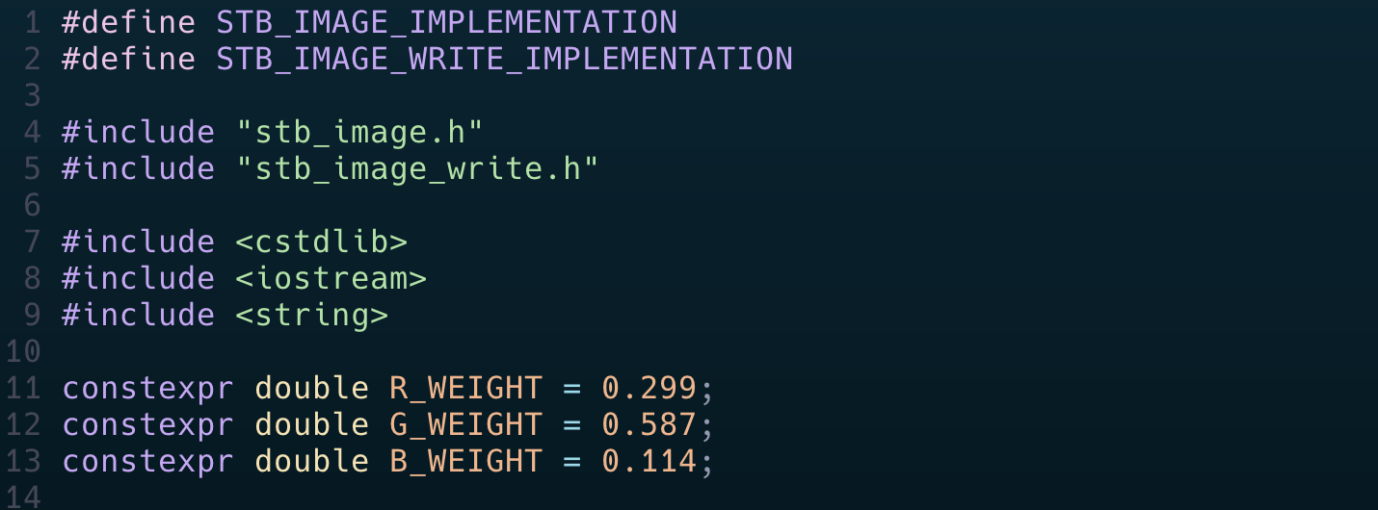
- We use the header files from the stb single-file public domain libraries for C/C++ :
  - stb_image_h to load and decode the image file
  - stb_image_write to write the converted grayscale image to disk

- Define constant RGB weight values from the formula and I/O filenames:
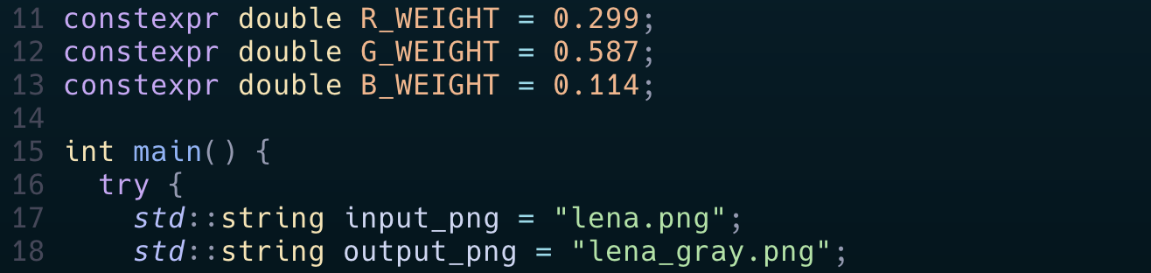

- Load the image data using the stbi_load function:
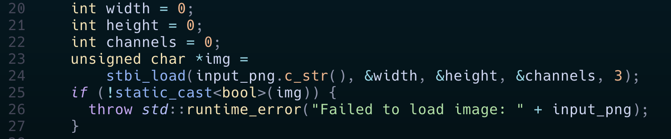
- stbi_load receives five (5) parameters:
  - Filename
  - Pointers to memory address to store:
    - Picture width
    - Picture height
    - Number of channels in file
  - Number of desired channels
    - In our case 3 for RGB
- Conversion to grayscale in-place
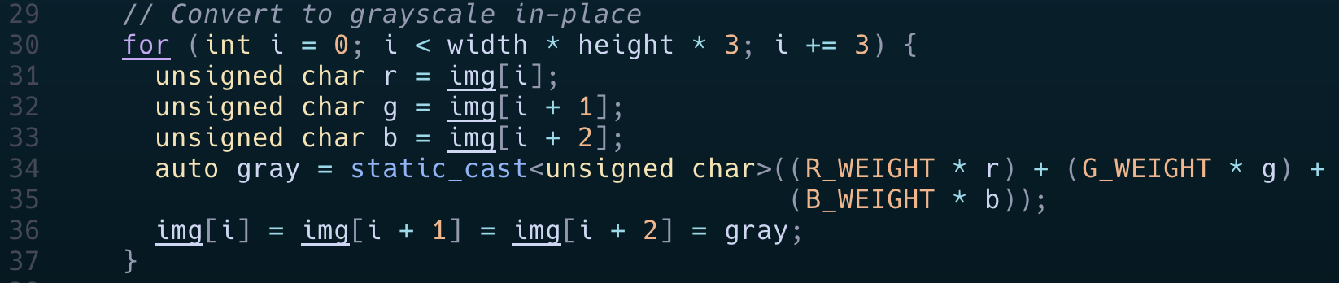
- Apply the given grayscale conversion formula to each of the pixel data collected in the previous array
  - Collect the pixel data for each channel
  - Compute the grayscale value with the RGB pixel data
  - Re-assign each pixel values for the three RGB channels to the obtained grayscale value
- Write the converted grayscale image data to the output file using stbi_write_png:
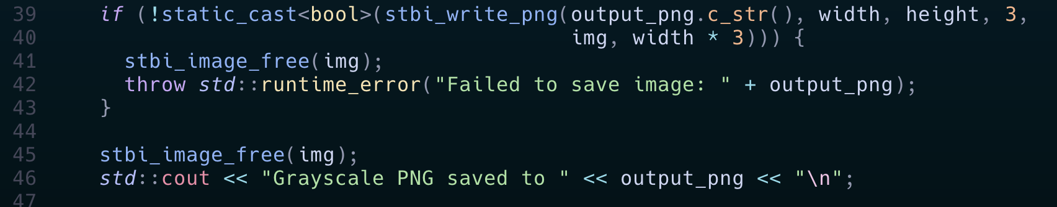
- stbi_write_png receives five (5) parameters:
  - The output file name
  - Width of the image in pixels
  - Height of the image in pixels
  - Number of color channels per pixel in data (3)
  - Pointer to raw pixel data from top-row
  - strides_in_bytes: number of bytes between the start of one row and the start of the next
- We also use stbi_image_free to free the pixel buffer returned by stbi_load when we were loading the image file.
- Open the output file optionally
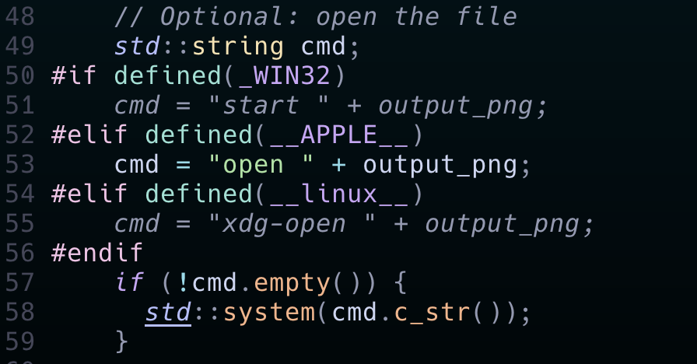
Finally we obtain the converted image output:
