Name : Neil Taison RIGAUD
Student ID : 411221367
Subject : Intro to Image Processing – Assignment #2
Date : 2025/10/22
- Code Listing and Explanation
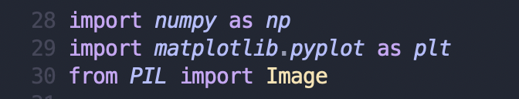
We import the necessary libraries for:
- Opening and saving images:
  - Image from the PIL library
- Processing the pixel values from the opened images:
  - numpy
- Creating the histograms:
  - pyplot from matplotlib
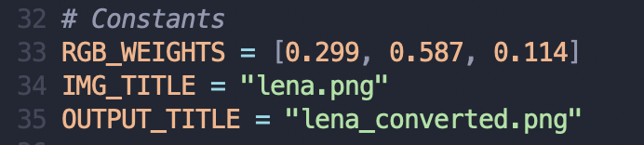
We define the weights for converting the color image to a grayscale using the given formula in the previous assignment along with constant values for opening and saving image file outputs.
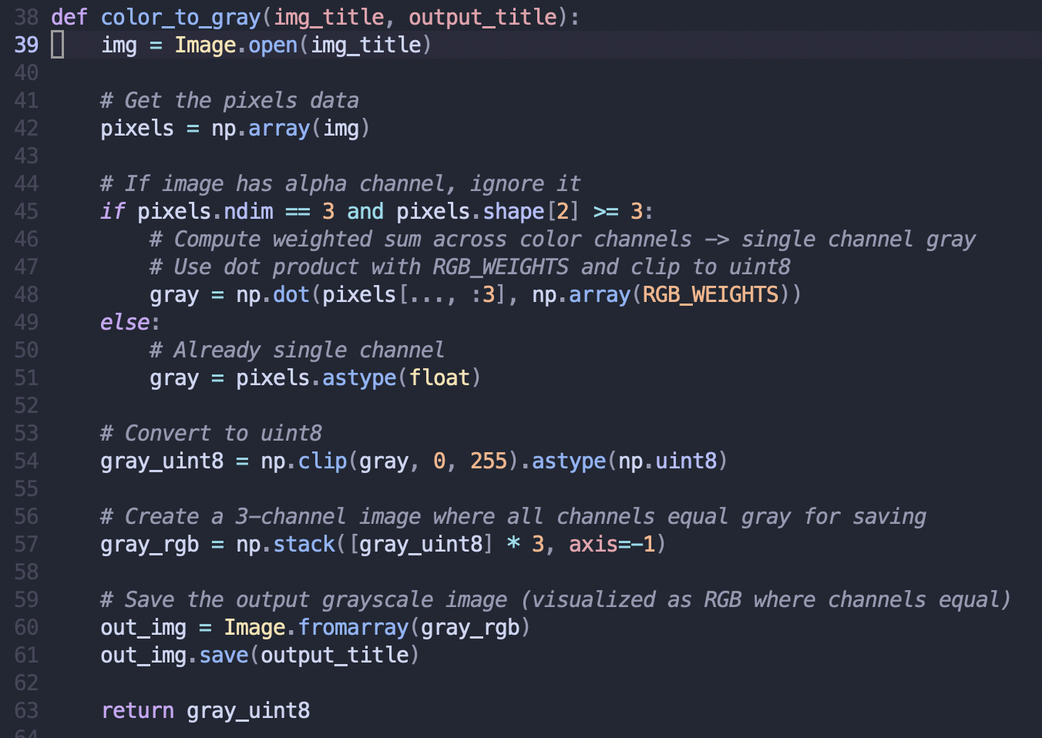

Here we proceed to convert the color image to a grayscale image by using the conversion formula with the previously defined weights to give each of the RGB channels the same weighted sum value for each pixels in the image.

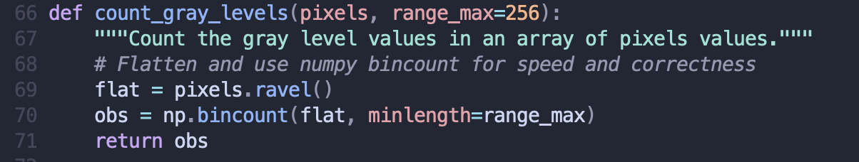

This function is used to count the number of observed gray level values in the image for the range 0 ~ 255.
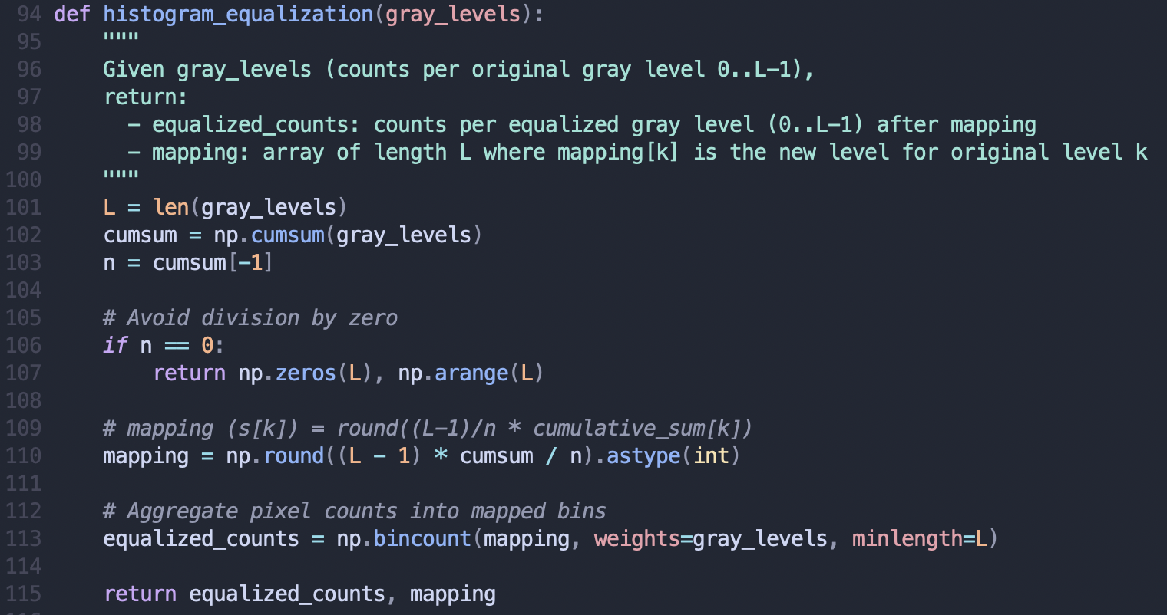

This is the core function for the histogram equalization procedure where we start by computing the cumulative summation for each gray level value i, then we round the values previously obtained into a mapping of rounded values that will be used for generating the enhanced image. Finally we count the respective observations for each of the distinct rounded values of the cumulative summations and store them into equalized_counts. Finally we return those values for generating the resulting image and produce the equalized histogram.

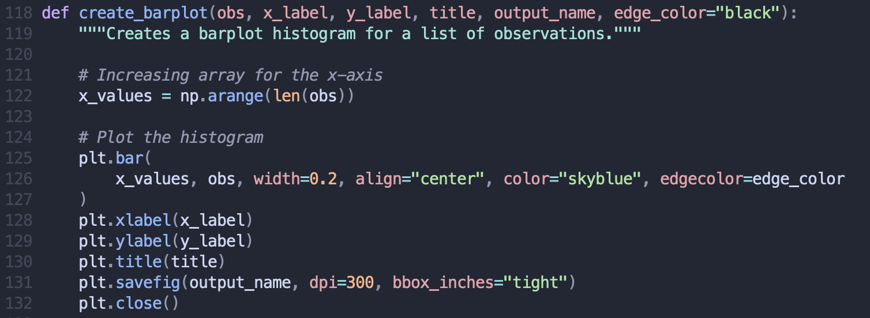

This function helps create the different barplots that we need before and after the histogram equalization process. As mentioned earlier, we use pyplot to plot the discrete histogram from the array of gray level observations and save the resulting image using the name parameter passed.

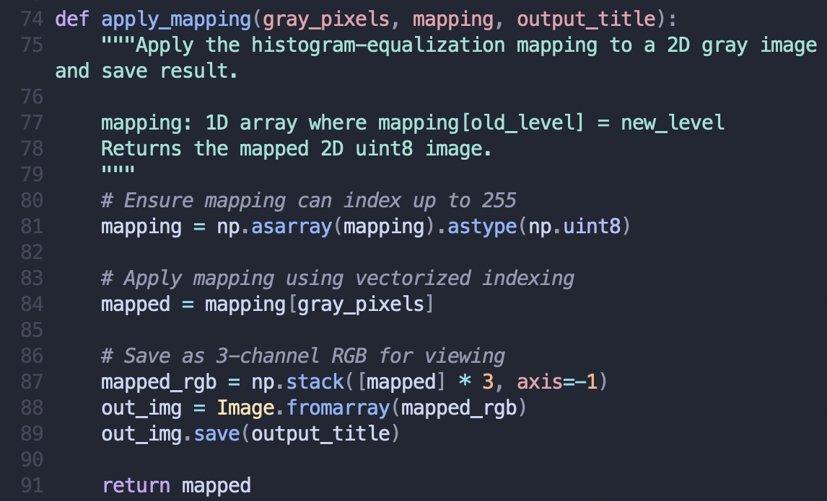

This function uses a mapping generated from the computation of the rounded cumulative sum of the gray level values from the Histogram Equalization procedure and generates the resulting enhanced image after the transformation.

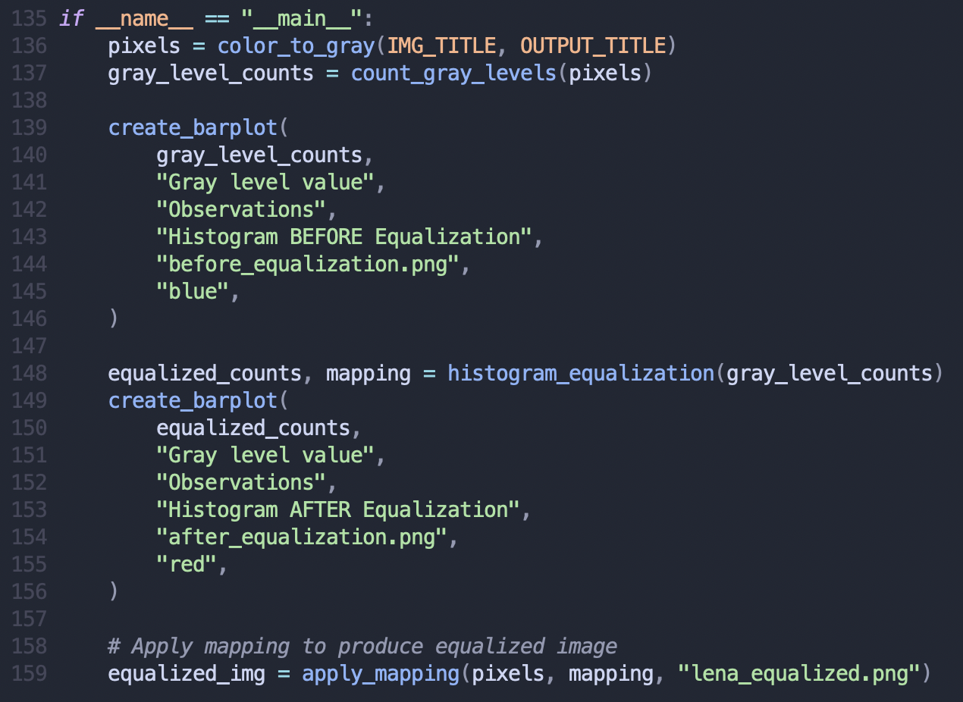

Finally, we have the main program procedure which uses the previously defined functions to:
- Convert the original color image into a grayscale image using the color_to_gray function.
- Obtain the gray level values for creating the original histogram for the converted grayscale image using the count_gray_levels function.
- Create the histogram before equalization using create_barplot
  - Note: We use barplot in the function name because we are using the discrete probability distribution.
- Obtain the equalized gray level count values and mapping to generate the enhanced image and final equalized histogram.
- Create the histogram after equalization using the equalized gray level values.

- Result images and corresponding histograms
