Name : Neil Taison RIGAUD
Student ID : 411221367
Subject : Intro to Image Processing – Assignment #3
Date : 2025/11/01

- Code Listing and Explanation
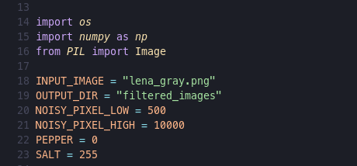
In our implementation we start by importing the necessary libraries for image manipulations such as:
- os: Creating directory paths and names to save image outputs.
- numpy: Manipulate image pixel values.
- PIL: Open and save images after performing processing operations.
We also define important constant values use throughout the program.

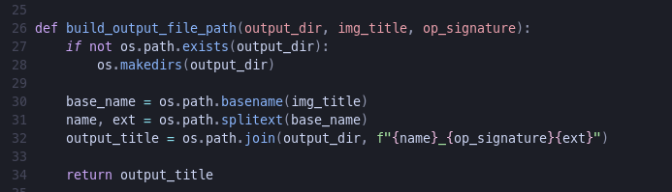
This function helps create the correct paths and names to save the image outputs after performing the spatial filtering operations. In this implementation the files are saved in the “filtered_images” directory path in the current directory where the program is located.

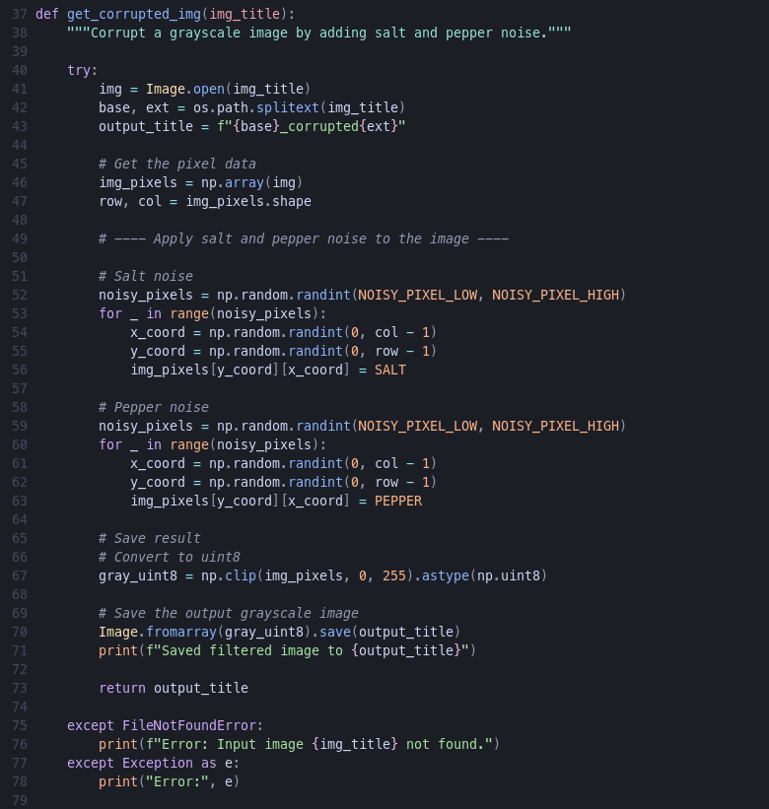

This function helps us add the salt and pepper noise to the original gray-scale image by:
- Opening the image file using its tile
- Retrieve the pixel data
- Randomly choose the amount of salt to be added to the image
- Add the salt noises to randomly chosen pixels
- Randomly choose the amount of pepper to be added to the image
- Add the pepper noises to randomly chosen pixels
N.B.: When adding salt or pepper noises to a pixel value, we simply overwrite the original value by either 0 (black or pepper noise) or 1 (white or salt noise).

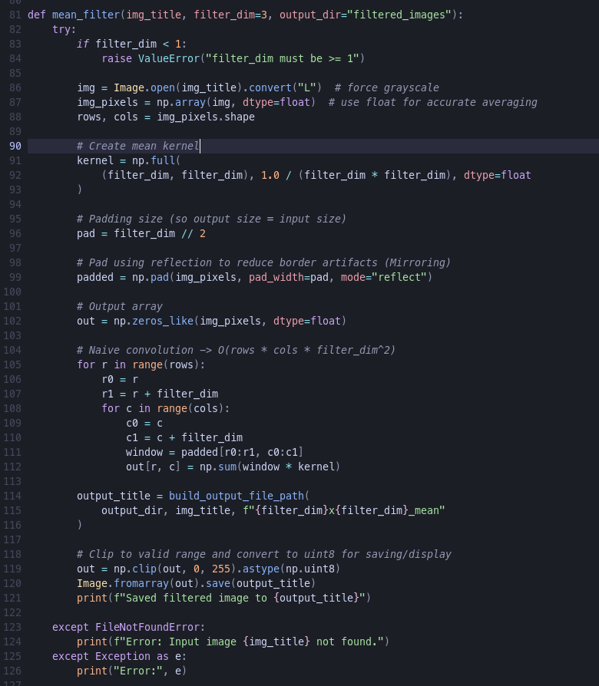

Here we implement the mean filter function which receives:
- Title of the image we want to perform the mean filter on.
- Dimension of the mean filter we want to apply on the image with default value of 3.
- Output directory to save the resulting image after applying the mean filter.

The procedure of applying the mean filter involves:
- Create a kernel or a mask of the specified dimension using np.full() where each values in the kernel is equal to 1 over the square of the filter dimension because when applying the filter we want to compute the mean value of all the pixel involved, and this result will be obtained by multiplying the sum obtained by those values.
- Using the mirroring approach to handle the edges of the image which consists using the closest pixel values in the image for the values that falls outside of the filter range.
- Then we create a empty array of zero values to act as a buffer for saving the result of the convolution operation with the dimensions of the padded image.
- Apply the filter to the image pixel values using a convolution operation where the resulting pixel values are the sum of the product of the each pixel values in the patch by the kernel which results in the mean value for the current patch.
- Since the convolution operation has been done on floating points values, and the results might fall out of the 0-255 range which is necessary for valid picture display on a computer, we proceed to clip those values and convert them to correct uint8 datatype.
- Save the resulting array into an image for display.

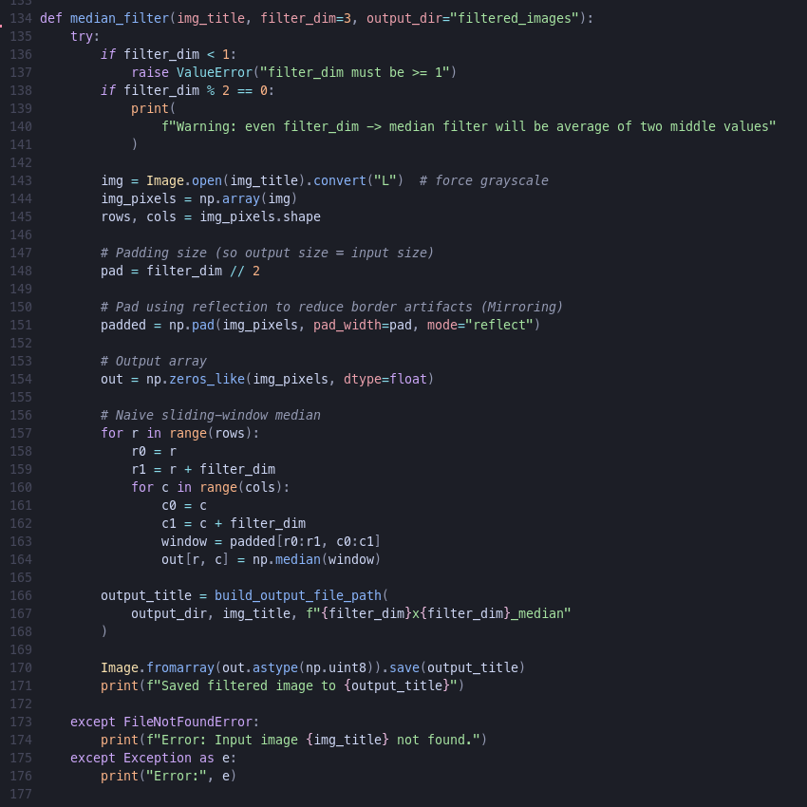
Here, we apply the median filter algorithm using a function which receives the same parameters as the previous mean filter algorithm and essentially involves:
- Validate the filter dimension parameter passed
- Open the input image and retrieve the pixel data in a numpy array
- Padding the image using the mirroring approach just as in the previous mean filter function to handle the edges of the image.
- Create an empty array to act as a buffer for the filtering operation.
- We use the same nested loop logic as previously for applying the median filter but this time we do not compute any average value by using a kernel. Instead we pick the median value of the list of pixel values under the patch specified by the window variable. This operation simply order the list of pixels values in increasing order and select the pixels value at the middle of the distribution and assign it to the pixel in the middle position of the filter or window.
- Finally, we proceed to save the resulting pixel array as an image as uint8 datatype. This time we don’t need any clip operation because we were operating directly on integer values, no floating-point operation was performed, thus there is no risk of falling out of the range 0-255.

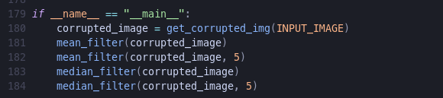
This is the main procedure of the program where we:
- Create a corrupted copy of the original gray-scale image by adding salt and pepper noise to it, and returned the saved name of the image.
- Apply the mean filter using the default value of 3x3 in the function implementation to the corrupted image while saving the result during execution.
- Apply a 5x5 mean filter to the same corrupted image and save the output during execution.
- Apply the median filter using the default value of 3x3 in the function implementation to the corrupted image while saving the result during execution.
- Apply a 5x5 median filter to the same corrupted image and save the output during execution.
The image outputs are save in the “filtered_images” directory by default and have specific names to denote which spatial filtering operation was performed on them.

- Resulting images
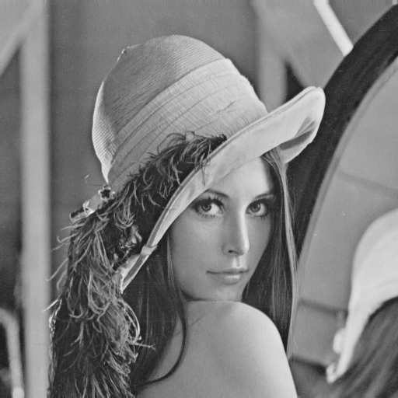Illustration 1: Original image | 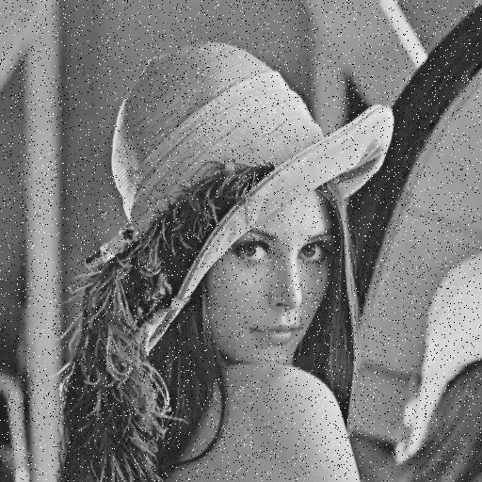Illustration 2: Corrupted image
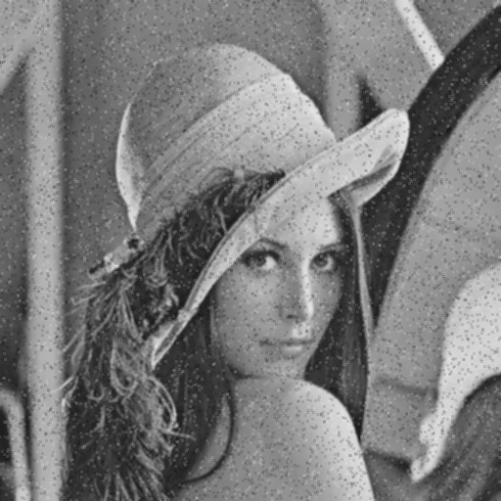Illustration 3: 3x3 Mean Filter | 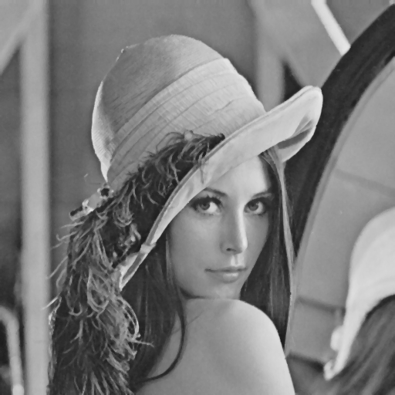Illustration 4: 3x3 Median Filter
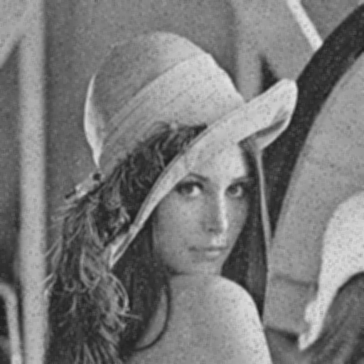Illustration 5: 5x5 Mean Filter | 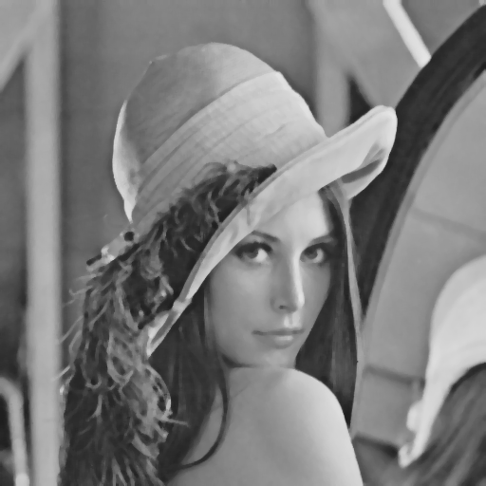Illustration 6: 5x5 Median Filter
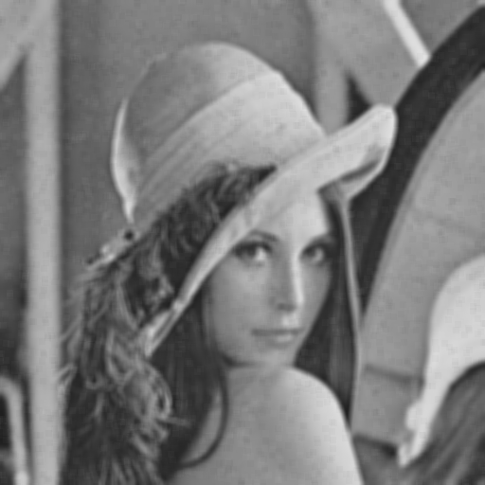Illustration 7: 7x7 Mean Filter | 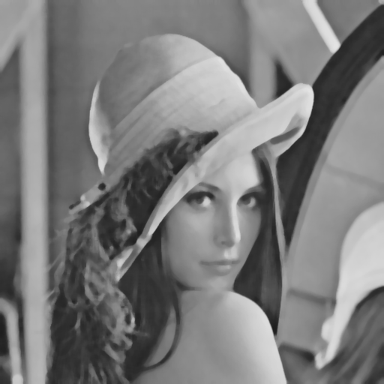Illustration 8: 7x7 Median Filter
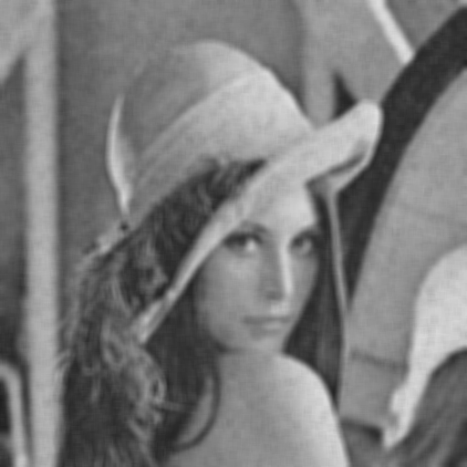Illustration 9: 9x9 Mean Filter | 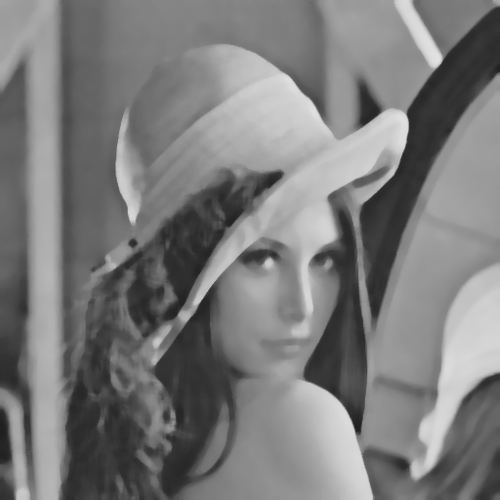Illustration 10: 9x9 Median Filter

The outputs of the 3x3 median filter looks best since the edges are sharper and the smoothing effect of the median filter is not exaggerated. But for the mean filter the results tends to become even more blurrier as we increase the filter size, the one with the 3x3 filter is the best among the mean filters even though it still contains salt and pepper noises.

