A site dedicated to the designs and work of Nicholas Summers



NTSummers.com will focus on the past, present, and future work that is/was designed, produced, and published by Nicholas Summers. This site has an emphasis on the best of the best that Nick has created, and will be used as a portfolio site to show employers that Nick is available for work and ready to task on new, challenging tasks.





**Recruiters/Headhunters/Employer -** I want to have the site show that I’m available for employment, as well as act as a platform to show off my work



**Designers -** I want my site to push the boundary of design, and to have designers look at and give feedback about my work



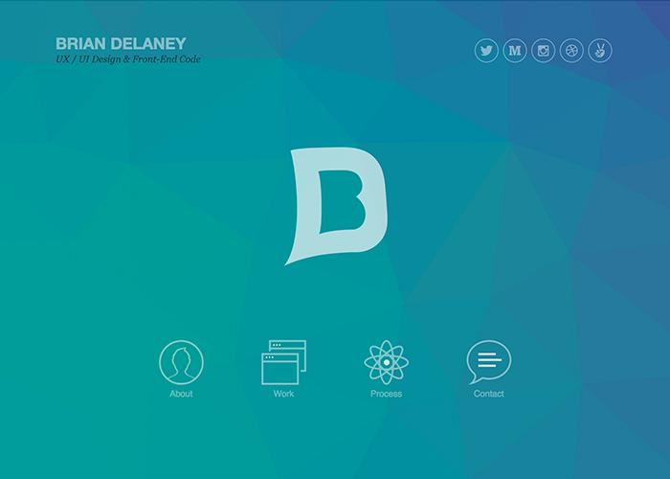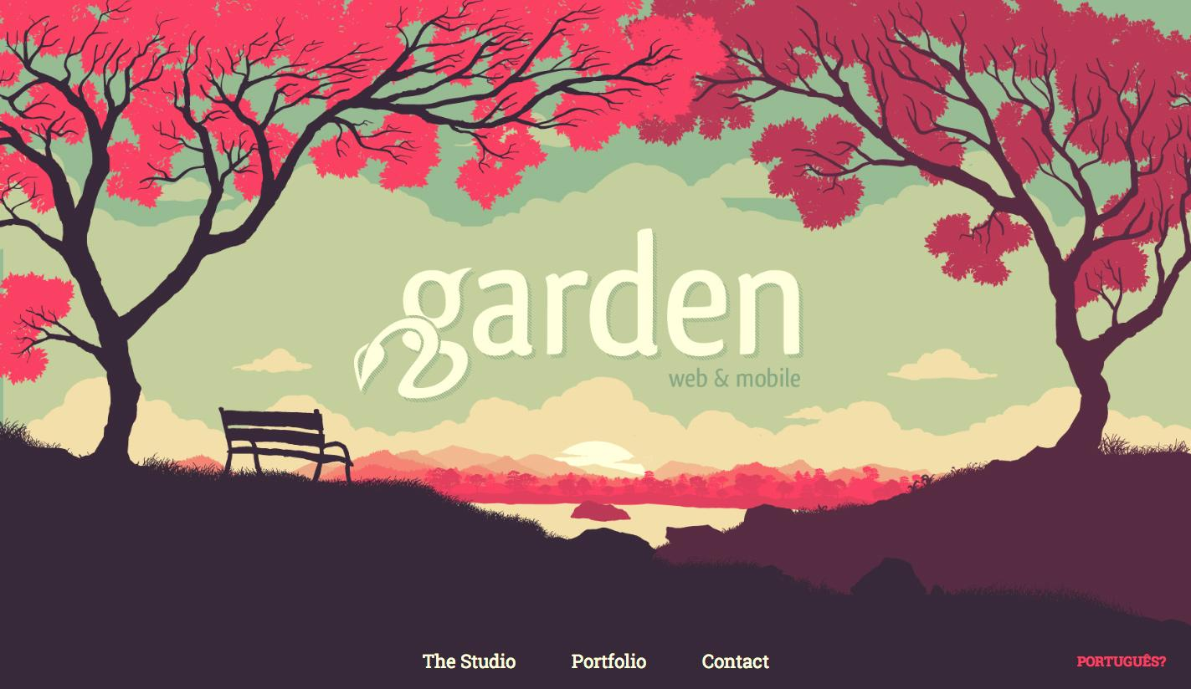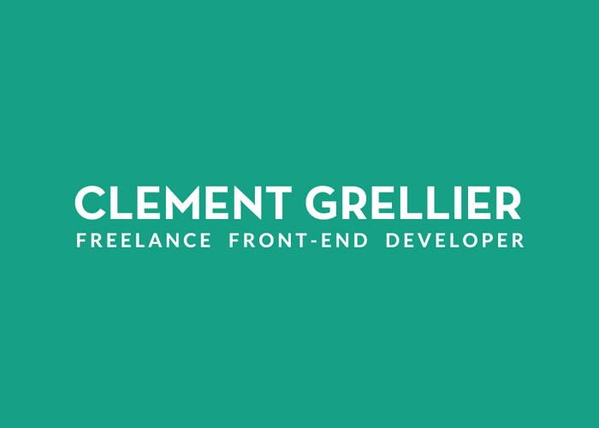

|  |  |  |
| --- | --- | --- |
| http://briandelaney.com/ | http://clementgrellier.fr/ | http://gardenestudio.com.br/ |