Anggota Kelompok :

* Nicholas Theodore
* Jason Walean

Link Figma: <https://www.figma.com/proto/coMAKcBIzUYg7LYTz0YH9X/Final-Project-HCI?node-id=49%3A4112&scaling=min-zoom&page-id=0%3A1&starting-point-node-id=49%3A4112&show-proto-sidebar=1>

Note: Saat gambar di homepage diklik, gambar tersebut akan membawa pengguna ke halaman khusus dari tema gambar tersebut.

Clothes :

<https://modesens.com/product/fendi-printed-fleece-zip-up-hoodie-yellow-40401241/>

<https://dshopsc.tk/products.aspx?cname=levi%27s+woodsman+jacket&cid=50>

[s-l640.jpg](https://i.ebayimg.com/images/g/Dz4AAOSwWeZfV-FK/s-l640.jpg)

<https://slimages.macysassets.com/is/image/MCY/products/6/optimized/9844616_fpx.tif?op_sharpen=1&wid=700&hei=855&fit=fit,1>

[362000090-alt1-pdp](https://lsco.scene7.com/is/image/lsco/362000090-alt1-pdp?fmt=jpeg&qlt=70,1&op_sharpen=0&resMode=sharp2&op_usm=0.8,1,10,0&fit=crop,0&wid=450&hei=750)

<https://kalahariholdings.com/hemisphere45d/aecafe495274.htm>

Yellow:

<https://www.saksfifthavenue.com/product/polo-ralph-lauren-vintage-satin-varsity-jacket-0400099021932.html>

[0400099021932_WINE](https://image.s5a.com/is/image/saks/0400099021932_WINE?wid=480&hei=640&qlt=90&resMode=sharp2&op_usm=0.9,1.0,8,0)

<https://www.one37pm.com/style/best-nike-basketball-shoes>

[nike-basketball-mobile.jpg](https://publish.one37pm.net/wp-content/uploads/2020/10/nike-basketball-mobile.jpg)

<https://id.pinterest.com/pin/558446422545321930/>

[5729edae57686b](https://i.pinimg.com/originals/57/29/ed/5729edae57686b7d64b33963f16455e4.jpg)

<https://www.nordstrom.com/browse/men/clothing/coats-jackets?filterByBrand=burberry>

[5a02d121-b9e1-48a4-a239-dd4d0b7449a7.jpeg](https://n.nordstrommedia.com/id/sr3/5a02d121-b9e1-48a4-a239-dd4d0b7449a7.jpeg?h=365&w=240&dpr=2)

<https://www.nordstrom.com/browse/men/clothing/coats-jackets?filterByBrand=burberry>

[5a02d121-b9e1-48a4-a239-dd4d0b7449a7.jpeg](https://n.nordstrommedia.com/id/sr3/5a02d121-b9e1-48a4-a239-dd4d0b7449a7.jpeg?h=365&w=240&dpr=2)

<https://hkbuy1s.tk/products.aspx?cname=force+270&cid=14>

[nike-air-force-270-dream-team-navy-red-metallic-gold-1.jpg](https://hypebeast.com/image/2018/05/nike-air-force-270-dream-team-navy-red-metallic-gold-1.jpg)

FMC :

<https://id.pinterest.com/pin/futuristic-headpiece-captain-hat-burning-man-hat--398568635775395027/>

[a4f3bd835ca66cfb184900052106a85f.png](https://i.pinimg.com/originals/a4/f3/bd/a4f3bd835ca66cfb184900052106a85f.png)

<https://id.pinterest.com/pin/407083253819602020/>

[3a3fe1eb23e3e9d7171c2b9372184863.jpg](https://i.pinimg.com/736x/3a/3f/e1/3a3fe1eb23e3e9d7171c2b9372184863.jpg)

<https://www.oso-7.top/products.aspx?cname=michael+kors+swim+trunks&cid=47>

Color Summer:

<https://www.walmart.com/ip/LUXUR-Men-s-Outdoor-Running-Shoes-Graffiti-Sneakers-Shock-Absorption-Sports-Running-Shoes/589878065>

[7ff6325a-6d9f-40d4-9d68-72ce8b279154.4e88ed09f703900c394dbe4cc8d290d3.jpeg](https://i5.walmartimages.com/asr/7ff6325a-6d9f-40d4-9d68-72ce8b279154.4e88ed09f703900c394dbe4cc8d290d3.jpeg)

[levis-Red-Plaid-Arctic-Cloth-Quilted-Woodsman-Trucker-Jacket-With-Sherpa-Collar.jpeg](https://cdna.lystit.com/photos/bloomingdales/7d38ceec/levis-Red-Plaid-Arctic-Cloth-Quilted-Woodsman-Trucker-Jacket-With-Sherpa-Collar.jpeg)

<https://dshopsc.tk/products.aspx?cname=levi%27s+woodsman+jacket&cid=50>

Other Media :

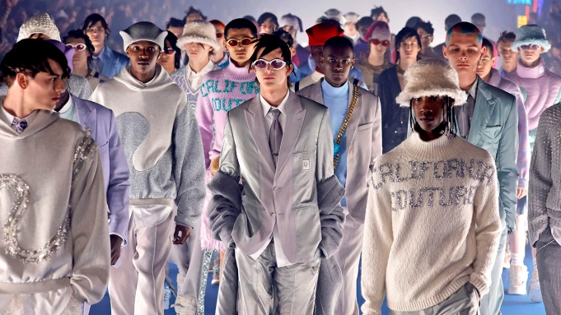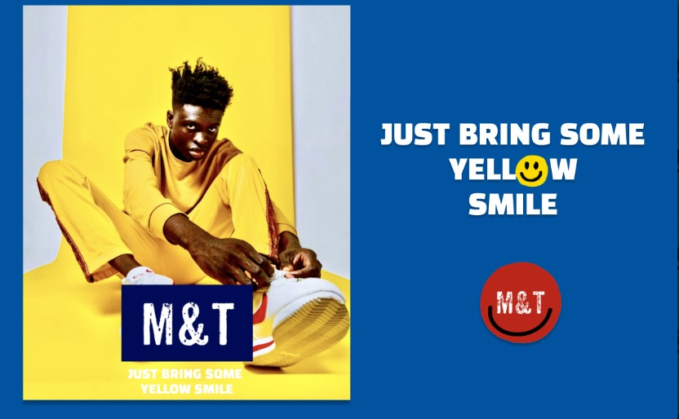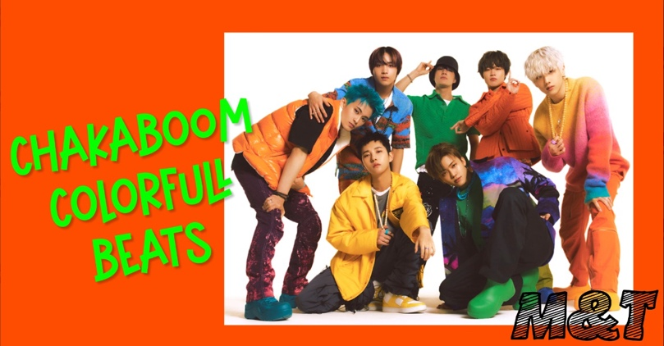

<https://www.lyst.com/accessories/chinatown-market-x-smiley-trucker-hat/>

[urban-outfitters-designer-Yellow-Smile-Trucker-Hat.jpeg](https://cdna.lystit.com/photos/urbanoutfitters/feb1f84c/urban-outfitters-designer-Yellow-Smile-Trucker-Hat.jpeg)

[image-6.jpeg](https://www.loveatfirstfit.com/wp-content/uploads/2020/05/image-6.jpeg)

<https://www.shopauto.fr/products.aspx?cname=spongebob+5+kyrie&cid=18&xi=1&xc=24&pr=62.99>

<https://www.ebay.com/b/Nike-Yellow-Coats-Jackets-Vests-for-Men/57988/bn_108563182>

[s-l300.jpg](https://i.ebayimg.com/thumbs/images/g/YK4AAOSwbu9iraHE/s-l300.jpg)

<https://www.ubuy.com.bh/en/product/19S9RI4EQ-men-s-print-letter-pattern-hoodies-streetwear-casual-hip-hop-fashion-pullover-sweatshirt-red-large>

<https://www.tradeinn.com/dressinn/en/levis---star-wars-the-trucker-jacket/137259477/p>

[levis---star-wars-the-trucker-jacket.jpg](https://www.tradeinn.com/f/13725/137259477/levis---star-wars-the-trucker-jacket.jpg)

<https://www.shopstyle.co.uk/p/hello-mrlin-mens-techwear-streetwear-hip-hop-fashion-hoodie-japanese-harajuku-outfits-black/862146290?imageId=8ee3acb1e5a7bdf8445b7c1c8e38767e41TQ7ugCtLL.jpg>

[a2d1ed01c8fb31d9c45d7febab3150df.jpg](https://i.pinimg.com/originals/a2/d1/ed/a2d1ed01c8fb31d9c45d7febab3150df.jpg)

<https://id.pinterest.com/pin/695595104925405207/>

<https://static.nike.com/a/images/t_PDP_1280_v1/f_auto,q_auto:eco/884b3cb9-1716-45d3-a7ba-289fae30a14d/lakers-icon-edition-2020-nba-swingman-jersey-hH6KpH.png>

<https://www.nike.com/id/t/lakers-icon-edition-2020-nba-swingman-jersey-hH6KpH>

[Acid-House-Smile-tshirt-yellow_1024x.jpg](http://cdn.shopify.com/s/files/1/1127/0890/products/Acid-House-Smile-tshirt-yellow_1024x.jpg?v=1549279335)

<https://www.ilovetaboo.com/products/acid-house-smile-t-shirt-yellow?variant=16091999535206>

<https://www.grailed.com/listings/30458530-louis-vuitton-louis-vuitton-black-yellow-varsity-jacket>

[6frXmctVS3iFdEH5wpW2](https://process.fs.grailed.com/AJdAgnqCST4iPtnUxiGtTz/auto_image/cache=expiry:max/rotate=deg:exif/output=quality:70/compress/6frXmctVS3iFdEH5wpW2)

[nike-kyrie-3-kobe-bruce-lee-1.jpg](https://image-cdn.hypb.st/https%3A%2F%2Fhypebeast.com%2Fimage%2F2017%2F08%2Fnike-kyrie-3-kobe-bruce-lee-1.jpg?q=75&w=800&cbr=1&fit=max)

<https://hypebeast.com/2017/8/nike-kyrie-3-bruce-lee>

[nike-air-speed-turf-max-university-gold-BV1165-700-1.jpg](https://sneakernews.com/wp-content/uploads/2018/10/nike-air-speed-turf-max-university-gold-BV1165-700-1.jpg)

<https://www.lokshop.gq/products.aspx?cname=nike+air+speed+turf+black&cid=64&url=avsenggcollege.ac.in>

[Nike-Air-Fear-of-God-1-Yellow-Amarillo-AR4237-700-Release-Date-4.jpg](https://www.modern-notoriety.com/wp-content/uploads/2019/07/Nike-Air-Fear-of-God-1-Yellow-Amarillo-AR4237-700-Release-Date-4.jpg)

<https://www.modern-notoriety.com/nike-air-fear-of-god-1-amarillo-release-date/>

[24f0a4da-1bc7-4992-9b2b-c52eabd34387_1.9a459e08de75ef1d7d719954cc3029bf.jpeg](https://i5.walmartimages.com/asr/24f0a4da-1bc7-4992-9b2b-c52eabd34387_1.9a459e08de75ef1d7d719954cc3029bf.jpeg)

<https://www.walmart.com/ip/Nike-Men-s-Sportswear-2019-Hooded-Windrunner-Jacket/643872283>

<https://id.pinterest.com/pin/givenchy-men--377809856236679011/>

[1e45a64e62854a4288634ec828f3a696](https://img.zolaprod.babsta.net/-CMuXje5C5V9RdW_g3NOZ40xI2I=/fit-in/375x395/1e45a64e62854a4288634ec828f3a696)

<https://www.24s.com/en-gb/teddy-jacket-celine_CELFG758>

<https://lookastic.com/men/grey-knit-cardigan/shop/stars-and-stripe-knitted-cardigan-7141798>

