**Chapter 8**

**Text Pattern Organizations**

**Objectives:**

After completing this chapter the students are able to:

1. Identify English text pattern of organization (listing, sequence, comparison/contrast, cause/effect, problem/solution, and extended definition).
2. Write English composition based on certain text pattern organization.

For thousands of years, people have looked at groups of stars in the night sky and found patterns. They have given names to these constellations and have used them as guides for travel on land and sea.

|  |  |
| --- | --- |
| Hasil gambar untuk stars formation names | In fact, our brain helps us make sense of the world by sorting information into mental networks. |
| These networks are organized in patterns, and we use those patterns to understand and remember what we see and experience.  Recognizing the pattern of organization is an important part of reading comprehension, since writers, too, use patterns to present their ideas in a way that makes sense. | |

Once you recognize the pattern, you will understand and follow their ideas more efficiently. In this unit, you will learn to identify six common patterns that are often found in paragraphs in English:

1. Listing

2. Sequence

3. Comparison/Contrast

4. Cause/Effect

5. Problem/Solution

6. Extended Definition

**1. Listing**



In the listing pattern, the writer states the main idea in the form of a generalization and gives a list of details or examples to support that general statement.

* Key words/phrases in the main idea: *many, several, a number of, a variety of, a few, kinds of*
* Signal words/phrases: *for example, for instance, first, second, another, also, besides, in addition, final, last, most important.*

***Task 1***

*Read the paragraph and the information below. Then underline the signal words in the paragraph.*

There are several different theories about the origin of the Moon. One theory, called the fission' theory, states that early in the life of Earth, a piece broke off, and that piece became the Moon. A second, closely related theory is that the Moon is composed of several pieces of Earth that broke away from our planet. Yet another theory is that the Moon formed elsewhere in the solar system and was captured by Earth's gravity.' The final theory states that a huge piece of planetary rock struck Earth and broke up into pieces. One of the pieces became the Moon.

*1.* ***fission****:* the act of splitting into parts

*2.* ***gravity****:* the force that causes objects to fall to the ground

Topic: Theories about the origin of the Moon.

Main idea: There are several different theories about the origin of the Moon.

Keyword in the main idea: Several.

Supporting facts and ideas

Signal words/phrases Details

One theory A piece of Earth broke off (fission theory)

A Second Several pieces of Earth became the Moon.

Yet Another The Moon formed elsewhere in the solar system.

The Final A piece of a huge planetary rock struck Earth and became the Moon.

**2. Sequence**

In the sequence pattern, the writer explains the main idea with *a series of events or steps in a process* that follow one after the other in time order.

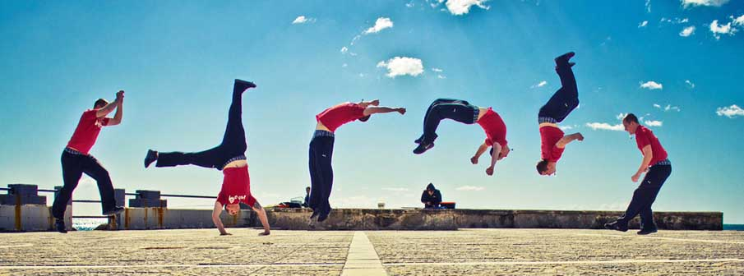

* Key word/phrases in the main idea: *began, account, story, process, history, sequence.*
* Signal words/phrases: *first, second, then, next, after, while, since, then, soon, finally, at last, in 1965, last June, later, over time, the next step, the following week.*

***Task 2***

***A. Series of Events***

*Read the paragraph and the information below. Then underline the signal words in the paragraph.*

Close-up study of the planet Mars began when rockets were developed that could send scientific instruments into space. In 1965, the first observations of Mars were done by the American spacecraft *Mariner 4,* which flew near the planet to collect data and take photographs. Four years later, more data and photographs were collected by *Mariners* 6 and 7 as they flew past the planet. Then, in 1971, *Mariner 9* actually went into orbit' around Mars, and during the following eleven months, sent back more than 7,000 images before contact with the spacecraft was lost. The next major step, in 1976, was the landing of two Viking crafts on two different areas of Mars' surface. These landers were able to send hack important data about the atmosphere 2 of the planet.

1. ***orbit****:* the path that is traveled by an object that is moving around a larger object
2. ***atmosphere****:* the mixture of gases that surround a planet

Topic: Close-up study of Mars.

Main idea: Close-up study of the planet Mars began when rockets were developed that could send scientific instruments into space.

Keyword in the main idea: Began.

Supporting facts and ideas

Signal words/phrases Details

In 1965 The first spacecraft flew near planet.

Four years later More photographs were collected of the Planet.

Then, in 1971 Mariner 9 orbited Mars.

During the following It sent back more than 7,000 images.

eleven months

The next major step,

in 1976 The landing of two Viking crafts on Mars’ surface.

***B. Steps in a Process***

*Read the paragraph and the information below. Then underline the signal words in the paragraph.*

Not all stars are the same age, so it is possible to see stars at every stage of their life cycle. From their observations, astrophysicists can explain the process of the formation of a star. A star begins life inside a *nebula,* a huge cloud of gas and dust in outer space. Over time, the force of gravity pulls some of the gas and dust together to form into clumps. Then the temperature inside the nebula begins to rise. Next, several clumps come together and become denser and hotter, and they form a *protostar* (an early form of a star). After that, the protostar continues to grow until it has become about as large as our Sun. At that point, nuclear reactions begin to occur in its core (center), and these reactions send energy to the surface of the protostar. Finally, the energy escapes as heat and light and a new star begins to shine.

***dump****:* a clustered mass; a lump

Topic: The process of the formation of a star.

Main idea: A star is formed in a process during which clumps of gas and dust form a protostar that becomes large and hot.

Keyword in the main idea: Process.

Supporting facts and ideas

Signal words/phrases Details

Begins In a cloud of dust and gas in outer space.

Over time Gravity makes clumps of dust and gas.

Then The temperature begins to rise.

Next Several clumps form a protostar.

After that The protostar grows larger.

At that point Nuclear reactions send energy to the surface.

Finally A new star begins to shine.

**3. Comparison/Contrast**

In the comparison/contrast pattern, the writer's main idea is a general statement about two things and how they are similar and/or different. A comparison can include both similarities and differences, or only the similarities. A contrast states only differences.

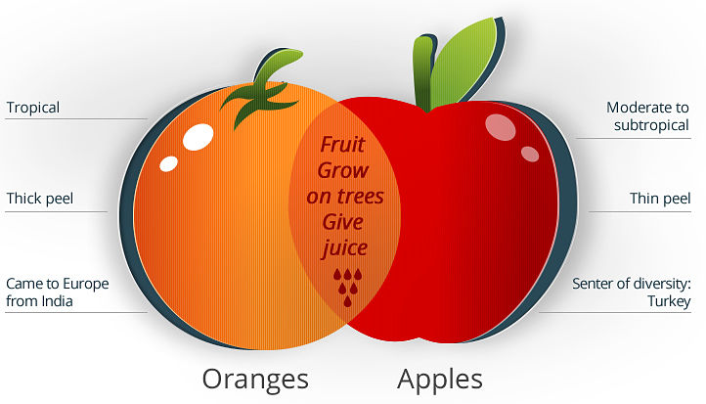

* Key words/phrases in the main idea: *similarities, differences, both, in common, same, different, compare, comparison.*
* Signal words/phrases for similarities: *similarly, also, in the same way, as, like, both, in common.*
* Signal words/phrases for differences: *however, but, on the other hand, although, while, in contrast, than, conversely, yet, unlike.*

***Task 3***

***A. Similarities and Differences***

*Read the paragraph and the information below. Then underline the signal words in the paragraph.*

Astronomy and astrology are similar in some ways, but they differ in a very important way. In both fields, the experts study planetary motion and constellations (groups of stars), and they use telescopes, tables, and charts to do their work. However, astronomers study the heavenly bodies as a science, and over the years people have used astronomy to discover more about the universe. Astrologers, on the other hand, use their knowledge of the heavenly bodies to advise people about their life situations. This is not science, but a belief that what happens in our lives is affected by the positions of the moon, sun, and planets.

Topic: Astronomy and astrology.

Main idea: Astronomy and astrology are similar in some ways, but they differ in a very important way.

Keyword in the main idea: Similar, Differ.

Supporting facts and ideas

Signal words/phrases Details

Both Experts study planetary motion and constellations.

However Astronomers study heavenly bodies as a science.

On the other hand Astrologers advise people about their lives.

***B. Differences Only***

*Read the paragraph and the information below. Then underline the signal words in the paragraph.*

Earth differs greatly from its two closest neighboring planets, Venus and Mars. The Venusian and Martian atmospheres are composed almost entirely of carbon dioxide, while Earth's atmosphere contains very little. The dominant material in our atmosphere is nitrogen (77 percent). The other major component of Earth's atmosphere is oxygen (21 percent), a gas that is almost nonexistent on Venus and Mars. Our planet has an abundance' of water, which covers about 70 percent of Earth's surface and supports life on our planet. In contrast, Venus and Mars are extremely dry planets and incapable of supporting life.

***abundance:***a large quantity of something

Topic: How Earth is different from Venus and Mars.

Main idea: The Earth differs greatly from that of its two closest neighboring planets, Venus and Mars.

Keyword in the main idea: Differs.

Supporting facts and ideas

Signal words/phrases Details

While The Venusian and Martian.

In contrast Earth has lots of water; Venus and Mars are very dry.

**4. Cause/Effect**

In this pattern, the writer's main idea is that one event or action caused another event or action.

* Key words/phrases in the main idea and the signal words for details are the same and often include: *causes, leads to, is the cause of, results in, creates, brings about, makes, provokes, produces, gives rise to, contributes to, is due to, is the result of, comes from, results from, is produced by, is a consequence of, follows, is caused by.*

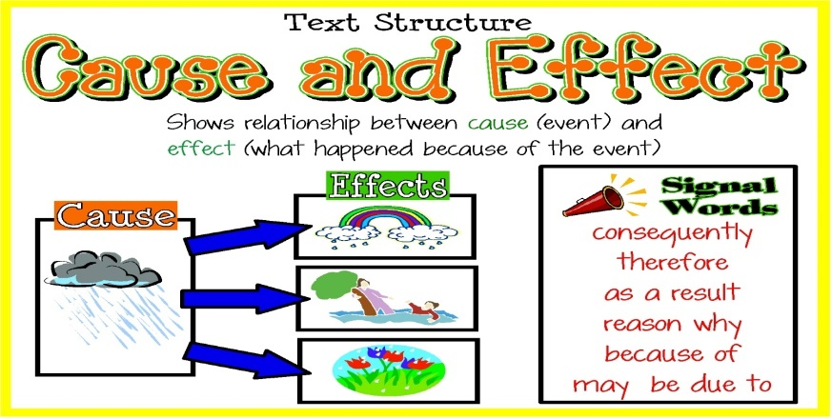

***Task 4***

*Read the paragraph and the information below. Then underline the signal words in the paragraph.*

In 2003, two robotic rovers landed on Mars and began sending back data about the possible existence of water on the red planet. This close examination of Mars was the result of new and improved technology. Because of advances in telecommunication systems, scientists on Earth can send commands faster and receive data in greater amounts. New software in the rovers led to their increased ability to make independent decisions and avoid dangers and hazards on their own. As a result of new technologies for severe environments, the rovers and their interior computers were able to survive the extreme cold and hot conditions in space and on Mars. And due to their new improved wheels the twin rovers could move around the rocky Martian landscape with ease.

Topic: Close examination of Mars

Main idea: This close examination of Mars was the result of new and improved technology.

Keyword in the main idea: The result of.

Supporting facts and ideas

Signal words/phrases Details

Because of Advances in telecommunication send commands and receive data faster.

Led to New software increased abilities of the rovers.

As a result of New technology rovers and computers can survive extreme conditions.

Due to Improved wheels the rovers can move around with ease.

**5. Problem/Solution**

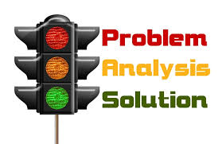

In this pattern, the main idea names a problem and indicates that one or more solutions.

The paragraph always consists of two parts: 1) a statement and 2) a description and explanation of how it was solved. There are often no signal words for the details.

* Key words/phrases in the main idea: *situation, trouble, crisis, dilemma* or *issue.*
* In the body of the paragraph, key words include: *solve, solution, resolved.*

***Task 5***

*Read the paragraph and the information below. Then underline the signal words in the paragraph.*

Beginning in the 1600s, astronomers had realized that their telescopes had serious limits. They had managed to build stronger and better telescopes, but no matter how strong the new telescopes were, they were less than satisfactory. The astronomers were able to view objects only when the objects were in view of Earth. At the same time, however, Earth's light and atmosphere made it difficult to see many heavenly objects. Thanks to the Hubble Telescope, this has been solved, because the Hubble is not just a telescope. It is a digital camera on a satellite that travels about 370 miles (600 km) above Earth, making a complete orbit every ninty-seven minutes. Since 1990, Hubble has been able to take digital pictures of planets, galaxies, comets, and more, and these are sent back to Hubble headquarters for scientists to study.

Topic:

The problem caused by telescope limitation

Main idea:

The new Hubble telescope has solved the problem of the conventional telescope

Keyword in the main idea:

New, Hubble Telescope, Solve, Problem

Supporting facts and ideas

Problem:

No matter how strong a telescope is, there are a lot of limitation for using it because of the condition of the earth

Solution:

The Hubble telescope is a digital camera on a satellite that orbiting the earth from 600 km above it

**6. Extended Definition**

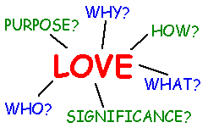

In this pattern, the writer names a concept or complicated process that the paragraph will define and explain. Usually, the main idea or first sentence of the paragraph states a dictionary definition of the concept or process, followed by a description and/or an explanation. There are usually no signal words for the details.

* Key words/phrases in the main idea: *consists of, is, seems to be, are.*

***Task 6***

*Read the paragraph and the information below. Then underline the signal words in the paragraph.*

A solar eclipse is an astronomical event during which the Moon seems to cover the Sun. When the Moon passes between the Earth and the Sun, all or part of the Sun's light is blotted out. The Moon, in fact, is much smaller than the Sun, but it is also a great deal closer to the Earth. As a result, both the Sun and the Moon seem to be about the same size to us. During a total eclipse, the Sun, the Moon, and the Earth are all in a straight line and the Moon completely hides the Sun from view. A partial eclipse occurs when the three bodies are not exactly in a straight line. In an annular solar eclipse, the Sun is visible as a bright ring around the Moon because the Moon is farthest from the Earth.

Topic:

Solar eclipse

Main idea:

A solar eclipse is an astronomical event during which the Moon seems to cover the Sun.

Keyword in the main idea:

Solar, Eclipse, Astronomical, Moon, Cover, Sun

Supporting facts and ideas

Explanation or Description:

How and why a solar eclipse occurs. Three different types of solar eclipse

**Identifying patterns**

In the exercises that follow, you will practice using key words and signal words to identify the patterns. Remember that when the Extended Definition and Problem/Solution patterns are used, there are usually no signal words for the details.

**Task 7**

*A. Each paragraph has a different pattern. Working with another student, read the paragraphs and write the topic, the main idea, the key words in the main idea, and the pattern. Then add the supporting facts and ideas as shown in the examples.*

* ***Listing, Sequence, Comparison/Contrast or Cause/Effect patterns: Signal words and details***
* ***Problem/Solution pattern: The problem and the solution***
* ***Extended Definition pattern: Explanation and/or description***

**1**

**Moon Landings**

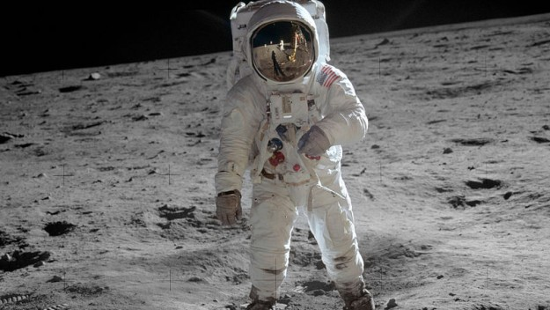

Only three and a half years passed between the first moon landing in 1969 and the sixth and last moon landing in 1972. But while the first landing was an enormous achievement in itself, the last landing contributed far more to the advancement of scientific knowledge. On the first mission, the two astronauts were on the Moon for only a few hours and remained close to the landing site.

Their time on the Moon was just sufficient to conduct several experiments and collect a small sample of lunar rocks. On the last mission, however, the three men (one of whom was a geologist) spent much more time on the lunar surface—three periods of about seven hours. With their special moon vehicle, they could travel much further from the landing site to investigate more of the lunar environment and collect a wider range of soil and rock samples.

Topic:

Moon Landings

Main idea:

The contribution of moon landing towards the advancement of scientific knowledge.

Keyword in the main idea:

Contribution, scientific, moon, landing

Pattern:

Sequence

Supporting facts and ideas:

The impact difference between the first and last moon landing, the activity which is done by the astronauts

**2**

The Apollo moon landings, may not have led to any great discovery—such as evidence 1 of life on the Moon—but it did have a significant impact on scientific and technological development in the twentieth century. One field that was undoubtedly affected by the moon landings was computer research. NASA, the U.S. space agency, did not invent the integrated circuit 2 (the basis of the computer), but it was the largest single consumer' of integrated circuits in the early 1960s. Working for the space program undoubtedly motivated computer engineers, pushing them toward the development of today's personal computer. Another related technological development that could be attributed at least in part to the Apollo program was the invention of the Internet. In this case, too, the moon landings served as an indirect motivation for scientists and engineers in their search for ways to communicate from computers in spacecraft to computers on Earth.

1. ***evidencer****:* use: facts, objects, or signs that make you believe that something exists or is true
2. ***integrated circuit****:* very small electronic parts working together as a single unit in a computer *consumer*

Topic:

The significant indirect impacts of the moon landing, which is the invention of integrated circuit and the internet

Main idea:

The Apollo moon landing may not have led to great discovery but it has an impact on scientific and technological development

Keyword in the main idea:

Discovery, impact, scientific, technological, development

Pattern:

Cause and effect

Supporting facts and ideas

The Apollo moon landing has an impact on scientific and technological development indirectly

**3**

In planning for future lunar missions, scientists are faced with one serious limitation to human exploration on the Moon, and that is the lack of water. The availability of water would make an enormous difference for humans working on the Moon for any length of time. The search for water, then, remains a high priority for space scientists. One technique that they have used is to send rockets crashing into the lunar surface. The crash creates a cloud of vapor' and dust that scientists can collect and analyze for evidence of water. Several rockets have already been sent to the Moon, but so far the results have not been conclusive. Another larger and heavier rocket, which will be sent to the moon in 2009, will have a greater impact and may produce different results. With the data from this larger rocket blast, scientists hope to establish conclusively the presence or absence of water on the Moon.

***vapor****:* a mass of very small drops of a liquid that floats in the air

Topic:

Search of water on the moon surface

Main idea:

The search of water on the moon is a high priority mission because it would greatly impact the research on the moon

Keyword in the main idea:

Search, Water, Moon, Priority

Pattern:

Listing (methods to find water)

Supporting facts and ideas

**4**

Lunar craters make travel on the Moon's surface a challenge for astronauts or robotic rovers. The surface of the Moon is marked by millions of the deep depressions or holes which are visible from the earth with just the naked eye. The craters are generally circular, range in size from a few feet to many hundreds of kilometers across, and can be surrounded by sharp mountainous peaks. They have been created by the impact of various objects—asteroids, comets, or meteorites. Since the Moon has no atmosphere to protect it from potentially dangerous objects in space, it is exposed to anything that may be in its path. The fact that there is no atmosphere on the Moon, and so no wind or rain, also means that the craters remain unchanged unless another object lands in the same spot.

Topic:

Lunar Crater

Main idea:

Because there is no atmosphere, the moon has no protection against the objects that is on it’s path thus it has a big crate from them.

Keyword in the main idea:

Atmosphere, Moon, Crate

Pattern:

Generalization/Extended Definition

Supporting facts and ideas

The craters on the moon remains the same as it’s first created, The moon has no atmosphere therefore it has no protection against meteorite and it would have no wind or rain to change the craters.

**Task 8**

*Each paragraph has a different pattern. Working with another student, read the paragraphs and write the topic, the main idea, the key words in the main idea, and the pattern. Then add further information for each pattern.*

* ***Listing, Sequence, Comparison/Contrast or Cause/Effect patterns: Signal words and details***
* ***Problem/Solution pattern: The problem and the solution***
* ***Extended Definition pattern: Explanation and/or description***

**1. Telescopes: Tools for Examining the Heavens**

According to some accounts, the first optical telescope was accidental invented in the 1600s by children who put two glass lenses together while playing with them in a Dutch optical shop. The owner of the shop, Hans Lippershey, looked through the lenses and was amazed by the way they made the nearby church look so much larger. Soon after that, he invented a device that he called a "looker," a long thin tube where light passed in a straight line from the front lens to the viewing lens at the other end of the tube. In 1608 he tried to sell his invention unsuccessfully. In the same year, someone described the "looker" to the Italian scientist Galileo, who made his own version of the device. In 1610 Galileo used his version to make observations of the Moon, the planet Jupiter, and the Milky Way. In April of 1611, Galileo showed his device to guests at a banquet in his honor. One of the guests suggested a name for the device: telescope.

Topic: the first optical telescope

Main idea:

the first optical telescope was accidental invented in the 1600s by children.

Keyword in the main idea: telescope

Pattern:

Extended Definition

Supporting facts and ideas

Hans Lippershey invented a device that he called a "looker," a long thin tube where light passed in a straight line from the front lens to the viewing lens at the other end of the tube. In 1608 he tried to sell his invention unsuccessfully. In the same year, someone described the "looker" to the Italian scientist Galileo, who made his own version of the device. In April of 1611, Galileo showed his device to guests at a banquet in his honor. One of the guests suggested a name for the device: telescope.

**2**

When Isaac Newton began using Galileo's telescope more than a century later, he noticed a problem. The type of telescope that Galileo designed is called a refractor because the front lens bends, or refracts, the light. However, the curved front lens also caused the light to be separated into colors. This meant that when Newton looked through the refracting telescope, the images of bright objects appeared with a ring of colors around them. This sometimes interfered with viewing. He solved this problem by designing a new type of telescope that used a curved mirror. This mirror concentrated the light and reflected a beam of light to the eyepiece at the other end of the telescope. Because Newton used a mirror, his telescope was called a reflector.

Topic: Problem from Galileo's telescope

Main idea:

When Isaac Newton began using Galileo's telescope more than a century later, he noticed a problem. The type of telescope that Galileo designed is called a refractor because the front lens bends, or refracts, the light.

Keyword in the main idea:

Galileo's telescope

Pattern:

Problem/solution

Supporting facts and ideas

This meant that when Newton looked through the refracting telescope, the images of bright objects appeared with a ring of colors around them. This sometimes interfered with viewing. He solved this problem by designing a new type of telescope that used a curved mirror.

**3**

Very much larger optical telescopes can now be found in many parts of the world, built on hills and mountains far from city lights. For example, the world's largest refracting telescope has lenses that are 40 inches (101 cm) across. It is located at the Yerkes Observatory in Williams Bay, Wisconsin. Another telescope stands on Mount Palomar in California. This huge reflecting telescope, with a 200- inch (508 cm) lens, was for many years the largest reflecting telescope in the world until an even larger reflecting telescope was built in the Caucasus Mountains. It has a 237-inch (6 m) mirror. A fourth famous reflector telescope, the Keck Telescope situated on a mountain in Hawaii, does not use a single large mirror to collect the light. Instead, the Keck uses the combined light that falls on thirty-six mirrors, each of which is 5.9 feet (1.8 m) in diameter.

Topic: The biggest telescopes in the world.

Main idea:

Very much larger optical telescopes can now be found in many parts of the world, built on hills and mountains far from city lights.

Keyword in the main idea:

larger optical telescopes

Pattern:

Extended definition.

Supporting facts and ideas

the world's largest refracting telescope has lenses that are 40 inches (101 cm) across. It is located at the Yerkes Observatory in Williams Bay, Wisconsin. Another telescope stands on Mount Palomar in California. This huge reflecting telescope, with a 200- inch (508 cm) lens, was for many years the largest reflecting telescope in the world until an even larger reflecting telescope was built in the Caucasus Mountains. It has a 237-inch (6 m) mirror. A fourth famous reflector telescope, the Keck Telescope situated on a mountain in Hawaii, does not use a single large mirror to collect the light. Instead, the Keck uses the combined light that falls on thirty-six mirrors, each of which is 5.9 feet (1.8 m) in diameter.

**4**

Radio telescopes, like optical telescopes, allow astronomers to collect data from outer space, but they are different in important ways. First of all, they look very different because instead of light waves, they collect radio waves. Thus, in the place of lenses or mirrors, radio telescopes employ bowl-shaped disks that resemble huge TV satellite dishes. Also, apart from their distinctive appearance, radio telescopes and optical telescopes use different methods to record the information they collect. Optical telescopes use cameras to take photographs of visible objects, while radio telescopes use radio receivers to record radio waves from distant objects in space. With both kids of telescopes, however, larger is better. In optical telescopes, images are clearer with larger lenses, and in radio telescopes, only really large dishes can capture radio waves.

Topic: The difference between optical and radio telescopes

Main idea:

Radio telescopes, like optical telescopes, allow astronomers to collect data from outer space, but they are different in important ways.

Keyword in the main idea:

radio telescopes, optical telescopes

Pattern:

Comparison/Contrast .

Supporting facts and ideas

Radio telescopes, like optical telescopes, allow astronomers to collect data from outer space, but they are different in important ways. First of all, they look very different because instead of light waves, they collect radio waves. Thus, in the place of lenses or mirrors, radio telescopes employ bowl-shaped disks that resemble huge TV satellite dishes.

**Task 9**

***In this task, each paragraph is missing a sentence. Working with another student, read each paragraph, identify its pattern of organization, and then choose the sentence that fits best. (There is one extra sentence.)***

***Use these abbreviations: Listing (L), Cause/Effect (C/E),*** ***Sequence (S), Problem/Solution (P/S), Comparison/Contrast (C/C), Extended Definition (ED)***

**1**

**Modern Astronomy: From Optical to Infrared**

Infrared light was discovered in 1800 by an astronomer, Sir William Herschel, who was curious about sunlight as a source of heat. He knew that sunlight produced heat, and he knew that it was made up of all the colors of the spectrum (as in a rainbow), but he wanted to find out which color or colors were responsible for the heat. He did this in an experiment using a special piece of glass called a prism, which separates light rays into all the different colors. First, he allowed sunlight to pass through the prism. Then he passed a thermometer over each color to measure the temperature. He observed that the temperature increased as he moved the thermometer from the color violet to the color red.. To his surprise, this area gave off the most heat. Herschel called this invisible radiation "calorific rays." Today, we know it as infrared light rays.

Pattern: *Effect (E)* Missing sentence : B

2

Herschel and other astronomers developed infrared telescopes in the hope that these new telescopes would allow them to see distant objects more clearly than optical telescopes. However, infrared telescopes presented a different problem: The Earth's atmosphere blocked out most infrared light. In 1946, astronomer Lyman Spitzer first came up with the idea of space telescopes that would operate from outside the Earth's atmosphere. It took more than four decades to develop the technology for a space telescope, but finally, NASA (National Aeronautics and Space Agency) launched the Hubble Space Telescope into orbit high above the Earth. .The problem was solved, and the photographs from the Hubble have revolutionized our view of the heavens.

Pattern: *Solution (S)* Missing sentence : A

**3**

When astronomers try to view an object with the Hubble telescope, they must follow certain procedures very precisely. Operating the telescope by remote computer, they need to keep their target object in view. This is not easy because the Hubble telescope revolves around Earth at 17,500 mph and the Earth is moving around the Sun at 67,000 mph. First they must pinpoint their tiny target's exact location in the vast sky. Then they select a pair of "guide stars" from the Space Telescope Science Institute's Guide Star Catalog, which lists the brightness and positions of 15 million stars. They choose guide stars whose apparent positions are near their desired viewing target. These guide stars will help center the target in the telescope's field of view. . Next, the telescope's guidance sensors search for the guide stars and "lock on" to them. From then on, the telescope can maintain the precise direction needed for a Hubble observation.

Pattern: *Sequence (S)* Missing sentence: E

**4**

The Hubble Space Telescope and the new Spitzer Space Telescope were both launched from Earth and sent out beyond the Earth's atmosphere so that they could make full use of infrared detectors and cameras.. The two telescopes are operated in a similar way by connecting to the computers of ground-based technicians. However, there is one big difference between them. The Hubble orbits the Earth and so has a limited view of the dark reaches of outer space. The Spitzer, on the other hand, was not launched to orbit the Earth. It was sent much further out, about 26 million miles from Earth. Thus, the Spitzer has been able to collect information about the outer reaches of space, including clues about how planets form and evidence of young galaxies that were present at the beginning of time.

Pattern: *Comparison/Contrast (C/C)*

Missing sentence : C

***Missing Sentences:***

1. There, far away from the Earth's atmosphere, the telescope could easily detect infrared light.
2. Then he moved the thermometer farther to an area next to the red light, where he could see no light or color.
3. Both have been highly successful in their missions, sending back thousands of exciting images of the heavens.
4. Some radio telescopes are set up in a group called an "array" to increase their capacity for collecting data from space.
5. Then the guide star information is transmitted to Hubble's onboard computers via satellite.

**Focus on Vocabulary**

**Task 10**

*A. Check your understanding of the following target words. Read each word aloud and then write* S, M, or N *beside it.*

**S = *you are sure of the meaning of the word***

**M = *you think you might know the meaning of the word***

**N = *you don't know the meaning of the word at all***

**S**Achievement **S**affect **S**analyze

**S**conduct **S**impact on **S**conclusive

**S**vehicle **S**motivate **S**potential

**S**investigate **S**attribute to **S**expose

**S**environment **S**availability

*B. Read the paragraphs from Exercise 1 again. As you read, look for the target words and circle them. Note that the words in Part A are listed in the same order as they appear in the passage but the form may be different.*

**Moon Landings**

Only three and a half years passed between the first moon landing in 1969, and the sixth and last moon landing in 1972. But while the first landing was an enormous achievement in itself, the last landing contributed far more to the advancement of scientific knowledge. On the first mission, the two astronauts were on the moon for only a few hours and remained close to the landing site. Their time on the moon was just sufficient to conduct several experiments and collect a small sample of lunar rocks. On the last mission, however, the three men (one of whom was a geologist) spent much more time on the lunar surface—three periods of about seven hours. With their special moon vehicle, they could travel farther from the landing site to investigate more of the lunar environment and collect a wider range of soil and rock samples.

The Apollo moon landings may not have led to any great new discovery—such as evidence of life on the moon—but they did have a significant impact on science and technology in the twentieth century. One field that was undoubtedly affected by the moon landings was computer research. NASA, the U.S. space agency, did not invent the integrated circuit (the basis of the computer), but it was the largest single consumer of integrated circuits in the early 1960s. Working for the space program motivated computer engineers, pushing them toward the development of today's personal computer. Another, related development that could be attributed at least in part to the Apollo program was the invention of the Internet. In this case, too, the moon landings served as indirect motivation for scientists and engineers in their research for ways to communicate from computers in spacecraft to computers on Earth.

In planning for future lunar missions, scientists are faced with one serious limitation to human exploration on the moon, and that is the lack of water. The availability of water would make an enormous difference for humans working on the moon for any length of time. The search for water, then, remains a high priority for space scientists. One technique that they have used is to send rockets crashing into the lunar surface. The crash creates a cloud of vapor and dust that scientists can collect and analyze for evidence of water. Several rockets have already been sent to the moon, but so far the results have not been conclusive. Another larger and heavier rocket, which will be sent to the moon in 2009, will have a greater impact and may produce different results. With the data from this larger rocket blast, scientists hope to establish conclusively the presence or absence of water on the moon.

Lunar craters make travel on the moon's surface a challenge for astronauts or robotic rovers. The surface of the moon is marked by millions of deep depressions or holes which are visible from the earth with just the naked eye. The craters are generally circular, range in size from a few feet to many hundreds of kilometers across, and can be surrounded by sharp mountainous peaks. They have been created by the impact of various objects—asteroids, comets, or meteorites. Since the moon has no atmosphere to protect it from potentially dangerous objects in space, it is exposed to anything that might be in its path. The fact that there is no atmosphere on the moon, and so no wind or rain, also means that the craters remain unchanged unless another object lands in the same spot.

*C. Working with another student, check to be sure that you have located all of the target words.*

**Task 11**

A. *These sentences are taken from the passage in Exercise 4. Working with another student, read each sentence aloud. Then circle the best meaning or synonym for the underlined word as it is used in the sentence.*

1. But while the first landing was an enormous achievement in itself, the last landing contributed far more to the advancement of scientific knowledge.

**a. success**  b. ability c. job

1. Their time on the moon was just sufficient to conduct several experiments and collect a small sample of lunar rocks.

a. take off b. look at **c. carry out**

1. With their special moon vehicle, they could travel farther from the landing site to investigate more of the lunar environment and collect a wider range of soil and rock samples.

a. light b. car **c. tool**

1. With their special moon vehicle, they could travel farther from the landing site to investigate more of the lunar environment and collect a wider range of soil and rock samples.

**a. find out about** b. take away c. look around

1. With their special moon vehicle, they could travel farther from the landing site to investigate more of the lunar environment and collect a wider range of soil and rock samples.

a. weather b. tests **c. conditions**

1. The Apollo moon landings may not have led to any great new discovery—such as evidence of life on the moon—but they did have a significant impact on science and technology in the twentieth century.

**a. effect** b. explosion c. invention

1. One field that was undoubtedly affected by the moon landings was computer research.

a. interested **b. influenced**  c. limited

1. Working for the space program motivated computer engineers, pushing them toward the development of today's personal computer.

a. disappointed **b. encouraged**  c. produced

1. Another, related development that could be attributed at least in part to the Apollo program, was the invention of the Internet.

**a. controlled by** b. prevented by c. caused by

1. The availability of water would make an enormous difference for humans working on the moon.

**a. presence**  b. lack c. production

1. The crash creates a cloud of vapor and dust that scientists can collect and analyze for evidence of water.

**a. examine**  b. experiment c. develop

1. Several rockets have already been sent to the moon, but so far the results have not been conclusive.

**a. direct** b. certain c. simple

1. Since the moon has no atmosphere to protect it from potentially dangerous objects in space, it is exposed to anything that might be in its path.

**a. possibly**  b. partly c. plainly

1. Since the moon has no atmosphere to protect it from potentially dangerous objects in space, it is exposed to anything that might be in its path.

**a. covered by** b. harmful c. without protection

**Task 12**

*A. Working with another student, write a form of one of the target words in each of the sentences below. Each word may be used only once.*

~~achievement~~ ~~conclusive~~ ~~impact~~

~~affect~~ ~~conduct~~ ~~motivate~~

~~analyze~~  ~~environment~~ ~~potential~~

~~attribute~~  ~~expose~~ ~~vehicle~~

~~availability~~ ~~investigate~~

1. Patients who need to have X-rays should be **expose** to as little radiation as possible.
2. The company designed a plan to **motivate** employees to work more efficiently.
3. In American supermarkets the **achievement** longer depends on the weather or the season.
4. After the remarkable **attribute** of his first novel that won several prizes,
5. This writer never managed to write anything else as interesting or original.
6. Scientists are **analyze** the relationship between air quality and cancer.
7. The police **conduct** roads. the cause of the accident to the bad weather and wet
8. Both young and middle-aged women were considered **potential** customers of the new clothing store.
9. The study was conclusive by a well-known company with long experience in political matters.
10. The areas most severely **affect** by the storm were those along the coast.
11. Living in an unhealthy **environment** can influence a child's behavior and development.
12. The police are waiting for **investigate** evidence before they can arrest the man they think is responsible for the crime.
13. Motor **vehicle** are not allowed on the roads in many national parks.
14. When the bones found on the mountain top were **availability**, scientists were surprised to discover they were five centuries old.
15. The stores in the downtown area are beginning to feel the **impact** of the huge new shopping center on the edge of town.

**Task 13**

*Write your own paragraph using the text pattern organization that you have learned*

1. Listing

Only three and a half years passed between the first moon landing in 1969, and the sixth and last moon landing in 1972.

2. Sequence

|  |
| --- |
| When I was a kid, I used to go vacation with my mom, I usually go to the carnival near my town. When I was there, I always ride the marry go round, then the carousel, after that we bought some cotton candy and we would stay there for hours until I feel tired |

3. Comparison/Contrast

|  |
| --- |
| With the data from this larger rocket blast, scientists hope to establish conclusively the presence or absence of water on the moon. |

4. Cause/Effect

|  |
| --- |
| One field that was undoubtedly affected by the moon landings was computer research |

5. Problem/Solution

|  |
| --- |
| The surface of the moon is marked by millions of deep depressions or holes which are visible from the earth with just the naked eye. The craters are generally circular, range in size from a few feet to many hundreds of kilometers across, and can be surrounded by sharp mountainous peaks |

6. Extended Definition

Since the moon has no atmosphere to protect it from potentially dangerous objects in space, it is exposed to anything that might be in its path. The fact that there is no atmosphere on the moon, and so no wind or rain, also means that the craters remain unchanged unless another object lands in the same spot.