**5. Problem/Solution**

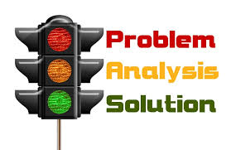

In this pattern, the main idea names a problem and indicates that one or more solutions.

The paragraph always consists of two parts: 1) a statement and 2) a description and explanation of how it was solved. There are often no signal words for the details.

* Key words/phrases in the main idea: *situation, trouble, crisis, dilemma* or *issue.*
* In the body of the paragraph, key words include: *solve, solution, resolved.*

***Task 5***

*Read the paragraph and the information below. Then underline the signal words in the paragraph.*

Beginning in the 1600s, astronomers had realized that their telescopes had serious limits. They had managed to build stronger and better telescopes, but no matter how strong the new telescopes were, they were less than satisfactory. The astronomers were able to view objects only when the objects were in view of Earth. At the same time, however, Earth's light and atmosphere made it difficult to see many heavenly objects. Thanks to the Hubble Telescope, this has been solved, because the Hubble is not just a telescope. It is a digital camera on a satellite that travels about 370 miles (600 km) above Earth, making a complete orbit every ninty-seven minutes. Since 1990, Hubble has been able to take digital pictures of planets, galaxies, comets, and more, and these are sent back to Hubble headquarters for scientists to study.

Topic:

The problem caused by telescope limitation

Main idea:

The new Hubble telescope has solved the problem of the conventional telescope

Keyword in the main idea:

New, Hubble Telescope, Solve, Problem

Supporting facts and ideas

Problem:

No matter how strong a telescope is, there are a lot of limitation for using it because of the condition of the earth

Solution:

The Hubble telescope is a digital camera on a satellite that orbiting the earth from 600 km above it

**6. Extended Definition**



In this pattern, the writer names a concept or complicated process that the paragraph will define and explain. Usually, the main idea or first sentence of the paragraph states a dictionary definition of the concept or process, followed by a description and/or an explanation. There are usually no signal words for the details.

* Key words/phrases in the main idea: *consists of, is, seems to be, are.*

***Task 6***

*Read the paragraph and the information below. Then underline the signal words in the paragraph.*

A solar eclipse is an astronomical event during which the Moon seems to cover the Sun. When the Moon passes between the Earth and the Sun, all or part of the Sun's light is blotted out. The Moon, in fact, is much smaller than the Sun, but it is also a great deal closer to the Earth. As a result, both the Sun and the Moon seem to be about the same size to us. During a total eclipse, the Sun, the Moon, and the Earth are all in a straight line and the Moon completely hides the Sun from view. A partial eclipse occurs when the three bodies are not exactly in a straight line. In an annular solar eclipse, the Sun is visible as a bright ring around the Moon because the Moon is farthest from the Earth.

Topic:

Solar eclipse

Main idea:

A solar eclipse is an astronomical event during which the Moon seems to cover the Sun.

Keyword in the main idea:

Solar, Eclipse, Astronomical, Moon, Cover, Sun

Supporting facts and ideas

Explanation or Description:

How and why a solar eclipse occurs. Three different types of solar eclipse

**Identifying patterns**

In the exercises that follow, you will practice using key words and signal words to identify the patterns. Remember that when the Extended Definition and Problem/Solution patterns are used, there are usually no signal words for the details.

**Task 7**

*A. Each paragraph has a different pattern. Working with another student, read the paragraphs and write the topic, the main idea, the key words in the main idea, and the pattern. Then add the supporting facts and ideas as shown in the examples.*

* ***Listing, Sequence, Comparison/Contrast or Cause/Effect patterns: Signal words and details***
* ***Problem/Solution pattern: The problem and the solution***
* ***Extended Definition pattern: Explanation and/or description***

**1**

**Moon Landings**

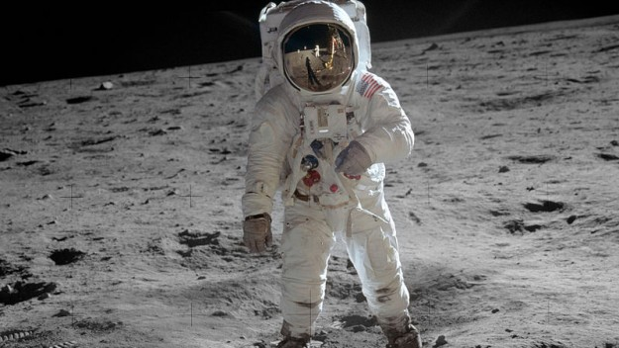

Only three and a half years passed between the first moon landing in 1969 and the sixth and last moon landing in 1972. But while the first landing was an enormous achievement in itself, the last landing contributed far more to the advancement of scientific knowledge. On the first mission, the two astronauts were on the Moon for only a few hours and remained close to the landing site.

Their time on the Moon was just sufficient to conduct several experiments and collect a small sample of lunar rocks. On the last mission, however, the three men (one of whom was a geologist) spent much more time on the lunar surface—three periods of about seven hours. With their special moon vehicle, they could travel much further from the landing site to investigate more of the lunar environment and collect a wider range of soil and rock samples.

Topic:

Moon Landings

Main idea:

The contribution of moon landing towards the advancement of scientific knowledge.

Keyword in the main idea:

Contribution, scientific, moon, landing

Pattern:

Sequence

Supporting facts and ideas:

The impact difference between the first and last moon landing, the activity which is done by the astronauts

**2**

The Apollo moon landings, may not have led to any great discovery—such as evidence 1 of life on the Moon—but it did have a significant impact on scientific and technological development in the twentieth century. One field that was undoubtedly affected by the moon landings was computer research. NASA, the U.S. space agency, did not invent the integrated circuit 2 (the basis of the computer), but it was the largest single consumer' of integrated circuits in the early 1960s. Working for the space program undoubtedly motivated computer engineers, pushing them toward the development of today's personal computer. Another related technological development that could be attributed at least in part to the Apollo program was the invention of the Internet. In this case, too, the moon landings served as an indirect motivation for scientists and engineers in their search for ways to communicate from computers in spacecraft to computers on Earth.

1. ***evidencer****:* use: facts, objects, or signs that make you believe that something exists or is true
2. ***integrated circuit****:* very small electronic parts working together as a single unit in a computer *consumer*

Topic:

The significant indirect impacts of the moon landing, which is the invention of integrated circuit and the internet

Main idea:

The Apollo moon landing may not have led to great discovery but it has an impact on scientific and technological development

Keyword in the main idea:

Discovery, impact, scientific, technological, development

Pattern:

Cause and effect

Supporting facts and ideas

The Apollo moon landing has an impact on scientific and technological development indirectly

**3**

In planning for future lunar missions, scientists are faced with one serious limitation to human exploration on the Moon, and that is the lack of water. The availability of water would make an enormous difference for humans working on the Moon for any length of time. The search for water, then, remains a high priority for space scientists. One technique that they have used is to send rockets crashing into the lunar surface. The crash creates a cloud of vapor' and dust that scientists can collect and analyze for evidence of water. Several rockets have already been sent to the Moon, but so far the results have not been conclusive. Another larger and heavier rocket, which will be sent to the moon in 2009, will have a greater impact and may produce different results. With the data from this larger rocket blast, scientists hope to establish conclusively the presence or absence of water on the Moon.

***vapor****:* a mass of very small drops of a liquid that floats in the air

Topic:

Search of water on the moon surface

Main idea:

The search of water on the moon is a high priority mission because it would greatly impact the research on the moon

Keyword in the main idea:

Search, Water, Moon, Priority

Pattern:

Listing (methods to find water)

Supporting facts and ideas

**4**

Lunar craters make travel on the Moon's surface a challenge for astronauts or robotic rovers. The surface of the Moon is marked by millions of the deep depressions or holes which are visible from the earth with just the naked eye. The craters are generally circular, range in size from a few feet to many hundreds of kilometers across, and can be surrounded by sharp mountainous peaks. They have been created by the impact of various objects—asteroids, comets, or meteorites. Since the Moon has no atmosphere to protect it from potentially dangerous objects in space, it is exposed to anything that may be in its path. The fact that there is no atmosphere on the Moon, and so no wind or rain, also means that the craters remain unchanged unless another object lands in the same spot.

Topic:

Lunar Crater

Main idea:

Because there is no atmosphere, the moon has no protection against the objects that is on it’s path thus it has a big crate from them.

Keyword in the main idea:

Atmosphere, Moon, Crate

Pattern:

Generalization/Extended Definition

Supporting facts and ideas

The craters on the moon remains the same as it’s first created, The moon has no atmosphere therefore it has no protection against meteorite and it would have no wind or rain to change the craters.