### CS171 Project Progress Final Report

**My name:** Trung Nguyen

**ID#** 14853167

**UCInetID:** [trungtn@uci.edu](mailto:trungtn@uci.edu)

By turning in this assignment, I/We do affirm that we did not copy any code, text, or data except CS-171 course material provided by the textbook, class website, or Teaching Staff.

**Part I**

**The programming language(s) and versions you used in your project:** Python 3.3

**The environment needed to compile and run your project:** Openlab machine / Ubuntu Linux with python3

**A small write up of your implementation:**

|  |  |  |  |
| --- | --- | --- | --- |
| **Heuristic Name** | **Command Line Abbreviation** | **Heuristic Type** | **Description** |
| Forward Checking | FC | Consistency Check | On an assignment of a value to a variable, each of the neighbors of the variable in the constraint graph will have inconsistent values removed from their domain. |
| Minimum Remaining Values | MRV | Variable Ordering | The next variable to be assigned a value will be the variable with the fewest number of legal moves remaining. |
| Degree Heuristic | DH | Variable Ordering | The next variable to be assigned a value will be the variable which is involved in the most number of constraints with other unassigned variables. |
| Least Constraining Value | LCV | Value Ordering | The next value to assign to a variable will be selected based on the number of constraints it places on other unassigned variables in the constraint graph, with the value causing the least number of constraints selected. |
| Arc Consistency | AC | Consistency Check | Arc consistency eliminates values from domain of variable that can  never be part of a consistent solution. |

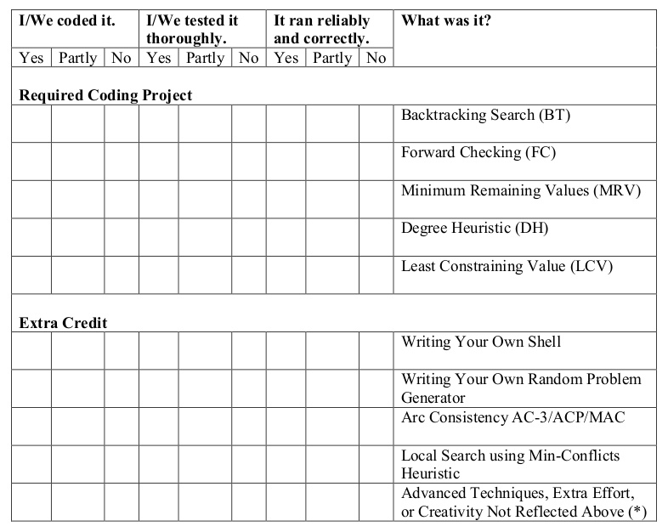

**(*) Advanced Techniques, Extra Effort, or Creativity Not Reflected Above:**

I wrote the small script automation in python3 to test all the test cases thoroughly.

Run 'python3 runtest.py' located in folder testfiles.

**Part II**

|  |  |  |  |  |  |  |  |
| --- | --- | --- | --- | --- | --- | --- | --- |
| **FC** | **MRV** | **DH** | **LCV** | **AC** | **AVERAGE # NODES** | **AVERAGE TIME** | **STD**  **DEV. TIME** |
|  |  |  |  |  | **390K+** | **1800+**  **timeout** | **0** |
| **X** |  |  |  |  | **5866.33** | **746.56** | **931.90** |
|  | **X** |  |  |  | **159411** | **600+** | **0** |
|  |  | **X**  **timeout** |  |  | **150K+** | **3600+** | **0** |
|  |  |  | **X** |  | **215614** | **1800+** | **0** |
|  |  |  |  | **X**  **timeout** | **1308** | **900+** | **0** |
| **X** | **X** | **X** | **X** |  | **3117.66** | **312.11** | **451.57** |
| **X** | **X** |  |  |  | **5782** | **607.32** | **1032.89** |

**(*) Note to TA:**

For part II: I got ***'timeout'*** on ***PH3 and PH4*** so I excluded them in these hard test cases. Only ***PH1 + PH2 + PH5 works*** for me under python3.

You can find all my result outputs under folder ***outputfiles***; I keep them as proof.

**Did you get the results you expected?**

**Why or why not?**

**Answer:**

**Yes, 70-80% reasonable**

I feel like if I have more time, I could finish running them. I believe my results are ***fast*** even with under ***limitation*** of Python ***slowness!***

***Did you implement any Advanced Techniques, Extra Effort, or Creativity not reflected***

***above? If so, please tell us what you did.***

***Answer:***

I wrote the small script automation in python3 to test all the test cases thoroughly.

*Run 'python3 runtest.py' located in folder* ***testfiles****.*

**Part III**

**Base on my result, I'm going to run FC-MRV-DH-LCV:**

|  |  |  |  |  |  |  |  |  |
| --- | --- | --- | --- | --- | --- | --- | --- | --- |
| **M** | **N** | **P** | **Q** | **R=M/N2** | **AVERAGE #NODES** | **AVERAGE TIME** | **STD. DEV. TIME** | **# (%) SOLVABLE** |
| **4** | **9** | **3** | **3** | **0.0494** |  |  |  |  |
| **8** | **9** | **3** | **3** | **0.0988** |  |  |  |  |
| **12** | **9** | **3** | **3** | **0.148** | **59.66** | **0.8825** | **0.34** | **100** |
| **16** | **9** | **3** | **3** | **0.198** |  |  |  |  |
| **17** | **9** | **3** | **3** | **0.210** |  |  |  |  |
| **18** | **9** | **3** | **3** | **0.222** | **29.33** | **0.463** | **0.1122** | **100** |
| **19** | **9** | **3** | **3** | **0.235** |  |  |  |  |
| **20** | **9** | **3** | **3** | **0.247** |  |  |  |  |
| **21** | **9** | **3** | **3** | **0.259** |  |  |  |  |
| **22** | **9** | **3** | **3** | **0.272** |  |  |  |  |
| **24** | **9** | **3** | **3** | **0.296** | **190.33** | **2.36** | **1.8** | **100** |
| **28** | **9** | **3** | **3** | **0.346** | **25.66** | **0.3279** | **0.1281** | **100** |
| **32** | **9** | **3** | **3** | **0.395** |  |  |  |  |
| **36** | **9** | **3** | **3** | **0.444** | **14** | **0.1748** | **0.1223** | **100** |

**3.2. Find the critical value of the “hardest R” for N = 9 and your best combination above.**

**Based upon your results above, you estimate the**

**“hardest R9”= 0.29**

**3.3. How does puzzle solvability for your best combination vary with R = M / N2?**

**3.3 Is the critical value for “hardest R” approximately the same as the value of R for which a random puzzle is solvable with probability 0.5?**

**I dont understand this question ?!**

**My solver is probability for 100% = 1.0**

**Part IV**

**Base on my result, I'm going to run FC-MRV-DH-LCV:**

|  |  |  |  |  |  |  |  |
| --- | --- | --- | --- | --- | --- | --- | --- |
| **“Hardest M”**  **round (N2 x R9)** | **N** | **P** | **Q** | **#(%)**  **Completed in 5 Minutes or Less** | **AVERAGE #NODES** | **AVERAGE TIME** | **STD. DEV. TIME** |
| **144*0.29 = 41.76** | **12** | **3** | **4** | **60%** | **3699.8** | **138.33** | **149** |
|  | **15** | **3** | **5** |  |  |  |  |
| **256*0.29 = 74.24** | **16** | **4** | **4** | **40%** | **9914** | **200.87** | **137.94** |
|  | **18** | **3** | **6** |  |  |  |  |
|  | **20** | **4** | **5** |  |  |  |  |
|  | **21** | **3** | **7** |  |  |  |  |
|  | **24** | **4** | **6** |  |  |  |  |
|  | **27** | **3** | **9** |  |  |  |  |
|  | **28** | **4** | **7** |  |  |  |  |
|  | **30** | **5** | **6** |  |  |  |  |
|  | **32** | **4** | **8** |  |  |  |  |
|  | **35** | **5** | **7** |  |  |  |  |