

CAPSTONE PROJECT REPORT
Report 2 – Project Management Plan

– Danang, September 2025 –
Table of Contents
I. Record of Changes 3
II. Project Management Plan 4
1. Overview 4
1.1 Scope & Estimation 4
1.2 Project Objectives 7
1.3 Project Risks 8
2. Management Approach 11
2.1 Project Process 11
2.2 Quality Management 12
2.3 Training Plan 13
3. Project Deliverables 14
4. Responsibility Assignments 15
5. Project Communications 16
6. Configuration Management 17
6.1 Document Management 17
6.2 Source Code Management 18
6.3 Tools & Infrastructures 19

I. Record of Changes
Date | A*  M, D | In charge | Change Description
18/09/2025 | A | ThanhNT | Init version — create the project management plan
19/09/2025 | M | HoangDH | Update Scope & Estimation (WBS)
20/09/2025 | M | NamLH | Update project risks and response plans
21/09/2025 | M | GiaHuyLT | Update training plan and project deliverables
22/09/2025 | M | MinhLV | Update tools & infrastructure
23/09/2025 | M | All | Align the repository structure and diagrams with the implementation source code
*A - Added M - Modified D - Deleted

II. Project Management Plan

1. Overview

1.1 Scope & Estimation
# | WBS Item | Complexity | Est. Effort  (man-days)
1 | Feature 1: Authentication & Account Management |  | 29
1.1 | Registration, Login & JWT/Refresh Tokens (bcrypt, BR-01/BR-02) | Complex | 10
1.2 | Google SSO Login (UC-03) | Medium | 6
1.3 | Forgot Password & Email Reset | Simple | 4
1.4 | First-Login Account Activation (UC-05) | Simple | 4
1.5 | Role-Based Navigation for the 6 User Roles | Simple | 5
2 | Feature 2: Patient Portal |  | 48
2.1 | Patient Dashboard (UC-06) | Medium | 8
2.2 | Declare Medical Record (UC-07) | Medium | 10
2.3 | Visit History & MRI/CT Scan Viewer (UC-08) | Medium | 10
2.4 | View AI Analysis Result — heatmap & bounding box (UC-09) | Complex | 12
2.5 | Medication Reminders & Premium Upgrade (UC-10, UC-11) | Medium | 8
3 | Feature 3: Clinical Workflow |  | 50
3.1 | Create Visit & Doctor Work Queue (UC-12, UC-13) | Medium | 8
3.2 | Order MRI Scan (UC-14) | Simple | 5
3.3 | Process MRI / PACS Queue (UC-15) | Complex | 12
3.4 | Prescribe Medication & Auto-Generated Reminders (UC-16) | Complex | 10
3.5 | End Visit / Transfer Patient (UC-17) | Simple | 5
3.6 | Invoice & PayOS Payment Confirmation (UC-18) | Complex | 10
4 | Feature 4: AI Diagnosis Core |  | 67
4.1 | CNN Ensemble (ResNet50, EfficientNet, DenseNet) with Risk-Calibrated Loss | Complex | 20
4.2 | YOLOv8 Tumor Localization | Complex | 15
4.3 | Grad-CAM Heatmap Explanation | Medium | 8
4.4 | Gemini 2.5 Flash Vision Cross-Validation | Complex | 12
4.5 | Doctor Correction & Active Learning Loop | Complex | 12
5 | Feature 5: RAG Chatbot & LLM Agents |  | 27
5.1 | RAG Chatbot (LangChain + Gemini + FAISS, protocol QD 1514) | Complex | 15
5.2 | Hippocratic Patient-Friendly Translation | Medium | 8
5.3 | Keyword Traps & Banned Words | Simple | 4
6 | Feature 6: EMR & PACS Storage |  | 56
6.1 | EMR — 14 Hospital Document Types (B2B) | Complex | 20
6.2 | Patient Health Book — 12 Personal Documents (B2C) | Medium | 10
6.3 | OCR Digitisation & CCCD/BHYT Stripping | Complex | 12
6.4 | QR Record Sharing Between Hospitals | Simple | 6
6.5 | Cloud PACS Upload (Firebase Storage) | Medium | 8
7 | Feature 7: Staff Scheduling |  | 16
7.1 | Assign Work Shifts — Weekly Grid (UC-19) | Medium | 6
7.2 | Request Shift Swap (UC-20) | Medium | 5
7.3 | Review Swap Request & Email Result (UC-21) | Medium | 5
8 | Feature 8: Pharmacy & Medication Management |  | 23
8.1 | Update Drug Stock (UC-22) | Simple | 5
8.2 | Medicine Reminder Generation (drug × day × slot, BR-06) | Medium | 8
8.3 | Mark Medication as Taken (UC-10) | Simple | 4
8.4 | Prescription Validation & Dispensing | Medium | 6
9 | Feature 9: Hospital Onboarding |  | 20
9.1 | Provision Temp Hospital Account & Drive Structure (UC-23) | Medium | 6
9.2 | Submit Onboarding Information & License (UC-24) | Medium | 8
9.3 | Activate Hospital — Email Switch-Over (UC-25) | Medium | 6
10 | Feature 10: Admin Backoffice |  | 30
10.1 | Lock / Unlock User Account (UC-26) | Simple | 4
10.2 | View System Statistics (UC-27) | Medium | 8
10.3 | Audit Log Viewer (SQLite audit_logs.db) | Medium | 8
10.4 | Verify Tenant Isolation (UC-28) | Complex | 10
11 | Feature 11: Nursing & Vitals |  | 20
11.1 | Care Sheets per Shift | Medium | 8
11.2 | Vital-Sign Tracking (Blood Pressure, Pulse, SpO2, Temperature) | Medium | 8
11.3 | Inpatient Progression & Hand-over Notes | Simple | 4
12 | Feature 12: Security & Compliance |  | 28
12.1 | JWT Authentication & 6-Role RBAC | Complex | 12
12.2 | Audit Logs of Medical-Data Operations | Medium | 8
12.3 | HIPAA Masking & Decree 13/2023/ND-CP Compliance | Medium | 8
13 | Testing & Quality Assurance |  | 40
13.1 | Unit Testing (Jest + fast-check + mongodb-memory-server) | Medium | 12
13.2 | Integration Testing | Medium | 10
13.3 | System Testing (6 seeded role accounts) | Medium | 10
13.4 | User Acceptance Testing | Simple | 8
14 | DevOps & Deployment |  | 12
14.1 | Repository & Environment Setup (BE / FE / AI Server) | Medium | 6
14.2 | Seed Data & Production Deployment | Medium | 6
15 | Documentation & Reports |  | 28
15.1 | Project Introduction Document | Simple | 3
15.2 | Project Management Plan | Medium | 4
15.3 | Software Requirements Specification (SRS) | Complex | 6
15.4 | Software Design Document (SDD) | Complex | 6
15.5 | Software Test Document (STD) | Medium | 5
15.6 | Software User Guides | Medium | 4
Total Estimated Effort (man-days) |  |  | 494

1.2 Project Objectives
To develop a smart healthcare platform that unifies cloud PACS, electronic medical records (EMR) and AI-assisted brain-tumor diagnosis from MRI/CT scans with a medical-ethics RAG chatbot. The system delivers an explainable second opinion through a CNN ensemble with YOLOv8 localization and Grad-CAM heatmaps, serves six user roles — patients, doctors, nurses, technicians, receptionists and administrators — and protects medical data with HIPAA-grade masking and Decree 13/2023/ND-CP compliance, while giving patients a personal health book with QR cross-hospital sharing.
# | Testing Stage | Test Coverage | No. of Defects | % of Defect | Notes
Reviewing | 100% | ≤ 5 | ≤ 2% | All code must be reviewed before merge | All code must be reviewed before merge
Unit Test | ≥ 80% | ≤ 10 | ≤ 5% | Critical business logic and the AI pipeline (Jest + fast-check) | Critical business logic coverage
Integration Test | ≥ 70% | ≤ 15 | ≤ 8% | FE–BE REST API, BE–FastAPI proxy and database integration | API and database integration
System Test | ≥ 60% | ≤ 20 | ≤ 10% | End-to-end workflows of all six roles | End-to-end functionality
Acceptance Test | 100% | ≤ 5 | ≤ 3% | User acceptance with the seeded test accounts | User acceptance criteria

Milestone Timeliness (%): 95% (All major milestones delivered on time)
Allocated Effort (man-days):
- Requirements Analysis & Design: 74 man-days (15%)
- Development & Coding: 296 man-days (60%)
- Testing & Quality Assurance: 74 man-days (15%)
- Project Management & Coordination: 25 man-days (5%)
- Documentation & Training: 25 man-days (5%)

1.3 Project Risks
# | Risk Description | Impact | Possibility | Response Plans
1 | AI Model Accuracy and Misdiagnosis Risk | High | Medium | - Ensemble of three CNNs with a risk-calibrated loss instead of a single model  - Gemini 2.5 Flash Vision cross-checks whenever the models disagree  - Every AI result requires doctor confirmation before entering the EMR  - Active Learning retrains the models on doctor-corrected hard cases
2 | External AI API Dependency (Gemini Quota) | Medium | Medium | - Graceful fallback to the local ensemble prediction when the quota is exhausted  - Monitor API usage and cache cross-check results where possible  - Asynchronous job processing so scans are never blocked  - Document rate limits and provision backup API keys
3 | Medical Data Security & Privacy (HIPAA, Decree 13/2023) | High | Medium | - OCR rules and input validation automatically strip CCCD/BHYT identifiers  - HIPAA-grade masking before any external AI call  - JWT with expiry and 6-role RBAC; patients visible only to assigned staff  - Audit logs trace every create/update/delete on medical data
4 | Large Model Weights & Environment Drift | Medium | Medium | - Model weights (.keras, .pt) are excluded from Git; provisioning is documented  - Pin Python 3.9–3.11 for the AI server and Node.js 18+ for the backend  - Use a virtual environment with a pinned requirements.txt  - Run an integration smoke test after every weight update
5 | Image Upload & Storage Performance | Medium | Medium | - Firebase Storage for cloud PACS uploads with compression and thumbnails  - MongoDB indexing on patient and visit identifiers  - Asynchronous upload queue on the Expo client  - Load-test the PACS queue with bulk MRI/CT studies
6 | Team Knowledge Gap (ML / FastAPI Stack) | Medium | High | - Training plan covers FastAPI, deep learning and LangChain RAG in weeks 4–6  - Pair programming between the AI owner and the backend developers  - Reuse the documented FastAPI endpoints from the architecture notes  - Allocate buffer time for the learning curve
7 | Third-Party Service Downtime (Firebase, MongoDB, PayOS) | Medium | Low | - Local MongoDB fallback for development and demonstrations  - Cache critical data on the client  - PayOS sandbox testing with a manual invoice fallback  - Monitor service status pages and schedule maintenance windows
8 | Scope Creep Across 28 Use Cases | High | Medium | - Strict sprint scope agreed at sprint planning  - Change requests evaluated against the WBS effort baseline  - Regular sprint reviews with the mentor  - Defer non-critical features to the product backlog
9 | Integration Complexity Across 3 Services (FE 8083, BE 3000, AI 8000) | High | Medium | - Define REST API contracts early  - update-ip.js automates backend IP configuration on the frontend  - Cross-service integration testing in every sprint  - Feature branches integrate into the working branch weekly
10 | Cross-Platform Behaviour (Expo Web vs Mobile) | Medium | Medium | - Verify the Web build first, then test the core mobile screens  - Responsive TailwindCSS v4 components  - Provide device compatibility guidelines  - Progressive rollout of advanced screens
11 | Team Coordination and Communication Issues | Medium | Medium | - Daily stand-up meetings  - Jira task tracking and Slack channels  - Clear responsibility assignments (RASCI)  - Weekly team meeting with mentor feedback
12 | Patient Understanding & Medical-Ethics Concerns | Medium | Low | - Hippocratic AI explanations that never alarm patients  - Keyword traps refuse dangerous chatbot requests (no lifespan predictions)  - Plain-language user guides and pilot testing  - Always direct patients to specialist doctors

2. Management Approach
The NeuroScan AI project is managed using the Scrum Agile methodology to ensure iterative development, continuous mentor feedback and adaptive planning across its 28 use cases. The work is divided into four iterations — Authentication & Patient Portal, Clinical Workflow & AI Diagnosis, Staff Scheduling & Pharmacy and Hospital Onboarding & Admin Backoffice — each ending with a reviewed, working increment of the three services (Expo React Native frontend, Node.js Express gateway and FastAPI AI server). This approach allows the team to adapt to clinical requirements quickly while keeping medical-data quality, security and HIPAA / Decree 13/2023 compliance under continuous control.

2.1 Project Process
Our team selected the Scrum framework, an Agile methodology, to guide the development process of the NeuroScan AI project. Here’s why we chose Scrum:
- Greater Flexibility (and Lower Risk):
- Scrum’s iterative sprints enable the team to adapt quickly to evolving clinical requirements and mentor feedback in the NeuroScan AI project. By working in short cycles, the team regularly re-prioritises the 28-use-case backlog, reassesses AI-accuracy findings and keeps the build aligned with real hospital workflows, reducing the risk of developing irrelevant features.
- Ongoing Enhancement:
- Sprint reviews and retrospectives drive continuous improvement, which is critical for a medical platform combining EMR, PACS and AI diagnosis. Each sprint lets the team refine components such as the MRI/CT shooting queue, the ensemble diagnosis pipeline and the EMR document lifecycle, addressing issues early before they grow into clinical risks.
- Quicker Deliveries:
- By dividing the project into four focused iterations, Scrum enables incremental delivery of specific modules — patient authentication, clinical workflow, scheduling & pharmacy and onboarding & admin. This approach supports early testing with the seeded six-role accounts and smooth integration of the three services (FE port 8083, BE port 3000, AI port 8000), minimising last-minute integration challenges.
- Stronger Team Dynamics:
- Scrum encourages collaboration, transparency and ownership through defined roles, sprint planning and daily stand-ups. In a project with demanding technical, security and medical-ethics requirements, this empowers all five members to tackle challenges creatively, share AI/BE/FE knowledge and stay engaged from admission to discharge workflows.
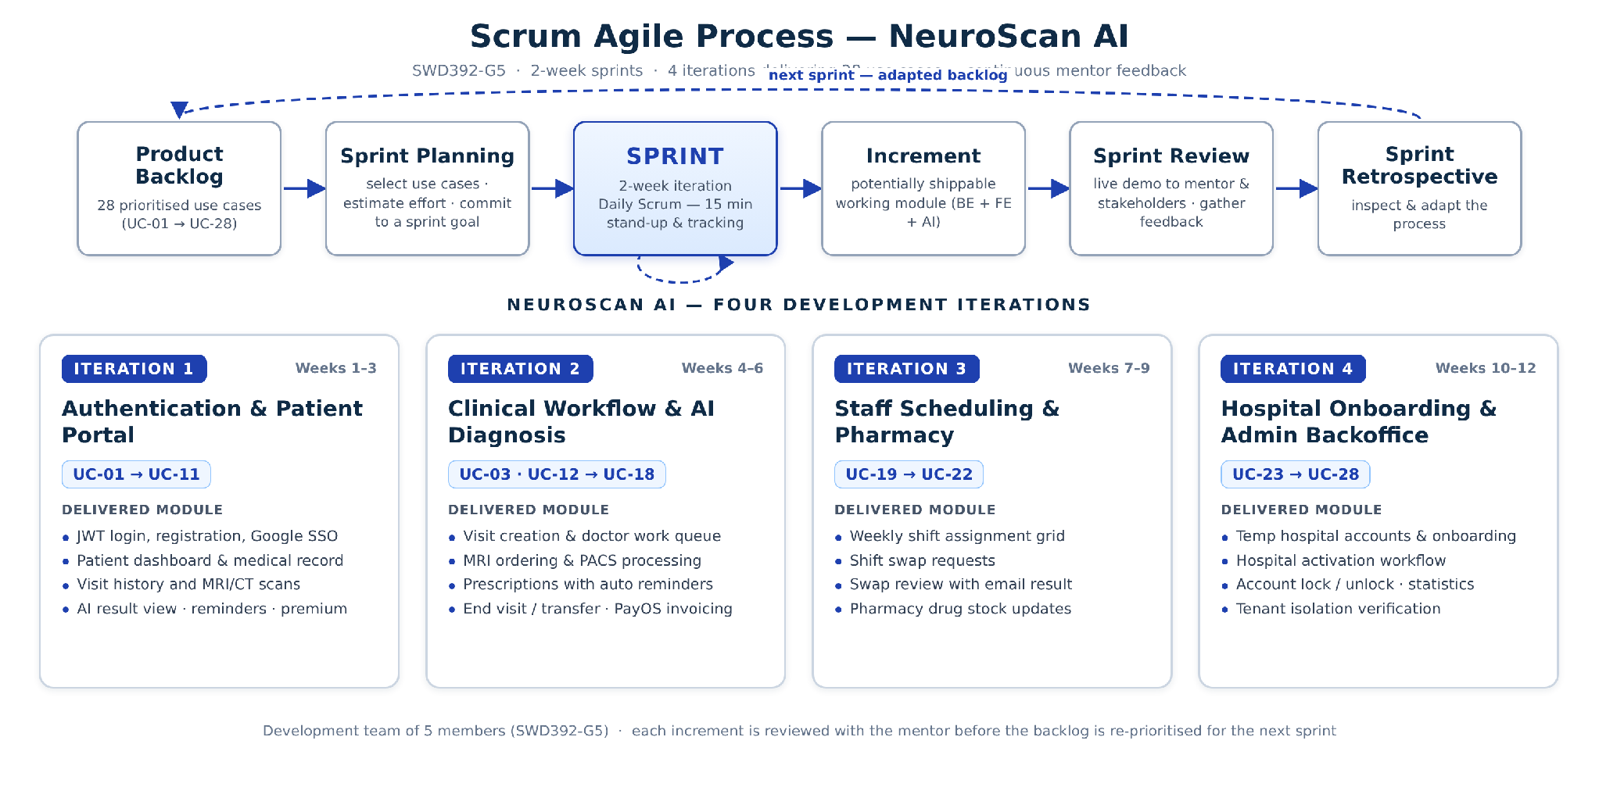

2.2 Quality Management
Quality Assurance Approach:
- Defect Prevention:
Code review process for all pull requests on the working branch (Huyle_MRI/CT)
Pair programming for the AI pipeline and security-critical middlewares
Early requirement validation with the mentor and clinical workflow review
Continuous integration to catch issues early
- Reviewing:
Code Reviews: Mandatory for all code changes
Design Reviews: System architecture and database schema validation
Documentation Reviews: Technical documentation accuracy
Security Reviews: Regular assessment of medical-data handling and access control
- Unit Testing:
Minimum 80% code coverage for critical business logic
Jest with fast-check (property-based testing) and mongodb-memory-server so tests run without a live database
Test-driven development for complex algorithms (ensemble voting, reminder generation)
Mock objects for external dependencies (Gemini API, Firebase, PayOS)
- Integration Testing:
API integration testing between the Expo frontend, Express gateway and FastAPI AI server
Database integration testing against the MongoDB/Mongoose models
Third-party service integration testing (Firebase Storage, Gemini, PayOS sandbox)
End-to-end workflow testing across the six roles
- System Testing:
Performance testing under load (PACS upload, AI inference queue)
Security penetration testing of JWT/RBAC endpoints
User acceptance testing with the seeded test accounts
Cross-platform compatibility testing (Expo Web build and mobile screens)
Quality Metrics:
- Defect density: ≤ 2 defects per 1000 lines of code
- Test coverage: ≥ 80% for critical modules
- Code review coverage: 100%
- Performance benchmarks: API response time ≤ 2 seconds; AI diagnosis result ≤ 30 seconds per scan

2.3 Training Plan
Training Area | Participants | When, Duration | Waiver Criteria
Node.js, Express & REST API Design | HoangDH, NamLH | Week 1–2, 12 hours | Mandatory
MongoDB & Mongoose Schemas | HoangDH, NamLH, MinhLV | Week 2, 8 hours | Mandatory
React Native & Expo (Web + Mobile) | All team members | Week 3, 12 hours | Mandatory
React Navigation & TailwindCSS UI | ThanhNT, GiaHuyLT | Week 3, 8 hours | Mandatory
Python FastAPI & Uvicorn | GiaHuyLT, MinhLV | Week 4, 10 hours | Mandatory
Deep Learning: CNN Ensemble, YOLOv8 & Grad-CAM | GiaHuyLT, NamLH | Week 5, 16 hours | Mandatory
Gemini API & LangChain RAG (FAISS) | GiaHuyLT, ThanhNT | Week 6, 10 hours | Mandatory
Firebase Storage & Cloud PACS | HoangDH, MinhLV | Week 5, 6 hours | Mandatory
Git, GitHub & Branching Strategy | All team members | Week 1, 4 hours | Mandatory
Jira Project Management | All team members | Week 1, 2 hours | Mandatory
Testing: Jest, fast-check & mongodb-memory-server | All team members | Week 6, 6 hours | Mandatory

3. Project Deliverables
# | Deliverable | Due Date | Notes
1 | Project Charter & Requirements Document | 11/09/2025 | Initial project scope and requirements
2 | System Architecture & Database Design | 18/09/2025 | Three-service architecture (FE :8083, BE :3000, AI :8000) and MongoDB schemas
3 | Project Management Plan | 25/09/2025 | This document — WBS, risks, RASCI and configuration management
4 | Software Requirements Specification | 02/10/2025 | 28 use cases with actors, flows and business rules
5 | Software Design Document | 09/10/2025 | Sequence diagrams, ER model and API contracts
6 | Backend API Core Modules | 16/10/2025 | Authentication, JWT, 6-role RBAC and user management
7 | Backend API Clinical Modules | 23/10/2025 | Visits, EMR documents, PACS queue and prescriptions
8 | AI Server — Ensemble & Localization | 30/10/2025 | ResNet50/EfficientNet/DenseNet + YOLOv8 + Grad-CAM
9 | AI Server — Gemini Cross-Check & RAG Chatbot | 06/11/2025 | LangChain + FAISS documents + chatbot configuration
10 | Frontend Core Screens | 13/11/2025 | Expo React Native Web — authentication, patient portal, dashboards
11 | Frontend Clinical & PACS Screens | 20/11/2025 | Work queue, MRI upload and AI result viewer
12 | Hospital Onboarding & Admin Modules | 27/11/2025 | Temp accounts, activation, statistics and audit logs
13 | Seed Data & Test Accounts | 27/11/2025 | seed.js, seedEMR.js, seedBiomarkers.js — six role accounts
14 | Testing & Quality Assurance | 04/12/2025 | Unit, integration and system testing completion
15 | User Acceptance Testing | 11/12/2025 | UAT with the six seeded role accounts
16 | Production Deployment | 18/12/2025 | Live deployment of the three services and go-live
17 | User Training & Documentation | 22/12/2025 | User manuals and training materials
18 | Project Closure & Handover | 29/12/2025 | Final documentation, handover and project closure

4. Responsibility Assignments
D~Do; R~Review; S~Support; I~Informed; <blank>- Omitted
Responsibility | ThanhNT | HoangDH | NamLH | GiaHuyLT | MinhLV
Project Planning & Tracking | D | S | S | S | S
Prepare Project Introduction Document | D | S | S | S | S
Prepare SRS Document (Overview Part) | D | R | R | R | R
Prepare SRS Document (User Requirements) | I | D | S | S | S
Prepare Use Case Specifications | I | D | S | S | S
Prepare Software Design Document | D | D | D | D | D
Coding Front-end (Expo React Native) | D | S | S | D | D
Coding Back-end (Node.js Express) | S | D | D | S | S
Coding AI Server (Python FastAPI) | I | S | S | D | I
Prepare Software Test Documentation | D | S | S | S | S
Prepare Unit Test Document | I | D | S | S | S
Testing | D | D | D | D | D
Prepare Software User Guides | I | S | S | S | D
Deployment | S | D | S | S | S
Prepare Project Report | D | S | S | S | S
Prepare Presentation Slides | D | S | D | S | S

5. Project Communications
Communication Item | Who/ Target | Purpose | When, Frequency | Type, Tool, Method(s)
Daily Standup Meetings | All Team Members | Progress updates, impediment identification | Daily, 15 minutes | Face-to-face / Video call, Slack
Sprint Planning | All Team Members | Define sprint goals, select use cases from the backlog | Every 2 weeks, 2 hours | Face-to-face, Jira
Sprint Review | All Team Members + Mentor | Demo completed features, gather feedback | End of each sprint, 2 hours | Presentation, live demo
Sprint Retrospective | All Team Members | Process improvement, lessons learned | After sprint review, 1 hour | Discussion
Weekly Team Meeting | All Team Members | Project status, technical discussions | Weekly, 1 hour | Face-to-face / Video call, Slack
Code Review Sessions | Developers | Code quality, knowledge sharing | As needed, 30–60 minutes | Pull requests, GitHub
Issue Escalation | Team Members | Problem resolution, decision making | As needed | Slack
Technical Discussions | Developers | Problem solving, best practices | Daily | Slack channels, GitHub issues

6. Configuration Management

6.1 Document Management
All documents for the NeuroScan AI project are managed on Google Drive, with edit permissions restricted to the five team members only. Additionally, we always prepare a backup in case of accidental deletion or other unforeseen issues. The folder structure is organised as shown below:
- Dev Guideline: Coding standards, branching strategy, commit conventions, review checklist, environment setup guides (Node.js 18+, Python 3.9–3.11, MongoDB).
- Ideas: Product ideas, feature proposals, brainstorming notes, feasibility assessments.
- Meetings: contains agendas, meeting minutes and mentor consultation notes.
- Notes: contains daily/weekly notes, technical findings, troubleshooting logs, decision records.
- Report: contains project reports (Project Introduction, Project Management Plan, SRS, SDD, STD).
- UI/UX: contains wireframes, mockups, design systems, assets, prototypes, usability findings.

Folder | Meaning
Dev Guideline | This folder includes development guidelines, particularly regarding Express API design, FastAPI service conventions and MongoDB provisioning.
Ideas | This folder holds documents outlining project ideas.
Meetings | This folder includes meeting minutes and notes.
Notes | This folder includes notes on system features and technical findings.
Report | This folder includes project report documents.
UI/UX | This folder contains documents related to user interface and user experience design.

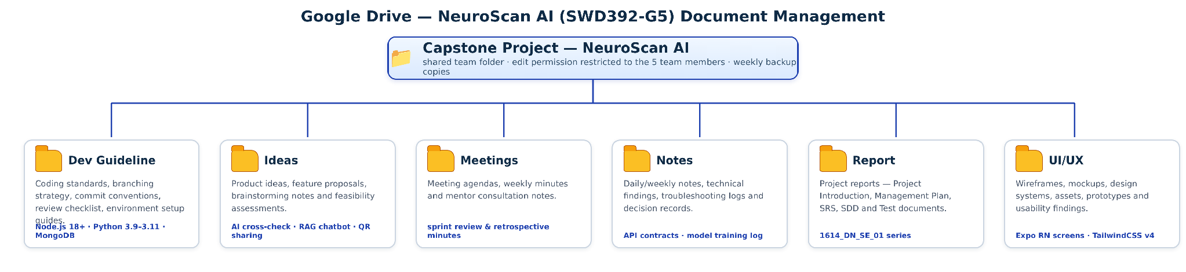

6.2 Source Code Management
Source Code Management Strategy:
- Repository Structure: Single repository (mono-repo) hosting all three services of NeuroScan AI — github.com/ntthanh2357/mri
- Repository Organization:
BE/: Node.js Express API Gateway (port 3000) — authentication, RBAC, business logic and the AI proxy
FE/: Expo React Native Web & Mobile application (port 8083) — all six-role user interfaces
MRIteam_team5/MRIteam/: Python FastAPI AI Server (port 8000) — ensemble diagnosis, localization, explainability and the RAG chatbot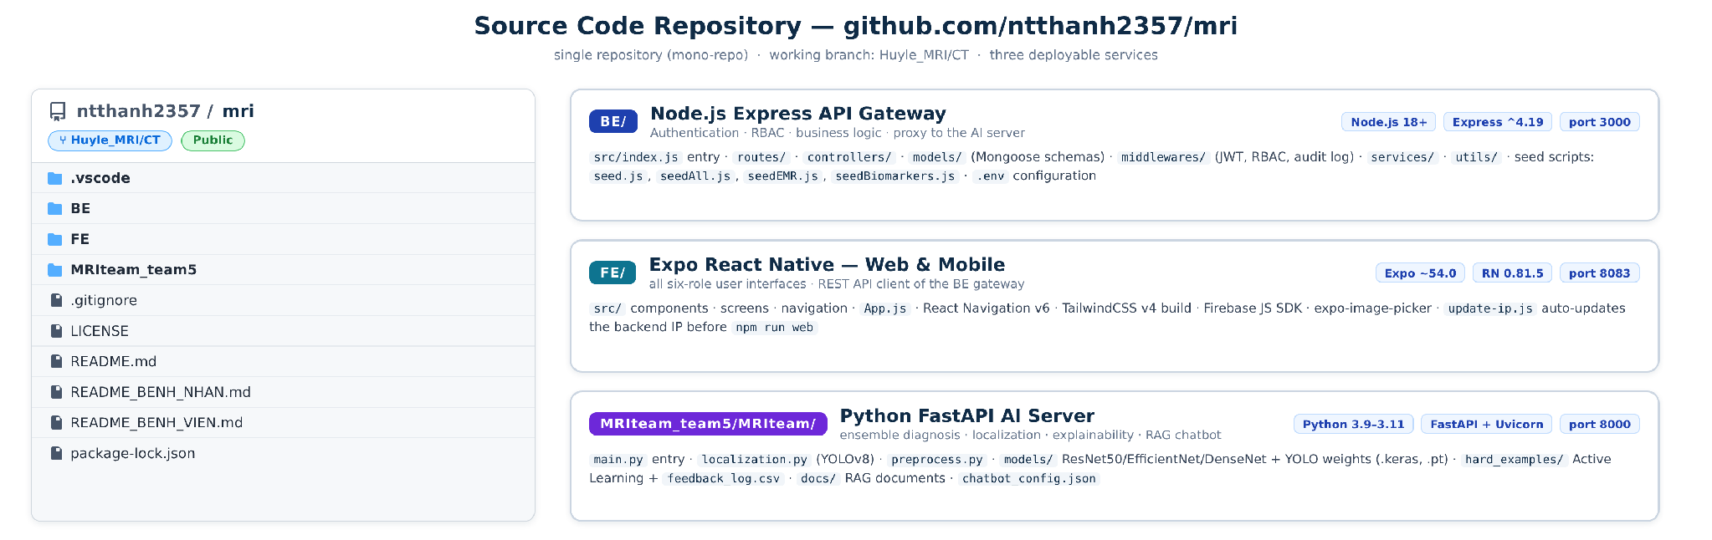
- Branching Strategy: main branch for stable releases, the Huyle_MRI/CT working branch for integration, and feature branches for individual use cases
- Code Review Process: Mandatory pull request reviews before merging into the working branch
- Commit Standards: Conventional commits with clear, task-referencing messages
- Automated Testing: Jest with fast-check and mongodb-memory-server runs the backend suite without a live database (NODE_OPTIONS=--experimental-vm-modules)
- Code Quality: ESLint and Prettier for consistent code style across the repository
- Repository Structure:
- BE/ — Node.js Express API Gateway:
src/index.js entry point listening on port 3000
routes/, controllers/, services/ and utils/ — API endpoints and business logic
models/ — Mongoose schemas for users, visits, EMR documents and subscriptions
middlewares/ — JWT authentication, 6-role RBAC and audit-log recording
seed scripts — seed.js, seedAll.js, seedEMR.js and seedBiomarkers.js for test data
.env configuration — MONGO_URI, JWT_SECRET, PORT, FIREBASE_PROJECT_ID
- FE/ — Expo React Native application:
src/ — components, screens and navigation for the six roles
App.js — application entry point
React Navigation v6 for role-based navigation
TailwindCSS v4 (CLI build) for styling
Firebase JS SDK and expo-image-picker for uploads
update-ip.js — auto-updates the backend IP before npm run web
- MRIteam_team5/MRIteam/ — Python FastAPI AI Server:
main.py — FastAPI entry point served by Uvicorn on port 8000
localization.py — YOLOv8 tumor bounding-box detection
preprocess.py — MRI image preprocessing pipeline
models/ — model weights (best_resnet_model.keras, best.pt) provisioned manually due to size
hard_examples/ — Active Learning store with feedback_log.csv of doctor corrections
docs/ + chatbot_config.json — RAG documents and chatbot system-prompt configuration
- Branching Model (applied to the repository):
main: production-ready code
Huyle_MRI/CT: integration branch for all features
feature/[feature-name]: individual use-case development
release/[version]: release preparation
hotfix/[issue]: critical bug fixes
- Code Review Requirements:
Minimum 2 reviewers for critical changes
All tests must pass before merge
Code coverage requirements met
Security scan passed

6.3 Tools & Infrastructures

Category | Tools / Infrastructure
Technology | Expo React Native 0.81 (Frontend, port 8083), Node.js 18+ & Express 4.19 (Backend, port 3000), Python 3.9–3.11 & FastAPI (AI Server, port 8000)
Database | MongoDB + Mongoose 8.3, Firebase Storage (cloud PACS), SQLite (audit_logs.db)
AI / ML | ResNet50 · EfficientNet · DenseNet (Keras/TensorFlow), YOLOv8 (Ultralytics), Grad-CAM, Gemini 2.5 Flash Vision, LangChain + FAISS (RAG)
IDEs/Editors | Visual Studio Code, Android Studio
Diagramming | DrawIO, StarUML
Documentation | MS Office, Google Docs/Sheets/Slides
Version Control | GitHub (Source Code — ntthanh2357/mri, branch Huyle_MRI/CT), Google Drive (Documents)
Project management | Jira (Tasks, Sprints, Defects), Slack (Communication)
Testing | Jest, fast-check (property-based), mongodb-memory-server (in-memory database)

