Mall Insight Technical Requirements
L1 Dashboard KPIs and Behavioral Segment Movement
1. Core L1 KPI Definitions
These calculations evaluate the value and penetration of members shopping at both companies in the same visit.
- Dual Members: The total count of distinct members who have $≥1$ transaction at AVN and $≥1$ transaction at AMV within the same-day session.
  - countIf(Company='AVN') > 0 AND countIf(Company='AMV') > 0
- Dual-Shopper Rate: Percentage of the total purchasing member base that qualifies as Dual Members.
$$\text{Dual-Shopper Rate}=\left(\frac{\text{Dual Members}}{\text{Total Purchasing Members}}\right)×100\%$$
- Dual Spend Share (%): Compares the average spend of a dual shopper against the average spend of all purchasing members.
$$\text{Dual Spend Share}=\left(\frac{\text{Avg Spend per Dual Member}}{\text{Avg Spend per Total Purchasing Member}}\right)×100\%$$
- Incremental Spend (%): The percentage increase in average spend of dual shoppers compared to single-company shoppers.
$$\text{Incremental Spend}=\left(\frac{{\text{Avg Spend}}_{\text{Dual}}-{\text{Avg Spend}}_{\text{Single}}}{{\text{Avg Spend}}_{\text{Single}}}\right)×100\%$$
2. Behavioral Segment Conditions
- Single-Mall: Members who generated transactions exclusively at one mall during the evaluated period.
Là những thành viên chỉ phát sinh giao dịch duy nhất tại đúng 1 mall trong suốt khoảng thời gian được đánh giá (không phát sinh mua sắm ở các mall khác trong hệ thống)
  - uniqExact(Mall_ID) = 1
- Single-Visit: Members who visited the mall on exactly one day during the evaluated period.
Là những thành viên chỉ đến mall và mua sắm trong đúng 1 ngày duy nhất trong khoảng thời gian được đánh giá (độ sâu ghé thăm / tần suất trung bình bằng 1)
  - uniqExact(toDate(Transaction_DT)) = 1
- Duo: Là những thành viên phát sinh ít nhất 1 giao dịch tại AVN VÀ ít nhất 1 giao dịch tại AMV trong cùng một ngày
3. Key Movement Logic (Single-Mall)
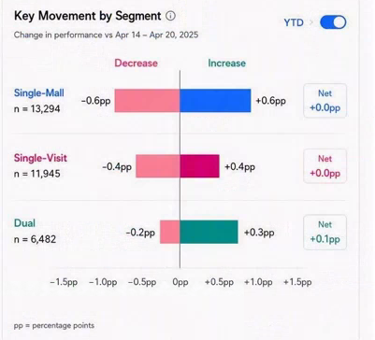
The Divergent Bar Chart measures the net migration of members into and out of the Single-Mall segment compared to the previous period. Note that "Total Purchasing Members" corresponds to the metric 1.11a base.
Movement Type | Business Logic | Formula (Percentage Points)
Increase (+pp) (Blue) | Members newly joining the Single-Mall segment.( Members who were not in the Single-Mall segment in the previous period but are in the current period.) | $$\left(\frac{\text{Count}\left(\text{Curr}=1\text{ Mall}\text{ and }\text{Prev}≠1\text{ Mall}\right)}{{\text{Total Purchasing Members}}_{\text{Curr}}}\right)×100$$
Decrease (-pp) (Pink) | Members abandoning the Single-Mall segment.( Members who left the Single-Mall segment in the current period.) | $$\left(\frac{\text{Count}\left(\text{Prev}=1\text{ Mal}\text{l and }\text{Curr}≠1\text{ Mall}\right)}{{\text{Total Purchasing Members}}_{\text{Prev}}}\right)×100$$
Net | The absolute net percentage point change. | $$\text{Increase}+\text{Decrease}$$
4. ClickHouse SQL Implementation
SQL
WITH
-- 1. Identify unique Malls visited by each Member per period
member_stat AS (
SELECT
Member_ID,
uniqExactIf(Mall_ID, Transaction_DT BETWEEN {prev_start} AND {prev_end}) AS prev_malls,
uniqExactIf(Mall_ID, Transaction_DT BETWEEN {curr_start} AND {curr_end}) AS curr_malls
FROM TB_Member_Consumption
WHERE IsDelete = 0
AND Transaction_DT BETWEEN {prev_start} AND {curr_end}
GROUP BY Member_ID
HAVING prev_malls > 0 OR curr_malls > 0
),
-- 2. Establish Total Purchasing Members denominators
totals AS (
SELECT
countIf(prev_malls > 0) AS total_prev,
countIf(curr_malls > 0) AS total_curr
FROM member_stat
)
SELECT
'Single-Mall' AS segment,
countIf(curr_malls = 1) AS n,
-- Increase (+pp)
round(countIf(curr_malls = 1 AND prev_malls != 1) * 100.0 / any(total_curr), 1) AS increase_pp,
-- Decrease (-pp)
-round(countIf(prev_malls = 1 AND curr_malls != 1) * 100.0 / any(total_prev), 1) AS decrease_pp,
-- Net Change (pp)
round(increase_pp + decrease_pp, 1) AS net_pp
FROM member_stat, totals;

L2 Characteristics – Shopper Behavior
- I. Spend Change After Starting Dual Usage
The "Spend Change After Starting Dual Usage" cohort trend chart tracks the cumulative percentage change in a customer's total spend relative to their personal baseline following their first dual-company visit. Below is the business logic and a concrete example for BI Developers to implement this directly.
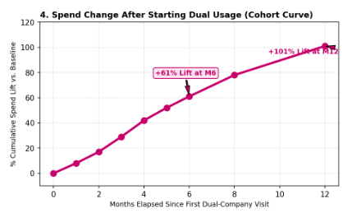

1. Core Calculation Logic (Cohort Math)
- Identify Month T0 (Activation): The system scans the transaction history to identify the first month (Month 0) in which a customer generates a transaction at AVN and a transaction at AMV within the same-day session.
- Calculate the Baseline: Retrieve the customer's total spend during the 3 months immediately prior to their first dual usage, then divide by 3 to establish their average monthly spend before conversion.
- Calculate Cumulative Spend (Y-axis): For each month (from 0 to 12) following activation, calculate the customer's cumulative average monthly spend (total spend from T0 to Tn divided by the number of elapsed months). Then calculate the percentage variance of this cumulative average against the Baseline.
- X-axis (Relative Time): Standardize all customers to a shared starting line spanning 0 to 12 months from their personal T0, disregarding actual calendar months. The final chart aggregates and displays the average percentage change across all customers at each monthly milestone.
2. Implementation Example
Assume User A makes their first dual-usage purchase in September (T0).
Cohort Milestone | Actual Calendar Month | Actual Total Spend | Cumulative Average Spend (T0 to Tn) | Growth Rate (Y-axis)
Baseline (3 Months) | June, July, Aug | 1.0M, 1.5M, 0.5M | 1.0M (Avg. 3 months prior to T0) | -
Month 0 (T0) | September | 1.08M | 1.08M / 1 month = 1.08M | (1.08 - 1.0) / 1.0 = +8%
Month 1 (T1) | October | 1.26M | (1.08M + 1.26M) / 2 = 1.17M | (1.17 - 1.0) / 1.0 = +17%
Month 2 (T2) | November | 1.53M | (1.08M + 1.26M + 1.53M) / 3 = 1.29M | (1.29 - 1.0) / 1.0 = +29%
3. Data Prep Notes for BI Developers
BI engineers must generate a derived table to assign a cohort_month = 0 flag for each Member_ID based on the date of their first dual transaction. Subsequent transactions are evaluated based on the elapsed month gap (months_between) from the cohort_month. If a customer generates no purchases in any specific month post-T0, the spend for that month is recorded as 0, but the denominator (cumulative months) must still increment to ensure the average value remains mathematically accurate.
- II. Monthly Visit Days Distribution
The Monthly Visit Days Distribution chart belongs to the L2 (Analysis) layer, categorizing shoppers by the number of days they visit the mall per month to directly compare frequency patterns between dual-company shoppers and single-company shoppers.
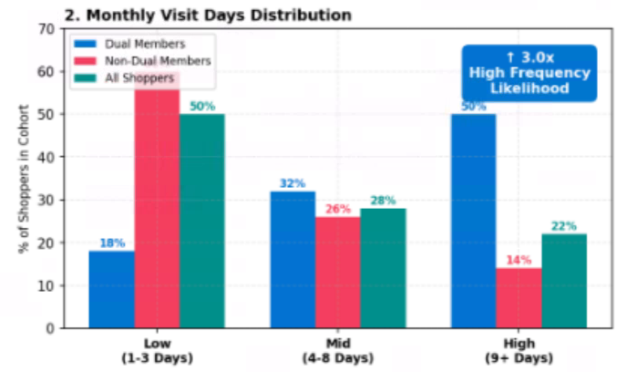
1. Cohort Targeting Logic
- Dual Members (Blue): Members who generate at least one transaction at AVN and at least one transaction at AMV within the same-day session.
- Non-Dual Members (Pink/Red): Members who generate transactions at only one company (either AVN or AMV) during the evaluated period.
- All Shoppers (Teal/Green): The average distribution baseline of all members with valid purchasing transactions at the mall.
2. Calculation Mechanism (Metrics & Dimensions)
- X-axis (Frequency Tiers): The system counts the distinct visit days for each individual customer within the month. Shoppers are then categorized into three fixed tiers: Low (1-3 days), Mid (4-8 days), and High (9+ days).
- Y-axis (% of Shoppers): Measures the percentage of members falling into each frequency tier, calculated against the total size of that specific cohort. The sum of the three columns belonging to the same color/cohort (Low + Mid + High) will always equal 100%.
- Dynamic Callout (if possible; otherwise place below the chart): The 3.0x multiplier is calculated by dividing the percentage of High-frequency Dual Members by the percentage of High-frequency Non-Dual Members. This indicates that Dual Members are 3.0 times more likely to be High-frequency visitors than Non-Dual Members.
3. Mathematical Example
Assume the system records a total of 1,000 Dual Members in a given reporting month.
Frequency Tier (X-axis) | Actual Customer Count | Y-axis Calculation Formula | Chart Display
Low (1-3 Days) | 180 customers visiting 1 to 3 days | (180 / 1000) * 100% | Blue column at 18%
Mid (4-8 Days) | 320 customers visiting 4 to 8 days | (320 / 1000) * 100% | Blue column at 32%
High (9+ Days) | 500 customers visiting 9 or more days | (500 / 1000) * 100% | Blue column at 50%

- III. Weekly Spending Distribution
From our database have P25,…p90 as below:
- p25_weekly_spend: 278,691.5 VND
- p50_weekly_spend (median): 558,122.38 VND
- p75_weekly_spend: 1,037,218.4 VND
- p90_weekly_spend: 1,781,619.9 VND
So We going to define(considering) : Low: < 500K
Mid: 500K to < 1,000K
High: ≥ 1,000K
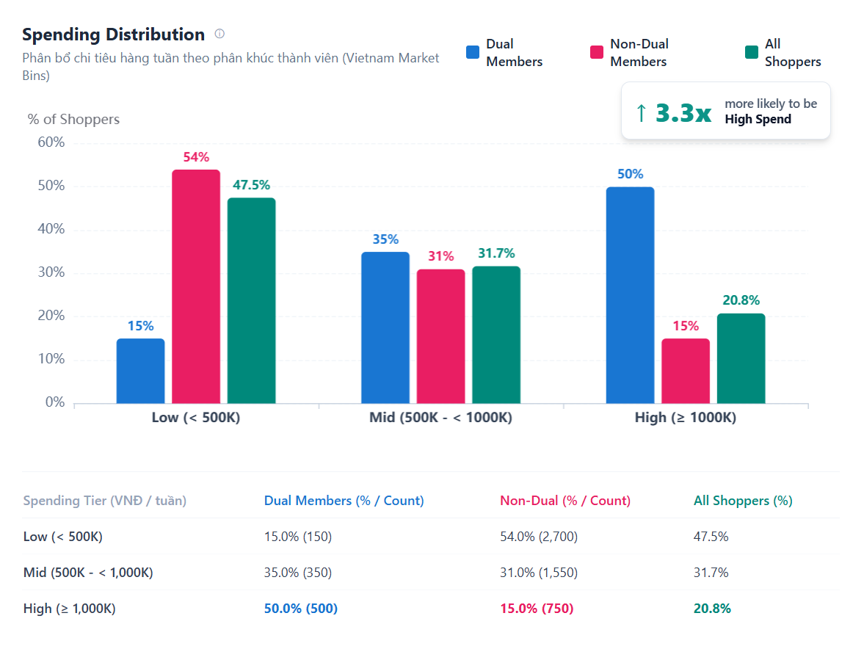
1. Cohort Targeting Logic
The visualization evaluates three member segments across identical weekly spending intervals:
- Dual Members (Blue): Members who generate at least one transaction at AVN and at least one transaction at AMV within the same calendar day during the evaluated week.
- Non-Dual Members (Pink/Red): Members who transact at only one company (exclusively AVN or exclusively AMV) during the evaluated period.
- All Shoppers (Teal/Green): The aggregate benchmark of all members with valid purchase activity across the mall during the evaluated period.
2. Calculation Mechanism (Metrics & Dimensions)
- X-axis (Spending Tiers / Bins): Each customer's total valid expenditure is aggregated at the weekly level (toMonday(Transaction_DT)). Weekly spend is segmented into three business tiers aligned with market percentiles (p50 ≈ 558K, p75 ≈ 1.037M):
  - Low: < 500,000 VND
  - Mid: 500,000 VND to < 1,000,000 VND
  - High: ≥ 1,000,000 VND
- Y-axis (% of Shoppers): Measures the within-cohort distribution percentage. For each cohort, the sum of percentages across the three tiers equals 100%:
$$\%{\text{ of Shoppers}}_{\text{Cohort, Tier}}=\left(\frac{\text{Count}\left({\text{Members}}_{\text{Cohort, Tier}}\right)}{{\text{Total Unique Members}}_{\text{Cohort}}}\right)×100\%$$
- Dynamic Callout Badge: Calculates the likelihood multiplier of Dual Members qualifying as High Spenders relative to Non-Dual Members:
$$\text{High Spend Multiplier}=\frac{\%\text{ Dual in High}}{\%\text{ Non-Dual in High}}$$
3. Mathematical Example
Given a sample cohort of 1,000 Dual Members and 5,000 Non-Dual Members:
Spending Tier (X-axis) | Customer Count | Y-axis Calculation Formula | Chart Display (% of Cohort)
Dual — Low (< 500K) | 150 members | $$\left(150/1,000\right)×100\%$$ | Blue column at 15.0%
Dual — Mid (500K - < 1,000K) | 350 members | $$\left(350/1,000\right)×100\%$$ | Blue column at 35.0%
Dual — High (≥ 1,000K) | 500 members | $$\left(500/1,000\right)×100\%$$ | Blue column at 50.0%
Non-Dual — Low (< 500K) | 2,700 members | $$\left(2,700/5,000\right)×100\%$$ | Pink column at 54.0%
Non-Dual — Mid (500K - < 1,000K) | 1,550 members | $$\left(1,550/5,000\right)×100\%$$ | Pink column at 31.0%
Non-Dual — High (≥ 1,000K) | 750 members | $$\left(750/5,000\right)×100\%$$ | Pink column at 15.0%
$$\text{Dynamic Callout}=\frac{50.0\%}{15.0\%}≈3.3x\text{ more likely to be High Spend}\left[cite:2\right]$$

- IV. Engagement & Lifetime Connection
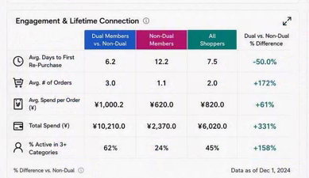
Recommended display mirrors the reference image: metrics are rows; member groups are columns; the final comparison column explains how much stronger or weaker Dual Members are than the pooled Non-Dual population.
Metric formulas
The KPI formula sheet supports AOV (2.6), ARPPU (2.7), AFM / Average Frequency per Member (2.8), Retention Rate (1.15b) and Member Recency (1.19a). For this chart, AFM is displayed as Avg. # of Orders. Visit Days and Tenant Breadth are additional L2 behavioral metrics.
Metric | Formula | Denominator / population | Direction | Source status
Avg. # of Orders | Total qualifying Sales Transactions / Purchasing Members | Current-period purchasing members in the segment | Higher = stronger engagement | KPI 2.8 AFM
Avg. Visit Days | SUM(member distinct purchase dates) / Purchasing Members | Current-period purchasing members in the segment | Higher = greater visit frequency | Proposed L2
Tenant Breadth | SUM(member distinct eligible tenants) / Purchasing Members | Current-period purchasing members in the segment | Higher = broader ecosystem engagement | Proposed L2
Retention Rate | Retained Members / Previous-Period Purchasing Members | Previous-period segment cohort | Higher = better retention | KPI 1.15b
Repeat Ratio | Members with >= 2 qualifying Sale transactions / Purchasing Members | Current-period purchasing members in the segment | Higher = stronger repeat behavior | Existing Mall Insight logic
Member Recency | AVG(Selected Period End Date - Member Last Valid Purchase Date) | Members in the defined recency base | Lower = more recent activity / better | KPI 1.19a

Shopper Actions – L3 Dashboard (still updating)
BI Implementation Requirement | Engagement & Lifetime Connection Drill-down
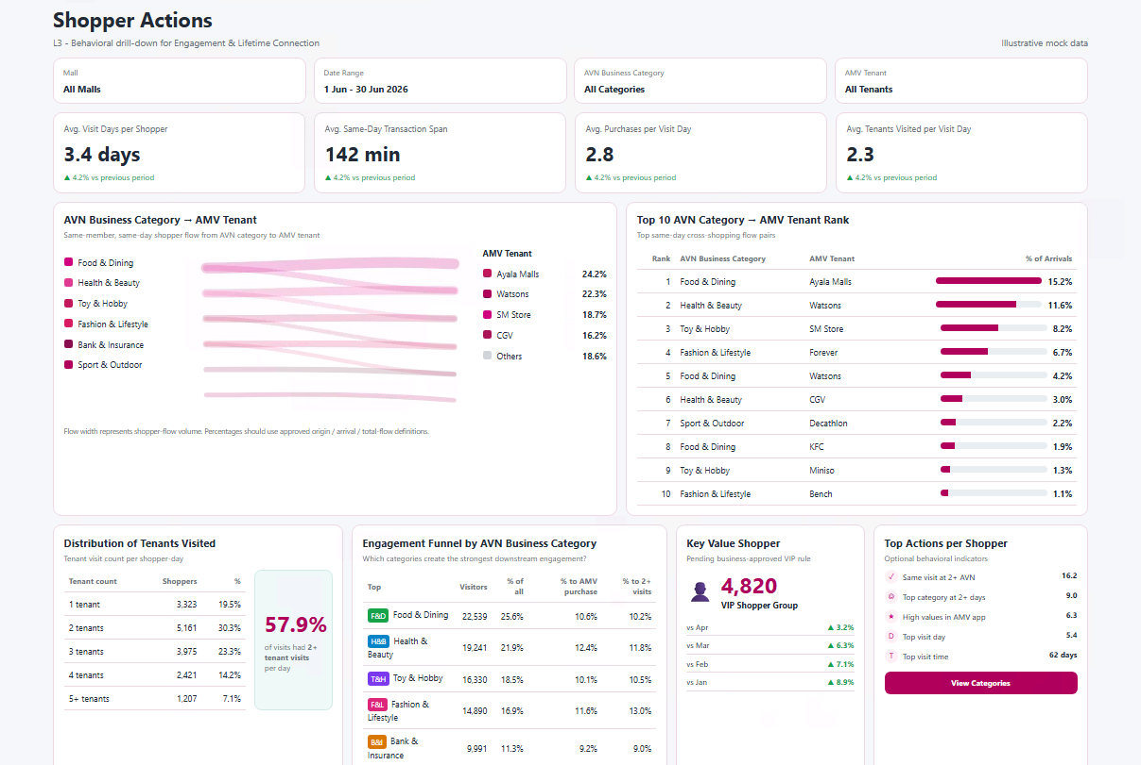
Behavioral drill-down for Engagement & Lifetime Connection
1. Scope & Filters
Item | Definition | BI rule
Mall | All Malls / selected Mall | Applies to all visuals.
Date Range | Selected transaction period | Inclusive; use local business timezone.
AVN Business Category | All / selected AVN category | Filters AVN-origin, Sankey, Top 10 and funnel.
AMV Tenant | All / selected AMV tenant | Filters AMV destination and flow/rank visuals.
Eligible shopper | Valid member with a de-duplicated Sale transaction | Exclude null members and invalid/cancelled transactions.
Visit day | Member + local transaction date | Core grain for visit behavior.
2. Top KPI Cards
KPI | Formula | Grain | Unit | Key rule
Avg. Visit Days / Shopper | Distinct(member, visit_date) / Distinct(member) | Shopper-period | days | Higher = more return frequency
Avg. Same-Day Transaction Span | AVG(last Sale ts - first Sale ts) | Shopper-day -> dashboard | minutes | Transaction span, not true dwell time
Avg. Purchases per Visit Day | Sale transactions / Distinct(member, visit_date) | Shopper-day | purchases/day | Measures visit intensity
Avg. Tenants per Visit Day | AVG(distinct AMV tenants per member-day) | Shopper-day | tenants/day | AMV tenant breadth
Comparison: (Current - Compare) / ABS(Compare) x 100; if Compare = 0, show N/A.
3. Core Visuals
Visual | Purpose | Calculation / output | Critical rule
AVN Category -> AMV Tenant Sankey | Show same-day cross-shopping paths. | Flow volume = Distinct(member, visit_date, AVN category, AMV tenant) | Same member + same day; The AVN event must occur before the AMV event. Link width = flow volume.
Top 10 AVN -> AMV | Rank the strongest flow pairs. | Rank | AVN Category | AMV Tenant | % of Arrivals | % Arrival = pair flow / all qualifying flows arriving at that AMV tenant. Same dataset as Sankey.
Tenant Visit Distribution | Show tenant breadth per visit. | Buckets: 1,2,3,4,5+ tenants; show shopper-day count and % | Base = member-day. 2+ rate = shopper-days with >=2 tenants / all eligible shopper-days.
Engagement Funnel by AVN Category | Identify categories that drive engagement. | Visitors | % all visitors | % to AMV purchase | % to 2+ visits | Visitors = distinct members in category. Conversion denominator = category visitors.
Key Value Shopper | Optional VIP summary. | VIP count + comparison trend | Do not release until the business defines the VIP rule.
Top Actions per Shopper | Optional behavioral indicators. | 2+ AVN same day; top category 2+ days; top visit day/time | Each action requires an explicit calculation rule before production.
4. Sankey Percentage Definitions
Metric | Formula | Meaning
% of AVN Origin | Flow(category, tenant) / all AMV flows from category | Share leaving the AVN category
% of AMV Arrival | Flow(category, tenant) / all AVN flows arriving at tenant | Share of tenant arrivals from the AVN category
% of Total Flow | Flow(category, tenant) / all AVN->AMV flows | Overall cross-shopping share

5. Recommended Data Layers
Layer | Grain | Minimum fields
transaction_base | 1 row per de-duplicated Sale transaction | member, transaction_dt/date, mall, AVN/AMV flag, category, tenant
shopper_day | 1 row per member per visit_date | first/last txn, sale_txns, distinct AVN categories, distinct AMV tenants
avn_amv_flow | 1 row per member, date, AVN category, and AMV tenant | first AVN time, first later AMV time, flow flag
6. Critical BI QA
- All visuals must update consistently when the Mall, Date Range, AVN Business Category, or AMV Tenant filter changes.
- The Sankey and Top 10 visuals must use the same flow dataset and reconcile.
- Multiple transactions in the same tenant/day count once for tenant breadth and once per flow pair.
- Tenant distribution percentages must reconcile to 100% (rounding allowed); 2+ callout must reconcile to 2/3/4/5+ bucket base.
- Display N/A when the denominator is zero; do not display 0%.
- VIP / high-value logic must remain hidden or as a placeholder until business approval.
Implementation priority: KPI cards -> Sankey + Top 10 -> Tenant Distribution -> Engagement Funnel. VIP and Top Actions are optional Phase 2.

Yêu cầu Kỹ thuật Mall Insight
Dashboard L1 - KPI và Biến động Phân khúc Hành vi
1. Định nghĩa KPI cốt lõi L1
Các phép tính này đánh giá giá trị và mức độ thâm nhập của các thành viên mua sắm tại cả hai công ty trong cùng một lần ghé thăm.
- Dual Members: Tổng số thành viên duy nhất có ít nhất 1 giao dịch tại AVN và ít nhất 1 giao dịch tại AMV trong cùng một phiên theo ngày.
  - countIf(Company='AVN') > 0 AND countIf(Company='AMV') > 0
- Dual-Shopper Rate: Tỷ lệ phần trăm trên tổng số thành viên mua sắm được xác định là Dual Members.
- Dual Spend Share (%): So sánh mức chi tiêu trung bình của một Dual Shopper với mức chi tiêu trung bình của toàn bộ thành viên mua sắm.
- Incremental Spend (%): Tỷ lệ phần trăm tăng thêm trong mức chi tiêu trung bình của Dual Shopper so với thành viên chỉ mua sắm tại một công ty.
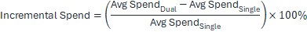
2. Điều kiện Phân khúc Hành vi
- Single-Mall: Thành viên chỉ phát sinh giao dịch tại duy nhất một mall trong khoảng thời gian được đánh giá.
Là những thành viên chỉ phát sinh giao dịch duy nhất tại đúng 1 mall trong suốt khoảng thời gian được đánh giá (không phát sinh mua sắm ở các mall khác trong hệ thống)
  - uniqExact(Mall_ID) = 1
- Single-Visit: Thành viên chỉ đến mall và phát sinh mua sắm trong đúng một ngày trong khoảng thời gian được đánh giá.
Là những thành viên chỉ đến mall và mua sắm trong đúng 1 ngày duy nhất trong khoảng thời gian được đánh giá (độ sâu ghé thăm / tần suất trung bình bằng 1)
  - uniqExact(toDate(Transaction_DT)) = 1
- Duo: Là những thành viên phát sinh ít nhất 1 giao dịch tại AVN VÀ ít nhất 1 giao dịch tại AMV trong cùng một ngày
3. Logic Key Movement (Single-Mall)
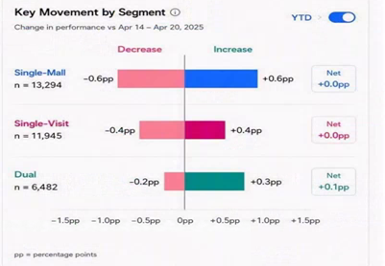
Biểu đồ Divergent Bar Chart đo lường mức dịch chuyển ròng của thành viên vào và ra khỏi phân khúc Single-Mall so với kỳ trước. Lưu ý rằng "Total Purchasing Members" tương ứng với tập nền của metric 1.11a.
Loại biến động | Logic nghiệp vụ | Công thức (Percentage Point)
Increase (+pp) (Xanh dương) | Thành viên mới gia nhập phân khúc Single-Mall (kỳ trước không thuộc Single-Mall nhưng kỳ hiện tại thuộc Single-Mall). | 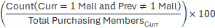
Decrease (-pp) (Hồng) | Thành viên rời khỏi phân khúc Single-Mall (kỳ trước thuộc Single-Mall nhưng kỳ hiện tại không còn thuộc Single-Mall). | 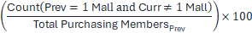
Net | Mức thay đổi ròng theo percentage point.
4. Triển khai SQL trên ClickHouse
SQL
WITH
-- 1. Xác định số Mall duy nhất mà mỗi Member đã ghé trong từng kỳ
member_stat AS (
SELECT
Member_ID,
uniqExactIf(Mall_ID, Transaction_DT BETWEEN {prev_start} AND {prev_end}) AS prev_malls,
uniqExactIf(Mall_ID, Transaction_DT BETWEEN {curr_start} AND {curr_end}) AS curr_malls
FROM TB_Member_Consumption
WHERE IsDelete = 0
AND Transaction_DT BETWEEN {prev_start} AND {curr_end}
GROUP BY Member_ID
HAVING prev_malls > 0 OR curr_malls > 0
),
-- 2. Xác định mẫu số Total Purchasing Members
totals AS (
SELECT
countIf(prev_malls > 0) AS total_prev,
countIf(curr_malls > 0) AS total_curr
FROM member_stat
)
SELECT
'Single-Mall' AS segment,
countIf(curr_malls = 1) AS n,
-- Tăng (+pp)
round(countIf(curr_malls = 1 AND prev_malls != 1) * 100.0 / any(total_curr), 1) AS increase_pp,
-- Giảm (-pp)
-round(countIf(prev_malls = 1 AND curr_malls != 1) * 100.0 / any(total_prev), 1) AS decrease_pp,
-- Thay đổi ròng (pp)
round(increase_pp + decrease_pp, 1) AS net_pp
FROM member_stat, totals;

L2 - Đặc điểm Hành vi Người mua sắm
- I. Thay đổi Chi tiêu Sau khi Bắt đầu Dual Usage
Biểu đồ xu hướng cohort "Spend Change After Starting Dual Usage" theo dõi mức thay đổi phần trăm tích lũy trong tổng chi tiêu của khách hàng so với baseline cá nhân sau lần đầu tiên mua sắm tại cả hai công ty. Phần dưới mô tả logic nghiệp vụ và ví dụ cụ thể để BI Developer có thể triển khai trực tiếp.
1. Logic Tính toán Cốt lõi (Cohort Math)
- Xác định Tháng T0 (Activation): Hệ thống quét lịch sử giao dịch để xác định tháng đầu tiên (Month 0) mà khách hàng phát sinh giao dịch tại AVN và giao dịch tại AMV trong cùng một phiên theo ngày.
- Tính Baseline: Lấy tổng chi tiêu của khách hàng trong 3 tháng ngay trước lần Dual Usage đầu tiên, sau đó chia cho 3 để xác định mức chi tiêu trung bình theo tháng trước khi chuyển đổi.
- Tính Cumulative Spend (trục Y): Với mỗi tháng từ 0 đến 12 sau activation, tính mức chi tiêu trung bình tích lũy theo tháng của khách hàng (tổng chi tiêu từ T0 đến Tn chia cho số tháng đã trôi qua). Sau đó tính tỷ lệ phần trăm chênh lệch của giá trị trung bình tích lũy này so với Baseline.
- Trục X (Relative Time): Chuẩn hóa tất cả khách hàng về cùng một mốc bắt đầu từ 0 đến 12 tháng tính từ T0 cá nhân, không phụ thuộc tháng thực tế trên lịch. Biểu đồ cuối cùng tổng hợp và hiển thị mức thay đổi phần trăm trung bình của toàn bộ khách hàng tại từng mốc tháng.
2. Ví dụ Triển khai
Giả sử User A có lần mua sắm Dual Usage đầu tiên vào tháng 9 (T0).
Mốc Cohort | Tháng thực tế | Tổng chi tiêu thực tế | Chi tiêu trung bình tích lũy (T0 đến Tn) | Tỷ lệ tăng trưởng (trục Y)
Baseline (3 tháng) | Tháng 6, 7, 8 | 1.0M, 1.5M, 0.5M | 1.0M (trung bình 3 tháng trước T0) | -
Tháng 0 (T0) | Tháng 9 | 1.08M | 1.08M / 1 tháng = 1.08M | (1.08 - 1.0) / 1.0 = +8%
Tháng 1 (T1) | Tháng 10 | 1.26M | (1.08M + 1.26M) / 2 = 1.17M | (1.17 - 1.0) / 1.0 = +17%
Tháng 2 (T2) | Tháng 11 | 1.53M | (1.08M + 1.26M + 1.53M) / 3 = 1.29M | (1.29 - 1.0) / 1.0 = +29%
3. Lưu ý Chuẩn bị Dữ liệu cho BI Developer
BI Engineer cần tạo một derived table để gán cờ cohort_month = 0 cho từng Member_ID dựa trên ngày phát sinh giao dịch Dual đầu tiên. Các giao dịch tiếp theo được đánh giá theo khoảng cách số tháng đã trôi qua (months_between) tính từ cohort_month. Nếu khách hàng không phát sinh giao dịch trong một tháng cụ thể sau T0, chi tiêu của tháng đó được ghi nhận là 0, nhưng mẫu số (số tháng tích lũy) vẫn phải tăng để bảo đảm giá trị trung bình chính xác về mặt toán học.
- II. Phân bố Số ngày Ghé thăm Hàng tháng
Biểu đồ Monthly Visit Days Distribution thuộc lớp L2 (Analysis), phân loại người mua sắm theo số ngày ghé mall trong tháng để so sánh trực tiếp mô hình tần suất giữa Dual Members và thành viên chỉ mua sắm tại một công ty.
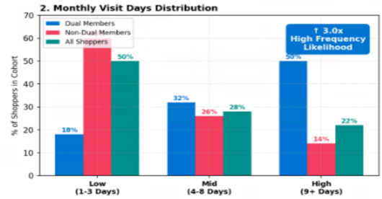
1. Logic Phân nhóm Cohort
- Dual Members (Xanh dương): Thành viên phát sinh ít nhất một giao dịch tại AVN và ít nhất một giao dịch tại AMV trong cùng một phiên theo ngày.
- Non-Dual Members (Hồng/Đỏ): Thành viên chỉ phát sinh giao dịch tại một công ty (AVN hoặc AMV) trong khoảng thời gian được đánh giá.
- All Shoppers (Xanh ngọc/Xanh lá): Tập baseline phân bố trung bình của toàn bộ thành viên có giao dịch mua sắm hợp lệ tại mall.
2. Cơ chế Tính toán (Metrics & Dimensions)
- Trục X (Frequency Tiers): Hệ thống đếm số ngày ghé thăm khác nhau của từng khách hàng trong tháng. Sau đó người mua sắm được phân thành ba nhóm cố định: Low (1-3 ngày), Mid (4-8 ngày) và High (9+ ngày).
- Trục Y (% of Shoppers): Đo tỷ lệ phần trăm thành viên thuộc từng nhóm tần suất, tính trên tổng quy mô của cohort tương ứng. Tổng ba cột cùng màu/cùng cohort (Low + Mid + High) luôn bằng 100%.
- Dynamic Callout (nếu có thể; nếu không thì đặt bên dưới biểu đồ): Hệ số 3.0x được tính bằng tỷ lệ High-frequency Dual Members chia cho tỷ lệ High-frequency Non-Dual Members. Chỉ số này cho thấy Dual Members có khả năng thuộc nhóm khách ghé thăm tần suất cao gấp 3.0 lần Non-Dual Members.
3. Ví dụ Tính toán
Giả sử hệ thống ghi nhận tổng cộng 1.000 Dual Members trong một tháng báo cáo.
Nhóm Tần suất (trục X) | Số khách hàng thực tế | Công thức tính trục Y | Hiển thị trên biểu đồ
Low (1-3 ngày) | 180 khách hàng ghé từ 1 đến 3 ngày | (180 / 1000) * 100% | Cột xanh dương ở mức 18%
Mid (4-8 ngày) | 320 khách hàng ghé từ 4 đến 8 ngày | (320 / 1000) * 100% | Cột xanh dương ở mức 32%
High (9+ ngày) | 500 khách hàng ghé từ 9 ngày trở lên | (500 / 1000) * 100% | Cột xanh dương ở mức 50%

- III. Phân bố Chi tiêu Hàng tuần
Dữ liệu hiện tại có các phân vị P25 đến P90 như sau:
- p25_weekly_spend: 278,691.5 VND
- p50_weekly_spend (median): 558,122.38 VND
- p75_weekly_spend: 1,037,218.4 VND
- p90_weekly_spend: 1,781,619.9 VND

Do đó, đề xuất phân nhóm như sau: Low: < 500K
Mid: 500K đến < 1.000K
High: ≥ 1,000K
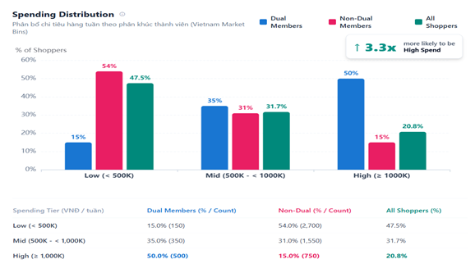
1. Logic Phân nhóm Cohort
Biểu đồ đánh giá ba nhóm thành viên trên cùng các khoảng chi tiêu theo tuần:
- Dual Members (Xanh dương): Thành viên phát sinh ít nhất một giao dịch tại AVN và ít nhất một giao dịch tại AMV trong cùng một ngày lịch trong tuần được đánh giá.
- Non-Dual Members (Hồng/Đỏ): Thành viên chỉ giao dịch tại một công ty (chỉ AVN hoặc chỉ AMV) trong khoảng thời gian được đánh giá.
- All Shoppers (Xanh ngọc/Xanh lá): Tập benchmark tổng hợp của toàn bộ thành viên có hoạt động mua sắm hợp lệ tại mall trong khoảng thời gian được đánh giá.
2. Cơ chế Tính toán (Metrics & Dimensions)
- Trục X (Spending Tiers / Bins): Tổng chi tiêu hợp lệ của từng khách hàng được tổng hợp theo tuần (toMonday(Transaction_DT)). Chi tiêu theo tuần được chia thành ba nhóm nghiệp vụ, tham chiếu theo các phân vị thị trường (p50 ≈ 558K, p75 ≈ 1,037M):
  - Low: < 500.000 VND
  - Mid: 500.000 VND đến < 1.000.000 VND
  - High: ≥ 1.000.000 VND
- Trục Y (% of Shoppers): Đo tỷ lệ phân bố bên trong từng cohort. Với mỗi cohort, tổng tỷ lệ của ba nhóm phải bằng 100%:
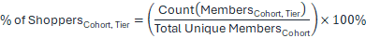
- Dynamic Callout Badge: Tính hệ số khả năng Dual Members thuộc nhóm High Spenders so với Non-Dual Members:
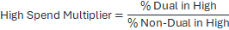
3. Ví dụ Tính toán
Với cohort mẫu gồm 1.000 Dual Members và 5.000 Non-Dual Members:
Nhóm Chi tiêu (trục X) | Số thành viên | Công thức tính trục Y | Hiển thị trên biểu đồ (% Cohort)
Dual — Low (< 500K) | 150 thành viên |  | Cột xanh dương ở mức 15,0%
Dual — Mid (500K - < 1,000K) | 350 thành viên |  | Cột xanh dương ở mức 35,0%
Dual — High (≥ 1,000K) | 500 thành viên |  | Cột xanh dương ở mức 50,0%
Non-Dual — Low (< 500K) | 2.700 thành viên |  | Cột hồng ở mức 54,0%
Non-Dual — Mid (500K - < 1,000K) | 1.550 thành viên |  | Cột hồng ở mức 31,0%
Non-Dual — High (≥ 1,000K) | 750 thành viên |  | Cột hồng ở mức 15,0%

- IV. Engagement & Lifetime Connection
Khuyến nghị hiển thị theo hình tham chiếu: các metric nằm theo hàng; các nhóm thành viên nằm theo cột; cột so sánh cuối cùng thể hiện Dual Members mạnh hơn hoặc yếu hơn bao nhiêu so với tập Non-Dual gộp.
Công thức Metric
Bảng công thức KPI hỗ trợ AOV (2.6), ARPPU (2.7), AFM / Average Frequency per Member (2.8), Retention Rate (1.15b) và Member Recency (1.19a). Trong biểu đồ này, AFM được hiển thị dưới dạng Avg. # of Orders. Visit Days và Tenant Breadth là các metric hành vi bổ sung của L2.
Metric | Công thức | Mẫu số / Population | Hướng đánh giá | Nguồn / Trạng thái
Số đơn hàng TB | Tổng giao dịch Sale hợp lệ / Purchasing Members | Purchasing Members trong phân khúc của kỳ hiện tại | Cao hơn = mức độ tương tác mạnh hơn | KPI 2.8 AFM
Số ngày ghé TB | SUM(số ngày mua hàng khác nhau của member) / Purchasing Members | Purchasing Members trong phân khúc của kỳ hiện tại | Cao hơn = tần suất ghé thăm lớn hơn | Đề xuất cho L2
Độ rộng Tenant | SUM(số tenant hợp lệ khác nhau của member) / Purchasing Members | Purchasing Members trong phân khúc của kỳ hiện tại | Cao hơn = mức độ tương tác hệ sinh thái rộng hơn | Đề xuất cho L2
Tỷ lệ Duy trì | Retained Members / Purchasing Members kỳ trước | Cohort phân khúc của kỳ trước | Cao hơn = khả năng duy trì tốt hơn | KPI 1.15b
Tỷ lệ Mua lặp lại | Members có >= 2 giao dịch Sale hợp lệ / Purchasing Members | Purchasing Members trong phân khúc của kỳ hiện tại | Cao hơn = hành vi mua lặp lại mạnh hơn | Logic Mall Insight hiện tại
Độ gần đây của Member | AVG(Ngày kết thúc kỳ được chọn - Ngày mua hợp lệ gần nhất của Member) | Members trong tập nền recency đã xác định | Thấp hơn = hoạt động gần đây hơn / tốt hơn | KPI 1.19a

Shopper Actions - Dashboard L3 (đang tiếp tục cập nhật)
Yêu cầu Triển khai BI | Drill-down Engagement & Lifetime Connection
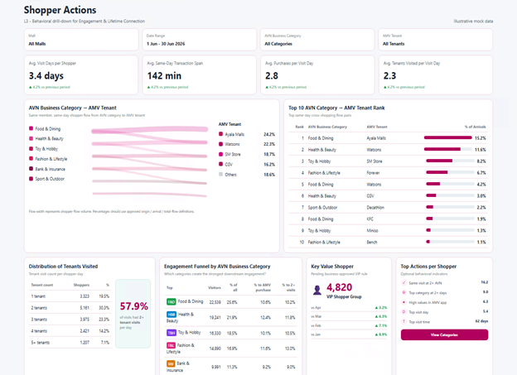
Drill-down hành vi cho Engagement & Lifetime Connection
1. Phạm vi & Bộ lọc
Hạng mục | Định nghĩa | Quy tắc BI
Mall | Tất cả Mall / Mall được chọn | Áp dụng cho tất cả biểu đồ.
Khoảng ngày | Khoảng thời gian giao dịch được chọn | Bao gồm cả ngày đầu/cuối; sử dụng múi giờ nghiệp vụ địa phương.
Nhóm ngành AVN | Tất cả / nhóm ngành AVN được chọn | Lọc AVN-origin, Sankey, Top 10 và funnel.
Tenant AMV | Tất cả / tenant AMV được chọn | Lọc điểm đến AMV và các biểu đồ flow/rank.
Người mua sắm hợp lệ | Member hợp lệ có giao dịch Sale đã khử trùng lặp | Loại member null và các giao dịch không hợp lệ/đã hủy.
Ngày ghé thăm | Member + ngày giao dịch theo giờ địa phương | Grain cốt lõi cho hành vi ghé thăm.
2. Các KPI Card chính
KPI | Công thức | Grain | Đơn vị | Quy tắc chính
Số ngày ghé TB / Shopper | Distinct(member, visit_date) / Distinct(member) | Shopper-kỳ | ngày | Cao hơn = tần suất quay lại cao hơn
Khoảng thời gian giao dịch TB trong cùng ngày | AVG(last Sale ts - first Sale ts) | Shopper-day -> dashboard | phút | Là khoảng thời gian giao dịch, không phải dwell time thực tế
Số giao dịch mua TB / Ngày ghé | Giao dịch Sale / Distinct(member, visit_date) | Shopper-day | lượt mua/ngày | Đo cường độ ghé thăm
Số Tenant TB / Ngày ghé | AVG(số AMV tenant khác nhau trên mỗi member-day) | Shopper-day | tenant/ngày | Độ rộng AMV tenant
So sánh: (Current - Compare) / ABS(Compare) x 100; nếu Compare = 0 thì hiển thị N/A.
3. Các Biểu đồ Cốt lõi
Biểu đồ | Mục đích | Cách tính / Output | Quy tắc quan trọng
Sankey AVN Category -> AMV Tenant | Hiển thị luồng mua sắm chéo trong cùng ngày. | Flow volume = Distinct(member, visit_date, AVN category, AMV tenant) | Cùng member + cùng ngày; sự kiện AVN phải xảy ra trước sự kiện AMV. Độ rộng link = flow volume.
Top 10 AVN -> AMV | Xếp hạng các cặp flow mạnh nhất. | Hạng | AVN Category | AMV Tenant | % Arrivals | % Arrival = pair flow / toàn bộ flow hợp lệ đi đến AMV tenant đó. Sử dụng cùng dataset với Sankey.
Phân bố Số Tenant Ghé thăm | Hiển thị độ rộng tenant trên mỗi lần ghé. | Buckets: 1, 2, 3, 4, 5+ tenants; hiển thị số shopper-day và % | Base = member-day. Tỷ lệ 2+ = shopper-days có >=2 tenants / toàn bộ shopper-days hợp lệ.
Engagement Funnel theo AVN Category | Xác định các category thúc đẩy engagement. | Visitors | % tổng visitors | % chuyển sang mua tại AMV | % có 2+ visits | Visitors = distinct members trong category. Mẫu số conversion = visitors của category.
Key Value Shopper | Tóm tắt VIP tùy chọn. | Số VIP + xu hướng so sánh | Không phát hành cho đến khi nghiệp vụ định nghĩa quy tắc VIP.
Top Actions theo Shopper | Các chỉ báo hành vi tùy chọn. | 2+ AVN cùng ngày; top category trong 2+ ngày; ngày/giờ ghé nhiều nhất | Mỗi action cần có quy tắc tính rõ ràng trước khi đưa lên production.
4. Định nghĩa Tỷ lệ % trên Sankey
Metric | Công thức | Ý nghĩa
% AVN Origin | Flow(category, tenant) / toàn bộ AMV flow xuất phát từ category | Tỷ trọng rời khỏi AVN category
% AMV Arrival | Flow(category, tenant) / toàn bộ AVN flow đến tenant | Tỷ trọng lượt đến tenant xuất phát từ AVN category
% Tổng Flow | Flow(category, tenant) / toàn bộ AVN->AMV flow | Tỷ trọng mua sắm chéo tổng thể

5. Các Lớp Dữ liệu Khuyến nghị
Lớp | Grain | Trường tối thiểu
transaction_base | 1 dòng cho mỗi giao dịch Sale đã khử trùng lặp | member, transaction_dt/date, mall, cờ AVN/AMV, category, tenant
shopper_day | 1 dòng cho mỗi member trên mỗi visit_date | giao dịch đầu/cuối, sale_txns, số AVN category khác nhau, số AMV tenant khác nhau
avn_amv_flow | 1 dòng cho mỗi member, date, AVN category và AMV tenant | thời điểm AVN đầu tiên, thời điểm AMV đầu tiên sau đó, flow flag
6. Các Kiểm tra BI QA Quan trọng
- Tất cả biểu đồ phải cập nhật nhất quán khi thay đổi bộ lọc Mall, Date Range, AVN Business Category hoặc AMV Tenant.
- Biểu đồ Sankey và Top 10 phải sử dụng cùng một flow dataset và số liệu phải đối soát khớp nhau.
- Nhiều giao dịch tại cùng một tenant trong cùng một ngày chỉ được tính một lần cho tenant breadth và một lần cho mỗi flow pair.
- Tỷ lệ phân bố tenant phải đối soát về 100% (cho phép sai số làm tròn); callout 2+ phải khớp với tập nền của các bucket 2/3/4/5+.
- Hiển thị N/A khi mẫu số bằng 0; không hiển thị 0%.
- Logic VIP / high-value phải được ẩn hoặc chỉ để placeholder cho đến khi nghiệp vụ phê duyệt.
Thứ tự ưu tiên triển khai: KPI cards -> Sankey + Top 10 -> Tenant Distribution -> Engagement Funnel. VIP và Top Actions là hạng mục tùy chọn của Phase 2.

