MaC (Music and Chill)

Vision Document

Version <1.2>

Revision History

| **Date** | **Version** | **Description** | **Author** |
| --- | --- | --- | --- |
| 07/11/2022 | 1.0 | Add content to Introduction, Positioning, Stakeholder and User Descriptions, Product Overview, Product Features and Non-Functional Requirements | Group 07 |
| 26/11/2022 | 1.1 | Add content to Revision History | Group 07 |
| 10/12/2022 | 1.2 | Edit Non-functional requirements |  |
|  |  |  |  |

Table of Contents

**1. Introduction** **4**

1.1 References 4

**2. Positioning** **4**

2.1 Problem Statement 4

2.2 Product Position Statement 4

**3. Stakeholder and User Descriptions** **4**

3.1 Stakeholder Summary 5

3.2 User Summary 5

3.3 User Environment 5

3.4 Summary of Key Stakeholder or User Needs 6

3.5 Alternatives and Competition 6

**4. Product Overview** **6**

4.1 Product Perspective 6

4.2 Assumptions and Dependencies 7

**5. Product Features** **7**

**6. Non-Functional Requirements** **8**

Vision (Small Project)

# Introduction

Music is an important part of life that helps people have a better spirit, be creative and can connect the emotions of music lovers together. Understanding that, our team - DKMS will create a website where people can discuss all issues related to music.

## References

* PA1, PA2 Guidelines - Teaching Assistant Ho Tuan Thanh

# Positioning

## Problem Statement

| The problem of | Music players have a hard time to finding materials about music. |
| --- | --- |
| affects | Beginners as well as the users want to learn about the music. |
| the impact of which is | Wasting users' time when not finding the right document they wanted. |
| a successful solution would be | Create a website for music players to exchange knowledge and develop into a healthy community of players. |

## 

## Product Position Statement

| For | All the users want to learning about the things relate to the music and develope a community about the music. |
| --- | --- |
| Who | For music lovers. |
| The (product name) | It is a website named MaC (Music and Chill) |
| That | Allow users can upload the cover videos, chords, comment, rating, etc.. |
| Unlike | Outdated music documentation system. |
| Our product | Bringing users many new experiences, making it easy to access the music world just through a website. |

# Stakeholder and User Descriptions

This section describes the users of the Music and Chill System. There are 3 types of users of the MaC System: the Admin, the Members, and the Viewers.

## 

## Stakeholder Summary

| **Name** | **Description** | **Responsibilities** |
| --- | --- | --- |
| Development Team | Students at Ho Chi Minh University of Science. | Responsible for project funding approval. Monitors project progress. |
| Ho Tuan Thanh | Teaching Assistant of Course Intro to Software Engineer CLC06. | Supervisor as well as mentor of the team. |
| Admin | Admin of the website. | Ensure that the system will meet the needs of the users include members and viewers have the best experience. |
| Members | Member registration of system. | Ensure that the system will meet the needs of the members as well as privilege when becoming a member of website. |
| Viewers | Viewers | Use the basic features of a website for visitors. |

## User Summary

| **Name** | **Description** | **Responsibilities** | **Stakeholder** |
| --- | --- | --- | --- |
| Admin | Manage the posts, the members, give reward. | A customer of our product | self-represented |
| Members | Interact with the posts, create playlists, post video covers, tutorial video, chords, view the list of chords were created on their own and comments from the other members. | The end-users of the website | self-represented |
| Viewers | Only search and view available contents in website. | The end-users of the website | self-represented |

## User Environment

For people who have a basic knowledge of using computers and smartphones and want to educate themselves about all things music related.

## 

## Summary of Key Stakeholder or User Needs

| **Need** | **Priority** | **Concerns** | **Current Solution** | **Proposed Solutions** | |
| --- | --- | --- | --- | --- | --- |
| **The videos tutorial, video covers, chords in one website** | High | **No variety of music material** | Users must visit each website to find video tutorials on how to play the instrument. There are songs that are old but very little about how to play so it will be difficult for users to find them. | | Users just need to go to the category like Chords/Videos Cover/Videos Tutorial respectively to be able to find whatever they want. |
| **Interact with people** | High | **No feature exchange users to each other** | Difficult to get feedback/requests from users about the content available on the web and the user experience is not high. | | Users can interact with each other like a forum in which people can post contents relates to music and can get rewards from admin if they do well. |

## Alternatives and Competition

Music library systems existed before, but only had some basic features, and there was no interaction between people. Realizing that, we built on that idea and developed some features to enhance the user experience such as allowing users to upload cover videos, chords, exchange and learn online. The common goal is to build a stronger community of music lovers.

# Product Overview

This section provides a high level view of the Website capabilities, interfaces to the external and the web configuration.s.

## Product Perspective

This Website will store the username and password of user in the SQL server . User can update profile and their information will be stored in SQL server too.

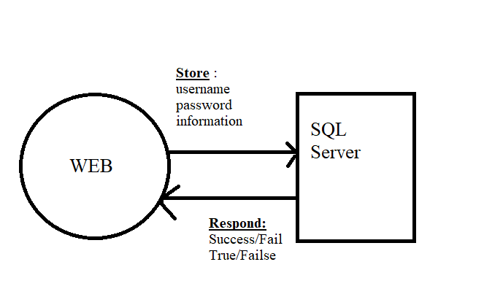

## Assumptions and Dependencies

The following assumptions and dependencies relate to the capabilities of the website as outlined in this Vision Document:

o The website will run 24/7

o The Interface will be easy to use with the user

o It can be overloaded if many people access it at the same time.

# Product Features

This section defines and describes the features of the Website MaC(Music and chill) . Features are the high-level capabilities of the website that are necessary to deliver benefits to the members

5.1 Sign in, Sign out

The website has a space where users can sign in, and sign out to create a new account, or log in to the website. By logging in to the website, the user(member) can have more ability to use than the viewer.

5.2 Create Playlist

The member can collect songs, that they want to listen to sequentially instead of the random music on the website.

5.3 Post

Members can post their chords, tutorials video, and cover videos to have more fans and become famous with others.

5.4 Require new tutorial song

The User ( member and viewer) can require the new tutorial song by contact with the admin by searching

5.5 Ban Member

In the future, some user is not friendly or have activities that affect the website or the other user,

admin can ban this account to protect the user's rights.

5.6 Remove Post

Some posts will not have reasonableness like advertisements, and violence,.. will be removed by Admin to protect the user rights..

5.7 Give the reward to Member

The event happens every month, and the admin can discount the % of some specific songs to every member who joins the game in that event.

# Non-Functional Requirements

This section defines non-functional requirements of the Website MaC(Music and chill) .

6.1 Application’s environment:

Web

6.2 Programming languages and frameworks:

NodeJS, ExpressJS, ReactJS, MySQL, JavaScript, HTML, CSS

6.3 Security:

Password must be encrypted before storing in the database

6.3 Other requirements:

* Valid song requests must be processed within 48 hours
* Warning must be sent as soon as a member is found to be in violation
* Users are asked not to post too much in a period of time to avoid spam
* Uploaded videos should not take up too much space.