MaC ( Music and Chill )

**Software Development Plan (Small Project)**

**Version <1.**1**>**

**Revision History**

| **Date** | **Version** | **Description** | **Author** |
| --- | --- | --- | --- |
| 07/11/2022 | 1.0 | Add content to Introduction, Project Overview, Project Organization ( Organizational Structure, Roles and Responsibilities), Project Estimates, Project Plan, Risk Management | Group 07 |
| 26/11/2022 | 1.1 | Edit project plan content (4.2) + add content to Revision History | Group 07 |
|  |  |  |  |
|  |  |  |  |

**Table of Contents**

**1. Introduction** **4**

1.1 Purpose 4

1.2 Scope 4

1.3 Overview 4

**2. Project Overview** **4**

2.1 Project Purpose, Scope, and Objectives 4

2.2 Assumptions and Constraints 5

2.3 Project Deliverables 5

**3. Project Organization** **5**

3.1 Organizational Structure 5

3.2 Roles and Responsibilities 6

**4. Management Process** **6**

4.1 Project Estimates 6

4.2 Project Plan 7

Sprint 1: PA0 7

Sprint 2: PA1 7

Sprint 3: PA2 7

Sprint 4: PA3 7

Sprint 5: PA4 8

Sprint 6: PA5 8

4.3 Project Monitoring and Control 8

4.3.1 Requirements Management 8

4.3.2 Reporting and Measurement 8

4.3.3 Risk Management 8

4.3.4 Configuration Management 9

**Software Development Plan (Small Project)**

# **Introduction**

The introduction of the **Software Development Plan** provides an overview of the entire document. It includes the purpose, scope, definitions, acronyms, abbreviations, references, and overview of this **Software Development Plan**.

## **Purpose**

The purpose of the *Software Development Plan* is to gather all information necessary to control the project. It describes the approach to the development of the software and is the top-level plan generated and used by managers to direct the development effort.

The following people use the *Software Development Plan*:

* The **project manager** uses it to plan the project schedule and resource needs, and to track progress against the schedule.
* **Project team members** use it to understand what they need to do, when they need to do it, and what other activities they are dependent upon.

## **Scope**

This *Software Development Plan* describes the overall plan to be used by the <project name> project, including deployment of the product.

The plans as outlined in this document are based upon the product requirements as defined in the *Vision Document*.

## **Overview**

This *Software Development Plan* contains the following information:

Project Overview — provides a description of the project's purpose, scope, and objectives.  It also defines the deliverables that the project is expected to deliver.

Project Organization — describes the organizational structure of the project team.

# **Project Overview**

## **Project Purpose, Scope, and Objectives**

We want to create a website for a place that is used for connecting between amateur musicians and professional musicians around the world much closely as well as helps users look up Chords and view many Cover videos.

## 

## **Assumptions and Constraints**

- Viewer: (14h - 20h)

+ See Chords, Tutorials Video

+ See list of Music genre, Singer, ...

+ Require new tutorial song

- Member: (18h - 28h)

+ Sign in, Sign out

+ Like, Comment, Share Post

+ Post Chords, Tutorials Video, Cover Video, ...

+ Create Playlist

- Admin: (7h - 14h)

+ Ban Member

+ Remove Post

+ Give the reward to Member

+ Accept new Post

Sum:

20$/1h

1560$ - 2480$

## **Project Deliverables**

Deliverables for each project phase are identified in the Development Case. Deliverables are delivered towards the end of the interaction, as specified in section *4.2.4 Project Schedule*.

# **Project Organization**

## **Organizational Structure**

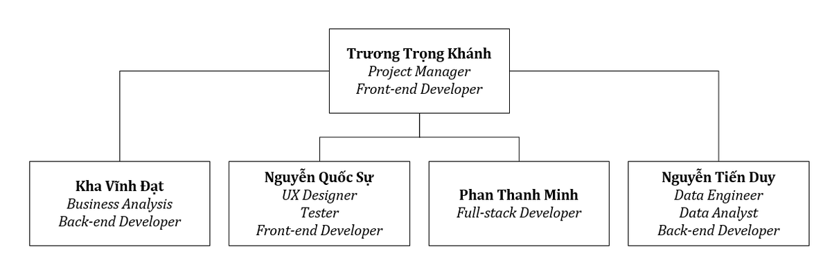

## **Roles and Responsibilities**

| **Person** | **Role** |
| --- | --- |
| Trương Trọng Khánh, Project Manager  ( Developer ) | Manage projects and assign work to members, support developer team |
|  |  |
| Kha Vĩnh Đạt, Developer - Business Analyst | builds and creates software and applications, collects customer requirements and connects the development team with the customer. |
| Nguyễn Quốc Sự, UX Designer - Tester | optimize the interaction between humans and products. Tests software for bugs, errors, defects or any problem that can affect the performance of computer software or an application. |
| Phan Thanh Minh, Full-Stack Developer | Develop both about Front-end and Back-end, the main developer of team |
| Nguyễn Tiến Duy, Data Engineer, Data Analyst | Responsible about analyze data, manage data, query data |

# **Management Process**

## **Project Estimates**

- Viewer: (14h - 20h)

+ See Chords, Tutorials Video (6h - 8h)

+ See list of Music genre, Singer, … (4h - 6h)

+ Require new tutorial song (4h - 6h)

- Member: (18h - 28h)

+ Sign in, Sign out (6h - 8h)

+ Like, Comment, Share Post (3h - 6h)

+ Post Chords, Tutorials Video, Cover Video, … (6h - 8h)

+ Create Playlist (3h - 6h)

- Admin: (7h - 14h)

+ Ban Member (3h - 6h)

+ Remove Post (1h - 2h)

+ Give the reward to Member (2h -4h)

+ Accept new Post (1h - 2h)

Sum:

20$/1h

1560$ - 2480$

## **Project Plan**

## Sprint 1: PA0

* Start: 16 October 2022, 12:00 AM
* End: 29 October 2022, 10:00 PM
* Tasks:
* Ideas for the project
* Write a description of project
* Output: PA0 submission

## Sprint 2: PA1

* Start: 30 October 2022, 12:00 AM
* End: 12 November 2022, 10:00 PM
* Tasks:
* Write report:
  + Project Plan: Kha Vĩnh Đạt, Nguyễn Quốc Sự, Trương Trọng Khánh
  + Vision document: Phan Thanh Minh, Nguyễn Tiến Duy
  + Planning Meeting: Phan Thanh Minh
* Training:
  + Front-end (HTML, CSS, JavaScript): Nguyễn Quốc Sự, Trương Trọng Khánh, Phan Thanh Minh
  + Back-end (NodeJs): Kha Vĩnh Đạt, Nguyễn Tiến Duy, Phan Thanh Minh
* Output: PA1 submission

## Sprint 3: PA2

* Start: 13 November 2022, 12:00 AM
* End: 26 November 2022, 10:00 PM
* Tasks:
* Revised project plan: Khánh + Đạt + Duy
* Detailed vision document: Khánh
* Use-case specification: Minh
* Use-case model: Sự + Khánh + Đạt + Duy
* Weekly Report: Sự + Minh
* Output: PA2 submission

## Sprint 4: PA3

* Start: 27 November 2022, 12:00 AM
* End: 10 December 2022, 10:00 PM
* Tasks:
* Revised Use-case specification: Sự + Khánh + Đạt
* Define software architecture: Khánh + Đạt
* Class diagrams: Minh + Duy
* Weekly report: Sự
* Coding:
  + Code back-end, organize storage and retrieve data from database: Đạt, Minh, Duy
  + Support: Khánh + Sự
* Output: PA3 submission

## 

## Sprint 5: PA4

* Start: 11 December 2022, 12:00 AM
* End: 17 December 2022, 10:00 PM
* Tasks:
* Revise SAD: Khánh + Đạt
* UI prototype: Sự + Duy
* Weekly report: Minh
* Coding:
  + Design UI/UX, Code front-end: Khánh, Sự
  + Support: Đạt, Minh, Duy
* Output: PA4 submission

## Sprint 6: PA5

* Start: 18 December 2022, 12:00 AM
* End: 31 December 2022, 10:00 PM
* Tasks:
* Test plan and test cases: All members
* Project presentation: All members
* Coding:
  + Combine front-end with back-end: Khánh + Đạt + Minh
  + Testing and debugging: Sự + Duy
  + Complete the application: All members
* Output: PA5 submission, demo product ( web app )

## **Project Monitoring and Control**

### *Requirements Management*

The requirements for this system are captured in the Vision document. Requested changes to requirements are captured in Change Requests, and are approved as part of the Configuration Management process.

### *Reporting and Measurement*

Updated cost and schedule estimates, and metrics summary reports, will be generated at the end of each iteration.

The Minimal Set of Metrics, as described in the RUP Guidelines: Metrics, will be gathered on a weekly basis. These include:

Earned value for completed tasks. This is used to re-estimate the schedule and budget for the remainder of the project, and/or to identify need for scope changes.

Total defects open and closed – shown as a trend graph. This is used to help estimate the effort remaining to correct defects.

Acceptance test cases passing – shown as a trend graph. This is used to demonstrate progress to stakeholders.

In addition, overall costs will be monitored against the project budget.

### *Risk Management*

Risks will be identified in the Inception Phase using the steps identified in the RUP for Small Projects activity “Identify and Assess Risks”. Project risk is evaluated at least once per iteration and documented in this table. The risks of the greatest magnitude are listed first in the table.

| **Risk Ranking (High, Medium, Low)** | **Risk Description and Impact** | **Mitigation Strategy and/or Contingency Plan** |
| --- | --- | --- |
| Medium | when no one has a creative idea to develop the project | Create a vote or consult one by one |
| High | The time required to develop the software is not like the plan | More overtime sessions, omit extended functions |
| Medium | someone have health problems | Members in team help them finish deadline |
| High | professional knowledge gap between members | Lower the standards to fit everyone like “wooden barrel theory” |

### *Configuration Management*

None