MR Submission Form

Approver
Name | Role | Status | Comments
Vy Tran | Project Manager

DEVELOPER
ID | Name | Email
122691 | Hoang Bui | bmhoang@tma.com.vn

Reviewer
Name | Email
Ngan Phan | pcngan@tma.com.vn

MR DESCRIPTION
ID | Title | Forecast Release(s)
EBCA017646 | VitalSuite UI's language change to Korean is not working | R14.3

Solution

Describe the problem being addressed by this update
Cannot display Chinese (Korean) on these pages:
- Issue 1: On Dashboard, click on VitalNet chart, the opened page cannot show Chinese
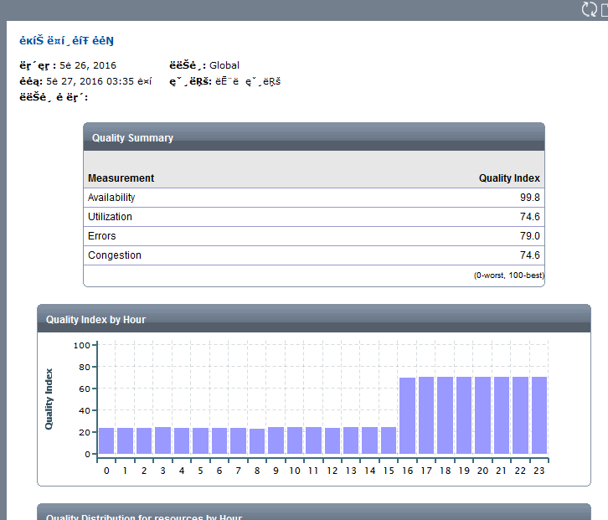

- Issue 2:

- Network→ Planning → click “any resource” e.g. in below, OXEstream205 → At the right button of select one, submit button is broken.
It is the same with even Chinese.
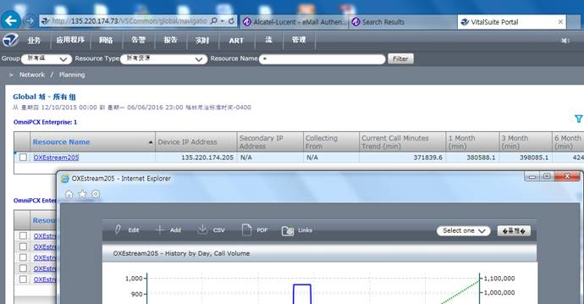

- If I click the +Add , Add To Folder pops up. The Folder name is broken.
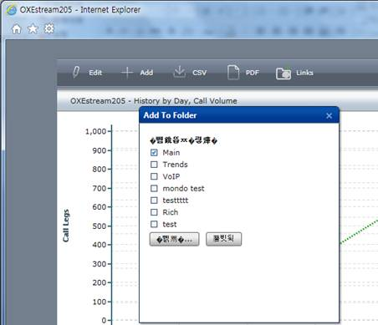
- Admin→ Servers ➔Vitalnet→ Properties.

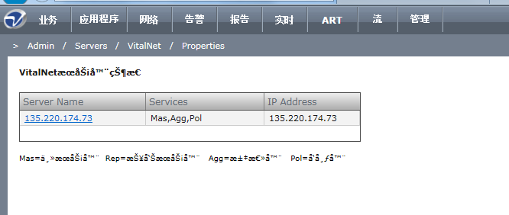

Describe the root cause
Issue 1:
The root cause is vnReport.exe returned data with charset ISO-8859-4
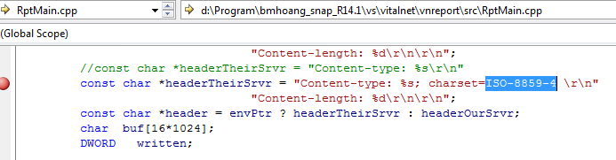
Issue 2:
By default, apache returns header with iso-8859-1 charset, this charset cannot show Chinese

Detail solution
Issue 1:
change the charset to utf-8
Issue 2:
Set default charset by add “AddDefaultCharset utf-8” to end of VSCommon\Apache\conf\VitalSuiteCommon.conf file
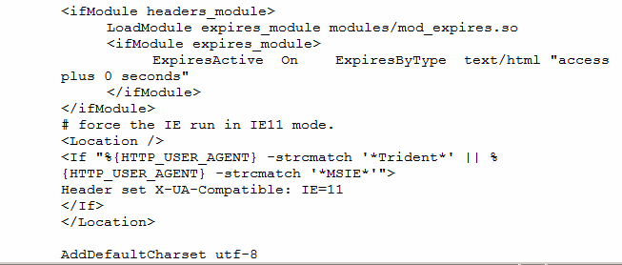

Interfaces and dependency
- VSCommon\Apache\conf\VitalSuiteCommon.conf
- Vnreport.exe

List all the modified files for this submission
- vs\thdparty\Apache_Tomcat\win32\conf\templates\VitalSuiteWebAppsTemplate.conf
- vs\vitalnet\vnreport\src\RptMain.cpp

Testing

Environment
R14.3 Build 01

Test cases
Pre-condition
- Setup VitalSuite Net
- Discovery some devices to collect VitalNet data

Detail test cases:
TC ID | UT-001
Purpose/Objectives | Verify issue 1: vnreport.exe module can show Chinese
Platform/Configuration | Windows Server 2008
Test data | NA
Procedure/Step | - Navigate Admin->Preferences->Viewing preferences->System Language  - Choose Chinese as default language  - On Vital Dashboard, click on VitalNet chart  - View the popup chart opened
Expected results | - The popup chart can display Chinese characters correctly
Test result | Passed
Remarks | NA

TC ID | UT-002
Purpose/Objectives | Verify that issue 2 was fixed
Platform/Configuration | Windows Server 2008
Test data | NA
Procedure/Step | - Navigate Admin->Preferences->Viewing preferences->System Language  - Choose Chinese as default language  - Go to all pages were listed in Item 5.1, issue 2
Expected results | - All pages at step 3 can display Chinese characters correctly
Test result | Passed
Remarks | NA

Usage notes [optional]
N/A

Revision History
Date | Version | Description | Revised by
06-07-2014 | 1.0 | Solution to fix EBCA017646 | Hoang Bui

