**TEST CASE SCENARIOS – LIST MESSAGES**

# 1. View list messages without parameter

_ Step 1: Run ApplicationTest

_ Step 2: Access <http://localhost:8080/jsondoc-ui.html#>

_ Step 3: enter jsondoc and click “Get documentation”

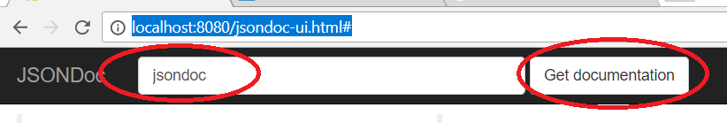

_ Step 4: Click “Messages” -> getListMessage

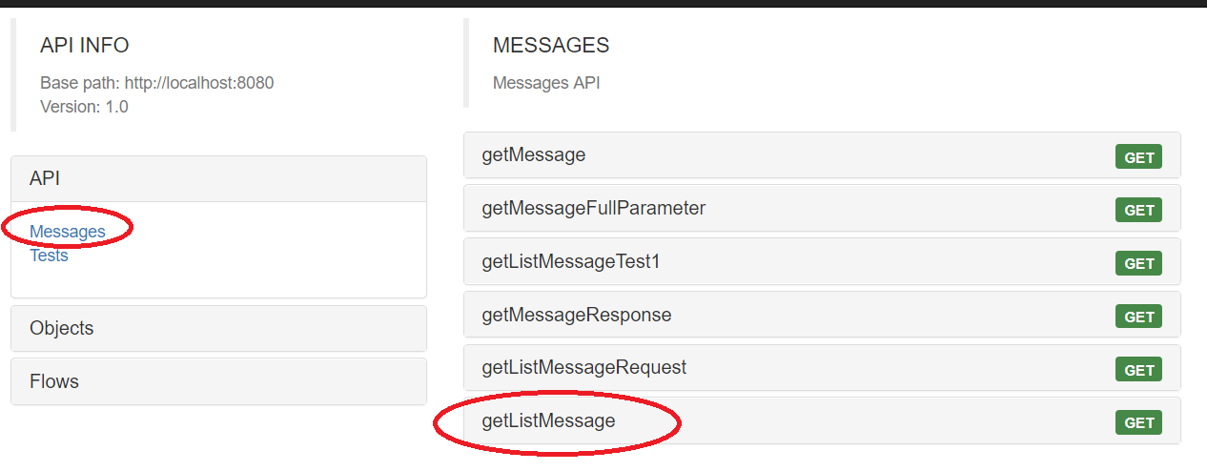

_ Step 5: Click “Submit” button and view the result:

[

{

"msgStatus": "N|N|N|N|N",

"msgRefInfo": "A600O5JD",

"casExRef": "99232382832",

"msgDat": "2015-09-28",

"msgFrom": "A6008KUU",

"msgTo": "97000002",

"msgSubject": "Test",

"casRef": "1508130010",

"dbName": "STANISLAVA",

"creditorName": "BUSINESS UNIT 1"

},

{

"msgStatus": "N|N|N|N|N",

"msgRefInfo": "A600O5LE",

"casExRef": null,

"msgDat": "2015-10-01",

"msgFrom": "A6008KUU",

"msgTo": "A3000305",

"msgSubject": "Re: Test message",

"casRef": "1508210001",

"dbName": "MY",

"creditorName": "BUSINESS UNIT 1"

},

{

"msgStatus": "N|N|N|N|N",

"msgRefInfo": "A600O5JB",

"casExRef": null,

"msgDat": "2015-09-28",

"msgFrom": "A6008KUU",

"msgTo": "A3000305",

"msgSubject": "Test message",

"casRef": "1508210001",

"dbName": "MY",

"creditorName": "BUSINESS UNIT 1"

},

{

"msgStatus": "N|N|N|N|N",

"msgRefInfo": "A600O6RO",

"casExRef": null,

"msgDat": "2016-06-09",

"msgFrom": "A3000305",

"msgTo": "A60050FU",

"msgSubject": "test",

"casRef": "1601050001",

"dbName": "DEBTOR_MT",

"creditorName": "BNP PARIBAS PF GREECE"

},

{

"msgStatus": "N|N|N|N|N",

"msgRefInfo": "A600O6JP",

"casExRef": null,

"msgDat": "2016-03-14",

"msgFrom": "A3000305",

"msgTo": "A60050FZ",

"msgSubject": "Test",

"casRef": "1602050003",

"dbName": "MY_DEBTOR_MT",

"creditorName": "BNP PARIBAS PF GREECE"

},

{

"msgStatus": "N|N|N|N|N",

"msgRefInfo": "A600O8BH",

"casExRef": null,

"msgDat": "2017-04-25",

"msgFrom": "A3000305",

"msgTo": "A60050FU",

"msgSubject": "test as msg att",

"casRef": "1609040004",

"dbName": "MY_DEBTOR_MT",

"creditorName": "BUSINESS UNIT 1"

},

{

"msgStatus": "N|N|N|N|N",

"msgRefInfo": "A600O8BG",

"casExRef": null,

"msgDat": "2017-04-25",

"msgFrom": "A3000305",

"msgTo": "A60050FU",

"msgSubject": "test 3 att",

"casRef": "1609040004",

"dbName": "MY_DEBTOR_MT",

"creditorName": "BUSINESS UNIT 1"

},

{

"msgStatus": "N|N|N|N|N",

"msgRefInfo": "A600O8AH",

"casExRef": null,

"msgDat": "2017-04-24",

"msgFrom": "A3000305",

"msgTo": "A60050FU",

"msgSubject": "tt3",

"casRef": "1609040004",

"dbName": "MY_DEBTOR_MT",

"creditorName": "BUSINESS UNIT 1"

},

{

"msgStatus": "N|N|N|N|N",

"msgRefInfo": "A600O8AC",

"casExRef": null,

"msgDat": "2017-04-24",

"msgFrom": "A3000305",

"msgTo": "A60050FU",

"msgSubject": "test asImg",

"casRef": "1609040004",

"dbName": "MY_DEBTOR_MT",

"creditorName": "BUSINESS UNIT 1"

},

{

"msgStatus": "N|N|N|N|N",

"msgRefInfo": "A600O892",

"casExRef": null,

"msgDat": "2017-04-21",

"msgFrom": "A3000305",

"msgTo": "A60050FU",

"msgSubject": "test multiple",

"casRef": "1609040004",

"dbName": "MY_DEBTOR_MT",

"creditorName": "BUSINESS UNIT 1"

},

{

"msgStatus": "N|N|N|N|N",

"msgRefInfo": "A600O88N",

"casExRef": null,

"msgDat": "2017-04-21",

"msgFrom": "A3000305",

"msgTo": "A60050FU",

"msgSubject": "att",

"casRef": "1609040004",

"dbName": "MY_DEBTOR_MT",

"creditorName": "BUSINESS UNIT 1"

},

{

"msgStatus": "N|N|N|N|N",

"msgRefInfo": "A600O7P2",

"casExRef": null,

"msgDat": "2017-02-09",

"msgFrom": "A6008L0W",

"msgTo": "96000693",

"msgSubject": "Test Message",

"casRef": "1612300003",

"dbName": "SVDB TEST1",

"creditorName": "BUSINESS UNIT 1"

},

{

"msgStatus": "N|N|N|N|N",

"msgRefInfo": "A600O7P0",

"casExRef": null,

"msgDat": "2017-02-09",

"msgFrom": "A6008L0W",

"msgTo": "96000693",

"msgSubject": "Test",

"casRef": "1612300003",

"dbName": "SVDB TEST1",

"creditorName": "BUSINESS UNIT 1"

},

{

"msgStatus": "N|N|N|N|N",

"msgRefInfo": "A600O7P4",

"casExRef": null,

"msgDat": "2017-02-08",

"msgFrom": "A6008KUX",

"msgTo": "A6008L0W",

"msgSubject": "RE:Test Message",

"casRef": "1612300003",

"dbName": "SVDB TEST1",

"creditorName": "BUSINESS UNIT 1"

},

{

"msgStatus": "N|N|N|N|N",

"msgRefInfo": "A600O7VW",

"casExRef": null,

"msgDat": "2017-03-22",

"msgFrom": "A6008L0W",

"msgTo": "A3000305",

"msgSubject": "Send new message.",

"casRef": "1703150005",

"dbName": "LAST HOPE",

"creditorName": "BUSINESS UNIT 1"

},

{

"msgStatus": "N|N|N|N|N",

"msgRefInfo": "A600O7XG",

"casExRef": null,

"msgDat": "2017-03-27",

"msgFrom": "A6008L0W",

"msgTo": "96000693",

"msgSubject": "RE:Send new message.",

"casRef": "1703200001",

"dbName": "FRESH_01",

"creditorName": "BUSINESS UNIT 1"

},

{

"msgStatus": "N|N|N|N|N",

"msgRefInfo": "A600O7VY",

"casExRef": null,

"msgDat": "2017-03-22",

"msgFrom": "A6008L0W",

"msgTo": "A3000305",

"msgSubject": "Send new message.",

"casRef": "1703200001",

"dbName": "FRESH_01",

"creditorName": "BUSINESS UNIT 1"

},

{

"msgStatus": "N|N|N|N|N",

"msgRefInfo": "A600O7W0",

"casExRef": null,

"msgDat": "2017-03-21",

"msgFrom": "96000693",

"msgTo": "A6008L0W",

"msgSubject": "RE:Send new message.",

"casRef": "1703200001",

"dbName": "FRESH_01",

"creditorName": "BUSINESS UNIT 1"

},

{

"msgStatus": "N|N|N|N|N",

"msgRefInfo": "A600O7XE",

"casExRef": null,

"msgDat": "2017-03-27",

"msgFrom": "A6008L0W",

"msgTo": "A60050FU",

"msgSubject": "dwadawdawd",

"casRef": "1703240001",

"dbName": "GEORGI_DEBTOR_NRT_01",

"creditorName": "BUSINESS UNIT 1"

},

{

"msgStatus": "N|N|N|N|N",

"msgRefInfo": "A600O81F",

"casExRef": null,

"msgDat": "2017-04-10",

"msgFrom": "A6008LSP",

"msgTo": "A60050FU",

"msgSubject": "TEST EK",

"casRef": "1704100001",

"dbName": "BLA BLA BANK",

"creditorName": "BUSINESS UNIT 1"

},

{

"msgStatus": "N|N|N|N|N",

"msgRefInfo": "A600O81H",

"casExRef": null,

"msgDat": "2017-04-09",

"msgFrom": "96000693",

"msgTo": "A6008LSP",

"msgSubject": "RE:TEST EK",

"casRef": "1704100001",

"dbName": "BLA BLA BANK",

"creditorName": "BUSINESS UNIT 1"

}

]

# 2. View list messages with parameter cusExRef

_ Step 1, 2, 3, 4: same as scenario 1.

_ Step 5: enter “40300383” to form “cusExref” and click “Submit” button:

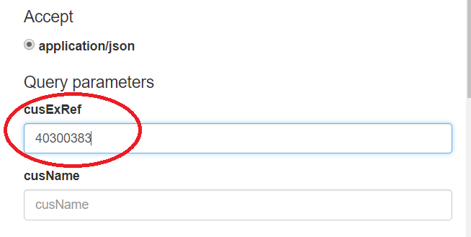

Check the result:

[

{

"msgStatus": "N|N|N|N|N",

"msgRefInfo": "A600O6RO",

"casExRef": null,

"msgDat": "2016-06-09",

"msgFrom": "A3000305",

"msgTo": "A60050FU",

"msgSubject": "test",

"casRef": "1601050001",

"dbName": "DEBTOR_MT",

"creditorName": "BNP PARIBAS PF GREECE"

},

{

"msgStatus": "N|N|N|N|N",

"msgRefInfo": "A600O6JP",

"casExRef": null,

"msgDat": "2016-03-14",

"msgFrom": "A3000305",

"msgTo": "A60050FZ",

"msgSubject": "Test",

"casRef": "1602050003",

"dbName": "MY_DEBTOR_MT",

"creditorName": "BNP PARIBAS PF GREECE"

}

]

# 3. View list messages with parameter msgFromDat

_ Step 1, 2, 3, 4: same as scenario 1.

_ Step 5: enter “2015-09-28” to form “msgFromDat” and click “Submit” button:

_ View the result:

[

{

"msgStatus": "N|N|N|N|N",

"msgRefInfo": "A600O5JD",

"casExRef": "99232382832",

"msgDat": "2015-09-28",

"msgFrom": "A6008KUU",

"msgTo": "97000002",

"msgSubject": "Test",

"casRef": "1508130010",

"dbName": "STANISLAVA",

"creditorName": "BUSINESS UNIT 1"

},

{

"msgStatus": "N|N|N|N|N",

"msgRefInfo": "A600O5LE",

"casExRef": null,

"msgDat": "2015-10-01",

"msgFrom": "A6008KUU",

"msgTo": "A3000305",

"msgSubject": "Re: Test message",

"casRef": "1508210001",

"dbName": "MY",

"creditorName": "BUSINESS UNIT 1"

},

{

"msgStatus": "N|N|N|N|N",

"msgRefInfo": "A600O5JB",

"casExRef": null,

"msgDat": "2015-09-28",

"msgFrom": "A6008KUU",

"msgTo": "A3000305",

"msgSubject": "Test message",

"casRef": "1508210001",

"dbName": "MY",

"creditorName": "BUSINESS UNIT 1"

},

{

"msgStatus": "N|N|N|N|N",

"msgRefInfo": "A600O6RO",

"casExRef": null,

"msgDat": "2016-06-09",

"msgFrom": "A3000305",

"msgTo": "A60050FU",

"msgSubject": "test",

"casRef": "1601050001",

"dbName": "DEBTOR_MT",

"creditorName": "BNP PARIBAS PF GREECE"

},

…

# 4. Check log file

_ Step 1: Go to “temp\log”

_ Step 2: check message.log, check SQL statement at line **com.demo.dao.impl.MessageDaoImpl** such as:

SELECT elem.refdoss casRef, msg.refinfo msgRefInfo, cusi.refext cusExRef, cusi.nom creditorName, dbi.nom dbName, msg.dtsaisie_dt msgDat, msg.refemetteur msgFrom, msg.encodeur msgTo, msg.libelinfo msgSubject, msg.typedoc isRead, msg.fg_urgent isUrgent, msg.fg_important isImportant, msg.str_10_1 isReplyReq, msg.typemetteur isAttachment, customer.refdossext casExRef FROM g_individu cusi, g_information msg, t_intervenants customer, t_elements elem, t_intervenants debtor, g_individu dbi WHERE 1=1 AND (msg.dtsaisie_dt >= to_date(:msgFromDat, 'YYYY-MM-DD')) AND (customer.reftype = 'CL') AND (debtor.reftype = 'DB') AND (debtor.refindividu = dbi.refindividu) AND (elem.refdoss = debtor.refdoss (+)) AND (elem.typeelem = 'ms') AND (customer.refindividu=cusi.refindividu) AND (elem.refdoss=customer.refdoss (+)) AND (msg.refinfo=elem.refelem) ORDER BY elem.refdoss, msg.dtsaisie_dt DESC NULLS LAST