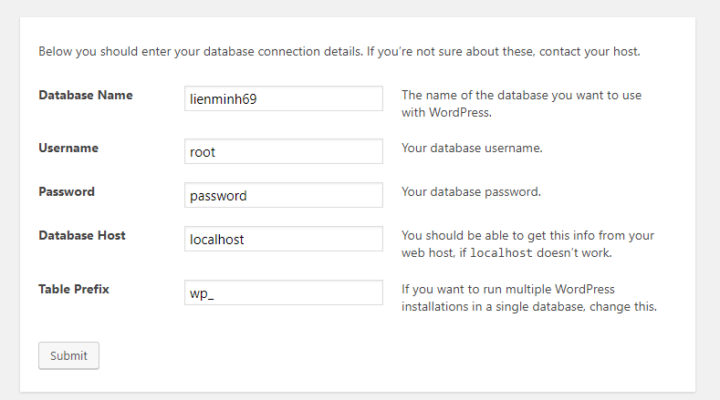

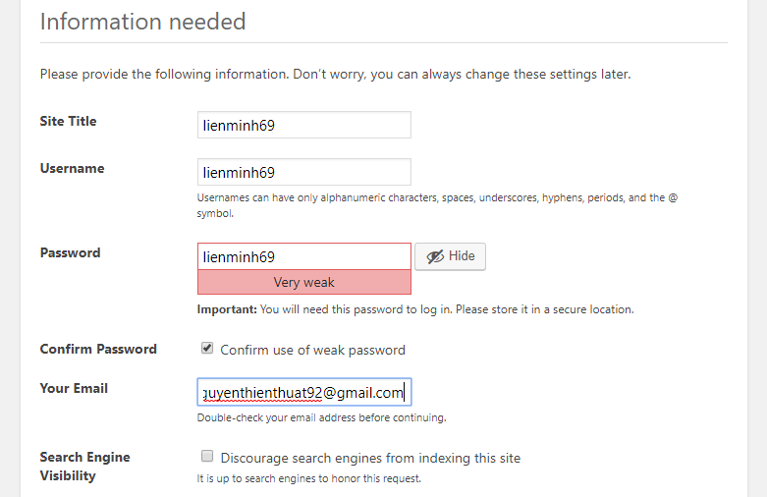

# 1. First post

<http://localhost/lienminh69/2018/02/26/first-post-for-test/>

# 2. Megamenu:

https://wpmegamenu.com/