# 1. pier

# 

They are standing on the pier

# 2. Counter

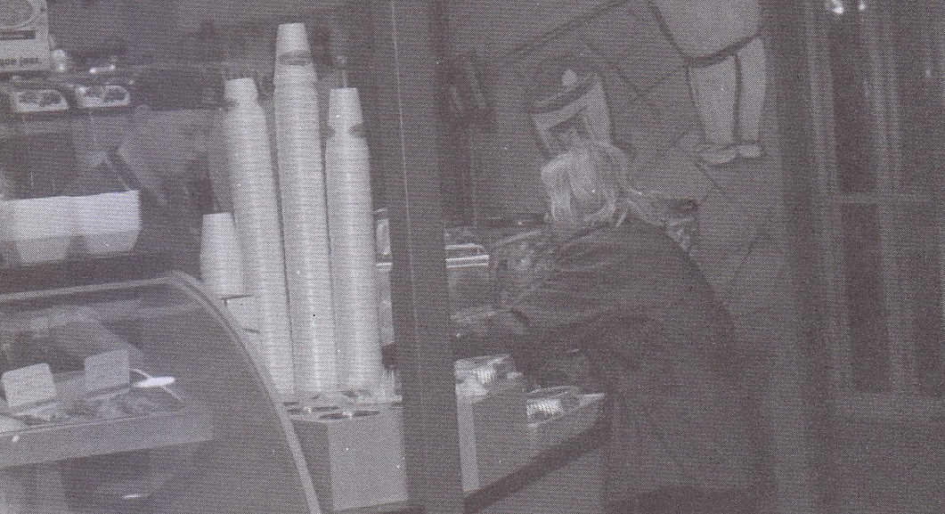

The woman is at the counter

# 3. ladder

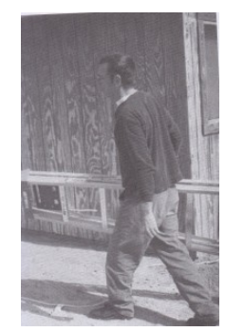

The man is carrying a ladder

# 4. clerk

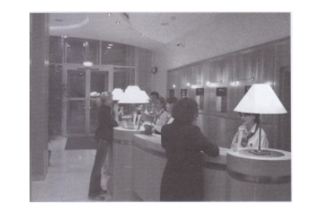

The clerks are standing behind the front desk

# 5. laboratory

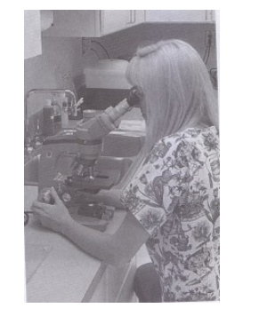

The woman is polishing the microscope

The woman is using the laboratory equipment.

# 6. bench

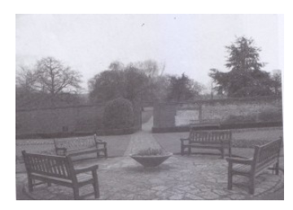

The benches are arranged in a circle.

# 7. porch

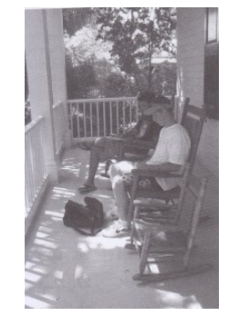

They’re resting on the porch

# 8. road curves

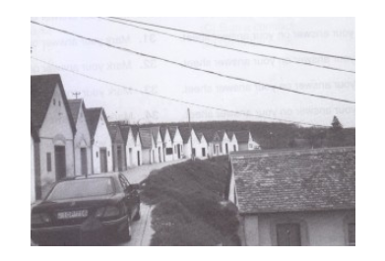

The car is parked in the driveway

The road curves into the distance.

# 9. machinery

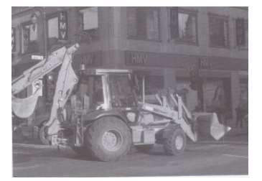

There is a heavy machinery on the road

# 10. sit across

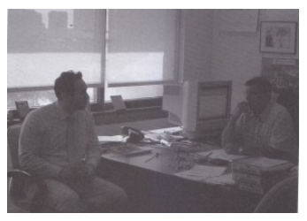

Two men are facing away from each other

They are sitting across from each other

# 11. pole

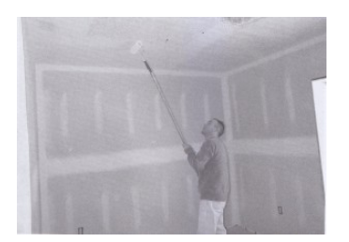

The man is painting the side of a fence.

He’s using a long pole

# 12. stroll

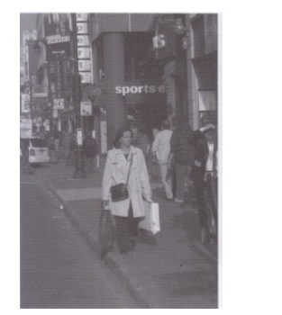

The woman is strolling on the sidewalk

# 13. stand

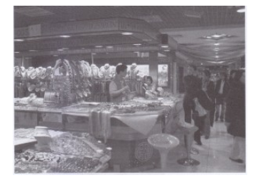

The goods are displayed on the stand

# 14. load onto

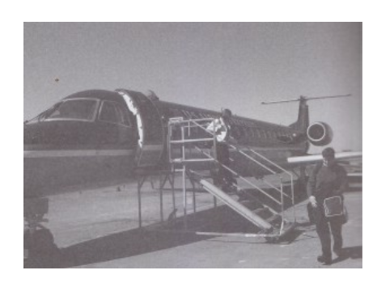

The cargo is being loaded onto the plane

The plane landed a short while ago

# 15. Art gallery

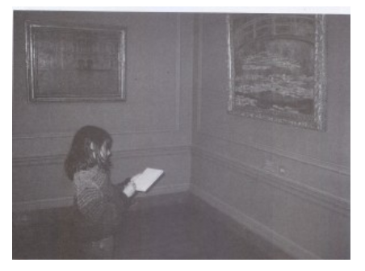

She’s standing front of the art gallery

She’s by herseft in the gallery

# 16. Occupied

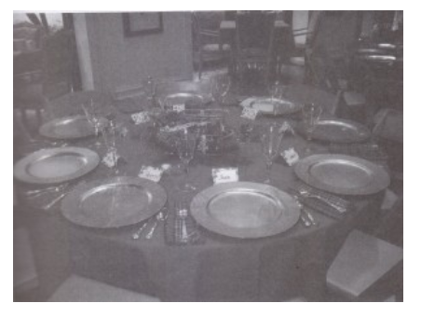

The seats are unoccupied at the moment

# 17. converse with one another

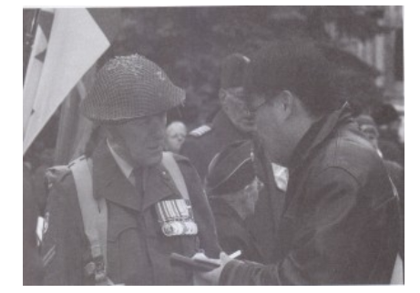

They’re conversing with one another

# 18. extend away

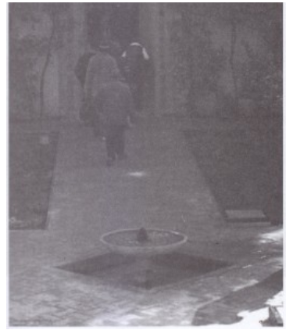

A pathway extends away from the fountain.

# 19. conveyor belt

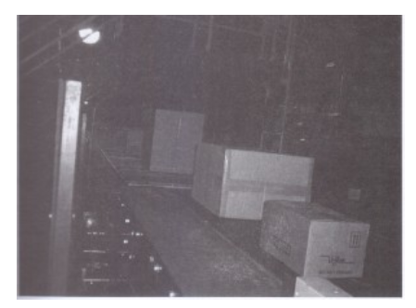

Some boxes are placed on the conveyor belt

# 20. tidy up

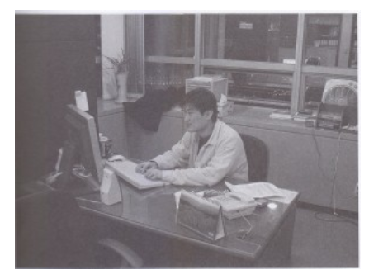

He’s tidying up his work area

He has taken a seat at a workstation

# 21. escort

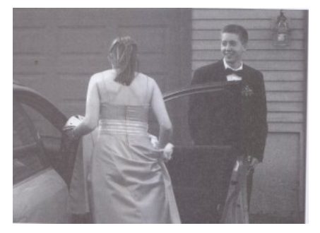

A man is escorting the woman into the vehicle

The door of vehicle is open

# Answer:

1. pier: bến tàu
2. …
3. ladder: cái thang
4. clerk: nhân viên
5. laboratory: phòng thí nghiệm, polish: đánh bóng, microscope: kính hiển vi
6. bench: băng ghế dài
7. porch: mái hiên
8. driveway: lối vào, road curves: đường cong
9. machinery: máy móc
10. face away: nhìn khác phía, sit across: ngồi đối diện
11. a side of a fence: 1 bên mặt của hàng rào, pole: cây sào
12. stroll: đi dạo
13. goods: hàng hóa, stand: quầy hàng
14. cargo: hàng hóa, load onto: xếp lên
15. gallery, art gallery: phòng triển lãm. be herseft: 1 mình cô ấy
16. occupied: bị chiếm, unoccupied: không bị chiếm, trống
17. converse with one another: trò chuyện với nhau
18. extend away: kéo dài từ
19. conveyor belt: băng chuyền
20. tidy up: dọn dẹp
21. escort: hộ tống