# 1. Example 1:

Table **employees**:



Table **employees_audit**: (khong co data)



Create trigger nhu sau:

delimiter $$

**create** **or** **replace** **trigger** before_employee_update

**before** **update** **on** employees

**for** **each** **row**

**begin**

**insert** **into** employees_audit

**set** **action** = 'update',

employeeNumber = **old**.employeeNumber,

lastName = **old**.jobTitle,

changedon = **now**();

**end** $$

delimiter ;

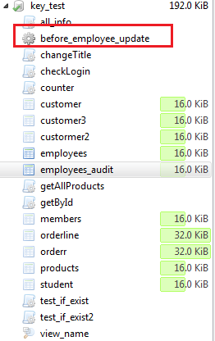

Update data cho table **employees** nhu sau:

**update** employees

**set** jobTitle = 'Manager'

**where** employeeNumber = 1;



**Result**: table **employees_audit** duoc tu dong cap nhat:

