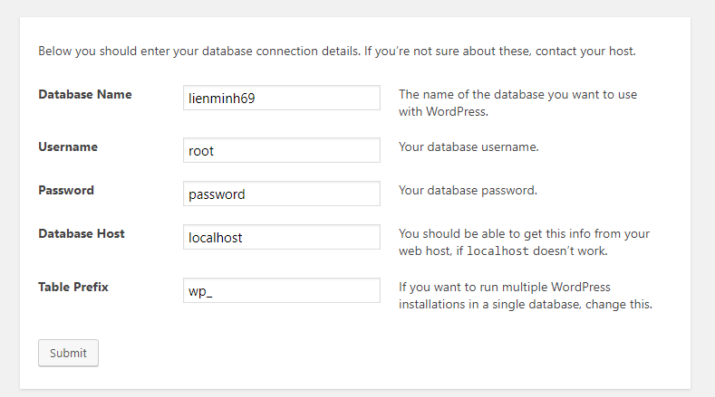

Trên máy công ty

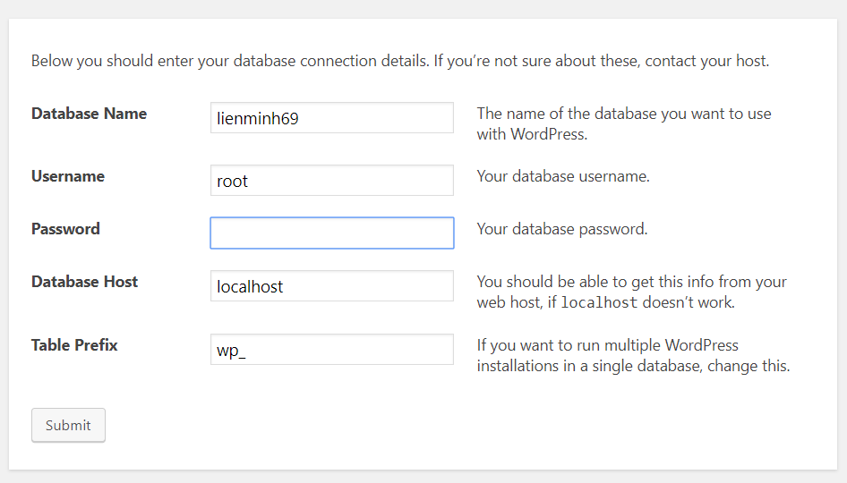

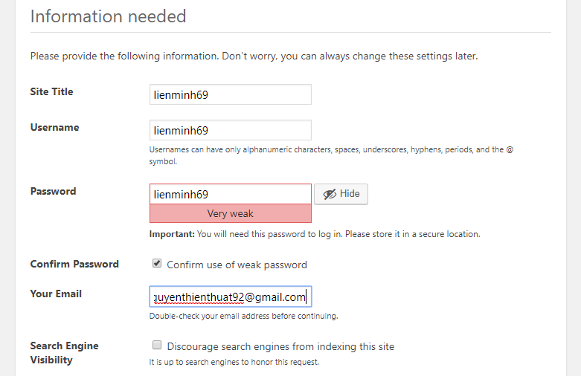

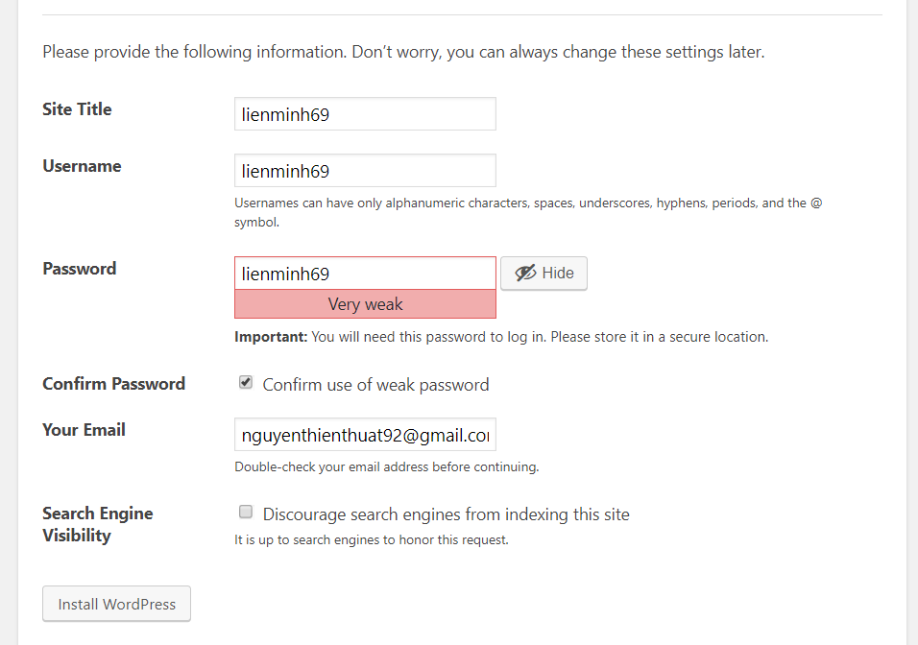

# 1. First post

<http://localhost/lienminh69/2018/02/26/first-post-for-test/>

# 2. Megamenu:

<https://wpmegamenu.com/>

# 3. Tools

PhpStorm 2018

HeidiSQL

Xampp

# 4. How to crack PhpStorm

1. Copy the JetbrainsCrack.jar file to bin directory.

2. Modify "bin/*[idea|clion|...][64].vmoptions" file.

Append "-javaagent:JetbrainsCrack.jar" to end line.

3. Start phpstorm and adding below code

{"licenseId":"ThisCrackLicenseId",

"licenseeName":"Rover12421",

"assigneeName":"Rover12421",

"assigneeEmail":"rover12421@163.com",

"licenseRestriction":"By Rover12421 Crack, Only Test! Please support genuine!!!",

"checkConcurrentUse":false,

"products":[

{"code":"II","paidUpTo":"2099-12-31"},

{"code":"DM","paidUpTo":"2099-12-31"},

{"code":"AC","paidUpTo":"2099-12-31"},

{"code":"RS0","paidUpTo":"2099-12-31"},

{"code":"WS","paidUpTo":"2099-12-31"},

{"code":"DPN","paidUpTo":"2099-12-31"},

{"code":"RC","paidUpTo":"2099-12-31"},

{"code":"PS","paidUpTo":"2099-12-31"},

{"code":"DC","paidUpTo":"2099-12-31"},

{"code":"RM","paidUpTo":"2099-12-31"},

{"code":"CL","paidUpTo":"2099-12-31"},

{"code":"PC","paidUpTo":"2099-12-31"},

{"code":"DB","paidUpTo":"2099-12-31"},

{"code":"GO","paidUpTo":"2099-12-31"},

{"code":"RD","paidUpTo":"2099-12-31"}

],

"hash":"2911276/0",

"gracePeriodDays":7,

"autoProlongated":false}

# 5. Menu navigation bar fixed top

# 6. Config Intelliji