The Theory-Data Gap in Counseling and Psychotherapy NLP: A Systematic Mapping Study of Text-Based Datasets

Abstract
Natural language processing (NLP) is increasingly used in counseling and psychotherapy, yet it remains unclear how well existing dataset infrastructure represents the clinical constructs that define psychotherapy research and practice. This paper presents a systematic map of text-based data resources in this domain, treating the dataset as the unit of analysis and coding each dataset along three axes: helping function, declared theoretical approach and associated measures, and interaction structure and treatment-course structure. From 9,849 records across five databases, we retained 1,205 relevant publications, identified 1,146 distinct datasets, and constructed a main map of 1,043 datasets after excluding 103 single-user social media datasets for disorder detection that contain no helping interaction. The infrastructure has expanded rapidly, with 76.0% of datasets appearing since 2023, but clinical coverage is uneven: 36.0% declare a therapy or communication framework, only 14.2% of datasets declare a psychotherapeutic approach, and cognitive behavioral therapy (CBT) accounts for 69.4% of therapy-label occurrences; 72.8% are multi-turn, but 90.6% are text-only and 45.0% contain real helping conversations; in the large language model (LLM) era, LLMs are involved in data generation or transformation in 39.1% of datasets. Only 3.7% link multiple sessions from the same case, and no dataset is described as covering all five stages of a course of treatment within a single case. Reuse is similarly fragmented: 95.0% of datasets are linked to only one publication in the review corpus, while language coverage is concentrated mainly in English and Chinese. Comparing these findings with the clinical reference framework reveals six gaps in shared resources, theoretical coverage, interaction signals, treatment-course structure, measurement targets, and language coverage. We conclude with design principles for the next generation of resources, emphasizing alignment among clinical objectives, units of data, dialogue provenance, and measurement.
Keywords: counseling; psychotherapy; natural language processing; NLP; LLM; conversational datasets; clinical NLP; text-based datasets; clinical grounding; therapeutic process; behavioral coding; dataset infrastructure; systematic mapping; theory-data gap.

1. Introduction
Counseling and psychotherapy are goal-directed helping processes in which clinical value is determined not by a single response, but by how interaction is organized and develops over time. Depending on the therapeutic orientation and practice setting, this process may include establishing the therapeutic relationship, assessing presenting problems and risk, setting goals, developing a case conceptualization, selecting and delivering interventions, monitoring change, and terminating treatment or conducting follow-up [4], [7], [15], [18]. Throughout the process, practitioners use orientation-specific techniques while also maintaining transtheoretical elements such as the therapeutic alliance, empathy, progress monitoring, and professional responsibility [1], [4], [6], [7], [30]. Surface resemblance to therapeutic language therefore does not imply that a data resource contains the knowledge required to study counseling and psychotherapy as clinical processes.
The development of natural language processing (NLP), especially since pretrained language models and large language models (LLMs) became the foundation of conversational systems, has rapidly expanded the text-data infrastructure of mental health research and shifted attention from standalone classifiers toward multi-turn conversational agents that simulate therapeutic interaction. Model architectures change across generations, but these systems are trained and evaluated on the same broad class of resources: datasets that record or simulate interaction between a party performing a helping function and a party seeking help. Unlike open-domain dialogue, collecting and disseminating these resources faces three constraints: the sensitivity of the content and risk of re-identification; the high professional cost of constructing or validating the data; and safety consequences when dataset biases propagate into systems used in contexts involving clinical risk. These constraints shape the infrastructure itself. Alongside transcripts of psychotherapy and counseling sessions, clinical interviews, crisis interactions, and peer-support exchanges, many resources are created through less constrained pathways, including role-play between lay participants (EmpatheticDialogues [42], ESConv [43]), Wizard-of-Oz screening interviews (DAIC-WOZ [44]), forum and social-media exchanges, data reconstructed from secondary sources, and, more recently, LLM-synthesized conversations (SMILE [47], SoulChat [48], Cactus [50]). On top of these sources, NLP research has developed tasks including recognition and coding of communication behavior, classification of states or strategies, response generation, dialogue-process modeling, prediction of clinical variables, and evaluation of conversational-system competence.
However, growth in the number of datasets, dialogue turns, or fluent responses does not directly indicate how much knowledge from counseling and psychotherapy practice is represented in the infrastructure. A corpus may be described as counseling, therapy, or mental-health support while containing only independent question-answer pairs; another may contain multi-turn dialogue without specifying a therapeutic orientation, intervention goal, professional behavior, or outcome variable; a synthetic corpus may reproduce the surface form of a therapy session without an independent standard for assessing fidelity to the approach it claims to simulate. Conversely, a small resource linked to an established behavioral coding system may provide clearer clinical evidence for a specific NLP task. Dataset scale and the degree of clinical knowledge represented are therefore distinct properties and must be evaluated separately. In a domain defined by clinical practice, a corpus whose therapeutic approach, measurement instrument, and preserved treatment structure cannot be identified cannot by itself support claims about systems assuming clinical responsibility.
This distinction motivates the central question of this study: to what extent does the text-data infrastructure used by NLP for counseling and psychotherapy contain the clinical knowledge of the domain? We operationalize this question through two properties of each dataset: whether the dataset contains the relevant clinical-knowledge component in its dialogue or labels; and whether the dataset is named and is reused by other publications. A dataset may contain clinically meaningful information, yet if it has no identifying name and is used only once, that knowledge does not accumulate as a shared resource for the field. The knowledge components used as coding criteria are drawn from psychotherapy research: forms of helping, the structure of therapeutic interaction, theoretical orientations and their measurement systems, and professional norms governing the recording and sharing of interactions. Measuring these properties requires two conditions that the existing literature has not jointly met: treating the infrastructure as a whole as the object of study, and classifying datasets by components of psychotherapy research rather than by NLP task type.
Recent reviews have approached this area from several perspectives (Table 1), but most use systems or studies as the unit of analysis [34]-[38], [40], [41]. The few reviews that take datasets as the unit of analysis typically cover only several dozen prominent resources or span all modalities and mental-health tasks. The most recent data-centric review by Mandal et al. [39] categorizes 89 clinical datasets by disorder, modality, task, access level, and cultural context, but does not use clinical theory as an analytic axis and does not include unnamed corpora.
Review | Focus | Unit of analysis | Catalog size | Clinical theory used as a classification criterion
Ma et al. [34] | Empathetic dialogue systems | System/study | — | ✗
Guo et al. [35] | LLMs for mental health applications | System/study | — | ✗
Na et al. [36] | LLMs in psychotherapy | System/study | — | ✗
Bucher et al. [37] | LLMs in mental health care | System/study | — | ✗
Cho et al. [38] | LLM chatbots and agents for counseling | System/study | — | ✗
Mandal et al. [39] | Multimodal clinical datasets for mental health AI | Dataset | 89 | ✗
Voultsiou & Moussiades [40] | LLMs in mental health | System/study | — | ✗
Chen et al. [41] | Psychological computing from PLMs to LLMs | System/study | — | ✗
This study | Text-data infrastructure for counseling and psychotherapy | Dataset | 1,043 | ✓
Table 1. Compared with prior reviews, this study uses the dataset as the unit of analysis at a scale of more than one thousand datasets, includes unnamed resources, and uses clinical theory as a classification criterion. Review focus is reported according to each review's title; unit of analysis follows each review's own framing; "—" indicates that the review does not construct a dataset catalog as its unit of analysis.
This study takes the dataset as the unit of analysis because clinical knowledge must be present in the data rather than only in the model architecture, and uses components of psychotherapy research as classification criteria: we first specify what constitutes the counseling-psychotherapy domain (Section 2), and then measure how much of each component is represented in the NLP dataset infrastructure (Section 4). Each dataset is coded along three axes: the clinical function it serves, the theoretical approach it declares, and the form in which it exists; all three axes are examined across three technological periods from 1999 to 2026. The two research questions correspond to the two properties of the central question. RQ1: To what extent does the text-data infrastructure used by NLP contain the clinical knowledge of counseling and psychotherapy, with respect to helping function, session-level interaction and treatment-course structure, declared theoretical approaches and measurement systems, and language? RQ2: Within that infrastructure, which datasets have become shared resources for NLP research, as assessed through two indicators: whether a dataset is named and whether it is reused by other publications? The difference between the answers to these questions and the components defined in Section 2 constitutes the theory-data gap.
This paper makes three contributions. First, we introduce a three-axis coding framework - function, declared theoretical approach, and data form - derived from components of psychotherapy research, and apply it to a map of 1,043 datasets spanning the infrastructure; every dataset is traceable to its source publication, and the accompanying repository supports reanalysis. Second, we provide quantitative evidence addressing RQ1 and RQ2, thereby measuring the theory-data gap component by component. Third, we identify six infrastructure gaps, each traceable to a research question, together with design principles for the next generation of resources derived from the evidence in the map. Treating the dataset as the unit of analysis and psychotherapy research as the classification frame makes it possible to identify what knowledge the next generation of resources should add, in which functional branch, and with which measurement tools.
To identify relevant resources, we conducted systematic searches in Web of Science, PubMed, arXiv, the ACL Anthology, and OpenAlex using three keyword blocks (mental health/counseling/psychotherapy; dialogue/data/corpus; NLP/language models/LLMs), supplemented by an additional search using names of therapeutic approaches and established measures. The search yielded 9,849 unique records. After a two-stage evidence-grounded screening workflow combining automated classification with human review, we retained 1,205 publications directly associated with text-based datasets, from which we constructed 1,146 distinct dataset entries and a main map of 1,043 datasets.

2. Clinical Foundations of Counseling and Psychotherapy

2.1. Forms of Psychological Helping
In counseling and psychotherapy research, forms of psychological helping can be distinguished by two criteria: who provides the help and the degree of professional responsibility for outcomes. On these dimensions, helping ranges from informal support by family and friends, through paraprofessional support by peers or trained volunteers, to professional services provided by counselors and therapists [11], [65], [66]. We distinguish four forms.
Emotional support (ES) is a form of social support [67] intended to help recipients feel heard, validated, and less isolated during distress. It may be provided by family members, friends, or volunteers; the helper does not assume professional responsibility for outcomes, conduct clinical assessment, or formulate a treatment plan. Peer support (PS) is an organized form of emotional support in which people with relevant lived experience support others facing similar difficulties; the helping relationship is reciprocal and grounded in shared experience, and this model is increasingly integrated into mental-health services through peer-support worker roles [68], [69]. Counseling (CO) is goal-directed professional helping, often time-limited, focused on adjustment difficulties, developmental crises, or specific problems; the counselor assumes professional responsibility and uses trained helping skills, with Hill's exploration-insight-action model providing a representative systematization [11], [70]. Psychotherapy (PT) is a structured intervention for mental disorders or clinically significant psychological distress and typically involves clinical assessment, case conceptualization, goal setting, multi-session intervention, progress monitoring, risk management, and termination; formal diagnosis may also be included depending on the clinical setting [15], [18].
These four forms constitute a gradient of professional responsibility and structure, not a hierarchy of value; stepped-care systems organize services along such a gradient [33], [71]. The boundary between counseling and psychotherapy is a professional convention that varies across countries [70]. In practice, therapists often use both counseling skills and psychotherapy interventions within the same course of treatment, and psychotherapy that lacks the relational qualities of emotional support is unlikely to be effective. In addition to these four helping forms, domain-relevant dialogue is also generated in treatment stages that are not themselves helping processes (Section 2.3) and in practitioner training (Section 2.6).

2.2. Therapeutic Relationship and Session-Level Interaction
Although therapies differ in mechanisms of change and specific techniques, they all unfold within a helping relationship over time. The common-factors tradition identifies the therapeutic relationship as a central component of treatment effectiveness [7]. Rogers described necessary and sufficient conditions for personality change, with empathy and unconditional positive regard at their core [1]; empathy measures in this tradition are rated by observers or clients [2], [3], and meta-analytic evidence shows a stable association between therapist empathy and outcomes [6]. Bordin defined the working alliance as a transtheoretical construct comprising agreement on goals, agreement on tasks, and an affective bond [4]. Alliance predicts treatment outcomes in meta-analyses [5], [7] and may undergo ruptures and repairs during interaction, with rupture-repair cycles themselves functioning as a mechanism of change [8], [9].
At the session level, interaction unfolds turn by turn: a helper intervention (e.g., a response, question, interpretation, or instruction) elicits a client response, and that response - for example, disclosure, resistance, or change talk - informs how the helper adjusts the next intervention [11], [12]. Process research therefore relies on audio recordings, video recordings, and transcripts of real sessions because observed client responses are essential for studying interactional processes and cannot be recovered from isolated helper turns; nonverbal and paralinguistic channels such as voice, silence, and facial expression are also part of the clinical signal.

2.3. Structure of a Course of Treatment
At the treatment-course level, care extends across multiple sessions and can be organized into five identifiable stages [15], [18]: (1) intake, including brief standardized screening such as the PHQ-9 to identify likely cases [29], triage by urgency, and diagnostic assessment using structured clinical interviews; (2) risk screening and crisis intervention when needed; (3) case conceptualization and goal agreement; (4) intervention with progress monitoring and reassessment; and (5) termination and relapse prevention. Where a service carries clinical responsibility, suicide-risk assessment and management are core professional responsibilities. In non-clinical support settings, appropriate procedures should be in place to identify risk, escalate support, and refer individuals to professional services when needed. Intake and crisis work may be delivered by separate services, such as screening points, assessment clinics, or crisis hotlines, and may end without leading to formal counseling or psychotherapy; screening, diagnostic assessment, and crisis intervention are therefore part of treatment-course structure even when they are not themselves the helping process. Many therapies explicitly organize these stages, such as agenda-based sessions and between-session homework in cognitive behavioral therapy [15], or the initial, middle, and termination phases of interpersonal psychotherapy [18]. The unit to which clinical outcomes are attributed is the case - one client across the full course of treatment - rather than a single session or utterance.

2.4. Theoretical Orientations
Modern psychotherapy is a pluralistic field. No single taxonomy is used across the entire profession; standard texts compare traditions and psychotherapeutic approach in terms of their accounts of psychological difficulty, mechanisms of change, therapist role, intervention structure, and outcome evidence. Psychoanalysis and subsequent psychodynamic approaches laid the foundation for talking therapies, emphasizing relational patterns and intrapsychic conflict interpreted within the therapeutic relationship [17]. From the mid-twentieth century, behavior therapy developed from learning theory; in parallel, humanistic-experiential approaches, especially Rogers' client-centered therapy, placed empathy and unconditional positive regard at the center of the therapeutic relationship [1], later extending to Gestalt and emotion-focused therapies. The cognitive models of Ellis and Beck converged with behavioral traditions to form the cognitive behavioral therapy (CBT) family, characterized by collaboration, goal orientation, explicit session structure, and case conceptualization [15]. From the 1980s onward, therapies for specific clinical problems became prominent, including interpersonal psychotherapy (IPT) for depression and interpersonal difficulties [18] and trauma-focused approaches such as EMDR, with its defined eight-phase protocol [22]. Within the cognitive-behavioral tradition, third-wave developments such as dialectical behavior therapy (DBT) [19], acceptance and commitment therapy (ACT) [20], and mindfulness-based cognitive therapy (MBCT) [21] broadened the focus to acceptance, mindfulness, emotion regulation, and psychological flexibility. Other traditions include systemic and family approaches, which situate individual difficulties within interactional systems, and integrative or brief approaches such as schema therapy and solution-focused brief therapy (SFBT). Figure 1 summarizes the historical development of these theoretical foundations.
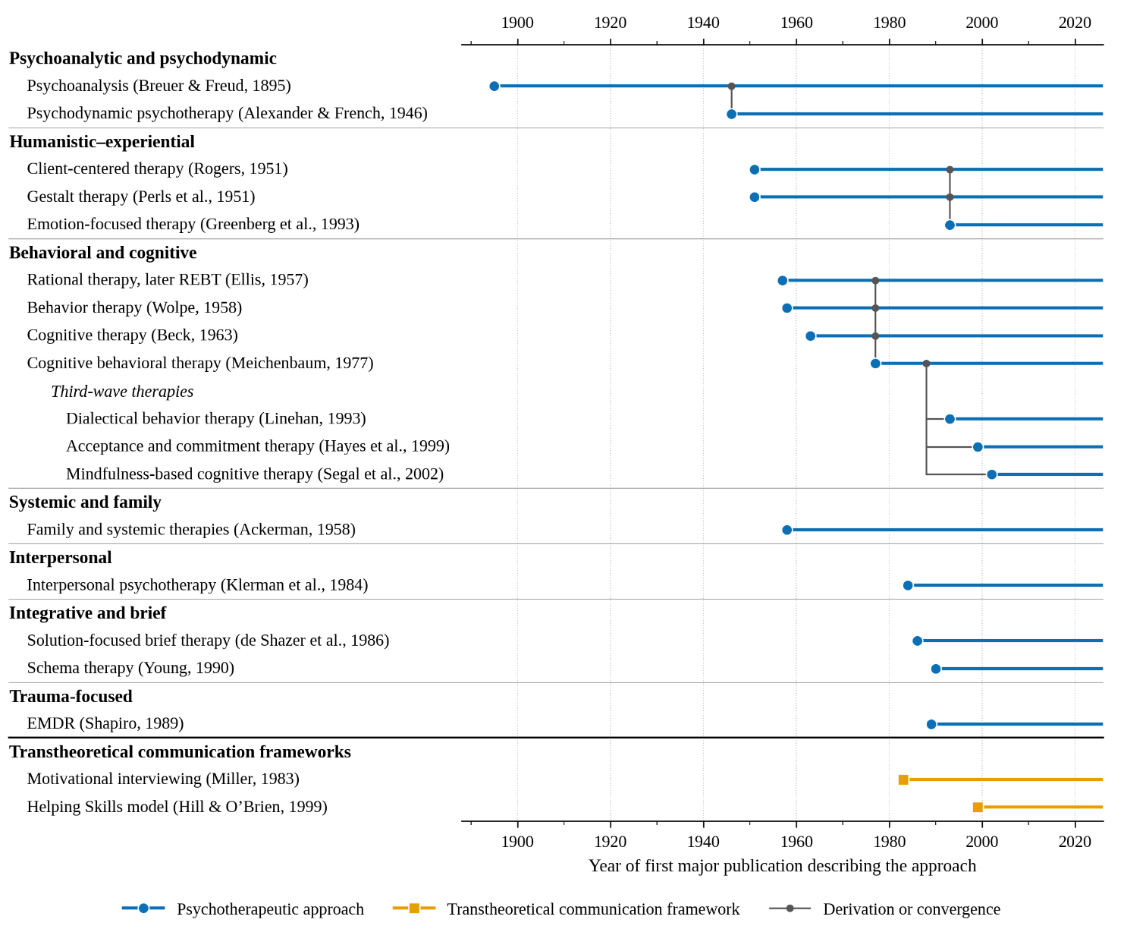
Figure 1. Historical timeline of the psychotherapeutic approaches and transtheoretical communication frameworks. Markers indicate selected foundational publications used to anchor each approach historically; horizontal lines indicate that the approach remains in use; grey connectors indicate derivation or convergence.
The treatment systems above should be distinguished from transtheoretical communication frameworks, which are not therapies but methods or behavioral vocabularies that can be integrated with multiple orientations. Motivational interviewing (MI) is a collaborative communication method designed to resolve ambivalence and strengthen motivation for change; it emerged from research on stages of behavior change and is positioned by its developers as a communication style that can be used within many forms of treatment [10], [12]. Hill's Helping Skills model systematizes core helping skills across three stages - exploration, insight, and action - and underpins counselor training in many programs [11]. This distinction matters for comparison: saying that an interaction is "CBT-based" refers to its mechanism of change and treatment structure, whereas saying that it "uses reflection skills" refers to communication behavior; these are not claims at the same level.
The distribution of orientations in clinical practice is uneven, but it is not concentrated in a single tradition. The most recent survey of practicing psychologists providing psychotherapy found that psychodynamic/relational orientations accounted for 29% [32], alongside cognitive-behavioral, integrative, and humanistic orientations. Evidence-based clinical guidelines recommend multiple therapies for the same disorder: for adult depression, NICE and APA guidelines list CBT, IPT, and MBCT among evidence-supported options [33]. An infrastructure intended to represent clinical practice should therefore reflect this diversity rather than a single therapy.

2.5. Measurement in Process-Outcome Research
Psychotherapy research measures practice across three distinct targets, each with its own instruments, rating units, and information sources (Table 2). The first is helper behavior, adherence, and competence, measured through behavioral coding systems or fidelity scales applied to sessions by trained raters. Different therapy traditions use different tools, ranging from turn-level coding systems for Helping Skills and motivational interviewing [11], [13], [14] to session-level fidelity scales for CBT, psychodynamic therapy, IPT, DBT, ACT, mindfulness-based interventions, and EMDR [16], [23]-[28]. The second target is client state and outcome, measured using self-report symptom and outcome scales such as the PHQ-9 [29] or ORS [30], administered outside the dialogue and repeated across the course of treatment. The third is the therapeutic relationship, measured using the Working Alliance Inventory (WAI) family, which includes parallel client- and therapist-rated forms as well as observer-rated adaptations [4], [31] and empathy measures from the Rogers tradition rated by observers or clients [2], [3]. These three targets are not interchangeable: a technically appropriate turn-level intervention does not support inference about alliance or symptom change, and the unit of measurement - turn, session, or case - must correspond to the unit of the conclusion.
Measure | Tradition/framework | Measurement target | Rating unit | Source
Helping Skills coding system | Helping Skills (Hill) | Helper behavior/competence | Turn | [11]
MISC/MITI | MI | Helper behavior/competence | Turn; session-level global ratings | [13], [14]
CTRS | CBT | Helper behavior/competence | Session (11 items) | [16]
CPPS | Psychodynamic-relational; CBT techniques | Helper behavior/competence | Whole session | [23]
CSPRS | IPT, CBT, clinical management | Helper behavior/competence | Whole session | [24]
DBT-ACS | DBT | Helper behavior/competence | Session | [25]
ACT-FM | ACT | Helper behavior/competence | Session | [26]
MBI:TAC | Mindfulness-based interventions | Helper behavior/competence | Session | [27]
EFRS | EMDR | Helper behavior/competence | Session | [28]
PHQ-9 | Transtheoretical | Client state/outcome | Self-report | [29]
ORS | Transtheoretical | Client state/outcome | Self-report | [30]
WAI scales | Transtheoretical | Therapeutic relationship | Client/therapist self-report; observer-rated variants | [4], [31]
Rogers-tradition empathy scales | Client-centered | Therapeutic relationship | Observer or client | [2], [3]
Table 2. Measures of behavior, relationship, and outcome in psychotherapy research: tradition, measurement target, rating unit, and source.
Measures of helper behavior differ in the material they require, and this requirement is a property of the instrument itself. One group of tools scores the helper's language at the turn or session level using publicly available manuals; these measures were designed for recordings or transcripts and have been applied directly to transcripts: the Helping Skills coding system, MISC/MITI, and CTRS [11], [13], [14], [16]. A second group requires trained observers to rate an entire session, audio/video recordings, or information outside the spoken text, such as nonverbal behavior or extra-session data: CPPS, CSPRS, DBT-ACS, MBI:TAC, and EFRS [23]-[25], [27], [28]. ACT-FM is scored at the session level and does not yet have an established text-annotation tradition [26]. Thus, only some traditions have measurement systems that can be applied by raters to text-only session data; others assess fidelity through whole-session observation, nonverbal channels, or information beyond the dialogue.

2.6. Professional Norms for Data Sharing, Training, and Cultural Context
Counseling and psychotherapy practice is governed by professional norms with direct consequences for recording and sharing interactions. First, informed consent and confidentiality are conditions of the helping relationship: session content may include symptoms, trauma, relationships, and self-harm risk, so recording audio or video, or retaining transcripts for research, requires separate consent and de-identification; consent to treatment does not automatically include permission to use sessions for model training or corpus release. Second, training and supervision are mechanisms for maintaining practitioner quality: training often uses practice with simulated clients or role-play accompanied by systematic feedback, whereas supervision relies on review of real sessions using the measures described in Section 2.5. Finally, expressions of psychological distress, symptom labels, communication norms, and help-seeking behavior vary across cultures [63], [64]. Cultural competence is therefore a professional norm, and the measures in Section 2.5 should be adapted and psychometrically validated for each language and context before use.

3. Methods

3.1. Publication Corpus and Search Strategy
The publication corpus was consolidated across three search rounds (the final round closed in July 2026) covering five databases: Web of Science, PubMed, arXiv, the ACL Anthology, and OpenAlex. The query intersected three keyword blocks: mental health/counseling/psychotherapy; dialogue/data/corpus; and NLP/language models/LLMs. A supplementary search used the names of the theoretical orientations and measurement instruments in Sections 2.4-2.5 as keywords to seek counterevidence for empty cells on the theoretical axis. After deduplication by DOI, arXiv identifier, and normalized title, the corpus contained 9,849 records. The exact query strings, search fields, and execution dates for each database are reported in Appendix A.

3.2. Two-Stage Evidence-Grounded Screening
Each record was screened at the title and abstract level using a two-stage procedure combining a language model with human review. Stage 1 classified all 7,578 newly retrieved records by relevance (in-domain / out-of-domain / uncertain) and contribution type. Every decision had to include a verbatim quotation from the abstract, which was automatically checked against the source text; if the quotation did not match, the decision was downgraded to "uncertain." Stage 2 independently adjudicated 3,451 records in the risk region (records classified as in-domain in Stage 1, uncertain cases, excluded records with contradictory signals, and technical-error cases): 2,655 were retained, 759 borderline cases were resolved, and 37 decisions were reversed. A supplementary retrieval recovered 37 missing abstracts and resolved 33 additional cases. The resulting pool comprised 2,031 records judged clearly in-domain, 5,075 out-of-domain records, and 472 uncertain records that were excluded from analysis; human review of excluded records restored five false exclusions. The full selection process, from records identified to datasets included, is reported as a PRISMA-style flow in Appendix B.

3.3. Unit of Analysis and Dataset Catalog Construction
The dataset is the unit of analysis. Publications directly associated with text-containing datasets were retained, including 601 newly screened papers judged clearly in-domain after the two stages and 604 papers from the previously validated corpus, for a total of 1,205 publications. For each paper, a reviewer read the abstract, identified the datasets mentioned, assigned the fields on the three coding axes with a supporting verbatim quotation, and labeled the paper's role with respect to the dataset (introduction, development, benchmark evaluation, or use). Approach labels were manually checked to remove false string matches (e.g., "CBT" in Children's Book Test). Publications referring to the same dataset were merged into one entry: descriptive fields were assigned according to the majority of supporting publications, theoretical labels were merged as a union, and the year was set to the earliest appearance in the corpus. This process yielded 1,146 distinct datasets. Unnamed datasets were retained using short descriptive labels rather than excluded, allowing us to measure resources that appear only once; publications naming the dataset only as "unknown" were merged into a single entry to preserve publication-dataset links but were excluded from statistics on named datasets. Two labeling conventions were applied: specific program labels (e.g., MBCT) were counted only when explicitly named, whereas generic descriptions such as "mindfulness-based" were assigned to the broader family; ambiguous abbreviations (e.g., EFT) were retained as declared and not further disambiguated at the abstract level. The main map contains 1,043 datasets after excluding 103 single-user social-media datasets for depression, suicide, or disorder detection, which are not two-party helping conversations in the sense of Section 2.1.

3.4. From Clinical Theory to a Three-Axis Coding Framework
The coding framework comprises three axes, each corresponding to a dataset property that psychotherapy research indicates should be assessed; fields on each axis operationalize the components of Section 2 using the terminology defined there (Table 3). The function axis operationalizes Section 2.1 as four forms of helping (ES, PS, CO, PT); datasets that do not record a helping process receive a "not applicable" value and are characterized using the other two axes. The theoretical axis operationalizes Sections 2.4 and 2.5 through three fields: the declared treatment system (hereafter, therapy), the declared transtheoretical communication framework, and the degree of operationalization. Motivational interviewing and the emotional-support strategy family are assigned to the communication-framework field according to the distinction in Section 2.4. The operationalization field distinguishes whether an approach is merely named, included in a prompt, used to organize the data, or used for annotation and filtering through a measurement instrument. The form axis operationalizes Sections 2.2, 2.3, and 2.6 through five fields recording which aspects of the therapeutic process the dataset captures (turn sequence and nonverbal channels, observed client responses, and treatment-course stages) and the professional conditions under which it is created and shared (training/supervision context and language).

Axis | Field | Description | Values
Function | Helping form | Form of helping recorded or simulated by the dataset | ES, PS, CO, PT
Theory | Declared treatment system | Therapy declared by the dataset | 9 therapies
Theory | Declared transtheoretical communication framework | Communication framework declared by the dataset | MI; Helping Skills; emotional-support strategies
Theory | Measure and degree of operationalization | How the approach is used in dataset construction; which measure is used; whether the measure can be applied to text | named → included in prompt → used to structure data → annotated/filtered with a measure
Form | Turn sequence and nonverbal channels | What the dataset captures at the session level | multi-turn / single-turn; text-only / multimodal
Form | Observed client response (dialogue provenance) | Whether dialogue is real or simulated | real, role-play, social media, mixed, LLM-synthesized, undetermined
Form | Treatment-course stage recorded | Which stage is recorded; how many stages occur within the same case | intake; risk and crisis; case conceptualization and goals; intervention and monitoring; termination; multi-valued
Form | Training and supervision context | Whether the dataset was created for practitioner training | yes / no
Form | Language | Language present in the resource | language code
Table 3. Three-axis coding framework used in the systematic map.

3.5. Indicators of Shared Resources: Naming and Reuse
RQ2 is measured using two dataset-level indicators. Named: the dataset has a specific name assigned by its authors. Reuse count: the number of distinct publications in the review corpus that use the dataset, beyond the publication that introduces it. Publication-dataset links are established by matching dataset names in abstracts to the catalog, supplemented by aliases and DOI or URL information where available; uses that do not name the dataset are recorded as unresolvable.

4. Results: How Much of Clinical Theory Is Reflected in NLP Dataset Infrastructure?

4.1. Forms of Helping: Coverage Across Four Forms
This subsection compares the infrastructure with the four theoretically defined forms of helping (Section 2.1). Figure 2 distributes all 1,043 datasets into two blocks: 835 datasets that record or simulate a helping process, and 208 datasets from other domain contexts (Sections 2.3 and 2.6).
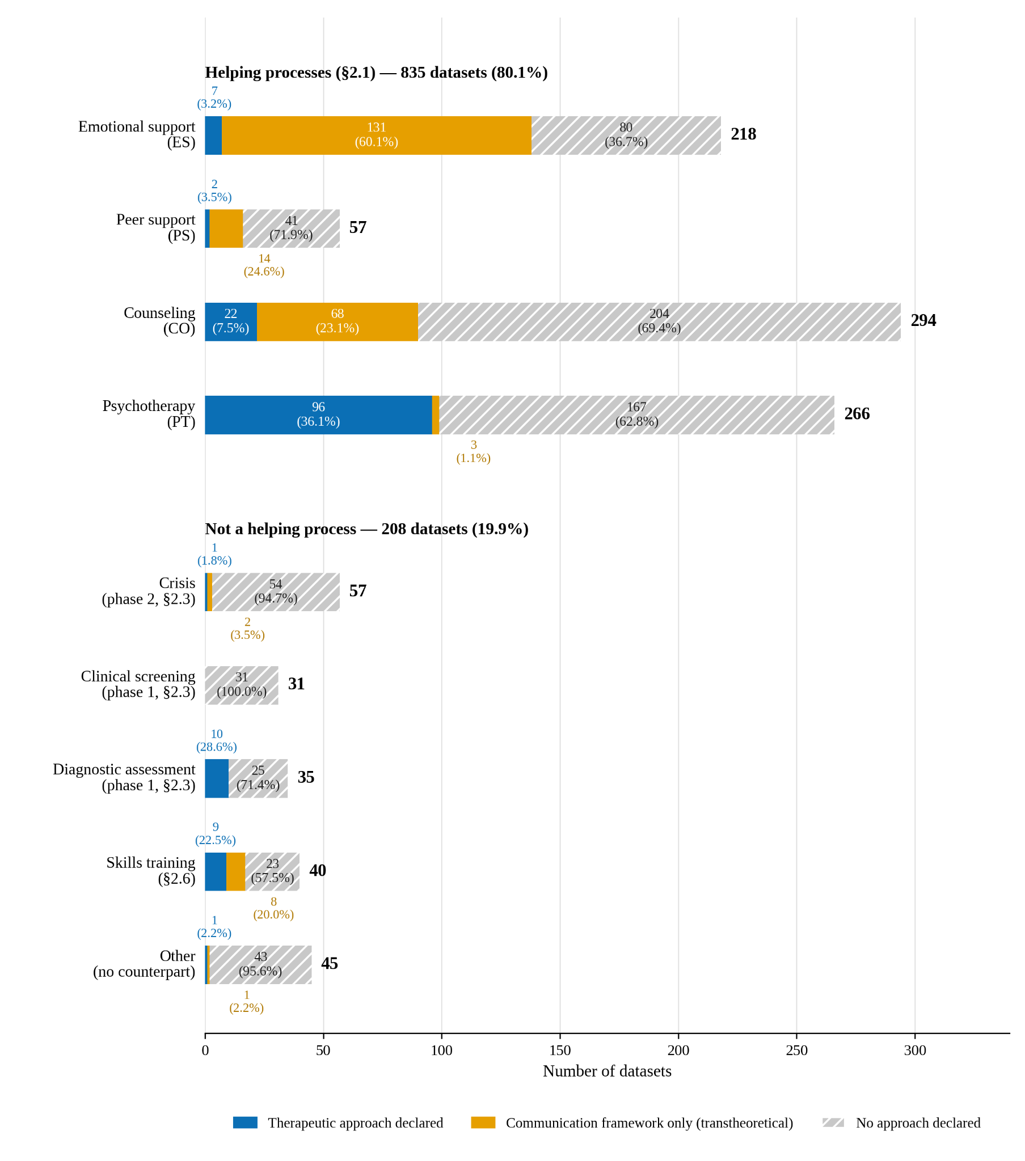
Figure 2. Distribution of datasets across four forms of helping and levels of declared theoretical grounding.
Overall distribution of the infrastructure. The four forms of helping account for 80.1% of the map: counseling (294 datasets) and psychotherapy (266) together constitute more than half, followed by emotional support (218) and peer support (57). The remainder comprises three branches corresponding to the intake and crisis stages of a course of treatment (123 datasets), skills training (40), and resources that could not be classified (45). In summary, the infrastructure is concentrated in the two professional forms of helping - counseling and psychotherapy - but scale alone does not indicate clinical quality.
Declared theoretical approaches by form of helping. Among the 835 helping datasets, 15.2% declare a therapy, 25.9% declare only a transtheoretical communication framework, and 58.9% declare neither. The four forms differ more in the type of knowledge declared than in the overall rate of declaration. Psychotherapy is the only form in which therapy labels predominate (36.1%, almost entirely CBT); emotional support has the highest declaration rate (63.3%) but this is almost entirely accounted for by the emotional-support strategies associated with the ESConv line [43]; counseling primarily declares a communication framework, namely motivational interviewing; and peer support rarely declares an approach (71.9% declare none). Thus, each helping form is associated with a narrow theoretical vocabulary, and even within the two professional forms, about two thirds of datasets lack an explicit clinical interpretive framework.
Comparison with the gradient of professional responsibility (Section 2.1). The four forms are ordered by increasing professional responsibility, and the proportion declaring a therapy follows the same direction: 3.2% in emotional support and 3.5% in peer support, 7.5% in counseling, and 36.1% in psychotherapy. Declaration of communication frameworks does not follow this gradient; instead, it clusters where NLP already has turn-level coding systems that can be applied to text (emotional-support strategies, MISC/MITI). In other words, the professional responsibility of a helping form determines the type of knowledge declared, whereas the availability of a coding system determines the degree of declaration; this proposition is examined further in Section 4.4.
Resources that do not record a helping process. The remaining 208 datasets correspond to three other components of the clinical framework. Crisis resources (57 datasets) map to Stage 2, while clinical screening (31) and diagnosis (35) map to Stage 1 of the course of treatment (Section 2.3); skills training (40) corresponds to professional norms of training and supervision (Section 2.6); the remaining 45 resources fall within the mental-health domain but have no theoretical counterpart in the framework and are not interpreted further. Declaration of an approach is generally low in this block, except for diagnosis and training, where resources are often constructed deliberately around a treatment framework or training program. Thus, the first two stages of the course of treatment appear in the infrastructure primarily as separate services rather than as components linked to an ongoing helping process; the implications for treatment-course coverage are examined in Section 4.3.

4.2. Session-Level Interaction: Turn Structure, Nonverbal Channels, and Observed Client Responses
The clinical framework defines therapeutic interaction at the session level as a sequence of turns in which observed client responses and nonverbal channels form part of the clinical signal (Section 2.2). We therefore assess how much of this structure is represented in the infrastructure using two fields on the form axis: turn sequence and nonverbal channels, operationalized through turn structure and modality; and observed client response, operationalized through dialogue provenance.
Turn sequence and nonverbal channels. Figure 3 shows the infrastructure by modality group, and Figure 4 shows turn structure within each group. Text-only data account for 945/1,043 datasets (90.6%), making unimodal text the dominant form in the domain. This distribution is consistent with previously noted advantages of text data in collection cost, processing convenience, and lower privacy risk relative to multimodal data [39]. Only 98 datasets combine text with one or more additional channels: speech (67), speech and video (13), images (10), video (6), or speech and images (2). These resources are concentrated in branches based on directly recorded interactions, particularly clinical screening and psychotherapy; DAIC-WOZ [44] is a representative screening resource. The scarcity of speech- and image-bearing datasets is also consistent with privacy constraints associated with biometric signals reported in prior reviews [39].
Within the text-only group, 671 datasets (71.0%) contain multi-turn dialogue with distinct helper and help-seeker roles, 259 (27.4%) consist of single-turn question-answer pairs, and 15 have undetermined turn structure. Among multimodal resources, 88 of 98 are multi-turn. Across the full map, 759 datasets (72.8%) are multi-turn, 266 (25.5%) are single-turn, and 18 are undetermined. Single-turn data are most common in branches derived from question-answer platforms or forums, including diagnosis (54.3%) and peer support (49.1%), whereas the proportion is substantially lower in crisis resources (15.8%) and psychotherapy (16.2%).
Single-turn data nevertheless serve a distinct infrastructural role. They can provide seed data for LLM-based expansion into multi-turn dialogue, as in PsyQA → SMILE [46], [47], and question-answer collections have also been used to construct SoulChat, PsyDTCorpus, and AuraDial [48], [60], [61]. This format is also appropriate for utterance-level tasks and, in some low-resource languages, may constitute an early source of native-language data. However, a single question-answer pair does not observe the help-seeker's subsequent response to the helper's intervention and therefore cannot support modeling of interactional development, the therapeutic relationship, or turn-by-turn changes in state. This limitation directly concerns two of the three measurement targets defined in Section 2.5: client state/outcome and the therapeutic relationship. When single-turn data are expanded into multi-turn dialogue by a generative model, the added turn sequence is simulated structure rather than an observed response from human-human interaction.
Overall, nearly three quarters of the infrastructure is multi-turn, but only 9.4% of datasets include channels beyond text. Most existing resources therefore represent interaction as text-based dialogue while providing much less information about paralinguistic, visual, and contingent response signals needed for session-level process analysis.
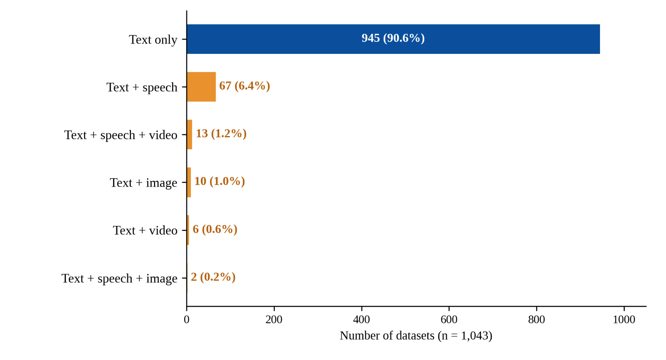
Figure 3. Distribution of datasets by modality group: counts and percentages across all 1,043 datasets for text-only resources and combinations of text with speech, video, or images.

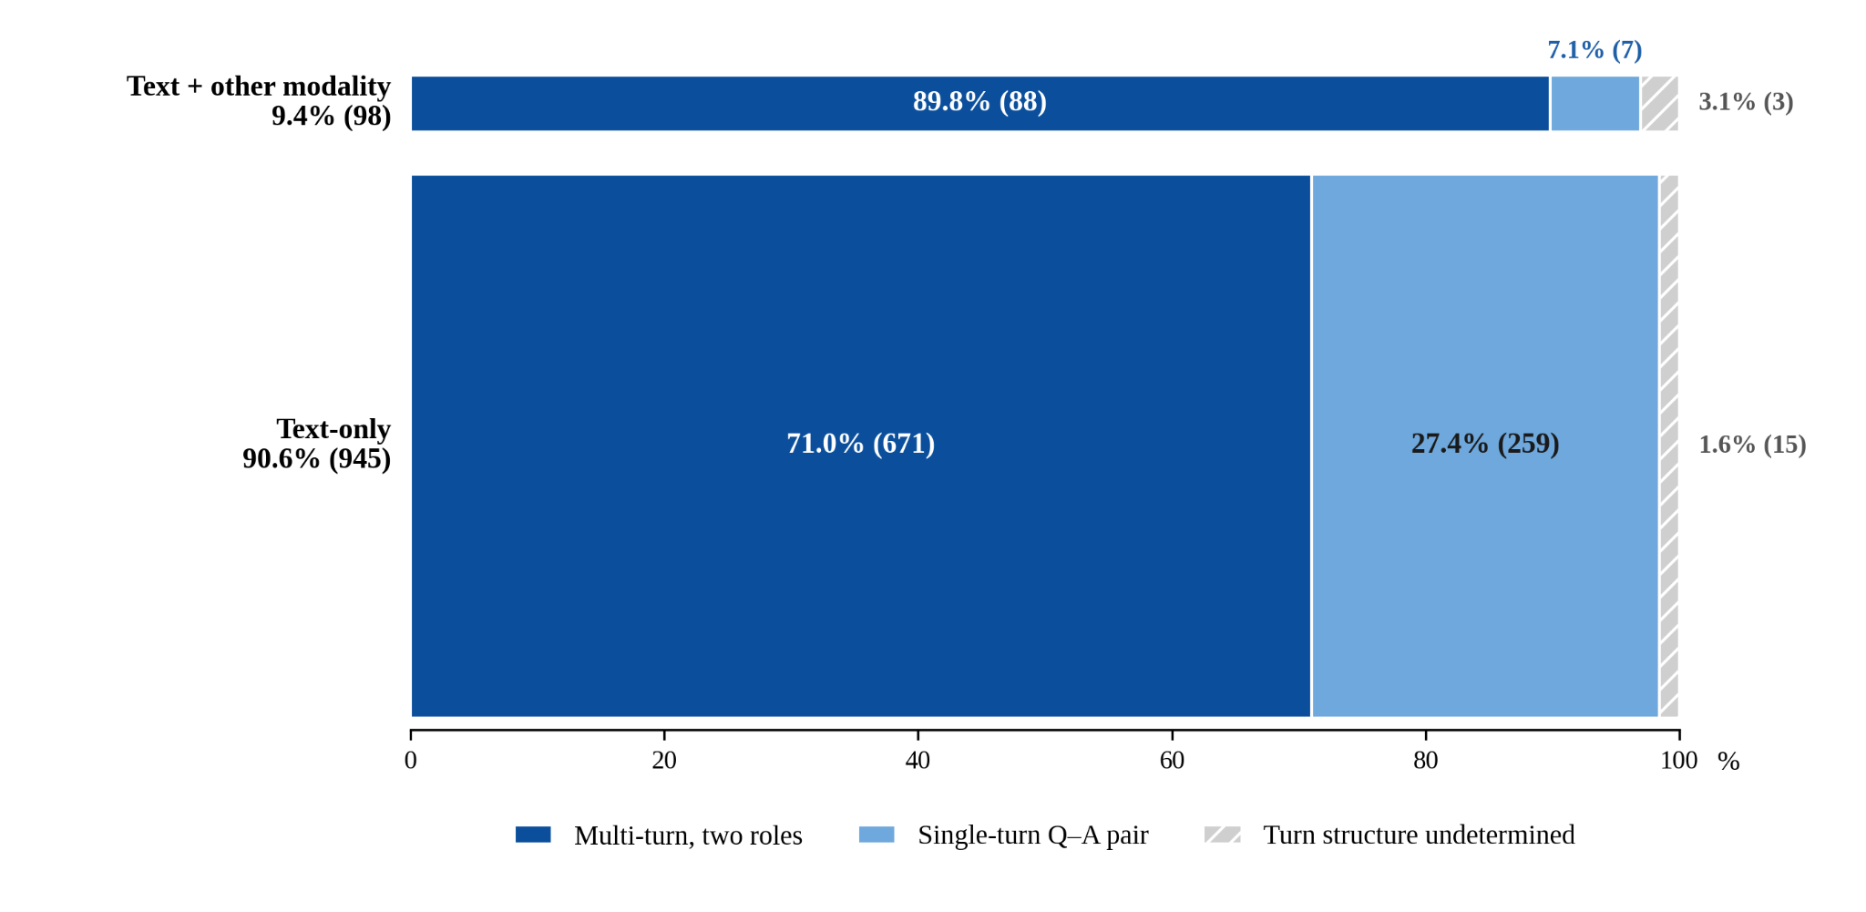
Figure 4. Turn structure by modality group. Distribution of multi-turn dialogue, single-turn question-answer pairs, and undetermined turn structure within the text-only and multimodal groups.
Observed client responses. A response from an actual help-seeker can be directly observed only in naturally occurring human-human helping interactions. Dialogue provenance is therefore an important indicator of whether the data contain responses observed in real interaction. Figure 5 and Table 4 show a clear shift in data sources across the pre-PLM, PLM, and LLM periods. Across the full map, 469 datasets (45.0%) contain real helping conversations, including psychotherapy sessions, crisis interactions, and peer-support exchanges. Their share declines from 79.5% in the pre-PLM period to 57.3% in the PLM period and 39.8% in the LLM period, even though the absolute number continues to rise.
Role-play accounts for 115 datasets (11.0%) and reaches its highest share during the PLM period, when empathetic-dialogue and emotional-support datasets became major sources for response-generation tasks. EmpatheticDialogues [42] and ESConv [43] are representative examples, while KokoroChat [51] illustrates a more controlled variant in which participants playing the counselor role had received training. In the LLM period, this role increasingly shifts to model-generated data. Fully LLM-synthesized data comprise 146 datasets (14.0%) and appear almost entirely from 2023 onward; when the 185 mixed-source datasets (17.7%) are added, resources in which models participate in generation or transformation account for 39.1% of datasets from the LLM period. SMILE [47], which expands question-answer data into multi-turn dialogue using ChatGPT, and Cactus [50], which generates conversations under a CBT framework, illustrate two ways LLMs are used to expand the infrastructure. In addition, dialogue provenance remains undetermined for 48 datasets (4.6%) even after checking both abstracts and publication sources.
The three technological periods therefore differ primarily in how datasets are produced. Before 2018, the infrastructure was small and relied mainly on human-human interaction. From 2018 to 2022, conversational corpora expanded markedly alongside pretrained models, especially for emotional support and counseling tasks. From 2023 onward, growth accelerated: 793 datasets, or 76.0% of the full map, appear in the LLM period. This expansion is accompanied by two structural changes: the share of real helping conversations continues to decline, and language models increasingly participate directly in data creation. Recent growth in the infrastructure therefore reflects expanded capacity to generate data more than a proportional increase in data observed from real helping interactions.
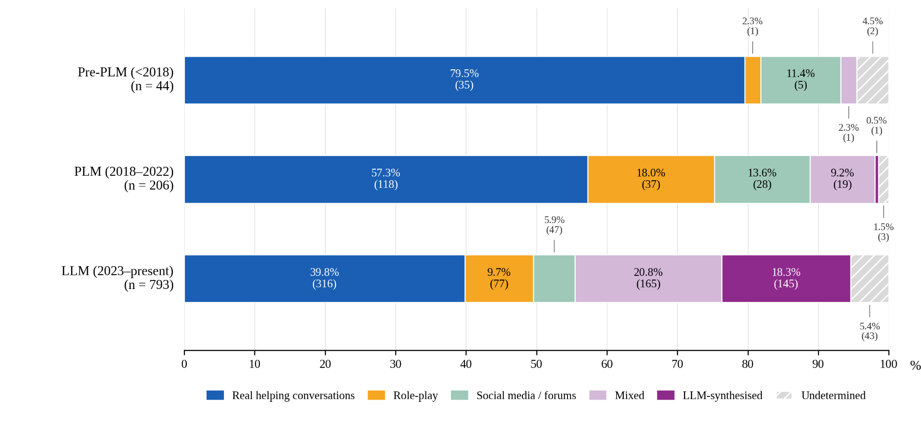
Figure 5. Dialogue provenance across three technological periods. The 100% stacked bars show the proportion of datasets derived from real helping conversations, role-play, social media or forums, mixed sources, LLM synthesis, and undetermined provenance in the pre-PLM (<2018; n = 44), PLM (2018-2022; n = 206), and LLM (2023-mid-2026; n = 793) periods. Percentages are calculated within each period; absolute counts are reported in parentheses. Hatched segments indicate undetermined provenance.
Provenance | Pre-PLM (<2018) | PLM (2018-2022) | LLM (2023-2026)
Real helping conversations | 35 (79.5%) | 118 (57.3%) | 316 (39.8%)
Role-play | 1 (2.3%) | 37 (18.0%) | 77 (9.7%)
Social media/forums | 5 (11.4%) | 28 (13.6%) | 47 (5.9%)
Mixed | 1 (2.3%) | 19 (9.2%) | 165 (20.8%)
LLM-synthesized | 0 | 1 (0.5%) | 145 (18.3%)
Undetermined | 2 (4.5%) | 3 (1.5%) | 43 (5.4%)
Total | 44 | 206 | 793
Table 4. Dialogue provenance across three technological periods. Counts and within-period percentages are reported for the pre-PLM (<2018), PLM (2018-2022), and LLM (2023-2026) periods.

4.3. Treatment-Course Structure: Which Stages Are Represented?
The clinical framework defines a course of treatment as comprising five stages, from intake through termination, with the case as the unit to which clinical process and outcome are attributed (Section 2.3). This subsection compares all 1,043 datasets with that structure to determine which stages are represented and whether datasets link the same case across multiple sessions. Table 5 presents the five stages in the order defined in Section 2.3; all percentages use the same denominator of 1,043 datasets. The 835 datasets assigned to the four helping forms ES, PS, CO, and PT in Section 4.1 are used to identify components that occur within the helping process.
Treatment-course stage (Section 2.3) | Representation identified in the infrastructure | No. datasets | %
1. Intake | Clinical screening | 31 | 3.0
 | Diagnostic assessment | 35 | 3.4
 | Stage 1 total | 66 | 6.3
2. Risk and crisis | Dedicated crisis services | 57 | 5.5
 | Risk management within helping datasets | 16 | 1.5
 | Stage 2 total | 73 | 7.0
3. Case conceptualization and goal agreement | Described within helping datasets | 17 | 1.6
4. Intervention and progress monitoring | Dataset records or simulates a helping process | 835 | 80.1
 | Includes progress monitoring/reassessment | 49 | 4.7
5. Termination and relapse prevention | Described within helping datasets | 8 | 0.8
Multiple sessions linked within the same case | Same case linked across multiple sessions | 39 | 3.7
 | Described from intake through termination within the same case | 0 | 0
Table 5. Coverage of the five stages of a course of treatment.
Intake and risk. The first two stages are represented mainly as specialized services. Intake is represented by 66 datasets (6.3%), including 31 clinical-screening datasets and 35 diagnostic-assessment datasets. DAIC-WOZ [44] and D4 [54] are representative examples of these two resource types. Risk and crisis are recorded in 73 datasets (7.0%): 57 are dedicated crisis services such as hotlines or suicide-prevention support, and 16 describe risk management as a component within a helping process. This distribution shows that intake and crisis response are present in the infrastructure, but are usually organized as specialized datasets rather than linked to later stages of the same treatment course.
Case conceptualization and goals. Case conceptualization and goal agreement are described in 17 datasets (1.6%). This stage links information gathered at intake to the selection and organization of intervention, yet it is much less visible in the infrastructure than data recording the helping process itself. Some recent resources have begun to incorporate this structure explicitly; DiaCBT [59], for example, organizes dialogue sequences around a case conceptualization diagram.
Intervention and progress monitoring. Intervention is the most widely represented part of the course of treatment. A total of 835 datasets (80.1%) record or simulate one of the four helping forms - ES, PS, CO, or PT - corresponding to the helping-process group defined in Section 4.1. However, the presence of helping interaction does not mean that the data capture change over time. Across the full map, progress monitoring or reassessment is described in 49 datasets (4.7%). These resources use repeated symptom measurement, cross-session state tracking, or trajectories of change in the help-seeker. The difference between 835 datasets containing helping interaction and 49 datasets containing a monitoring component indicates that the infrastructure focuses more on the content of interaction than on the evolution of the same case over time.
Termination and relapse prevention. Termination or relapse prevention is the least frequently described stage, appearing in 8 datasets (0.8%). Within treatment-course structure, this stage consolidates change, prepares for the end of the helping relationship, and supports maintenance of gains after intervention. Its low prevalence indicates that the final phase of treatment is represented far less often than intervention itself.
Multi-session structure within the same case. Beyond coverage of individual stages, process data require the ability to link the same case across multiple sessions. Only 39 datasets (3.7%) are described as having this structure. Recent resources such as PsyDial [76], PsychEval [77], TheraPhase [78], PATH [79], and DiaCBT [59] have begun to incorporate multi-session design. Multi-session data, however, are not equivalent to a complete treatment course: a dataset may link several sessions while recording only part of the clinical process. Within the scope of this study, no dataset is described as covering all five stages of a course of treatment within the same case.

4.4. Theoretical Orientations and Measures: What Is Declared and How Far Is It Operationalized?
Clinical theory describes a pluralistic field in which multiple therapies are practiced and recommended for the same disorder (Section 2.4), together with measurement systems used to determine whether an interaction actually reflects the approach it claims to follow (Section 2.5). This subsection examines two questions: which approaches are declared in the dataset infrastructure, and how far those approaches are translated into measurable structure in the data.
Coverage of theoretical approaches. Among 1,043 datasets, 375 (36.0%) declare at least one therapy or communication framework, whereas 668 (64.0%) declare none. Within the declared group, 148 datasets (14.2% of the full map) name a therapy, 231 (22.1%) name a communication framework, and only four belong to both fields. Thus, most of the infrastructure does not state an explicit theoretical foundation; even among resources that do, vocabularies of communication behavior appear more often than named treatment systems.
The distribution across therapies is also highly concentrated. Counting label occurrences, CBT accounts for 111 of 160 therapy labels (69.4%), followed by psychodynamic and client-centered approaches with 16 occurrences each. The remaining approaches appear only sporadically: mindfulness-based approaches 6, ACT 4, schema therapy 3, SFBT 2, DBT 1, and EFT 1. No dataset within the search scope explicitly names IPT, MBCT, EMDR, Gestalt, or systemic/family approaches.
This pattern differs from the diversity of clinical practice described in Section 2.4. For example, psychodynamic/relational orientations constitute a substantial share of therapist practice in survey data [32], yet appear only in a small part of the map.
Declared transtheoretical communication frameworks. Communication frameworks appear in 231 datasets (22.1%), more often than therapies, and the two fields are almost disjoint. The emotional-support strategy family has the largest number of label occurrences in the entire map (146), followed by MI (81) and Helping Skills (5). Datasets that operationalize Hill's framework through ESConv-derived strategies are counted under the strategy label, so the two labels are not additive. Overall, communication frameworks cover more datasets than therapies (231 vs. 148), with only four datasets carrying labels from both fields. The approach-by-helping-form matrix (Figure 6) shows that the three dominant vocabularies are distributed across different helping forms: emotional-support strategies in emotional support (130/146 label occurrences), CBT in psychotherapy (74/111), and MI in counseling (65/81). Within each branch, psychotherapy has the highest therapy-declaration rate (36.1%), whereas counseling reaches only 7.5% despite being the largest branch. Emotional support almost never declares a therapy but has high coverage by communication frameworks; clinical screening declares no approach. The infrastructure therefore does not form a single theoretical space: major functional branches rely on different theoretical vocabularies.
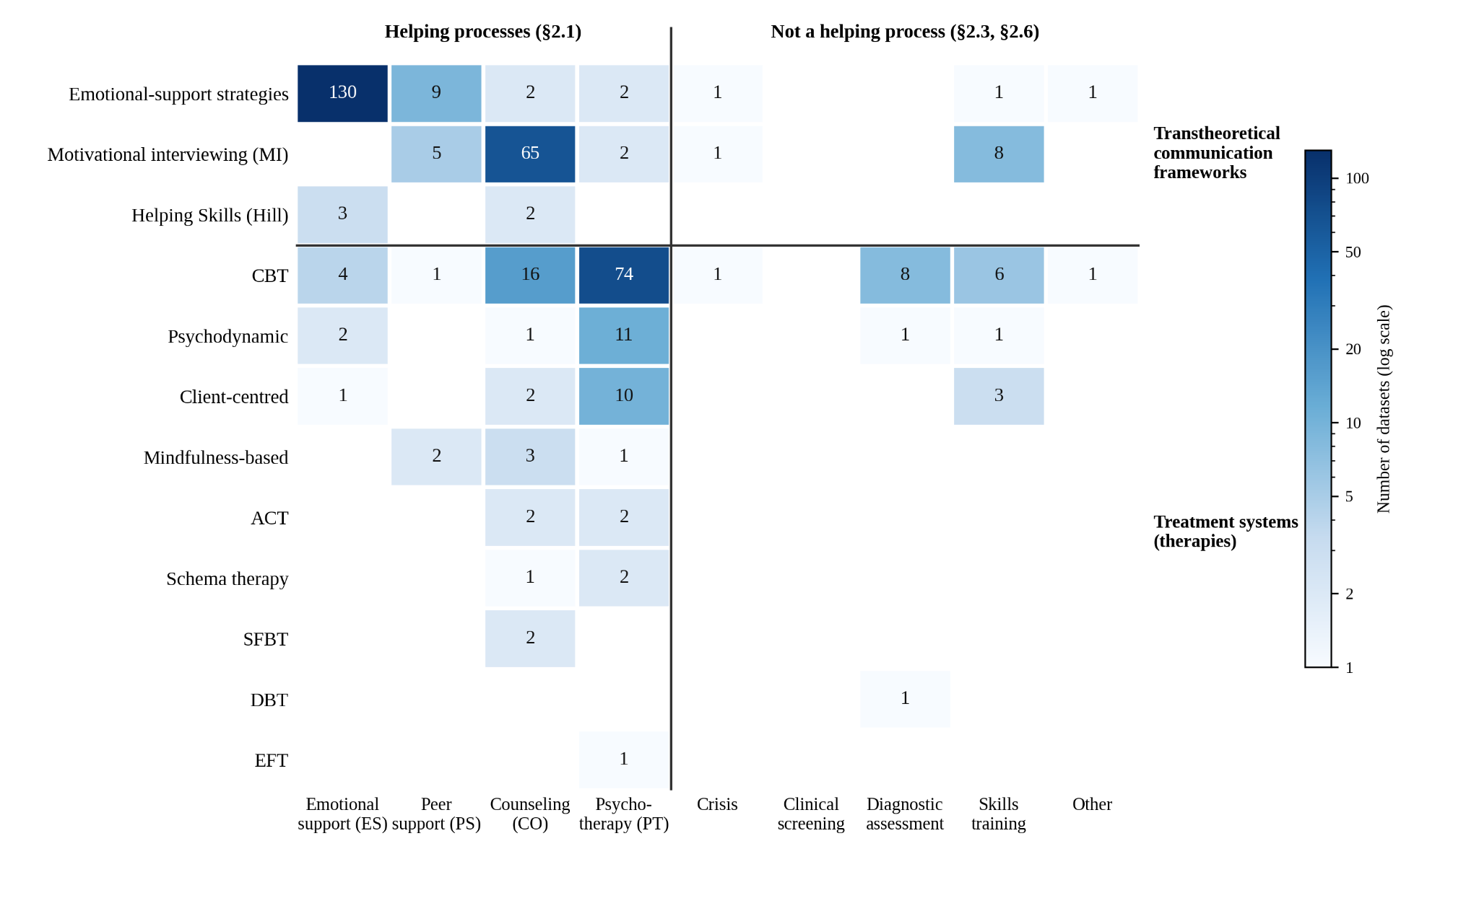
Figure 6. Matrix of declared theoretical approaches by operational branch (dataset counts; a dataset may carry multiple labels; blank cells indicate 0). Rows are divided into the two fields of the theoretical axis (transtheoretical communication frameworks and treatment systems), and columns into the four forms of helping plus resources that do not record a helping process. Color intensity follows a logarithmic scale.
From theoretical labels to measurement systems. The presence of a therapy name does not show how far that approach has been operationalized in the data. The degree of operationalization cannot be read reliably from abstracts; Table 6 therefore matches each line against the measure of its tradition (Section 2.5) and against the named datasets that represent that line. This sequence is complete in three lines. For MI, MISC/MITI provide turn-level and session-level coding systems that have been applied directly to transcripts, and AnnoMI [45], BiMISC [56], MI-TAGS [57], and MIDAS [55] use or extend this annotation tradition. For CBT, CTRS provides a session-level evaluation standard that is reused by newer resources: Cactus filters synthetic data using CTRS, while DiaCBT organizes dialogue around a case conceptualization diagram. For the emotional-support strategy family, the strategy system is built directly into the construction and annotation of ESConv. These are also the three dominant vocabularies associated with the three helping forms in Figure 6. Other lines show a wider gap between approach labels and measurement. Psychodynamic therapy, IPT, DBT, ACT, mindfulness-based interventions, and EMDR all have fidelity instruments or process measures in psychotherapy research, but these tools require whole-session assessment, trained expert raters, or signals beyond text (Section 2.5), and no equivalent text-annotation tradition has emerged within the reference catalog used in this study.
Dialogue provenance in Table 6 differs systematically across lines. MI has the highest proportion of real conversations among the major lines (48/81; 59.3%), consistent with its tradition of coding real sessions. CBT occupies an intermediate position (48/111; 43.2%), with role-play, mixed, and synthetic components together exceeding half of the line. The emotional-support strategy family, the largest line, contains only 17/146 datasets (11.6%) based on real helping conversations. The most widely represented vocabulary in the domain therefore primarily describes interactions that are not real helping encounters. Counts are too small for proportional inference in the rare lines, but the direction is consistent: all four ACT datasets, the single DBT dataset, the single EFT dataset, and all five datasets explicitly labeled Helping Skills contain no real sessions. For ACT and DBT, datasets are being constructed through simulation, while we did not identify established transcript-based annotation implementations of ACT-FM or DBT-ACS in the reviewed NLP literature. Helping Skills shows the reverse pattern: Hill's coding system can be applied to text, but NLP research has adopted it mainly through ESConv-derived strategy variants rather than under the original label. These counts describe the current corpus, not stable properties of the therapies themselves.

Approach | Measure from originating tradition | Applicable to text-only data | No. datasets | Real conversations | Model involved
Transtheoretical communication frameworks
Emotional-support strategies | ESConv strategy family [43] | yes | 146 | 17 (11.6%) | 66
Motivational interviewing | MISC/MITI [13], [14] | yes | 81 | 48 (59.3%) | 25
Helping Skills | Hill coding system [11] | yes | 5 | 0 | 4
Treatment systems
CBT | CTRS [16] | yes | 111 | 48 (43.2%) | 48
Psychodynamic | CPPS [23] | no (observer-rated) | 16 | 11 | 3
Client-centered | empathy scales [2], [3] | no (observer-rated) | 16 | 10 | 4
Mindfulness-based | MBI:TAC [27] | no | 6 | 3 | 3
ACT | ACT-FM [26] | no | 4 | 0 | 4
Schema therapy | not identified in the reference catalog | - | 3 | 1 | 1
SFBT | not identified in the reference catalog | - | 2 | 1 | 1
DBT | DBT-ACS [25] | no | 1 | 0 | 1
EFT | not identified in the reference catalog | - | 1 | 0 | 1
IPT; MBCT; EMDR; Gestalt; systemic/family | CSPRS [24]; MBI:TAC [27]; EFRS [28]; none identified | no | 0 | - | -
Table 6. Categories along the theoretical axis: measurement systems from the originating traditions, applicability to text-only data (Section 2.5), coverage, and dialogue provenance.
The three fields on the theoretical axis show the same overall pattern: only 36.0% of the infrastructure declares an approach; therapy declarations are concentrated almost entirely in CBT; communication-framework declarations are largely separate from therapy labels; and the sequence from theory through measurement to reused data is complete only for MI, CBT, and the emotional-support strategy family. The intuitive explanation that more highly structured therapies should be easier to digitize does not fit Table 6: DBT and EMDR are among the most tightly manualized approaches [19], [22] yet are nearly absent, whereas MI emphasizes process quality rather than a fixed script [12] and has the most persistent resource chain. What the three represented lines share - and the absent lines lack - is a public turn-level or session-level behavioral coding system that can be applied to transcripts (Section 2.5). In this corpus, sustained reuse is observed primarily for approaches with public behavioral coding systems applicable to transcripts. We treat this association as a hypothesis rather than evidence that such systems are necessary or sufficient for reuse. This hypothesis can be tested as future resources emerge, particularly for approaches whose fidelity measures have not yet been adapted for transcript-based annotation.

4.5. Language Coverage
The clinical framework emphasizes that expressions of psychological distress, communication norms, and help-seeking practices can vary across linguistic and cultural contexts; measurement instruments also require adaptation and validation before they are applied outside the language in which they were developed. In this study, the field coded directly is the language present in the resource. The analysis below therefore describes language coverage rather than cultural representation. Multilingual datasets are counted under every language they contain. After supplementary source checking, language could be identified for 984 of 1,043 datasets (94.3%); 59 datasets (5.7%) remained undetermined.
Language | No. datasets | Notes
English | 683 | includes multilingual datasets containing English
Chinese | 171 | primarily LLM-era; synthetic/mixed sources
German | 31
Japanese | 31
Korean | 30
Hebrew | 19
Dutch | 13
Italian | 13
Spanish | 12
Arabic | 7
French | 7
Persian | 6
Polish | 4
Finnish | 4
Swedish | 4
Turkish | 4
Russian | 3
Bengali | 3
Hindi | 3
Portuguese | 2
Scottish Gaelic | 1
Urdu | 1
Thai | 1
Greek | 1
Amharic | 1
Indonesian | 1
Unspecified multilingual component | 2 | resources described as multilingual without naming the languages
Language undetermined | 59 | could not be determined after checking both the abstract and source
Table 7. Languages represented in datasets with identified language information (n = 984/1,043). Because coding records whether a language is present in a resource, multilingual datasets are counted under each constituent language and the column total therefore exceeds n.
The distribution is concentrated in English and Chinese. English appears in 683 datasets, corresponding to 69.4% of datasets with identified language and 65.5% of the full map. Chinese ranks second with 171 datasets and appears almost entirely in the LLM period, often in resources generated or transformed by models, such as SMILE [47], SoulChat [48], CPsyCoun [49], PsyDTCorpus [60], AuraDial [61], and CPsDD [62]. This pattern shows rapid expansion of Chinese-language data in the recent period, but most of that growth comes from synthetic or mixed sources rather than real helping sessions. The observation is consistent with the concentration in English and Chinese reported by Mandal et al. [39] for multimodal mental-health AI datasets. After these two languages, coverage drops sharply. The next ten languages each appear in 6 to 31 datasets (German, Japanese, Korean, Hebrew, Dutch, Italian, Spanish, Arabic, French, and Persian), while fourteen additional languages appear in only 1 to 4 datasets each. Because multilingual resources are counted in multiple rows, these values describe the presence of languages in resources rather than mutually exclusive dataset groups.
Low-resource languages. Beyond the twelve languages discussed above, fourteen languages in Table 7 are represented by only 1 to 4 datasets. Among the named datasets in languages other than English, three patterns of resource construction can be identified. The first is annotation of existing conversations with an established coding system, as in MIDAS [55], which extends the MI annotation tradition to Spanish in the lineage of AnnoMI [45]. This pathway retains responses observed in human-human interaction and allows behavior to be evaluated using a defined measure, but depends on dialogue sources that can be used legally. The second is professionally controlled role-play, as in Japanese KokoroChat [51], in which participants playing the counselor role had received training. This approach is easier to release and may preserve interactional structure better than lay role-play, but it does not provide client responses from a real helping context. The third is LLM-based generation under a communication or theoretical framework, as in Korean KMI [58]. This approach lowers cost and scales quickly, but the interaction structure is model-generated; its clinical appropriateness therefore depends on an independent measure that has been validated in the target language.
These three patterns are not intended as an exhaustive taxonomy of multilingual resource construction; they are strategies observed in the current review corpus. Their common implication is that expansion into a new language requires more than translation or generation of additional dialogue: the corresponding measurement system must also be adapted to that language. In particular, real-session data are the only one of the three patterns that retain observed responses from help-seekers, but inference about the therapeutic relationship or outcomes still requires the corresponding measures described in Section 2.5 and cannot be drawn from transcripts alone.

4.6. Reuse of Resources
Professional norms on data sharing (Section 2.6) set the conditions under which a dataset becomes a shared resource; this subsection measures that accumulation with the two indicators defined in Section 3.5. Among the 1,043 datasets in the main map, 991 (95.0%) are linked to only one publication in the review corpus, whereas 52 datasets (5.0%) appear in two or more publications, including 39 named datasets and 13 unnamed entries. Only six named datasets appear in at least five publications, and only two appear in ten or more (Figure 7). This fragmentation cannot be explained solely by the recent age of the infrastructure: among 250 datasets introduced before 2023, 92.8% still appear only once; when the analysis is restricted to 366 named datasets, only 10.7% are used in two or more papers. Reuse is also highly concentrated. The four leading datasets are EmpatheticDialogues (47 papers) [42], ESConv (20) [43], DAIC-WOZ (8) [44], and AnnoMI (7) [45]. The first two account for 67 of 194 reuse links (34.5%), and the top four account for 82 (42.3%). None of these four datasets consists of real counseling or psychotherapy sessions with real clients: EmpatheticDialogues [42] and ESConv [43] are crowdworker role-play datasets; AnnoMI [45] consists of professionally transcribed MI demonstration sessions annotated by experienced MI practitioners; and DAIC-WOZ [44] is a semi-structured screening interview with a virtual agent. The two other datasets reaching five publications are ExTES [72], model-generated emotional-support data, and HOPE [73], counseling dialogue reconstructed from public videos. Most resources appearing in two to four papers are LLM-generated counseling resources (MentalQA [74], Cactus [50], PsyDTCorpus [60], MentalChat16K [53], CounselChat [52], KokoroChat [51]), together with D4 [54] and AvaMERG [75].
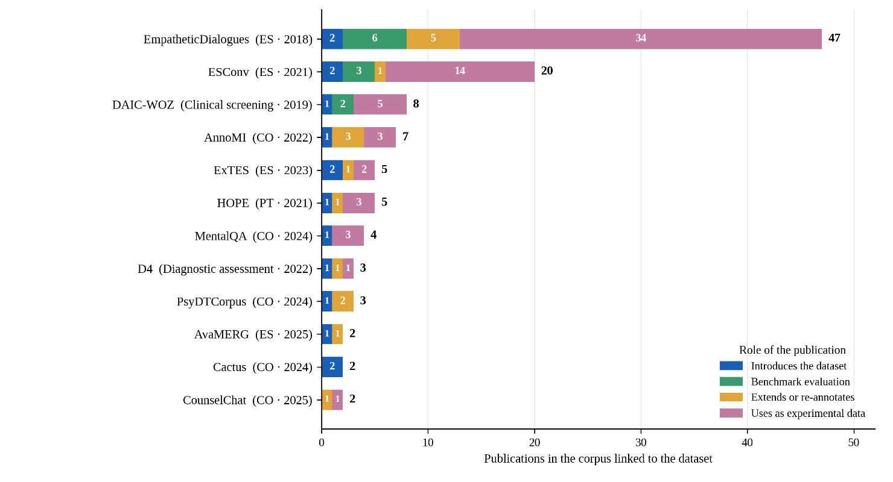
Figure 7. Named datasets appearing in the largest number of publications in the review corpus (12 datasets; branch and earliest year of appearance in the corpus are shown next to each name), segmented by publication role: introduction (dataset release), evaluation (model benchmarking on the dataset), development (extension, additional annotation, or translation), and use (the dataset is used unchanged as experimental data).

5. Discussion

5.1. Patterns in the Development of the Dataset Infrastructure
The systematic map shows that the text-data infrastructure for counseling and psychotherapy has reached substantial scale and is now dominated by multi-turn dialogue. Yet the components used in psychotherapy research to characterize a clinical process remain sparsely and unevenly represented. Comparing the results in Section 4 with the clinical reference framework in Section 2 identifies six infrastructure gaps: clinically relevant interaction signals (Section 4.2), treatment-course structure (Section 4.3), coverage of theoretical approaches (Section 4.4), operationalized measurement targets (Section 4.4), language coverage (Section 4.5), and accumulation into shared resources (Section 4.6).
One plausible explanation for some of these gaps is the three constraints introduced in the Introduction: data sensitivity, professional cost, and safety requirements. These constraints are especially salient for human-human helping interactions, multi-session case data, and measures requiring trained raters. Observed client responses and longitudinal case data require consent and confidentiality to be maintained across the course of treatment. Measures of the therapeutic relationship and outcome require clinical instruments administered to real clients. Annotation under therapeutic approaches beyond CBT requires raters trained in the relevant framework (Section 2.5). By contrast, the data sources that expanded most rapidly across the three technological periods - lay role-play, forum exchanges, and LLM-generated conversations - are less constrained in these respects (Section 4.2). This interpretation is consistent with the mapped pattern but was not directly tested, because the review did not code authors' reasons for selecting particular data sources.
Even if this explanation is correct, simply increasing the number of datasets under prevailing construction practices does not guarantee that the theory-data gap will narrow. The gap is defined at the infrastructure level and does not imply that every dataset should reproduce a complete course of treatment. Its consequences emerge at the level of individual studies when questions about process, the therapeutic relationship, or outcome are addressed with data that preserve only helper utterances. In such cases, the scope of inference exceeds the evidence supported by the dataset structure.

5.2. Conversation Structure Is Not Treatment Structure
The shift from isolated question-answer pairs to multi-turn dialogue is an important advance in NLP dataset infrastructure for counseling and psychotherapy. However, multi-turn structure shows only that alternation between roles is preserved; it does not establish that the responses were observed in an actual helping interaction. Section 4.2 shows that, in the LLM era, an increasing share of resources involve models in dialogue generation or reconstruction. In such data, help-seeker responses may be generated within the data pipeline rather than directly observed. Dialogue provenance therefore defines the evidential scope of a multi-turn conversation.
Likewise, continuity within a dialogue is not continuity across a course of treatment. Psychotherapy research locates process and outcome at the case level - that is, the same client across sessions - whereas most current resources stop at the utterance or single-session level. Section 4.3 shows that only a small number of datasets link multiple sessions from the same case, while components such as case conceptualization, progress monitoring, and termination are sparsely represented. It is therefore important to distinguish conversational continuity, responses observed in real interaction, and clinical continuity across sessions; these properties support different levels of inference and are not interchangeable.

5.3. From Theoretical Labels to Measurement Structure
Section 4.4 shows that theoretical coverage remains narrow and concentrated in a small number of approaches, particularly CBT. Several therapies used in clinical practice appear in only a few datasets or are not explicitly named in the review corpus. Na et al. [36] likewise reported limited theoretical integration and a strong predominance of CBT at the study level. The two analyses are not directly comparable because they use different units of analysis and corpus scopes, but their convergence suggests that theoretical concentration is visible from multiple vantage points in the field.
However, attaching a therapy label to a dataset does not establish that the approach has been operationalized in the data. Labels such as CBT, MI, or DBT identify a declared orientation; to become tractable for NLP, the relevant constructs must be translated into observable behaviors, annotations, or evaluation criteria. In the present map, the clearest theory-to-data lineages occur where coding or measurement frameworks can be applied at the turn or session level, such as MISC/MITI for MI and CTRS for CBT. This pattern suggests that measurement infrastructure may mediate between clinical theory and computational representation.
Another asymmetry concerns the target of measurement. The most widely used coding systems primarily assess helper behavior and competence, whereas client response, the therapeutic relationship, and outcome have not generated resource lineages with comparable accumulation. The theory-data gap therefore concerns not only whether a therapy is named, but also which components of the therapeutic process have been converted into measurable variables that can be used in NLP.

5.4. Design Principles for the Next Generation of Resources
Based on the findings above, we propose the following design principles.
First, for model-involved data, generation should be separated from validation. The input source, model, prompt, filtering steps, and acceptance criteria should be reported. Fit to the declared clinical approach should be evaluated using evidence independent of the generation process, such as expert raters or data from human-human interaction. Cactus [50] and DiaCBT [59] incorporate clinical criteria into dataset construction; however, this does not replace independent validation of the resulting data.
Second, the unit and modality of data should match the inference being made. Turn-level data are appropriate for questions about utterance-level behavior. Session-level data are required for claims about session fidelity. Questions about process and outcome require multiple sessions from the same case, with temporal order and repeated measures preserved.
Third, theoretical approaches should be operationalized through behavior or measurement rather than only names or prompts. The target construct, annotation unit, and evaluation criteria should be specified before dataset construction. For approaches without transcript-based coding systems, a priority is to assess the extent to which existing fidelity measures can be adapted and validated for text; where a construct depends on non-textual signals, resources should preserve the relevant modality rather than forcing measurement into a text-only setting.
Fourth, measurement should extend beyond helper behavior to client response, the therapeutic relationship, and outcome. This requires preserving intervention-response pairs and incorporating measures at the appropriate level of inference, so that client change is not inferred merely from a helper response being rated as technically appropriate.
Fifth, expansion into new languages should be accompanied by adaptation of measurement systems. Annotation guidelines, coding systems, and measures should be adapted to the target language and context. Inter-rater reliability should be assessed, and limitations in the transfer of constructs across cultures should be made explicit [63], [64].
Finally, reference resources should be defined by function and designed for reuse. The four forms of helping differ in their goals and evaluation criteria. A benchmark should therefore state the helping function it represents, the measurement target, dialogue provenance, and the scope of inference supported by the data.

6. Limitations
This study has several limitations that should be considered when interpreting the map.
First, the corpus was constructed from five databases and three rounds of searching, with the final search completed in July 2026. Although the query strategy covered NLP, biomedical, and preprint sources, it cannot guarantee retrieval of every resource in the field. Corpora described only in repositories, theses, technical reports, commercial platforms, or unindexed sources may be missing. The findings therefore characterize the infrastructure observable within the review corpus rather than an exhaustive inventory of every dataset ever created.
Second, most screening and coding were conducted at the title and abstract level, using statements in the publications as evidence. This made it possible to process a large corpus while limiting inference beyond what authors reported, but it may miss attributes described only in Methods sections, appendices, or repositories. Accordingly, values coded as "not declared" or zero-coverage cells do not necessarily mean that an attribute is absent from every version of a resource; they reflect what could be established from the evidence sources used in the mapping workflow.
Third, resolving dataset identity and merging multiple publications associated with the same resource required lineage decisions. Translations, additional annotations, extended versions, or reconstructed corpora may share a common origin while differing in content or labels. Although names, aliases, DOIs, URLs, and source information were used to establish links, resources with unstable names or incomplete provenance may still have been split or merged imperfectly.
Fourth, the reuse indicator reflects publication-dataset links identified within the corpus, not the full usage history of a resource. A study may use a dataset without naming it in the abstract, and resources without stable names are inherently more difficult to trace. The proportion of datasets linked to only one publication should therefore be interpreted as reuse observable under the linkage procedure used in this study, not as evidence that those datasets have only ever been used once.
Finally, the five-stage treatment-course framework in Section 2.3 is used as an analytic reference model rather than a sequential ontology that all forms of therapy must follow. Risk assessment, goal setting, progress monitoring, and reassessment may recur at multiple points and be organized differently across approaches. More broadly, this systematic map evaluates the types of knowledge, structures, and measurements represented or reported in the dataset infrastructure; it does not directly assess the therapeutic quality of individual dialogues, the effectiveness of datasets for model training, or the clinical effectiveness of systems built from them.

7. Conclusion
This study maps 1,043 text-based datasets used in NLP for psychological support, counseling, and psychotherapy, with the dataset as the unit of analysis. The results show that the infrastructure has expanded rapidly and increasingly takes the form of multi-turn dialogue, but coverage of clinical components remains uneven and accumulation into shared resources is limited. Six gaps are identified in shared resources, theoretical coverage, interaction signals, treatment-course structure, measurement targets, and language coverage.
These gaps do not imply that every resource should simulate an entire course of therapy. They point to a more fundamental requirement: the unit of data, dialogue provenance, clinical constructs, and measurement systems should align with the type of inference the resource is used to support. For NLP in counseling and psychotherapy, the next step is therefore not simply to generate more dialogue, but to build infrastructure in which theory, interaction structure, and measurement are linked in ways that can be validated, reused, and accumulated across studies.

References
[1] C.R. Rogers. The necessary and sufficient conditions of therapeutic personality change. Journal of Consulting Psychology 21(2):95-103, 1957.
[2] C.B. Truax, R.R. Carkhuff. Toward Effective Counseling and Psychotherapy: Training and Practice. Aldine, 1967.
[3] G.T. Barrett-Lennard. The empathy cycle: Refinement of a nuclear concept. Journal of Counseling Psychology 28(2):91-100, 1981.
[4] E.S. Bordin. The generalizability of the psychoanalytic concept of the working alliance. Psychotherapy: Theory, Research & Practice 16(3):252-260, 1979.
[5] A.O. Horvath, B.D. Symonds. Relation between working alliance and outcome in psychotherapy: A meta-analysis. Journal of Counseling Psychology 38(2):139-149, 1991.
[6] R. Elliott, A.C. Bohart, J.C. Watson, L.S. Greenberg. Empathy. Psychotherapy 48(1):43-49, 2011; updated by: R. Elliott, A.C. Bohart, J.C. Watson, D. Murphy. Psychotherapy 55(4):399-410, 2018.
[7] B.E. Wampold, Z.E. Imel. The Great Psychotherapy Debate: The Evidence for What Makes Psychotherapy Work (2nd ed.). Routledge, 2015.
[8] J.D. Safran, J.C. Muran. Negotiating the Therapeutic Alliance: A Relational Treatment Guide. Guilford Press, 2000.
[9] C.F. Eubanks, J.C. Muran, J.D. Safran. Alliance rupture repair: A meta-analysis. Psychotherapy 55(4):508-519, 2018.
[10] J.O. Prochaska, C.C. DiClemente. Stages and processes of self-change of smoking: Toward an integrative model of change. Journal of Consulting and Clinical Psychology 51(3):390-395, 1983.
[11] C.E. Hill. Helping Skills: Facilitating Exploration, Insight, and Action (3rd ed.). American Psychological Association, 2009.
[12] W.R. Miller, S. Rollnick. Motivational Interviewing: Helping People Change (3rd ed.). Guilford Press, 2013.
[13] W.R. Miller, T.B. Moyers, D. Ernst, P. Amrhein. Manual for the Motivational Interviewing Skill Code (MISC). University of New Mexico, 2003.
[14] T.B. Moyers, L.N. Rowell, J.K. Manuel, D. Ernst, J.M. Houck. The Motivational Interviewing Treatment Integrity code (MITI 4). Journal of Substance Abuse Treatment 65:36-42, 2016.
[15] A.T. Beck, A.J. Rush, B.F. Shaw, G. Emery. Cognitive Therapy of Depression. Guilford Press, 1979; J.S. Beck. Cognitive Behavior Therapy: Basics and Beyond (3rd ed.). Guilford Press, 2021.
[16] J.E. Young, A.T. Beck. Cognitive Therapy Scale: Rating Manual. Unpublished manuscript, University of Pennsylvania, 1980.
[17] J. Shedler. The efficacy of psychodynamic psychotherapy. American Psychologist 65(2):98-109, 2010; G.O. Gabbard. Long-Term Psychodynamic Psychotherapy: A Basic Text (3rd ed.). American Psychiatric Publishing, 2017.
[18] G.L. Klerman, M.M. Weissman, B.J. Rounsaville, E.S. Chevron. Interpersonal Psychotherapy of Depression. Basic Books, 1984; M.M. Weissman, J.C. Markowitz, G.L. Klerman. The Guide to Interpersonal Psychotherapy. Oxford University Press, 2018.
[19] M.M. Linehan. Cognitive-Behavioral Treatment of Borderline Personality Disorder. Guilford Press, 1993; DBT Skills Training Manual (2nd ed.). Guilford Press, 2015.
[20] S.C. Hayes, K.D. Strosahl, K.G. Wilson. Acceptance and Commitment Therapy: The Process and Practice of Mindful Change (2nd ed.). Guilford Press, 2011.
[21] Z.V. Segal, J.M.G. Williams, J.D. Teasdale. Mindfulness-Based Cognitive Therapy for Depression (2nd ed.). Guilford Press, 2013.
[22] F. Shapiro. Eye Movement Desensitization and Reprocessing (EMDR) Therapy: Basic Principles, Protocols, and Procedures (3rd ed.). Guilford Press, 2018.
[23] M.J. Hilsenroth, D.R. Bonge, M.D. Blagys, S.J. Ackerman, M.A. Blais. Measuring psychodynamic-interpersonal and cognitive-behavioral techniques: Development of the Comparative Psychotherapy Process Scale (CPPS). Psychotherapy: Theory, Research, Practice, Training 42(3):340-356, 2005.
[24] C.E. Hill, K.E. O'Grady, I. Elkin. Applying the Collaborative Study Psychotherapy Rating Scale to rate therapist adherence in cognitive-behavior therapy, interpersonal therapy, and clinical management. Journal of Consulting and Clinical Psychology 60(1):73-79, 1992.
[25] M.S. Harned, K.E. Korslund, S.C. Schmidt, R.J. Gallop. The Dialectical Behavior Therapy Adherence Coding Scale (DBT ACS): Psychometric properties. Psychological Assessment 33(6):552-561, 2021.
[26] L. O'Neill, G. Latchford, L.M. McCracken, C.D. Graham. The development of the Acceptance and Commitment Therapy Fidelity Measure (ACT-FM): A Delphi study and field test. Journal of Contextual Behavioral Science 14:111-118, 2019.
[27] R.S. Crane, C. Eames, W. Kuyken, R.P. Hastings, J.M.G. Williams, T. Bartley, A. Evans, S. Silverton, J.G. Soulsby, C. Surawy. Development and validation of the Mindfulness-Based Interventions - Teaching Assessment Criteria (MBI:TAC). Assessment 20(6):681-688, 2013.
[28] D.L. Korn, L. Maxfield, R. Stickgold, N.J. Smyth. EMDR Fidelity Rating Scale (EFRS), version 2.1. EMDR Research Foundation, 2023.
[29] K. Kroenke, R.L. Spitzer, J.B.W. Williams. The PHQ-9: Validity of a brief depression severity measure. Journal of General Internal Medicine 16(9):606-613, 2001.
[30] S.D. Miller, B.L. Duncan, J. Brown, J.A. Sparks, D.A. Claud. The Outcome Rating Scale: A preliminary study of the reliability, validity, and feasibility of a brief visual analog measure. Journal of Brief Therapy 2(2):91-100, 2003.
[31] S.V. Tichenor, C.E. Hill. A comparison of six measures of working alliance. Psychotherapy 26(2):195-199, 1989.
[32] J.C. Norcross, M.N. Rocha, A.A. Chrysler. Psychologists conducting psychotherapy in 2022: Contemporary practices and historical patterns. Psychotherapy 60(4):587-592, 2023.
[33] National Institute for Health and Care Excellence. Depression in adults: treatment and management (NG222). NICE, 2022; American Psychological Association. Clinical Practice Guideline for the Treatment of Depression. APA, 2019.
[34] Y. Ma, K.L. Nguyen, F.Z. Xing, E. Cambria. A survey on empathetic dialogue systems. Information Fusion 64:50-70, 2020.
[35] Z. Guo, A. Lai, J.H. Thygesen, J. Farrington, T. Keen, K. Li. Large Language Models for Mental Health Applications: Systematic Review. JMIR Mental Health 11:e57400, 2024. DOI 10.2196/57400.
[36] H. Na, Y. Hua, Z. Wang, T. Shen, B. Yu, L. Wang, W. Wang, J. Torous, L. Chen. A Survey of Large Language Models in Psychotherapy: Current Landscape and Future Directions. arXiv:2502.11095, 2025.
[37] A. Bucher, S. Egger, I. Vashkite, W. Wu, G. Schwabe. "It's Not Only Attention We Need": Systematic Review of Large Language Models in Mental Health Care. JMIR Mental Health 12:e78410, 2025.
[38] H.N. Cho, J. Wang, D. Hu, K. Zheng. Large Language Model-Based Chatbots and Agentic AI for Mental Health Counseling: A Systematic Review of Methodologies, Evaluation Frameworks, and Ethical Safeguards. JMIR AI 5:e80348, 2026.
[39] A. Mandal, P.K. Adhikary, H. Arnaout, I. Gurevych, T. Chakraborty. A Comprehensive Review of Datasets for Clinical Mental Health AI Systems. arXiv:2508.09809, 2025.
[40] E. Voultsiou, L. Moussiades. A Systematic Review of Large Language Models in Mental Health: Opportunities, Challenges, and Future Directions. Electronics 15(3):524, 2026.
[41] H. Chen, R. Liu, Y. Luo, J. Zhang, M. Zhang, B. Hu, M. Zhang. From Pre-trained Models to Large Language Models: A Comprehensive Survey of AI-Driven Psychological Computing. arXiv:2604.03259, 2026.
[42] H. Rashkin, E.M. Smith, M. Li, Y.-L. Boureau. Towards Empathetic Open-domain Conversation Models: a New Benchmark and Dataset. ACL 2019.
[43] S. Liu, C. Zheng, O. Demasi, S. Sabour, Y. Li, Z. Yu, Y. Jiang, M. Huang. Towards Emotional Support Dialog Systems. ACL-IJCNLP 2021.
[44] J. Gratch, R. Artstein, G. Lucas, G. Stratou, S. Scherer, A. Nazarian, R. Wood, J. Boberg, D. DeVault, S. Marsella, D. Traum, S. Rizzo, L.-P. Morency. The Distress Analysis Interview Corpus of human and computer interviews (DAIC-WOZ). LREC 2014, 3123-3128.
[45] Z. Wu, S. Balloccu, V. Kumar, R. Helaoui, E. Reiter, D. Reforgiato Recupero, D. Riboni. AnnoMI: A Dataset of Expert-Annotated Counselling Dialogues. ICASSP 2022.
[46] H. Sun, Z. Lin, C. Zheng, S. Liu, M. Huang. PsyQA: A Chinese Dataset for Generating Long Counseling Text for Mental Health Support. Findings of ACL-IJCNLP 2021.
[47] H. Qiu, H. He, S. Zhang, A. Li, Z. Lan. SMILE: Single-turn to Multi-turn Inclusive Language Expansion via ChatGPT for Mental Health Support. Findings of EMNLP 2024.
[48] Y. Chen, X. Xing, J. Lin, H. Zheng, Z. Wang, Q. Liu, X. Xu. SoulChat: Improving LLMs' Empathy, Listening, and Comfort Abilities through Fine-tuning with Multi-turn Empathy Conversations. Findings of EMNLP 2023.
[49] C. Zhang, R. Li, M. Tan, M. Yang, J. Zhu, D. Yang, J. Zhao, G. Ye, C. Li, X. Hu. CPsyCoun: A Report-based Multi-turn Dialogue Reconstruction and Evaluation Framework for Chinese Psychological Counseling. Findings of ACL 2024.
[50] S. Lee, S. Kim, M. Kim, D. Kang, D. Yang, H. Kim, M. Kang, D. Jung, M.H. Kim, S. Lee, K.-M. Chung, Y. Yu, D. Lee, J. Yeo. Cactus: Towards Psychological Counseling Conversations using Cognitive Behavioral Theory. Findings of EMNLP 2024.
[51] Z. Qi, T. Kaneko, K. Takamizo, M. Ukiyo, M. Inaba. KokoroChat: A Japanese Psychological Counseling Dialogue Dataset Collected via Role-Playing by Trained Counselors. arXiv:2506.01357, 2025.
[52] N. Bertagnolli. Counsel Chat: Bootstrapping High-Quality Therapy Data. Online data resource, 2020.
[53] J. Xu, T. Wei, B. Hou, P. Orzechowski, S. Yang, R. Jin, R. Paulbeck, J. Wagenaar, G. Demiris, L. Shen. MentalChat16K: A Benchmark Dataset for Conversational Mental Health Assistance. KDD 2025.
[54] B. Yao, C. Shi, L. Zou, L. Dai, M. Wu, L. Chen, Z. Wang, K. Yu. D4: a Chinese Dialogue Dataset for Depression-Diagnosis-Oriented Chat. EMNLP 2022, 2438-2459. DOI 10.18653/v1/2022.emnlp-main.156.
[55] A.E. Gunal, B. Yi, J.D. Piette, R. Mihalcea, V. Pérez-Rosas. Examining Spanish Counseling with MIDAS: a Motivational Interviewing Dataset in Spanish. NAACL 2025 (Short Papers), 866-872. DOI 10.18653/v1/2025.naacl-short.73.
[56] X. Sun, J. Pei, J. de Wit, M. Aliannejadi, E. Krahmer, J. Dobber, J. Bosch. Eliciting Motivational Interviewing Skill Codes in Psychotherapy with LLMs: A Bilingual Dataset and Analytical Study (BiMISC). LREC-COLING 2024.
[57] B. Cohen, M. Zisquit, S. Yosef, A. Brunstein, D. Friedman, K. Bar. Motivational Interviewing Transcripts Annotated with Global Scores (MI-TAGS). LREC-COLING 2024.
[58] H. Kim, S. Lee, Y. Cho, E. Ryu, Y. Jo, S. Seong, S. Cho. KMI: A Dataset of Korean Motivational Interviewing Dialogues for Psychotherapy. NAACL 2025.
[59] Y. Zhou, N. Zhou, Q. Chen, J. Zhou, A. Zhou, L. He. DiaCBT: A Long-Periodic Dialogue Corpus Guided by Cognitive Conceptualization Diagram for CBT-based Psychological Counseling. arXiv:2509.02999, 2025.
[60] H. Xie, Y. Chen, X. Xing, J. Lin, X. Xu. PsyDT: Using LLMs to Construct the Digital Twin of Psychological Counselor with Personalized Counseling Style (PsyDTCorpus). ACL 2025 (Long Papers); arXiv:2412.13660.
[61] X. Zhang. AURADIAL: A Large-Scale Human-Centric Dialogue Dataset for Chinese AI Psychological Counseling. Findings of EMNLP 2025.
[62] Y. Shi, L. Zhang, F. Kong. Toward Real-World Chinese Psychological Support Dialogues: CPsDD Dataset and a Co-Evolving Multi-Agent System. arXiv:2507.07509, 2025.
[63] L.J. Kirmayer. Cultural variations in the clinical presentation of depression and anxiety: implications for diagnosis and treatment. Journal of Clinical Psychiatry 62(Suppl 13):22-30, 2001.
[64] S.G. Hofmann, D.E. Hinton. Cross-cultural aspects of anxiety disorders. Current Psychiatry Reports 16:450, 2014.
[65] G. Egan. The Skilled Helper: A Problem-Management and Opportunity-Development Approach to Helping (10th ed.). Brooks/Cole, 2014.
[66] S.T. Gladding. Counseling: A Comprehensive Profession (8th ed.). Pearson, 2018.
[67] J.S. House. Work Stress and Social Support. Addison-Wesley, 1981.
[68] S. Mead, D. Hilton, L. Curtis. Peer support: A theoretical perspective. Psychiatric Rehabilitation Journal 25(2):134-141, 2001.
[69] J. Repper, T. Carter. A review of the literature on peer support in mental health services. Journal of Mental Health 20(4):392-411, 2011.
[70] D.M. Kaplan, V.M. Tarvydas, S.T. Gladding. 20/20: A vision for the future of counseling: The new consensus definition of counseling. Journal of Counseling & Development 92(3):366-372, 2014.
[71] P. Bower, S. Gilbody. Stepped care in psychological therapies: Access, effectiveness and efficiency. British Journal of Psychiatry 186(1):11-17, 2005.
[72] Z. Zheng, L. Liao, Y. Deng, L. Qin, L. Nie. Self-chats from Large Language Models Make Small Emotional Support Chatbot Better. ACL 2024 (Long Papers), 11325-11345. DOI 10.18653/v1/2024.acl-long.611.
[73] G. Malhotra, A. Waheed, A. Srivastava, M.S. Akhtar, T. Chakraborty. Speaker and Time-aware Joint Contextual Learning for Dialogue-act Classification in Counselling Conversations. WSDM 2022, 735-745. DOI 10.1145/3488560.3498509.
[74] H. Alhuzali, A. Alasmari, H. Alsaleh. MentalQA: An Annotated Arabic Corpus for Questions and Answers of Mental Healthcare. IEEE Access 12:101155-101165, 2024. DOI 10.1109/ACCESS.2024.3430068.
[75] H. Zhang, Z. Meng, M. Luo, H. Han, L. Liao, E. Cambria, H. Fei. Towards Multimodal Empathetic Response Generation: A Rich Text-Speech-Vision Avatar-based Benchmark. WWW 2025, 2872-2881. DOI 10.1145/3696410.3714739.
[76] H. Qiu, Z. Lan. PsyDial: A Large-scale Long-term Conversational Dataset for Mental Health Support. ACL 2025 (Long Papers), 21624-21655. DOI 10.18653/v1/2025.acl-long.1049.
[77] Q. Pan, J. Wang, J. Zhou, Y. Yang, J. Li, K. Xu, Y. Zhou, Y. Li, J. Zhao, Q. Chen, N. Zhou, K. Chen, L. He. PsychEval: A Multi-Session and Multi-Therapy Benchmark for High-Realism AI Psychological Counselor. Findings of ACL 2026, 22192-22212. DOI 10.18653/v1/2026.findings-acl.1115.
[78] H. Na, T. Shen, S. Yu, L. Chen. Multi-Session Client-Centered Treatment Outcome Evaluation in Psychotherapy. LREC 2026; arXiv:2410.05824.
[79] P.K. Adhikary, S. Singh, S. Singh, R. Choudhary, C. Saxena, P. Chauhan, P. Sharma, S.M. Singh, S.K. Gupta, K.S. Deb, T. Chakraborty. Towards Richer AI-Assisted Psychotherapy Note-Making and Performance Benchmarking. medRxiv, 2025. DOI 10.1101/2025.06.25.25330252.

Appendix A. Search Strategy: Query Strings and Search Fields
All searches reported in Section 3.1 were executed on 31 July 2026, with 31 July 2026 as the cutoff date and no lower year limit. The same two keyword blocks were submitted to every database and differed only in field syntax: a counseling and psychotherapy block of 43 terms and an NLP block of 39 terms, combined with OR within each block and with AND between blocks. Because the arXiv API and the offline filters do not support truncation, no wildcards were used; spelling and inflectional variants were listed explicitly and multiword terms were submitted as exact phrases. "Machine learning" and "neural network" were deliberately excluded from the NLP block because they retrieve neuroimaging and non-text machine-learning studies. Scopus was not searched because no institutional access was available; OpenAlex served as the broad-coverage bibliographic index. The query strings below are reproduced verbatim from the saved search files.
Database | Interface | Search field | Filters applied | Records
Web of Science | Advanced Search (web interface) | TS = Topic (title, abstract, author keywords, Keywords Plus) | All years; document types Article, Proceedings Paper, and Review; no language filter. Exported as RIS (full record) in six batches of at most 1,000 records. | 5,327
PubMed | Web interface (pubmed.ncbi.nlm.nih.gov) | [tiab] = Title/Abstract | No date or language filter. All results exported through Send to > Citation manager (.nbib). The E-utilities request failed on the execution date, so the identical term was run in the web interface. | 2,547
arXiv | arXiv API (export.arxiv.org/api/query) | abs: = abstract | Categories cs.CL, cs.AI, and cs.HC; sorted by submission date; records submitted up to 2026-07-31. | 1,221
ACL Anthology | Offline filter over the full Anthology BibTeX export with abstracts (128,618 entries) | Title and abstract; case-insensitive whole-word match | At least one term of the counseling and psychotherapy block; the NLP block was not required because the venue itself is NLP (469 of the 641 records also match it); publication year up to 2026. | 641
OpenAlex | OpenAlex API (api.openalex.org/works) | title_and_abstract.search | to_publication_date: 2026-07-31; type: article, review, preprint, and proceedings-article; language: en. The server returned 18,637 works; because this endpoint applies stemming and relevance matching, every work was verified locally for at least one term of each block as whole words in title and abstract, which retained 7,251. | 7,251
Total |  |  |  | 16,987
Table A1. Databases, interfaces, search fields, filters, and records retrieved on 31 July 2026. Publication years in the exports range from 1924 (OpenAlex), 1978 (PubMed), 1980 (ACL Anthology), 1984 (Web of Science), and 2016 (arXiv) to 2026. Deduplication of these records is described in Section 3.1.
Web of Science. Advanced Search; both blocks submitted in the Topic field.
TS=("counseling" OR "counselling" OR "counselor" OR "counsellor" OR "counselors" OR "counsellors" OR "psychotherapy" OR "psychotherapies" OR "psychotherapeutic" OR "psychotherapist" OR "psychotherapists" OR "therapist" OR "therapists" OR "therapy session" OR "therapy sessions" OR "talk therapy" OR "talking therapy" OR "motivational interviewing" OR "cognitive behavioral therapy" OR "cognitive behavioural therapy" OR "CBT" OR "dialectical behavior therapy" OR "dialectical behaviour therapy" OR "acceptance and commitment therapy" OR "psychodynamic" OR "psychoanalytic" OR "psychoanalysis" OR "person-centered therapy" OR "person-centred therapy" OR "client-centered" OR "client-centred" OR "Rogerian" OR "therapeutic alliance" OR "working alliance" OR "crisis intervention" OR "crisis line" OR "crisis text line" OR "emotional support" OR "peer support" OR "mental health support" OR "empathy" OR "empathetic" OR "empathic") AND TS=("natural language processing" OR "NLP" OR "computational linguistics" OR "large language model" OR "large language models" OR "LLM" OR "LLMs" OR "language model" OR "language models" OR "text generation" OR "text mining" OR "text classification" OR "sentiment analysis" OR "topic model" OR "topic modeling" OR "topic modelling" OR "word embedding" OR "word embeddings" OR "transformer" OR "transformers" OR "BERT" OR "GPT" OR "ChatGPT" OR "chatbot" OR "chatbots" OR "conversational agent" OR "conversational agents" OR "conversational AI" OR "dialogue system" OR "dialogue systems" OR "dialog system" OR "dialog systems" OR "natural language understanding" OR "natural language generation" OR "automatic speech recognition" OR "speech and language processing" OR "sequence-to-sequence" OR "seq2seq" OR "deep learning")
PubMed. Web interface; both blocks submitted in the Title/Abstract field.
(counseling[tiab] OR counselling[tiab] OR counselor[tiab] OR counsellor[tiab] OR counselors[tiab] OR counsellors[tiab] OR psychotherapy[tiab] OR psychotherapies[tiab] OR psychotherapeutic[tiab] OR psychotherapist[tiab] OR psychotherapists[tiab] OR therapist[tiab] OR therapists[tiab] OR "therapy session"[tiab] OR "therapy sessions"[tiab] OR "talk therapy"[tiab] OR "talking therapy"[tiab] OR "motivational interviewing"[tiab] OR "cognitive behavioral therapy"[tiab] OR "cognitive behavioural therapy"[tiab] OR CBT[tiab] OR "dialectical behavior therapy"[tiab] OR "dialectical behaviour therapy"[tiab] OR "acceptance and commitment therapy"[tiab] OR psychodynamic[tiab] OR psychoanalytic[tiab] OR psychoanalysis[tiab] OR "person-centered therapy"[tiab] OR "person-centred therapy"[tiab] OR "client-centered"[tiab] OR "client-centred"[tiab] OR Rogerian[tiab] OR "therapeutic alliance"[tiab] OR "working alliance"[tiab] OR "crisis intervention"[tiab] OR "crisis line"[tiab] OR "crisis text line"[tiab] OR "emotional support"[tiab] OR "peer support"[tiab] OR "mental health support"[tiab] OR empathy[tiab] OR empathetic[tiab] OR empathic[tiab]) AND ("natural language processing"[tiab] OR NLP[tiab] OR "computational linguistics"[tiab] OR "large language model"[tiab] OR "large language models"[tiab] OR LLM[tiab] OR LLMs[tiab] OR "language model"[tiab] OR "language models"[tiab] OR "text generation"[tiab] OR "text mining"[tiab] OR "text classification"[tiab] OR "sentiment analysis"[tiab] OR "topic model"[tiab] OR "topic modeling"[tiab] OR "topic modelling"[tiab] OR "word embedding"[tiab] OR "word embeddings"[tiab] OR transformer[tiab] OR transformers[tiab] OR BERT[tiab] OR GPT[tiab] OR ChatGPT[tiab] OR chatbot[tiab] OR chatbots[tiab] OR "conversational agent"[tiab] OR "conversational agents"[tiab] OR "conversational AI"[tiab] OR "dialogue system"[tiab] OR "dialogue systems"[tiab] OR "dialog system"[tiab] OR "dialog systems"[tiab] OR "natural language understanding"[tiab] OR "natural language generation"[tiab] OR "automatic speech recognition"[tiab] OR "speech and language processing"[tiab] OR "sequence-to-sequence"[tiab] OR seq2seq[tiab] OR "deep learning"[tiab])
arXiv. Value of the search_query parameter of the API; both blocks submitted in the abstract field and restricted to three categories.
(abs:counseling OR abs:counselling OR abs:counselor OR abs:counsellor OR abs:counselors OR abs:counsellors OR abs:psychotherapy OR abs:psychotherapies OR abs:psychotherapeutic OR abs:psychotherapist OR abs:psychotherapists OR abs:therapist OR abs:therapists OR abs:"therapy session" OR abs:"therapy sessions" OR abs:"talk therapy" OR abs:"talking therapy" OR abs:"motivational interviewing" OR abs:"cognitive behavioral therapy" OR abs:"cognitive behavioural therapy" OR abs:CBT OR abs:"dialectical behavior therapy" OR abs:"dialectical behaviour therapy" OR abs:"acceptance and commitment therapy" OR abs:psychodynamic OR abs:psychoanalytic OR abs:psychoanalysis OR abs:"person-centered therapy" OR abs:"person-centred therapy" OR abs:"client-centered" OR abs:"client-centred" OR abs:Rogerian OR abs:"therapeutic alliance" OR abs:"working alliance" OR abs:"crisis intervention" OR abs:"crisis line" OR abs:"crisis text line" OR abs:"emotional support" OR abs:"peer support" OR abs:"mental health support" OR abs:empathy OR abs:empathetic OR abs:empathic) AND (abs:"natural language processing" OR abs:NLP OR abs:"computational linguistics" OR abs:"large language model" OR abs:"large language models" OR abs:LLM OR abs:LLMs OR abs:"language model" OR abs:"language models" OR abs:"text generation" OR abs:"text mining" OR abs:"text classification" OR abs:"sentiment analysis" OR abs:"topic model" OR abs:"topic modeling" OR abs:"topic modelling" OR abs:"word embedding" OR abs:"word embeddings" OR abs:transformer OR abs:transformers OR abs:BERT OR abs:GPT OR abs:ChatGPT OR abs:chatbot OR abs:chatbots OR abs:"conversational agent" OR abs:"conversational agents" OR abs:"conversational AI" OR abs:"dialogue system" OR abs:"dialogue systems" OR abs:"dialog system" OR abs:"dialog systems" OR abs:"natural language understanding" OR abs:"natural language generation" OR abs:"automatic speech recognition" OR abs:"speech and language processing" OR abs:"sequence-to-sequence" OR abs:seq2seq OR abs:"deep learning") AND (cat:cs.CL OR cat:cs.AI OR cat:cs.HC)
OpenAlex. Value of the title_and_abstract.search filter; the remaining filters are listed in Table A1.
(counseling OR counselling OR counselor OR counsellor OR counselors OR counsellors OR psychotherapy OR psychotherapies OR psychotherapeutic OR psychotherapist OR psychotherapists OR therapist OR therapists OR "therapy session" OR "therapy sessions" OR "talk therapy" OR "talking therapy" OR "motivational interviewing" OR "cognitive behavioral therapy" OR "cognitive behavioural therapy" OR CBT OR "dialectical behavior therapy" OR "dialectical behaviour therapy" OR "acceptance and commitment therapy" OR psychodynamic OR psychoanalytic OR psychoanalysis OR "person-centered therapy" OR "person-centred therapy" OR client-centered OR client-centred OR Rogerian OR "therapeutic alliance" OR "working alliance" OR "crisis intervention" OR "crisis line" OR "crisis text line" OR "emotional support" OR "peer support" OR "mental health support" OR empathy OR empathetic OR empathic) AND ("natural language processing" OR NLP OR "computational linguistics" OR "large language model" OR "large language models" OR LLM OR LLMs OR "language model" OR "language models" OR "text generation" OR "text mining" OR "text classification" OR "sentiment analysis" OR "topic model" OR "topic modeling" OR "topic modelling" OR "word embedding" OR "word embeddings" OR transformer OR transformers OR BERT OR GPT OR ChatGPT OR chatbot OR chatbots OR "conversational agent" OR "conversational agents" OR "conversational AI" OR "dialogue system" OR "dialogue systems" OR "dialog system" OR "dialog systems" OR "natural language understanding" OR "natural language generation" OR "automatic speech recognition" OR "speech and language processing" OR sequence-to-sequence OR seq2seq OR "deep learning")
ACL Anthology. No query string was submitted. Each of the 128,618 entries of the Anthology export was retained when its title or abstract matched the case-insensitive regular expression \b(?:t1|t2|...|t43)\b built from the 43 terms of the counseling and psychotherapy block, with internal spaces matched as \s+. The same expression built from the 39 terms of the NLP block was evaluated for every retained entry and stored as a flag, so the effect of requiring the NLP block can be audited.

Appendix B. Study Selection: PRISMA-Style Flow
This appendix reports the selection process of Sections 3.1 to 3.3 in the form of a PRISMA 2020 flow. Four adaptations are necessary and are described at the end of this appendix, the most important being that the unit of analysis is the dataset rather than the study, so the final stage reports both the publications retained and the datasets they describe.
Phase | Records retained | Records removed or excluded
Identification | Records identified from five databases on 31 July 2026 (Appendix A): n = 16,987  Web of Science: n = 5,327  PubMed: n = 2,547  arXiv: n = 1,221  ACL Anthology: n = 641  OpenAlex: n = 7,251 | Duplicate records removed across databases: n = 7,136  Records outside the publication window (early-access items dated after 2026): n = 2
Screening | Records screened on title and abstract: n = 9,849  newly screened in this round: n = 7,578  screened and retained in the two earlier rounds: n = 2,271 | Records excluded: n = 5,542  out of scope of the review: n = 5,070  insufficient information to decide: n = 472  (reasons in Table B2)
Eligibility | Records assessed for dataset eligibility: n = 4,307  judged in scope in this round: n = 2,036  carried over from the earlier rounds: n = 2,271 | No identifiable dataset named or used: n = 3,067  Dataset contains no written language: n = 35  (reasons in Table B2)
Included | Publications included in the analysis: n = 1,205  newly screened: n = 601; carried over: n = 604  Distinct datasets after merging by name: n = 1,146  Datasets in the main map: n = 1,043 | Single-user social-media datasets, retained as a separate comparison group rather than analyzed in the main map (Section 3.3): n = 103
Table B1. Selection of publications and datasets, reported as a PRISMA 2020 flow. Counts at each phase are reproducible from the screening table deposited with the review.
Table B2 gives the reasons recorded for every excluded record. At the screening phase the reason is the contribution type assigned during screening; at the eligibility phase it is the reason no dataset could be extracted. Each column sums to the corresponding exclusion count in Table B1.
Phase | Reason recorded | n
Screening | out of scope: no counseling or psychotherapy content, or no language-processing component | 5,045
 | insufficient information in the abstract to decide | 215
 | user trial or clinical study | 97
 | review or survey | 97
 | method or system paper | 70
 | analysis of clinical language | 16
 | dataset or benchmark paper that remained uncertain | 2
Eligibility: no identifiable dataset | user trial or pilot study | 532
 | review or survey | 405
 | method or system paper with no identifiable corpus | 377
 | benchmark evaluation with no dataset named in the abstract | 67
 | dataset paper whose dataset could not be identified from the abstract | 16
 | analysis of clinical language with no dataset named | 15
 | use of an existing dataset that could not be named | 2
 | carried over from the earlier rounds; no dataset named and no contribution type coded | 1,653
Eligibility: no written language | spoken audio only | 28
 | spoken audio and video only | 5
 | modality could not be determined | 1
 | spoken audio and images only | 1
Table B2. Reasons for exclusion. Screening: n = 5,542. Eligibility, no identifiable dataset: n = 3,067. Eligibility, dataset without written language: n = 35. The language condition follows Section 3.3: a dataset qualifies only if it contains written or transcribed language.

