BK-Airbus

Feature:

* Hight performance

Crystal: 16MHz

Power: 5VDC – 0.6W minimun

* Low power consume

Less than 0.6w in DC5V temperature 25oC

* Multiple mode operation

6 mode operation and 5 menu option in Lcd interface.

* User interface lcd16x2

User interface with lcd and keypad to choose option menu.

* Dual keypad scan

Dual scan keypad, priority to keypad inside cockpit.

* Reliable function

BK-Airbus

1. 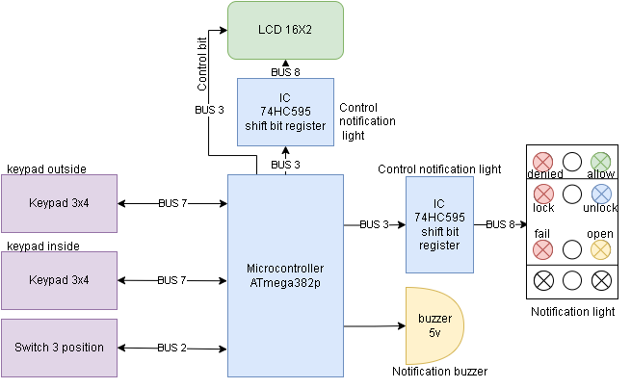Hardware block diagram

BK-Airbus

1. Summary flowchart software

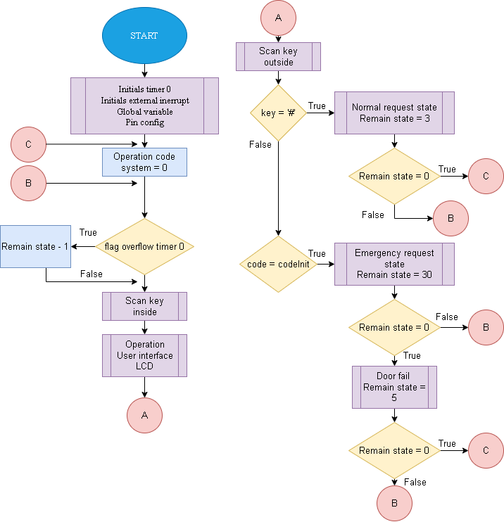

BK-Airbus

1. 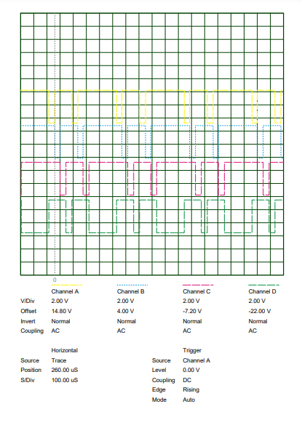Signal scan keypad

Prioty

BK-Airbus

1. Details hardware design

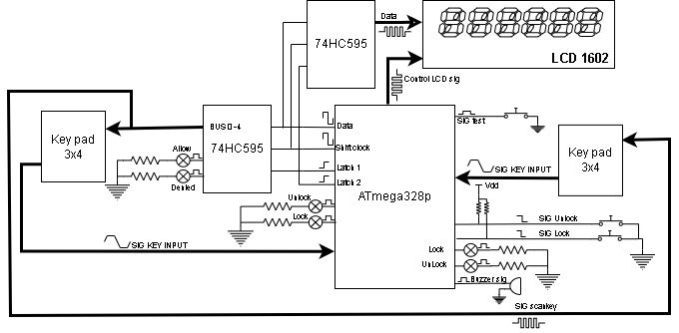

BK-Airbus

Information design

|  |  |  |  |
| --- | --- | --- | --- |
| STT | Full name | Status | Descrition |
| 1 | Nguyen Thanh Toan | Fullstack Student | Probationary |
| 2 | Nguyen Anh Dao | Hardware Student | Probationary |
| 3 | Nguyen Minh Quang | Software Student | Probationary |
| 4 | Nguyen Minh Nghia | Hardware Student | Probationary |
| 5 | … | … | … |

Prototype contact

SDT: 0394044026

Email: [ntkhiem2510@gmail.com](mailto:ntkhiem2510@gmail.com)

**Note:** This is open source. If you want contribute please follow link

*github.com/nttoan-khiem/bkAirbus*

or scan QR code in below. To access open source code.