**softeng2023-49**

**Software Requirements Specification**

Version 2.0

# Revision History

|  |  |  |  |
| --- | --- | --- | --- |
| Date | Version | Description | Author |
| 16/12/2023 | 1.0 | Initial srs | Team 49 |
| 17/2/2024 | 2.0 | Final srs | Team 49 |

# Table of Contents

Revision History 2

Table of Contents 3

Introduction 4

Purpose 4

Scope 4

Definition, Acronyms and Abbreviations 4

References 4

Overall Description 4

Problem Statement 4

Background 4

Objectives 4

Functional Requirements 4

Use Cases 4

Requirements 5

User Requirements 5

Technical Requirements 5

Performance 5

Maintainability 5

Usability 5

Auditing and Logging 5

Deployment Requirements 6

Components 6

# Introduction

## This Software Requirements Specification (SRS) document details the functional and non-functional requirements for the development of "ntuaflix", a platform for navigating and analyzing movie and series data. This document aims to clearly define the intended functionality of the application and the expected requirements to achieve it.

## Purpose

## The purpose of this Specification is to record the detailed requirements for the development of "ntuaflix". Through this document, end-users are expected to gain a better understanding of the capabilities that the application will offer, while designers and developers will obtain a complete picture of the requirements to be met.

## Scope

## The SRS encompasses the development of the "ntuaflix" application, including all aspects of design, development, and delivery of the software. The application is designed to integrate movie and series data from various sources, providing search capabilities to users.

## Definition, Acronyms and Abbreviations

|  |  |
| --- | --- |
| Term | Definition |
| ntuaflix | The name of the application being developed within the Software Technology course |

## References

* TMDB API

# Overall Description

## Problem Statement

## The existing problem includes the need for a unified platform that allows easy and accurate search and analysis of movie and series data.

## Background

## The need for developing "ntuaflix" arose from the increasing demand for online personal entertainment services and the need for better organization and access to related data.

## Objectives

The goal of "ntuaflix" is to provide a useful, flexible, and secure platform that allows users to discover, organize, and analyze movies and series.

# Functional Requirements

## Detailed description of use cases supported by the application, such as searching for movies based on various criteria and viewing information about actors and directors.

## Use Cases

### Use Case Diagram1

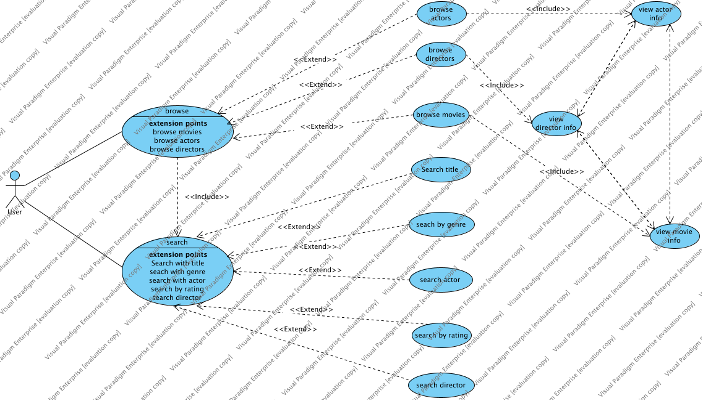

|  |  |
| --- | --- |
| Use Case | Description |
| browse | Allows users to navigate and view lists of movies, actors, and directors within the application. |
| search | Enables users to perform targeted searches for movies, actors, or directors based on specific criteria like title, genre, or rating. |

## Sequences Detailed description of sequences performed by the applications’ users.

## Requirements

### requirements diagram

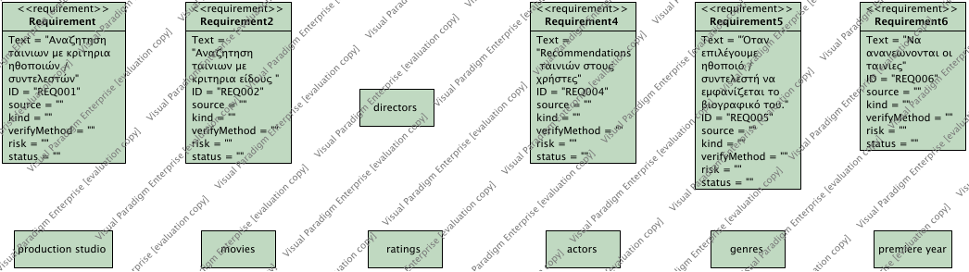

|  |  |
| --- | --- |
| Requirement | Description |
| Requirement | Search by name/title |
| Requirement2 | Search by genre/rating |
| Requirement4 | Movie recommendation |
| Requirement5 | View Principal/Title info |
| Requirement6 | Up to date titles |

# User Requirements

|  |  |
| --- | --- |
| Actor | Description |
| User | "ntuaflix" is tailored for movie enthusiasts and industry professionals for use in home entertainment and professional research contexts. |

# Technical Requirements

## Performance

Specifications for the response time of the application and handling of concurrent user sessions.

## Maintainability

Guidelines for code maintainability and update procedures.

## Usability

The application should have an intuitive user interface and be easy to navigate.

## Components

|  |  |
| --- | --- |
| Name | Description |
| CLI | Rest-api command line interface |
| TMDB API | Used to fetch data |
| Node.js Express / back-end | scalable back-end framework managing HTTP requests, application routing, and interactions with the "ntuaflix" backend. |
| React / Next.js / Redux / front-end | React combined with Next.js (and redux for state management) forms the responsive and SEO-friendly front-end of "ntuaflix," facilitating dynamic user interfaces and server-side rendering. |

## 

## Classes

|  |  |
| --- | --- |
| Name | Description |
| titleObject | Object that contains out app’s title information |
| nameObject | Object that contains out app’s names information |

