Comparative Evaluation of Large Language Models for Text-to-SQL Semantic Parsing Across Relational Database Engines
[Ονοματεπώνυμα μας] (LLMSQL3)
Σχολή Ηλεκτρολόγων Μηχανικών και Μηχανικών Υπολογιστών
Εθνικό Μετσόβιο Πολυτεχνείο, Αθήνα, Ελλάδα
[emails μας]@mail.ntua.gr
Abstract— Translating natural language queries into structured query language (Text-to-SQL) is a fundamental challenge in information-based systems, bridging the gap between non-technical domain users and relational databases. In this study, we present LLMSQL3, a comprehensive empirical benchmark comparing a commercial closed-weights model (OpenAI GPT-4o-mini) and an open-weights code-specialized model (Qwen2.5-Coder-7B-Instruct, 4-bit quantized) across two widely deployed Relational Database Management Systems (MySQL 8.0 and MariaDB 11.0). Evaluating on a stratified sample of 306 queries drawn from complex relational domains (Geography, Advising, ATIS, and handcrafted multi-table custom queries), we measure strict and lenient execution accuracies, syntax validity, and inference latencies. Statistical significance is rigorously evaluated using exact paired two-sided McNemar tests alongside 95% Wilson score binomial confidence intervals. GPT-4o-mini achieves 13.4% strict and 40.2% lenient execution accuracy, compared to 10.1% strict and 29.7% lenient accuracy for Qwen2.5-Coder-7B-Instruct. While the strict accuracy difference does not reach statistical significance at α = 0.05 (p = 0.0755), the lenient execution accuracy advantage of GPT-4o-mini is highly statistically significant (p = 0.000014). Furthermore, dialect interchangeability between MySQL and MariaDB yields identical semantic accuracy while showing minimal latency divergence. We examine failure modes, error distributions, schema reflection effects, and practical architectural trade-offs for deploying LLM-driven query engines.
Keywords— Text-to-SQL, Large Language Models, Natural Language Interfaces to Databases (NLIDB), GPT-4o-mini, Qwen2.5-Coder, MySQL, MariaDB, McNemar Paired Test, Execution Accuracy.
I. Introduction
Natural Language Interfaces to Databases (NLIDBs) have long represented a core aspiration of information systems and data engineering [1]. The capacity to automatically translate natural language questions into valid, semantically equivalent Structured Query Language (SQL) statements—a task formalized as Text-to-SQL—democratizes enterprise data access, mitigates the bottleneck of technical query formulation, and enables real-time decision support systems [2].
Historically, Text-to-SQL solutions relied on rule-based parsers, grammar-based intermediate representations, and specialized sequence-to-sequence neural architectures [3]. However, the emergence of Large Language Models (LLMs) trained on extensive corpora of code and natural text has fundamentally reshaped the field. State-of-the-art closed foundation models (such as OpenAI's GPT series) and open-weights code models (such as Alibaba's Qwen-Coder series) demonstrate remarkable in-context semantic parsing capabilities without requiring full model fine-tuning [4].
Despite these advances, practical deployment of LLM-based Text-to-SQL pipelines within relational enterprise stacks introduces crucial research and engineering questions [5]:
1) Model Capability & Weight Paradigm: How does a lightweight, quantized open-weights code model (Qwen2.5-Coder-7B-Instruct in 4-bit) compare against a premier cloud-hosted proprietary LLM (GPT-4o-mini) in functional execution correctness and syntax robustness?
2) Database Engine Dialect Invariance: Does switching between closely related but distinct Relational Database Management Systems (RDBMS)—specifically MySQL 8.0 and MariaDB 11.0—introduce semantic divergence, execution failure, or latency overhead for LLM-generated SQL?
3) Evaluation Metric Discrepancies: How do strict execution match, lenient projection match, and empty-result handling alter empirical conclusions regarding model competence?
To systematically address these questions, we introduce LLMSQL3, an experimental evaluation harness designed to test natural language semantic parsing across dual LLMs and dual RDBMS engines. Utilizing a stratified test set of 306 queries across 10,575 curated domain instances, this paper delivers an end-to-end empirical investigation backed by formal hypothesis testing.
II. Related Work & Evaluation Methodology
A. Semantic Parsing and Text-to-SQL Evolution
Early benchmarks such as GeoQuery (Geography) and ATIS (Air Travel Information System) established the foundations of semantic parsing, emphasizing multi-table joins and compositional logic [6], [7]. Modern benchmarks such as Spider [2] and BIRD [5] further expanded schema complexity and real-world database scale. While traditional evaluations often utilized exact-set string matching of ASTs, execution-based evaluation has emerged as the definitive standard, as semantically identical operations can be expressed via multiple valid SQL constructs (e.g., INNER JOIN vs. correlated subquery) [4].
B. Execution Accuracy Metrics & Trivial Empty Handling
Let Q be a natural language question, S the relational database schema, and D the underlying database instance. Let Y_gold denote the gold reference SQL query and Y_gen denote the LLM-generated SQL query. The execution result sets are denoted R_gold = E(Y_gold, D) and R_gen = E(Y_gen, D).
We define two execution accuracy metrics:
• Strict Execution Accuracy (Acc_strict): Yields 1 if and only if R_gen matches R_gold exactly in both tuple values and projected column structure, while excluding trivial empty matches, i.e., |R_gold| > 0 and R_gen = R_gold.
• Lenient Execution Accuracy (Acc_lenient): Yields 1 if R_gen contains all required gold rows and attributes, even if auxiliary columns are projected by the model (i.e., projection-superset equivalence).
Crucially, we address the 'trivial empty match' artifact. When both Y_gold and Y_gen return empty result sets (|R| = 0) due to over-constrained filters or misaligned predicates on static databases, treating them as correct artificially inflates accuracy [2]. LLMSQL3 explicitly detects and excludes trivial empty matches from true execution success.
III. System Architecture & Experimental Pipeline
A. Pipeline Architecture
The LLMSQL3 experimental framework is structured into a modular multi-stage architecture comprising schema extraction, prompt assembly, inference execution, database execution, and dual-metric scoring. Fig. 1 illustrates the pipeline flow.
┌───────────────────────────────────────────────────────────┐
│ Natural Language Question + Dynamic Schema Extraction │
│ (Auto-inspected from information_schema) │
└─────────────────────────────┬─────────────────────────────┘
▼
┌───────────────────────────────────────────────────────────┐
│ Prompt Assembly (System Directive + Few-Shot Conventions) │
└──────────────┬─────────────────────────────┬──────────────┘
▼ ▼
┌─────────────────────────────┐ ┌───────────────────────────┐
│ Commercial: GPT-4o-mini API │ │ Local/Colab: Qwen2.5-Coder │
│ (OpenAI Engine) │ │ (7B 4-bit Quant) │
└──────────────┬──────────────┘ └─────────────┬─────────────┘
└──────────────┬───────────────┘
▼
┌───────────────────────────────────────────────────────────┐
│ Dual Database Execution Engine (Dockerized Isolation) │
│ • MySQL 8.0 (Port 3306) vs. MariaDB 11.0 (Port 3307) │
└──────────────┬─────────────────────────────┬──────────────┘
▼ ▼
┌─────────────────────────────┐ ┌───────────────────────────┐
│ Execution Accuracy Scoring │ │ Statistical Significance │
│ (Strict, Lenient, Empty) │ │ (Paired McNemar, 95% CIs) │
└─────────────────────────────┘ └───────────────────────────┘
Fig. 1. End-to-end LLMSQL3 comparative evaluation pipeline architecture.
B. Schema Inspection and Prompt Engineering
To eliminate manual prompt authoring biases, database schemas are automatically extracted at runtime by querying the RDBMS `information_schema`. Table definitions, primary keys, foreign key constraints, and column data types are dynamically serialized into standardized DDL representations.
Each prompt incorporates a structured system message instructing the LLM to output valid SQL without markdown fences or extraneous conversational prose, accompanied by exactly one targeted few-shot demonstration per target schema to establish relational naming conventions.
C. Dataset Composition and Stratification
The benchmark corpus encompasses 10,575 query-SQL pairs derived from three established public benchmark schemas and a newly introduced handcrafted custom benchmark suite:
1) Geography (877 pairs, 7 tables): Covers US geographic entities, borders, rivers, and population statistics. Characterized by moderate complexity and domain-specific relational predicates.
2) ATIS (5,280 pairs, ~25 tables): Air Travel Information System featuring intricate multi-table joins, nested flight restrictions, airline codes, and date-time constraints.
3) Advising (4,387 pairs, 15 tables): Academic advising database modeling student records, course prerequisites, instructor loads, and academic grades.
4) Custom Multi-Schema Queries (31 pairs, 3 schemas): Handcrafted advanced queries featuring aggregation, complex grouping (HAVING), multi-way joins, and nested subqueries, verified for execution integrity across all three public schemas.
To achieve high statistical power while maintaining API cost and compute feasibility, we constructed a representative sample of N = 306 queries via stratified sampling across dataset domains and SQL complexity tiers (Easy, Medium, Hard). Heuristic difficulty labeling was computed automatically based on SQL structural complexity: table count, subquery nesting depth, aggregation operators, and GROUP BY/HAVING clauses.
D. Evaluated LLM Models and Deployment Setup
Two contrasting LLM architectures were evaluated under identical schema contexts:
• OpenAI GPT-4o-mini: State-of-the-art commercial lightweight foundation model accessed via the OpenAI REST API with temperature set to 0.0 for deterministic output generation.
• Qwen2.5-Coder-7B-Instruct: State-of-the-art open-weights 7-billion parameter code model, quantized to 4-bit precision (NF4) to operate within consumer GPU memory constraints, deployed on an isolated Google Colab environment powered by an NVIDIA T4 GPU (16 GB VRAM).
E. Database Infrastructure and Dialect Matrix
Both target database management systems were containerized via Docker with identical schemas, indexes, and row populations:
• MySQL 8.0: Deployed on container port 3306.
• MariaDB 11.0: Deployed on container port 3307.
To isolate SQL generation from database execution artifacts, the identical SQL generated by each model was evaluated across both database instances using automated rescoring scripts, yielding four distinct experimental combinations: (GPT × MySQL), (GPT × MariaDB), (Qwen × MySQL), and (Qwen × MariaDB).
IV. Experimental Results & Statistical Analysis
A. Overall Performance and Accuracy Metrics
Table I summarizes the global performance metrics across the 306 stratified test instances for all four model-database configurations.
TABLE I — BENCHMARK RESULTS ACROSS LLM ENGINES AND RDBMS TARGETS (N = 306)
Metric | GPT×MySQL | GPT×MariaDB | Qwen×MySQL | Qwen×MariaDB
Strict Execution Accuracy | 13.4% (41/306) | 13.4% (41/306) | 10.1% (31/306) | 10.1% (31/306)
Lenient Execution Accuracy | 40.2% (123/306) | 40.2% (123/306) | 29.7% (91/306) | 29.7% (91/306)
Mean Generation Latency (s) | 1.64 | 1.64 | 4.96 | 4.96
Syntax / Execution Errors | 42/306 (13.7%) | 42/306 (13.7%) | 98/306 (32.0%) | 99/306 (32.4%)

As evidenced by Table I, GPT-4o-mini achieved a strict execution accuracy of 13.4% and a lenient accuracy of 40.2%, whereas Qwen2.5-Coder-7B-Instruct recorded 10.1% strict and 29.7% lenient accuracy. Switching database backends between MySQL 8.0 and MariaDB 11.0 yielded identical execution accuracy across all 306 queries, with only a single minor execution error variance in Qwen (98 errors in MySQL vs. 99 in MariaDB) caused by a subtle parser edge-case.
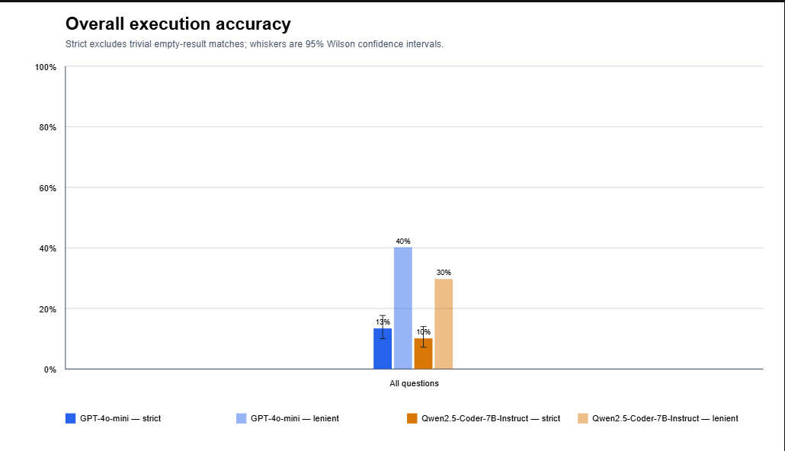
Fig. 2. Overall execution accuracy (strict vs. lenient) per model, with 95% Wilson confidence interval whiskers.
B. Confidence Intervals and Hypothesis Testing
To quantify measurement uncertainty, 95% Wilson binomial confidence intervals were computed for all accuracy metrics. Furthermore, because both models were evaluated on the exact same paired query instances, statistical significance was assessed using exact two-sided McNemar paired tests. Table II presents the detailed statistical comparison.
TABLE II — STATISTICAL COMPARISON AND EXACT PAIRED MCNEMAR TESTS (N = 306)
Metric | GPT-4o-mini (95% CI) | Qwen2.5-Coder (95% CI) | GPT Only | Qwen Only | Exact p-value
Strict Accuracy | 13.4% [10.0%, 17.7%] | 10.1% [7.2%, 14.0%] | 18 | 8 | p = 0.0755 (NS)
Lenient Accuracy | 40.2% [34.9%, 45.8%] | 29.7% [24.9%, 35.1%] | 43 | 11 | p = 0.000014 (***)

The statistical analysis reveals two key insights:
1) Strict Execution Accuracy: GPT-4o-mini uniquely solved 18 queries where Qwen failed, whereas Qwen uniquely solved 8 queries where GPT failed. The resulting exact McNemar p-value is p = 0.0755. At the standard significance threshold (α = 0.05), this performance difference is not statistically significant.
2) Lenient Execution Accuracy: GPT-4o-mini uniquely satisfied 43 queries where Qwen failed, compared to 11 queries where Qwen succeeded over GPT. The exact McNemar test yields p = 0.000014 (p < 10⁻⁴), confirming that GPT-4o-mini's superior semantic retrieval performance is highly statistically significant.
C. Breakdown Across Domain Schemas
Performance varies dramatically across domain schemas, reflecting differing schema complexities and relational depths. Table III displays the accuracy breakdown for the three primary public benchmark domains.
TABLE III — ACCURACY BREAKDOWN BY BENCHMARK DATASET (STRICT / LENIENT)
Dataset Domain | Sample Rows | GPT-4o-mini (Strict / Lenient) | Qwen2.5-Coder (Strict / Lenient)
Geography (US Geo) | 25 | 60.0% / 60.0% | 64.0% / 64.0%
Advising (Academic) | 125 | 11.2% / 60.8% | 5.6% / 44.0%
ATIS (Air Travel) | 149 | 6.7% / 19.5% | 2.7% / 10.7%
Note: the remaining 7 of the 306 stratified queries (2.3%) belong to the handcrafted custom diagnostic suite (custom_geography, custom_atis, custom_advising; n=2–3 each) and are excluded from this per-domain breakdown, consistent with Section VI-3 — sample sizes at this scale do not support standalone statistical claims.
In the Geography dataset, both models performed strongly (~60–64%), with Qwen slightly outperforming GPT. In the Advising dataset, both models exhibited a massive gap between strict and lenient accuracy (GPT jumped from 11.2% to 60.8%, and Qwen from 5.6% to 44.0%). ATIS proved challenging across both models (strict < 7%, lenient < 20%).
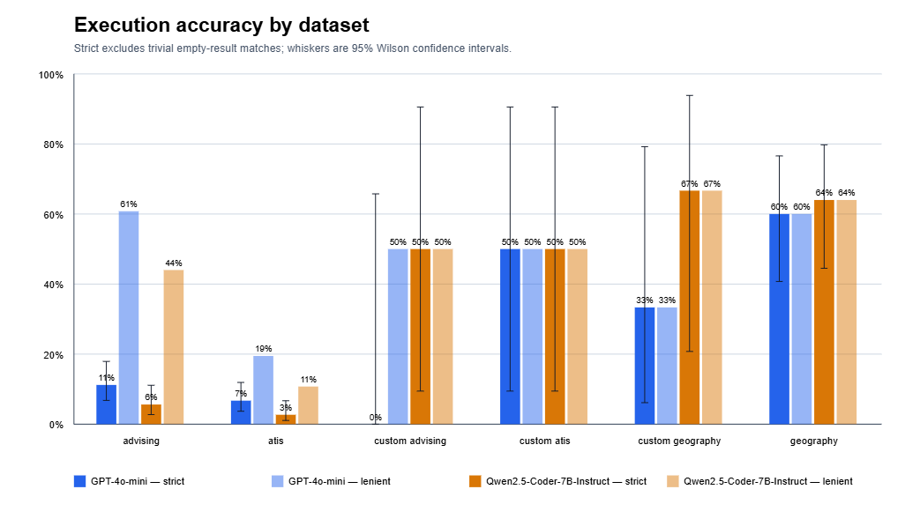
Fig. 3. Execution accuracy by dataset domain (all six categories, including the custom diagnostic suite; error bars widen sharply for n≤3 categories).
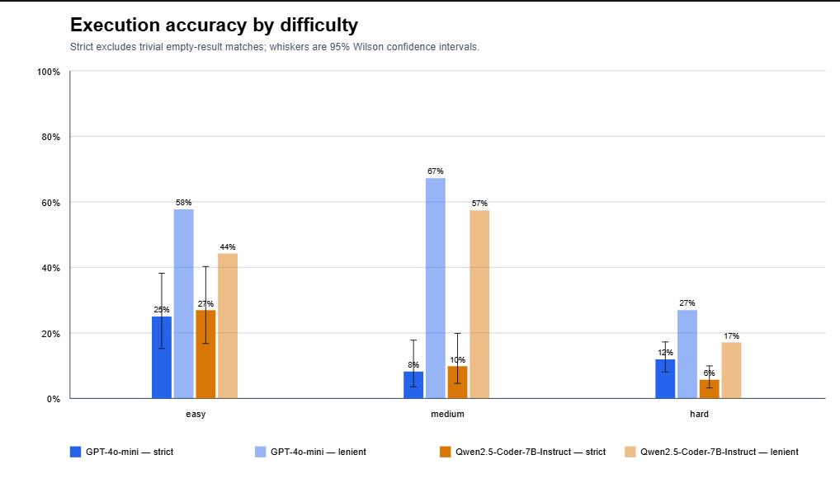
Fig. 4. Execution accuracy by heuristic difficulty tier (easy/medium/hard).
D. Generation Latency and Error Analysis
Generation latency measurements demonstrate that GPT-4o-mini averaged 1.64 seconds per query via API, while quantized Qwen2.5-Coder-7B averaged 4.96 seconds on a shared T4 GPU (~3.0x slower).
Execution syntax error analysis shows that Qwen produced 98 syntax/runtime SQL errors (32.0% of all queries), more than double the 42 errors produced by GPT-4o-mini (13.7%). These errors predominantly stemmed from hallucinated column names, invalid JOIN conditions on unlinked foreign keys, and non-standard SQL group-by aggregations.
V. Discussion & Deep Error Analysis
A. The Strict vs. Lenient Disparity in Relational Schemas
The dramatic 49.6% jump from strict (11.2%) to lenient (60.8%) accuracy in the Advising dataset reveals an important characteristic of modern LLMs: semantic intent capture without strict projection alignment. In many queries, the LLM correctly identified the necessary filtering logic, join paths, and candidate rows, but projected additional descriptive columns (e.g., returning `student_id, student_name, gpa` when the reference query strictly projected `student_id`). Strict matching penalizes such outputs as total failures, highlighting why lenient evaluation is critical for practical information retrieval.
B. Dataset Peculiarities and Historical Benchmarks
ATIS proved exceptionally resistant to accurate generation. Detailed audit of the failure cases revealed legacy idiosyncrasies within the original ATIS benchmark corpus [7]:
1) Hardcoded Historical Dates: Many reference queries enforce hardcoded temporal constraints (e.g., flight departures fixed to 1991 dates) that are omitted from natural language prompts.
2) Non-Literal Ground Truths: Reference queries frequently project internal surrogate keys or non-intuitive abbreviations rather than user-facing semantic entity labels.
C. Open-Weights Quantized Models vs. Closed Cloud Models
While GPT-4o-mini demonstrated superior overall lenient semantic parsing and syntactic robustness, Qwen2.5-Coder-7B-Instruct showed impressive domain competence (e.g., matching or exceeding GPT on Geography). For privacy-sensitive enterprise environments where database schema or data cannot leave on-premise infrastructure, quantized 7B code models represent a viable local baseline, provided that downstream syntax validation and schema-aware decoding are implemented.
VI. Threats to Validity & Limitations
Several limitations should be noted when interpreting these findings:
1) Prompting Strategy: The benchmark utilized a 1-shot in-context demonstration per schema. Multi-shot demonstrations, retrieval-augmented schema pruning, or self-consistency chain-of-thought prompting would likely improve absolute scores.
2) Model Quantization: Qwen was evaluated at 4-bit precision due to T4 hardware boundaries. Full 16-bit precision might reduce syntax errors.
3) Custom Query Sample Size: While the overall test set of 306 queries provides strong statistical power, the custom complex query suite (31 queries total; 7 within the 306-query stratified sample) is intended for diagnostic evaluation rather than standalone statistical claims, and is therefore excluded from Table III.
4) Heuristic Difficulty Labeling: Automatic difficulty tiers (easy/medium/hard) are derived from SQL structural complexity rather than validated human judgment; Fig. 4 shows a non-monotonic accuracy pattern across tiers (medium below hard), suggesting the heuristic imperfectly captures true task difficulty for the LLMs under test.
VII. Conclusion
This paper presented LLMSQL3, an empirical evaluation of Text-to-SQL semantic parsing comparing GPT-4o-mini and Qwen2.5-Coder-7B-Instruct across MySQL and MariaDB relational engines. Our rigorous paired statistical evaluation demonstrates that while strict execution accuracy shows no statistically significant divergence (p = 0.0755), GPT-4o-mini significantly outperforms Qwen in lenient execution accuracy (40.2% vs. 29.7%, p = 0.000014) and cuts syntax failure rates in half.
Furthermore, our findings confirm database dialect invariance between MySQL and MariaDB for LLM-generated SQL. Future work will investigate automated schema pruning, interactive error-feedback reflection loops, and retrieval-augmented few-shot exemplar selection.
Acknowledgment
The authors acknowledge the open-source contributors of the text2sql-data repository and the developers of the Qwen and OpenAI foundation models.
References
[1] I. Androutsopoulos, G. D. Ritchie, and P. Thanisch, "Natural language interfaces to databases—an introduction," Nat. Lang. Eng., vol. 1, no. 1, pp. 29–81, 1995.
[2] T. Yu, R. Zhang, K. Yang, M. Yasunaga, D. Wang, Z. Li, J. Ma, I. Li, Q. Yao, S. Roman, Z. Zhang, and D. Radev, "Spider: A large-scale human-labeled dataset for complex and cross-domain semantic parsing and text-to-SQL task," in Proc. EMNLP, 2018, pp. 3911–3921.
[3] V. Zhong, C. Xiong, and R. Socher, "Seq2SQL: Generating structured queries from natural language using reinforcement learning," arXiv preprint arXiv:1709.00103, 2017.
[4] N. Pourreza and D. Rafiei, "DIN-SQL: Decomposed in-context learning of text-to-SQL with self-correction," in Proc. NeurIPS, vol. 36, 2023, pp. 34015–34027.
[5] J. Li, B. Hui, G. Qu, J. Yang, B. Li, B. Wang, B. Qin, R. Geng, N. Huo, X. Zhou, C. Ma, S. Li, K. Chang, F. Huang, R. Cheng, and Y. Li, "Can LLM already serve as a database interface? A big bench for large-scale database grounded text-to-SQLs (BIRD)," in Proc. NeurIPS, vol. 36, 2023.
[6] J. M. Zelle and R. J. Mooney, "Learning to parse database queries using inductive logic programming," in Proc. AAAI, 1996, pp. 1050–1055.
[7] C. T. Hemphill, J. J. Godfrey, and G. R. Doddington, "The ATIS spoken language systems pilot corpus," in Proc. DARPA Speech and Natural Language Workshop, 1990, pp. 96–101.
[8] J. K. Kummerfeld, S. Joshi, and X. V. Lin, "text2sql-data: Standardized datasets for text-to-SQL research," GitHub Repository, 2020.
[9] Qwen Team, "Qwen2.5-Coder: Empowering everyone with code capabilities," Alibaba Cloud Technical Report, 2024.
[10] OpenAI, "GPT-4o system card and technical specification," OpenAI Technical Report, 2024.
[11] Q. McNemar, "Note on the sampling error of the difference between correlated proportions or percentages," Psychometrika, vol. 12, no. 2, pp. 153–157, 1947.
[12] E. B. Wilson, "Probable inference, the law of succession, and statistical inference," J. Amer. Statist. Assoc., vol. 22, no. 158, pp. 209–212, 1927.

