GIFT TO NTUADF

Please scan the QR Code to donate online

National Taiwan University Academic Development Foundation (NTUADF) was established by NTU alumni to support the advancement of our alma mater. The foundation cooperates closely with NTU and receives a U.S. tax exempt status (**NTUADF’s Tax ID number is 36-4221899**) and all gifts made to NTUADF are tax deductible in the U.S.

Donor English Name Receipt Title □same as Donor

If NTU alumnus: □ NO □ Graduation Year School/Dpt. Mailing Address Tel E-mail

□Historic Building Maintenance Project

□Emergency Financial Aid for Students

□Centennial Vision Fund □Endowed Financial Aid Fund for Students in Need

□Campus Tree Conservation Fund

※If donation is USD$200 or more, a 12-word message can be left on an unspecified tree’s placard (left for one year per donation).

□University Priorities □Other programs

□Online Credit Card/Debit Card/PayPal Donation,

**Please visit https://giving.ntu.edu.tw to make donation online.**

□**One-time** □**Monthly** □**Quarterly** □**Annual, USD**

□Check or Money Order, USD

**Please make the check payable to "NTUADF" and mail it together with this form.**

□Wire Transfer, Marketable Securities and/or Mutual Fund Shares

**Please contact NTUADF** (**ntuadf@gmail.com**) **or NTU for more information.**

□Company Matching Funds

**Please contact NTUADF** (**ntuadf@gmail.com**) **or NTU for more information.**

**Please let us know if you’d like your gift remain confidential.**

□**ok to publicize (default)** □**make it anonymous, but open to the donee** □**make it anonymous strictly**

**How would you like your thank-you letter?**

□**an email** □**a letter** □**I don’t need it**

**Where do you get this donation information?**

□**Donation Letter** □**NTU e-paper** □**NTU Alumni Bimonthly** □**NTU donation website**

□**Alumni** □**Others**

Our office abides by regulations concerning the protection of personal information and will properly protect your information. All information will remain within this office and donors may verify, search, copy, supplement, update, delete and stop this information whenever they wish.

**NTUADF**

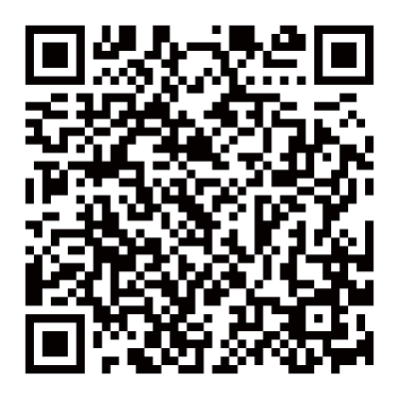

Dr. Ching-Chong Huang 黃慶鍾醫師, Treasurer of NTUADF 38 Ridgefield Lane, Willowbrook, Illinois 60527

Tel: 630-569-3701

[ntuadf@gmail.com](mailto:ntuadf@gmail.com)

**NTU Office of Financial Affairs**

Ms. Shiang-Ting Wang Tel: +886-2-3366-9799

[redrootwang@ntu.edu.tw](mailto:redrootwang@ntu.edu.tw)