Delivery System

Prepared for: MPP Course Project

THE WORST COMPANY

Prepared by: Anh Nguyen (986428) & Hai Dang Nguyen (986425)

March 11, 2018

# **SUMMARY**

## Overview

*A Delivery System is a system that receives customer’s packages or envelopes from their places and send to other locations. The Delivery System is developed in Java which mainly focuses on operations like in a delivery company.*

*Delivery System is a desktop application that performs the functions of a delivery company. That allows users come and register their accounts, create shipments and tracking their shipments’ status. In a process of creating a new shipment, users provide their shipment’s detail information, then they can see shipment’s pricing, get discounted, and receive a tracking number for their shipments. Designing this system will be elaborated using UML class diagram and Sequence Diagram while implementation of the project will be done with Java and use object-oriented concepts like Polymorphism, Inheritance, Relationships, Singleton, Abstract classes, Interfaces and JavaFX for UI.*

THE WORST COMPANY

## Goals

*The demand of sending and receiving packages is always a top demand of people around the world. But sometimes we need a lot of time to send a big value package to a place that thousands mile faraway. That is the time for a lot of company using technology to provide brief and precise information for their customers. The goals of this application are shown as below:*

* + *Register/Login*
  + *Create new shipment*
  + *Tracking customer’s shipments*
  + *Calculate pricing for every shipment*
  + *Apply discount for shipment*
  + *Chose type of service for shipment*
  + *Display user report*

## Technology

The main technologies use for the development of this system are as follow:

**Front end development**

* + JavaFX

**Back end development**

* + Java

**Database**

* + SQLite

## Functional Requirement

The Delivery System based on real needs of customers and administration. The system has the following functional requirements:

* **Register New Customer**

The system is required to provide a register function for customer creating their account which helps them to manage their shipments. It is not necessary to create a sever side or authentication method for a regular user to access their account.

THE WORST COMPANY

* **Create New Shipment**

The system is required to provide a screen for customer create their shipment request. The layout provides details of shipment such as: from location, to location, type of package …There is no require for object decryption when saving into database.

* **Tracking Customer Shipment**

The system provides a function that helps customer track their package location. This information will be retrieved from database.

* **Apply Discount for Shipment**

When customers completely create a shipment. They have a chance to get a discount for their payment base on coupon which are collected outside the system by customer. A coupon will show the amount that the customer can get discounted.

* **Calculate Pricing for Shipment**

After providing all detail information of a shipment, the system calculates the pricing of the shipment. This function is related to discount function and type of service.

* **Chose type of Service of Shipment**

The system provides two types of services: regular and express. Express service is faster but more expensive than regular service.

* **Display User Report**

The system provides report function to help user check their activities on sending shipments. That will list out all shipments that user have done.

**Non-Functional Requirements**

* Performance
* Speed
* Memorize
* User friendly Interface

**Use Case Diagram:**

# 

**Class Diagram:**

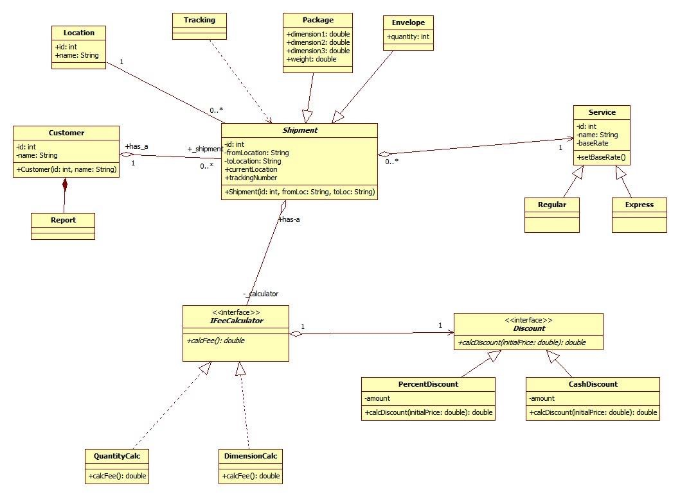

**Domain Classes:**

1. **Customer**

The people who want to use the delivery service.

1. **Shipment**

Thing that customers want to ship.

1. **Package**

A type of shipment: can be identified by 4 properties: width, length, height, weight.

1. **Envelope**

A flat type of shipment.

1. **Service**

The service customers want to use to ship the shipment. There are two types of service: Regular and Express.

1. **Location**

The place where shipment comes from and goes to.

1. **Tracking**

A tool to monitor the current status of shipment.

1. **Discount**

The amount of shipping fee is reduced. There are 2 kinds of discounts: specific amount discount and percent discount.

1. **Fee Calculator**

A tool to calculate the shipping fee. There are 2 kind of calculator corresponding to each type of shipment.

1. **Report**

List all shipments that a customer has done.

**Sequence Diagram:**

1. **Register Sequence Diagram**

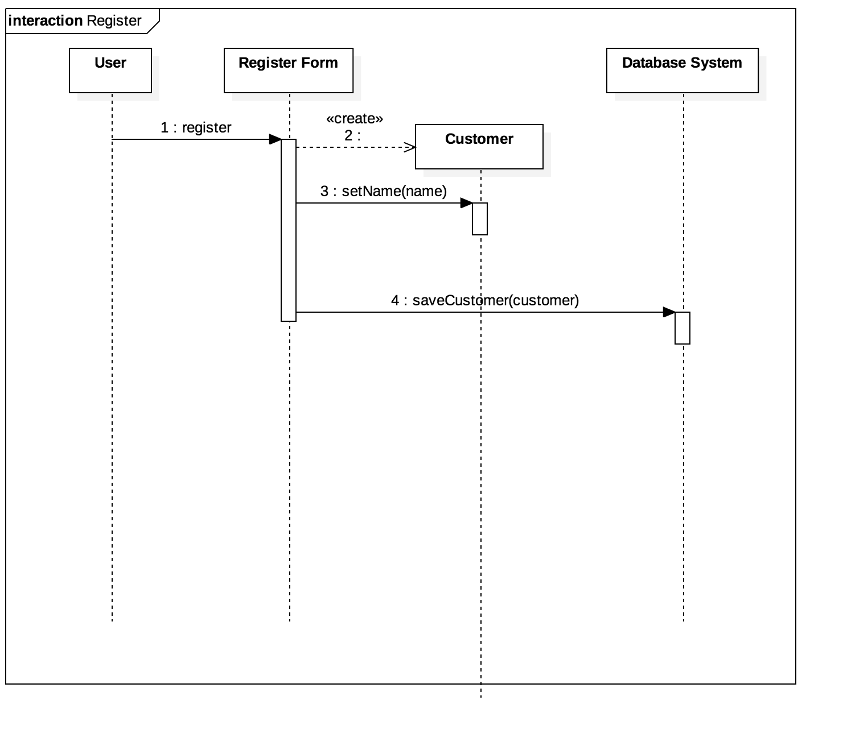

**2. Create Shipment Diagram**

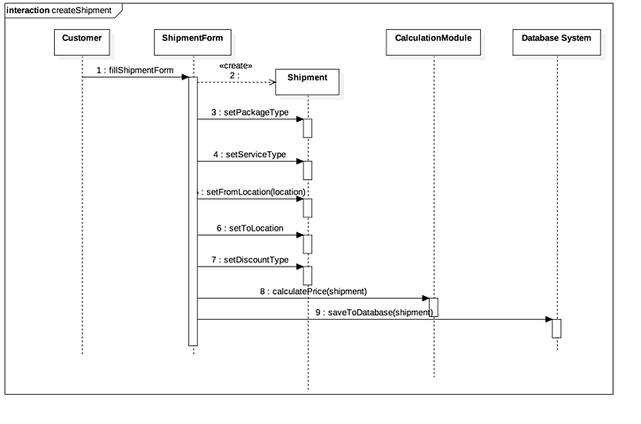

**3. Select Type of Service**

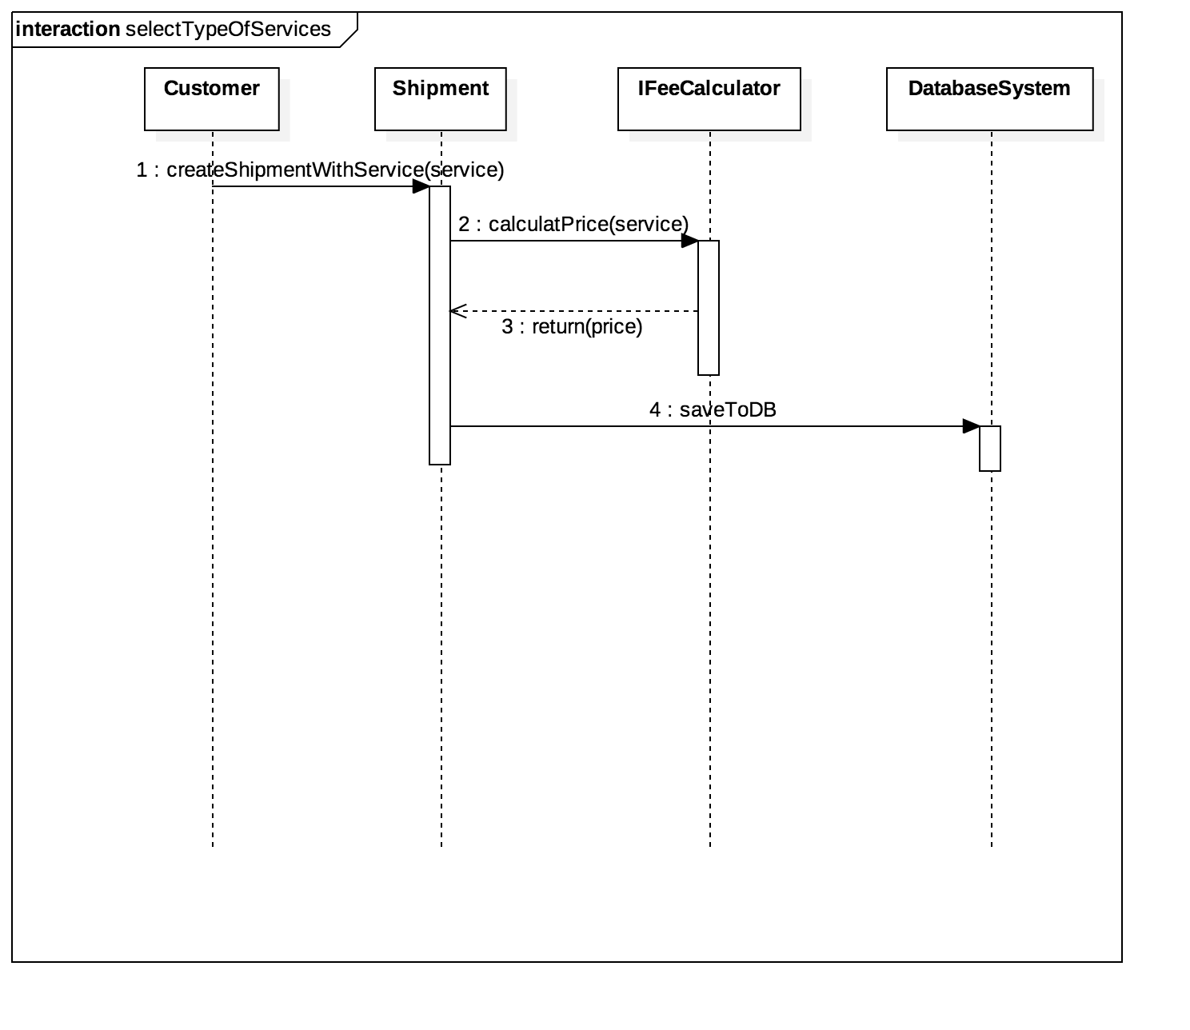

**4. Apply Discount**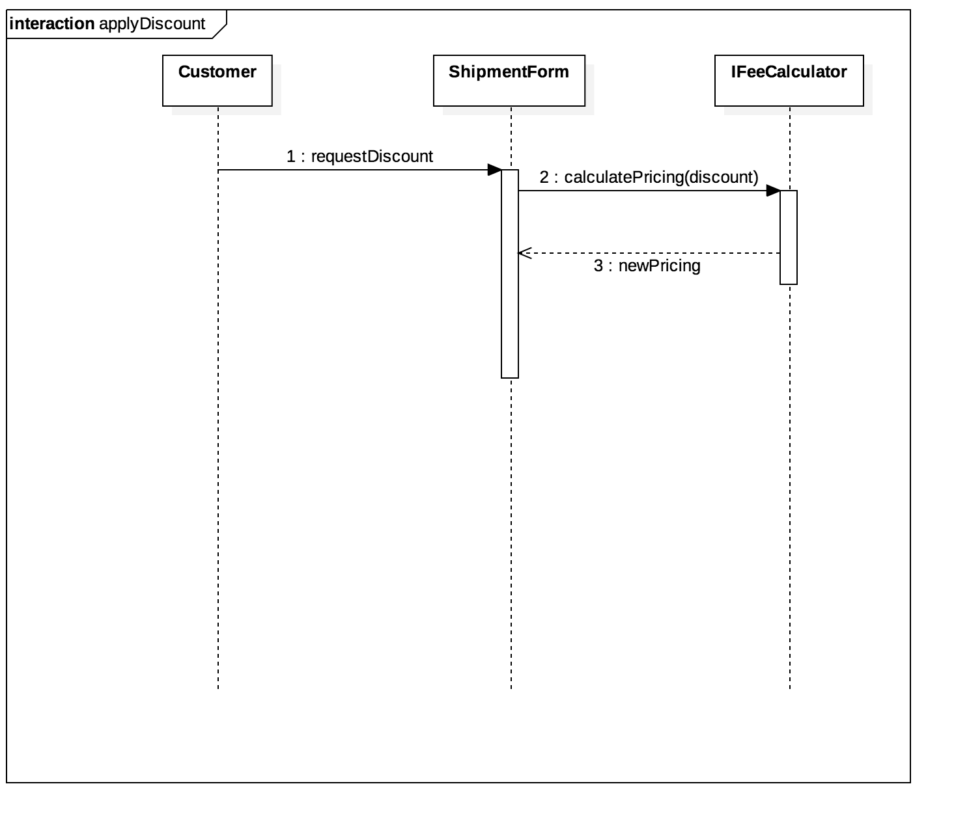

**5. Calculate Pricing**

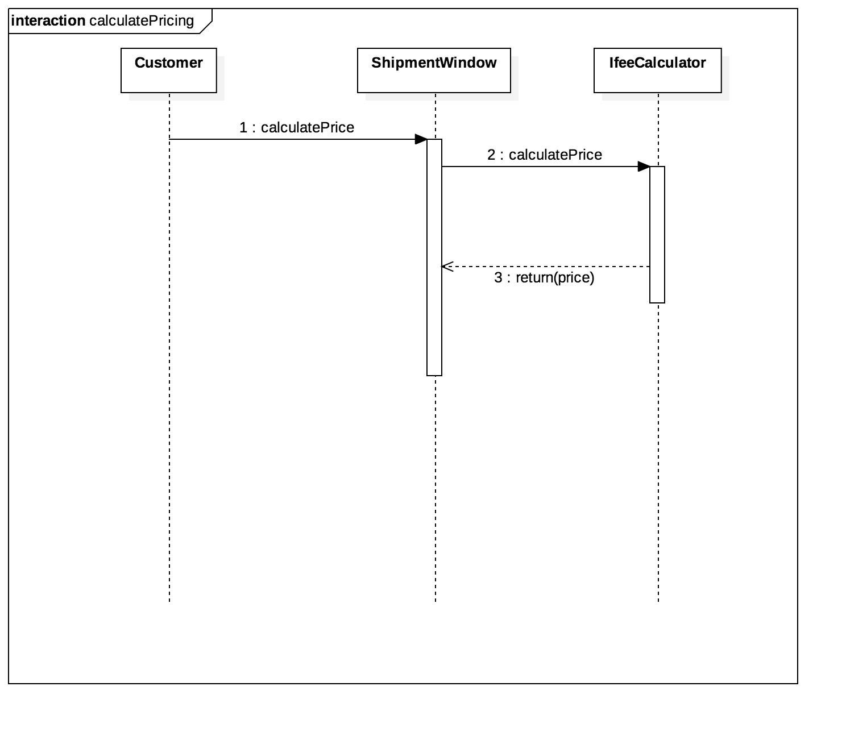

**6. Tracking Sequence Diagram** 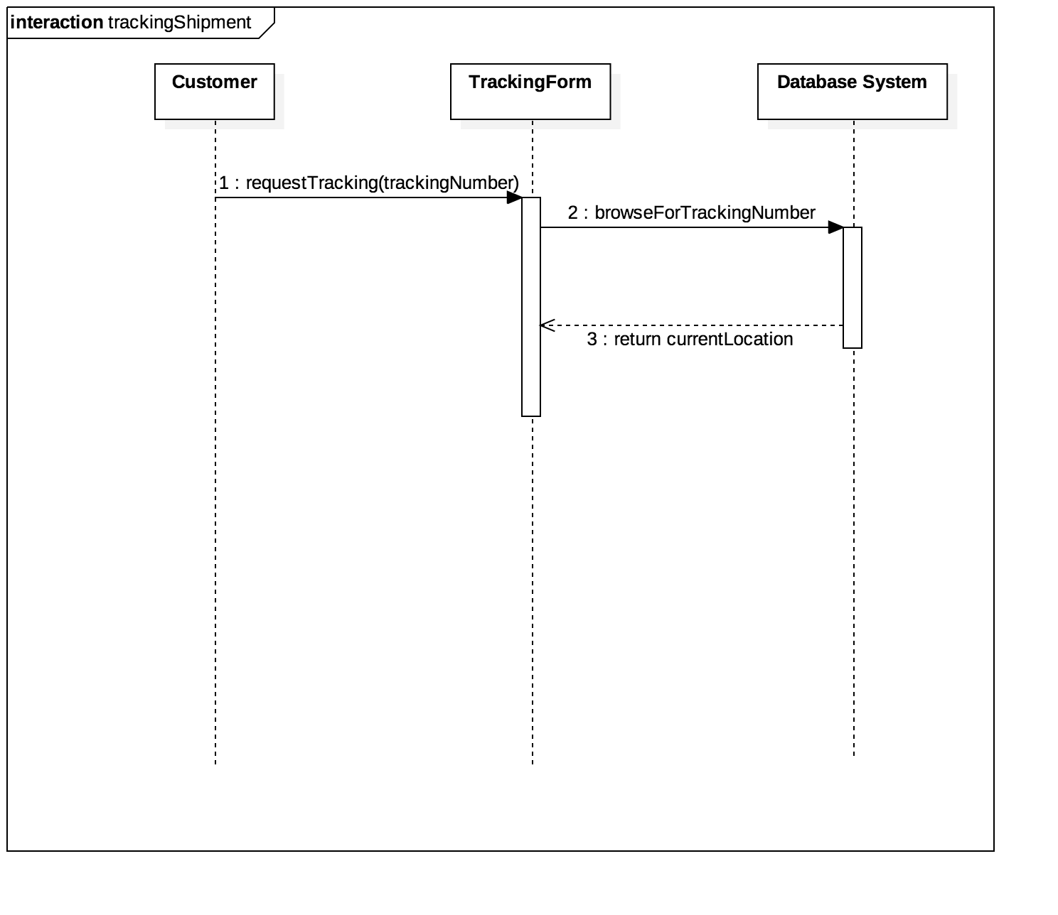

**7. Report Sequence Diagram**

