**第6章　設計模型**

**6-1 循序圖(Sequential diagram)**

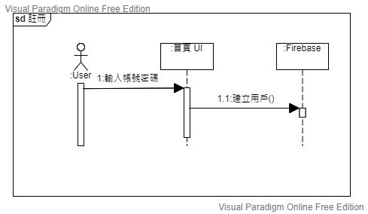

▲圖6-1-1、註冊帳號Sequential diagram

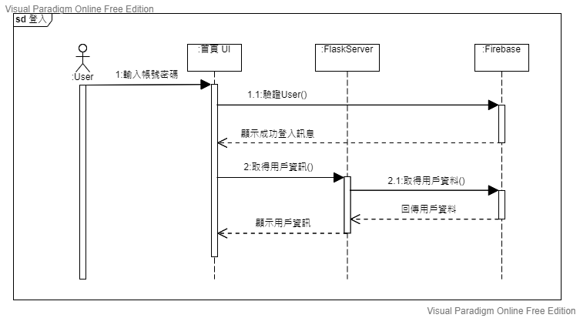

▲圖6-1-2、登入帳號Sequential diagram

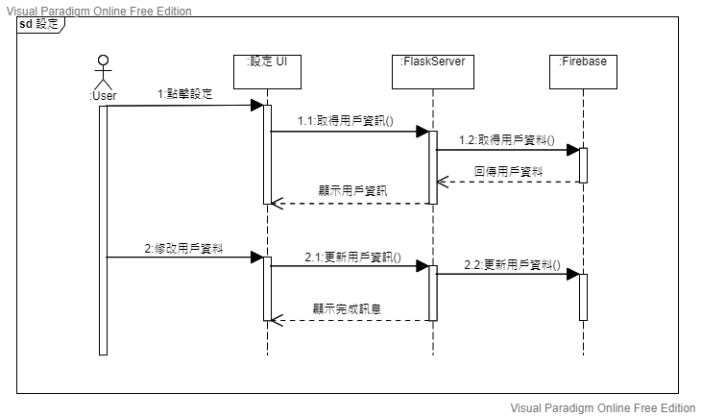

▲圖6-1-3、修改基本資料Sequential diagram

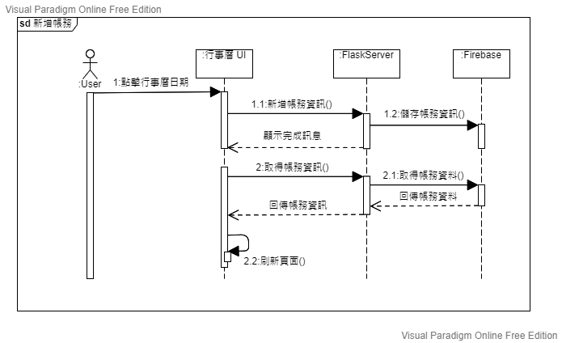

▲圖6-1-4、新增帳目Sequential diagram

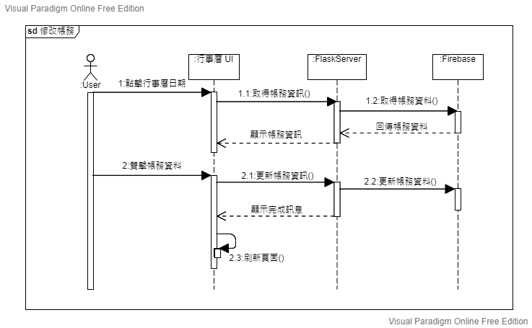

▲圖6-1-5、修改帳目Sequential diagram

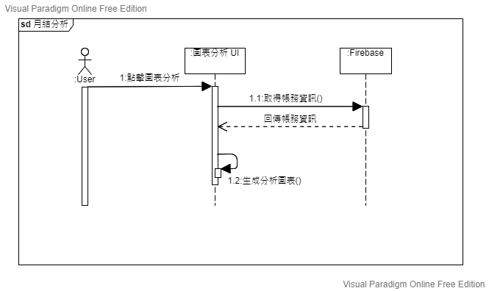

▲圖6-1-6、月結分析Sequential diagram

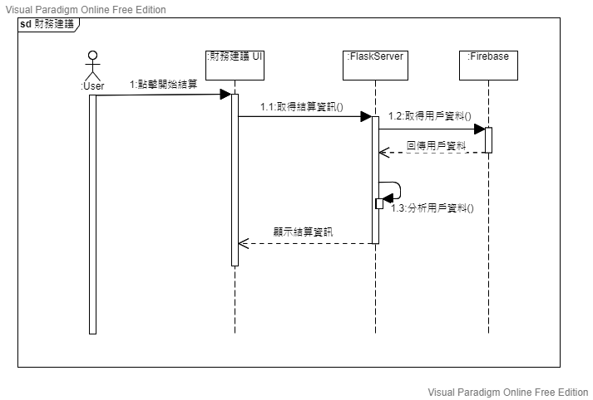

▲圖6-1-7、顯示財務建議Sequential diagram

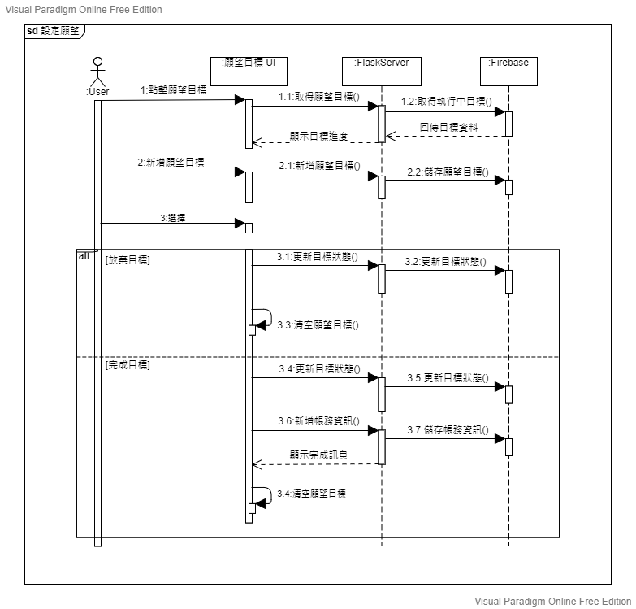

▲圖6-1-8、設定願望目標Sequential diagram

**6-2 設計類別圖(****Design class diagram)**

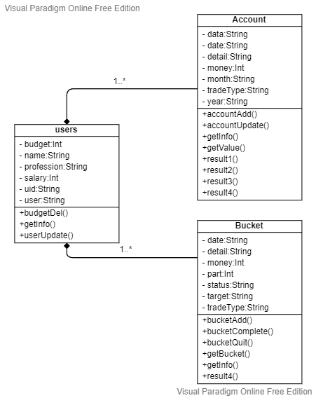

▲圖6-2-1、設計類別圖Design class diagram