Design of Fuzzy Sliding Controller Based on Cerebellar Learning Model

HENG - KANG FAN CHIN - MING HONG
Dept. of Electrical Engineering Dept. of Industrial Education
Kuang-Ku Institute of Technology National Taiwan Normal University
and Commerce 151 I-Te St. Peito 162 Sec. 1, Hoping E Rd
Taipei, Taiwan, R.O.C. Taipei, Taiwan, R.O.C.

Abstract

As to the control of fuzzy sliding mode, this paper proposes a cerebellar learning model for on-line learning of the controller. Fuzzy sliding mode has excellent robustness to the system uncertainty and immunity to the noise of the external noise. As for the cerebellar learning mode, it possesses the advantages of easy and fast correction. The combination of the two leads to the design of a fuzzy sliding mode controller with self-learning capability to improve the short-comings of difficulties in setting up the regulations of fuzzy control. It also improves the system stability and enhances the effectiveness of the controller.
This paper describes the implementation of a fuzzy sliding controller with cerebellar learning mode. After system simulation and capability test, it is applied to the control of slew-up, stand-on and positioning of a 360 ° inverted pendulum.

Key words: Variable structure system, Sliding mode, Fuzzy control, Cerebellar Model Articulation Controller, Inverted pendulum.

1. Introduction
A variable structure system[8] can be applied in control mainly through the structure of switching control system and the introduction of the concept of sliding mode. It drives the representative point of the state space to a pre-defined sliding plane, and slides along this plane to the equivalent point of the state space so that the system response can converge steadily in a gradual manner[6].
Fuzzy sliding mode controller (FSMC) combines the merits of variable structure system and fuzzy control. It achieves high degree of control level for the non-linear system, yet maintains the features of robustness and ease of design[15].
To make a controller work efficiently when facing the problems of time varying, the vigorous parameter change of the non-linear system and the inability of accommodating control regulation in time, this paper proposes a cerebellar model articulation controller (CMAC) as the on-line learning system[3][4]. It enables the system parameters to follow the controlled object through continuous correction and to achieve the desired standard .

2. Theory of CMAC Fuzzy Sliding Control
2.1 Control Theory of Fuzzy Sliding Mode
By combining the fuzzy control and the sliding mode control[7] approaches together, and fuzzify the non-ideal sliding plane, this system is driven to slide forward according to the pre-set sliding route.
Suppose the dynamic equation is 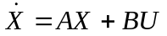, a sliding function can be designed as:
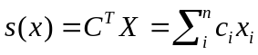 (1)
where 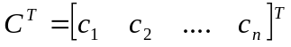is the coefficient vector of the pre-defined sliding plane.
To make the representative point slide to the sliding plane, it is necessary to satisfy the inequality equation of
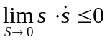 (2)
The equation of fuzzy sliding model thus becomes
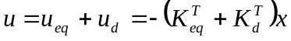 (3)
where 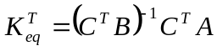
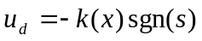
and sgn(s) is the sign of representative point s.
However, under many circumstances, it is impossible to know AX and B, and also difficult to get a precise information of 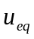. Under such uncertain conditions, the control equation will be represented as:
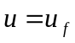 (4)
where 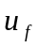 is obtained from the fuzzy sliding mode equation of the following fuzzy rule base:

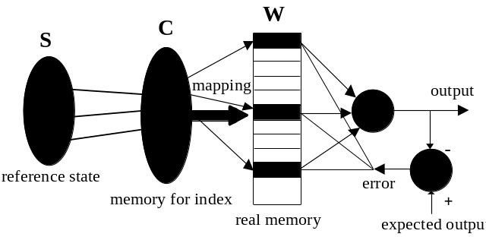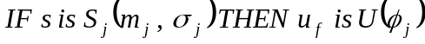 (5)

where s is the system state, 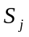 is the system fuzzify input, 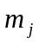 is the mean value of bell-shaped membership function, 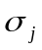 is the standard deviation and U(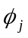) is the de-fuzzify output.
Using fuzzy control and fuzzify the sliding plane (as shown in Figure 1), the system state can be driven into the sliding plane and proceed to the origin through the sliding route to achieve the result of sliding mode control.

(a) (b)

Figure 1. (a) The state space of sliding model
(b) Fuzzify sliding plane

2.2 Basic Structure of Cerebellar Model
Cerebellar model articulation controller (CMAC)[1][2] uses a structure which mimics the cerebella cortex to store the information. Under this model, it is necessary to map out the memory structure for the learning of cerebella model. During the learning process, the memory content is modified according to the expected output to achieve the feature of enhancing memory similar to human learning process. Under such model, every learning reference state is quantified and partitioned to many discrete values. These values are then mapped to different memory space. CMAC uses a set of indices to generate the corresponding addresses to fetch memory content, and then generates a set of output signal accordingly. The difference between this output and expected output is feedback to the memory for the update and correction (as shown in Figure 2). This learning process repeats itself until the output converges to a tolerable range. Basically, CMAC uses the technique of table look-up and converges very rapidly.

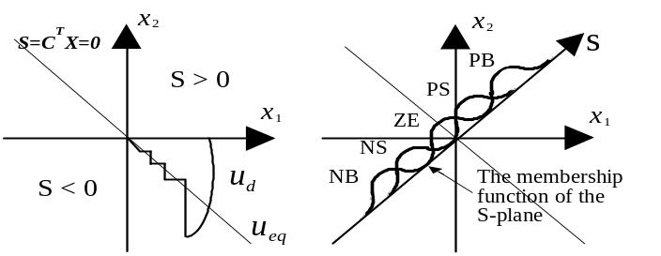
Figure 2. The basic structure of cerebella model

- Design of Fuzzy Sliding Controller Based on Cerebellar Learning Model
The design of fuzzy sliding-mode controller based on cerebellar learning model (CFSMC) consists of two parts: the design of FSMC as the main part with a learning part the design of CMAC. The system structure is shown in Figure 3.
The FSMC output signal, is the main input of controlled object. And the output of CMAC learning system is the corrected signal source 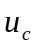. These two signals are synthesized as the control signal of the controlled object. The learning system adopts a one-dimensional cerebella model, which uses the output error state as the guiding index to modify the FSMC output.
The initial value of CMAC state memory unit is set to zero. Therefore, the output of FSMC control the system while CMAC is idle in the beginning. However, as time moves on, CMAC continues learning through the system operation and participates the control procedure. Eventually it makes the output of FSMC become zero. This also guarantees the output error reduce to zero to achieve the control goal.
While the system becomes stable, if there occurs any non-identified condition which renders the system parameter change; or a disturbance develops from external to result in errors, FSMC will take control immediately. CMAC only needs to participate part of the learning and it will enable the corrected output value to be adjusted to a better condition already, lest the system diverge. Therefore, it not only reduces the steady state error but also achieves excellent robustness.

(a)
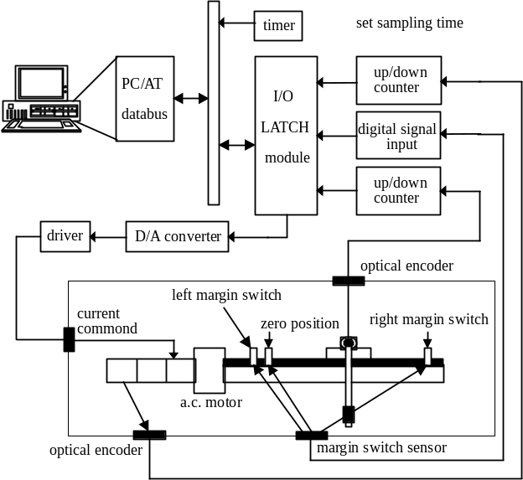
(b)
Figure 3(a). Fussy sliding mode controller with
cerebellar mode learning system
3(b). The structure of CFSMC system

4. The experiment of inverted pendulum
The inverted pendulum is often used to verify the effectiveness of control method on the real system because of its non-linear and uncertain features. In this section, the CFSMC controller is used to verify its effectiveness on eliminating the track error, achieving the actions of slew-up, stand-on and positioning actions of the 360 ° inverted pendulum. It is also used to examine the robustness of the controller when the system variables change.

4.1 Hardware Structure
The experimental set-up consists of a straight platform with an inverted pendulum of one-degree freedom, which can swing from 0 to 360 degrees. Pendulum rod is an aluminum rod of 33 cm in length, 6 mm in diameter and 50g in weight. It is driven by an a.c. brushless server motor and moves along a track of 29 cm long in X-direction. The 52g aluminum pendulum tests the robustness of the controller when system changes through the shift of the center of gravity of pendulum rod by pendulum moving.
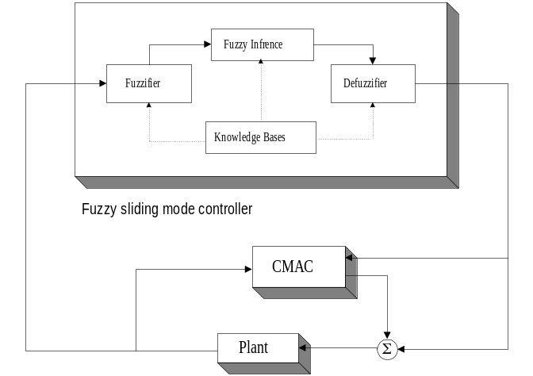The angle of inverted pendulum is input to computer interface through a set of encoding counter by an optical encoder. The position of the straight platform is input to computer interface through another set of encoding counter by the optical encoder in the motor.
After the computer receives the information such as the angle and its variation, the positioning and its variation, of the inverted pendulum, CFSMC will calculate the current command for the next moment. It then sends the command to the driver of an a.c. brushless server motor through the D/A converter. The whole experimental system structure is shown in Figure 4.
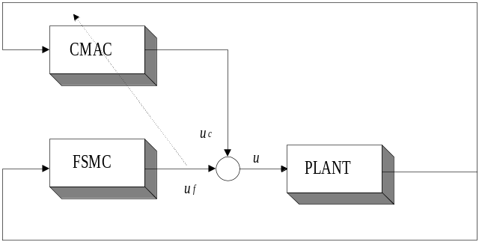

Figure 4. Experimental Set-up Structure

4.2 Software Structure
The main software structure is based on C language, which is coded for I/O interface and the control program of CFSMC. MATLAB is used to present the output of system response. The information propagates between these two languages using ASCII files as interface. After system executes, the input/output states and the capability values are stored in ASCII format and then plotted with MATLAB.

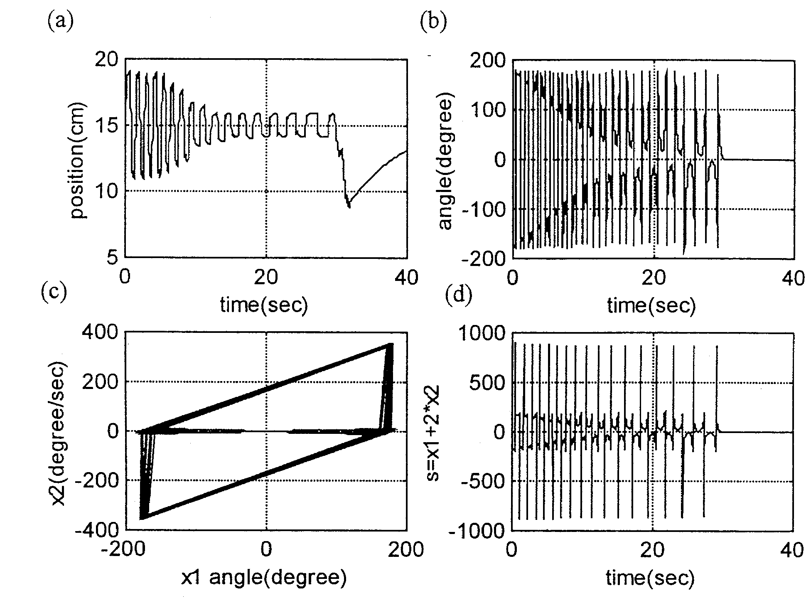
4.3 Experimental Results
In the experiment of inverted pendulum, the complete action sequence includes:
- Reset
At the beginning of the program execution, the inverted pendulum platform will be reset and moved to the left. The test positioning is set to zero. The pendulum rod is static as reset state.
- Positioning
As the pendulum begins to slew, it must be positioned at the center to gain the maximum degree of freedoms. Positioning is achieved through the use of fuzzy sliding mode control method.
- Slew-up
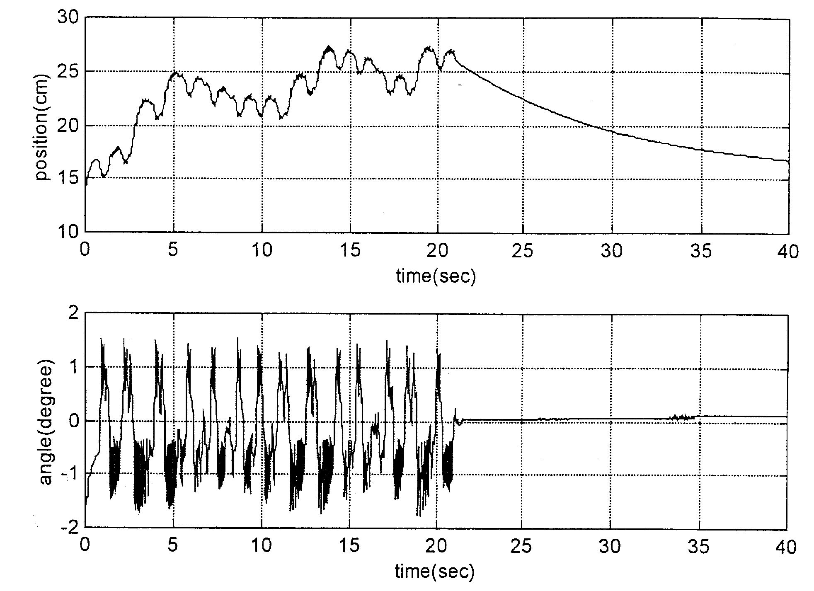
The fuzzy sliding mode will control the platform to swing from left to right and uses the angle of pendulum rod as the control target to achieve the slew-up action.
- stand-on
When the angle of pendulum rod becomes ready for the control stage of stand-on action, the angle of pendulum rod is maintained at certain control range and positioned toward central point.

It is demonstrated in the experiment that the control method of fuzzy sliding mode can achieve the requirements of positioning and stand-on of the inverted pendulum. The results are shown below:
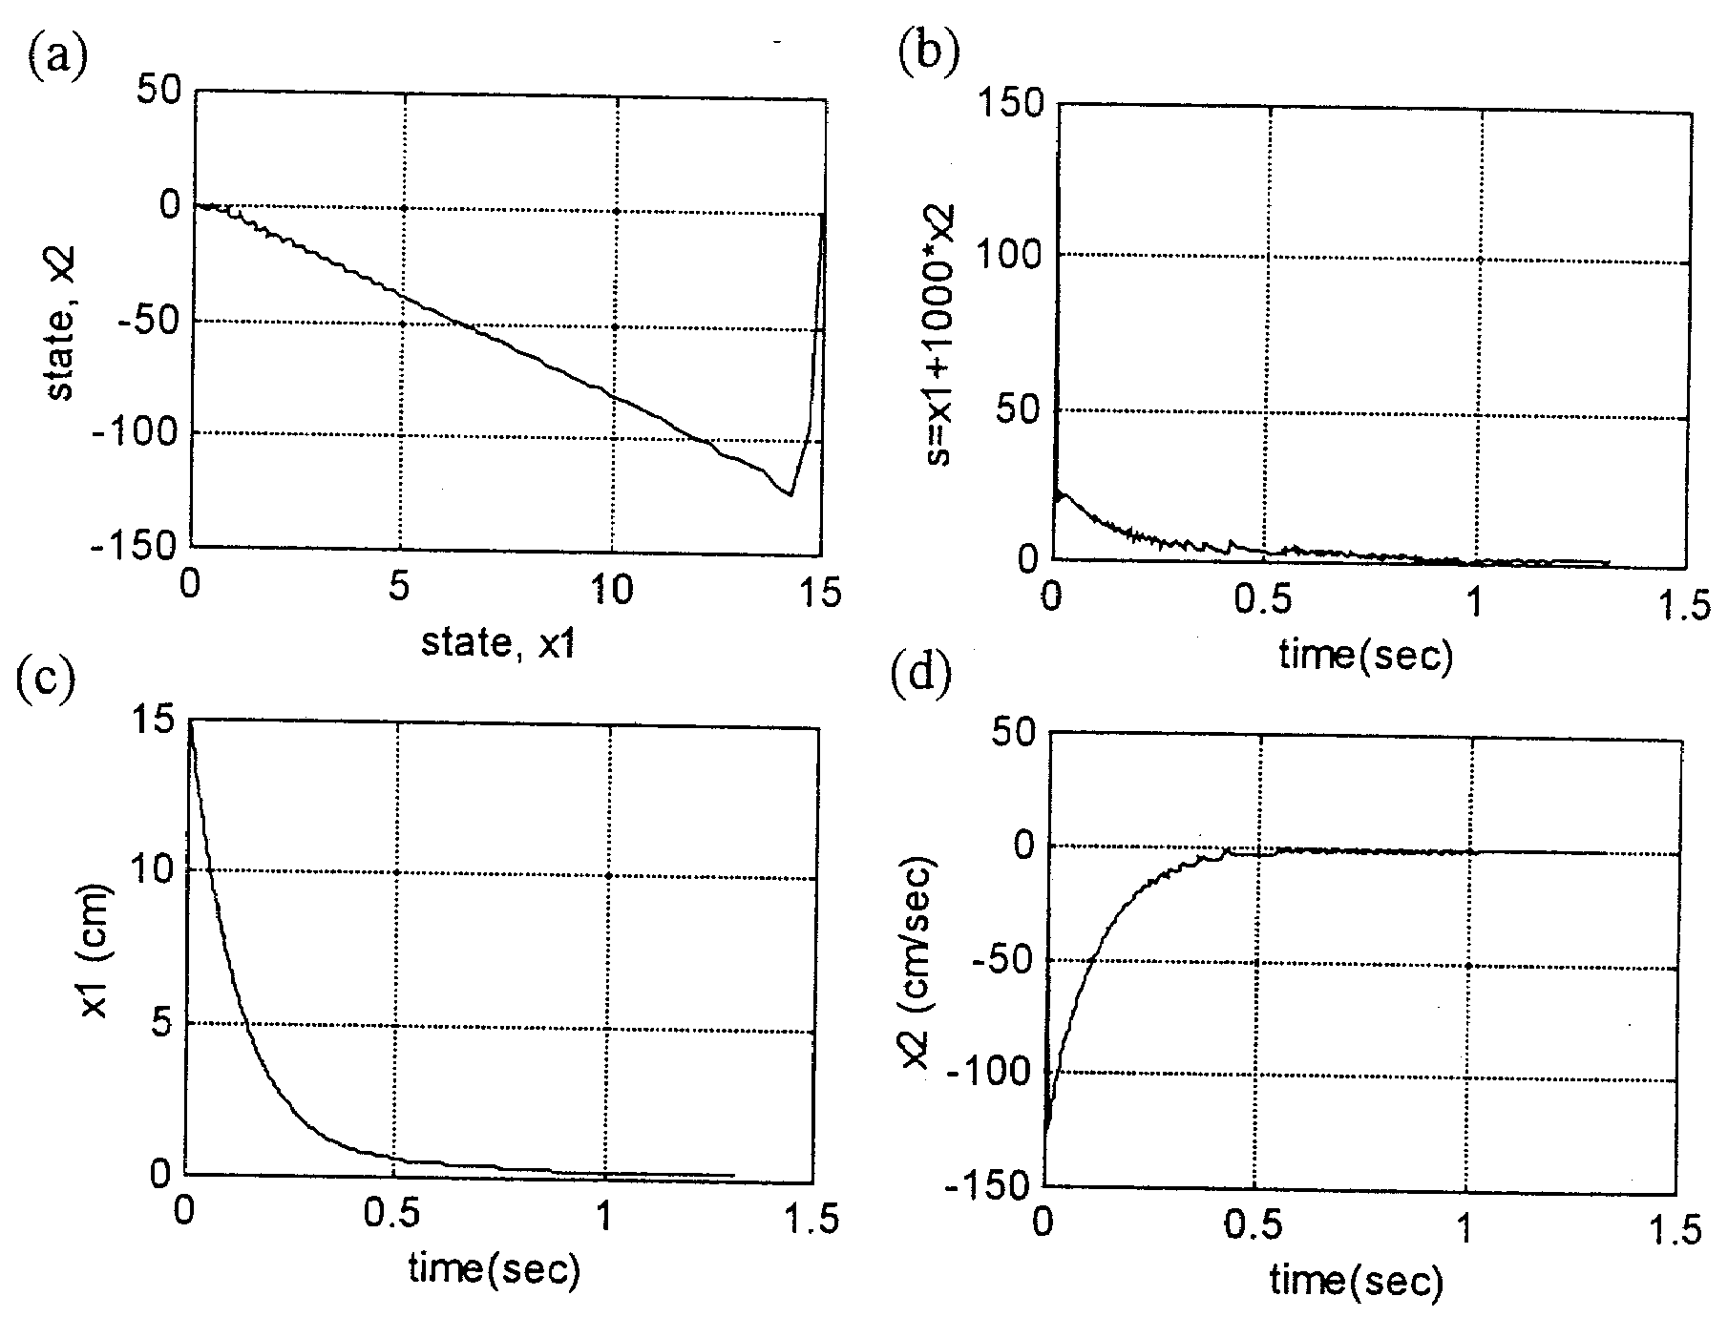
Figure 5. The system response of Positioning of
inverted pendulum.

Figure 6. The system response of the slew-up of
inverted pendulum

Figure 7. The system response of the stand-on and
positioning of inverted pendulum.

5. Conclusions
In the traditional control, due to the change of the mathematical parameters of the controlled device, the operator must respond and adjust the system with empirical rule repeatedly. This results in great inconvenience in practical application. Therefore, the modern control development favors the trend of self-learning, i.e. the system is capable of learning and accommodating the variation of the controlled device parameters to enhance the system adaptability.
In summary, this paper describes the performance of a controller which is designed with the concepts of variable structure, fuzzy control and CMAC. The experimental results reveal two unique features:
- Through the sliding mode, the multi-input variables are mapped to the sliding plane so that the rule base of the fuzzy control and the design of membership function are related only to the rule and independent of the input variables. This greatly reduces the difficulties of designing the fuzzy controller.
- Since all the variables are mapped to the sliding plane, the design of CMAC is essentially one-dimensional. It relieves the computation burden of the controller. Fuzzify the sliding plane makes the requirements of CMAC state input the same as fussy theory. This reduces the required memory size and greatly helps the whole system timing.

Acknowledgement

In acknowledgement of being funded by the National Science Council (title : Design of Cerebellar Model Articulation Controller based on Fuzzy Reasoning project # 88-2213-E-003-005)

Reference
- Albus,J.S. , “A New Approach to Manipulator Control: The Cerebellar Model Articulation Controller (CMAC),” Journal of Dynamic System, and Control, Transaction of ASME , pp.220-227, September 1975.
- Albus, J. S. , “Data Storage in the Cerebellar Model Articulation Controller (CMAC),” Journal of Dynamic Systems, Measurement, and Control, Transactions of ASME , pp. 228-233, September 1975.
- Chun-Shin Lin and Hyongsuk Kim, “CMAC-Based Adaptive Critic Self-Learning Control , “IEEE Transactions on Neural Network, Vol. 2, No.5 , pp.530-535, 1991.
- Chun-Shin Lin and Hyongsuk Kim, “Selection of Learning Parameters for CMAC-Based Adaptive Critic Learning,” IEEE Transactions on Neural Networks, Vol. 6, No.3, pp.642-647, 1995
- Ching-Tsan Chiang and Chun-Shin Lin, “CMAC with General Basis Functions,” Neural Networks, Vol.9 , No.7 , pp1199-1211, 1996
- Giuseppe S. Buja, Roberto Menis and Maria I. Valla, “Variable Structure Control of An SRM Drive,” IEEE Transactions on Industrial Electronics, Vol. 40, No 1, February 1993.
- Jacob S. Glower and Jeffrey Munighan, “Designing Fuzzy Controller From a Variable Structures Standpoint,” IEEE Transactions on Fuzzy Systems. Vol. 5, No. 1, pp. 138-144, February 1997.
- John Y. Hring, Weibing Gao and James C. Hung, “Variable Structure Control: A Survey,” IEEE Transactions on Industrial Electronics, Vol. 40, No. 1, February 1993.
- Jong-Lick Lin and Wen-Tay, “Application of Variable-Structure System in DC-motor velocity-control”, Journal of Institute of Engineers. Vol. 10, No. 2, pp201-208, 1987.
- Seungrohk Oh and Hassan K. Khalil, “Nonlinear Output-Feedback Tracking Using High-Gain Observer and Variable Structure Control,” Automatica, Vol. 33, No. 10, pp. 1845-1856, 1997.
- Shinn-cheng Lin and Yung-Yaw Chen, “A GA-Based Fuzzy Controller with Sliding Mode,” IEEE INT. Conference on fuzzy system, Vol. 71, No. 3, pp. 1103-1110 1995.
- S.K. Bag, S.K. Spurgeon, C., “Output feedback Sliding mode design for linear uncertain systems,” IEEE proc.-Control Theory Appl., Vol. 144, No. 3, May 1997.
- Susy Thomas and B. Bandyopadhyay, “Variable Structure model following control for industrial robotos,” International Journal of Systems Science, Vol. 28, No. 4, pp. 325-334, 1997.
- Tian-Ping Zhang and Chun-Bo Feng, “Fuzzy variable structure control via output feedback,” International Journal of System Science, Vol. 28, No. 3, pp. 309-319, 1997.
- Tong Shaocheng, Chai Tianyou, Shao Cheng, “Adaptive Fuzzy Sliding Mode Control for Nonlinear Systems,” IEEE INT.conference on fuzzy system, Vol. 1, pp. 49-54, 1996.
- Vadim I. Utkin, “Sliding Mode Control Design Tong Shaocheng, Chai Tianyou, Shao Cheng, Principles and Applications to Electric Drives,” IEEE Transactions on Industrial Electronics, Vol. 40, No. 1, February 1993.
- Weibing Gao and James C. Hung, “ Variable Structure Control of Nonlinear Systems A New Approach,” IEEE Transactions on Industrial Electronic, Vol. 40, No. 1, February 1993.

