Artificial Intelligence Programming

Final Test

August 30, 2002
- Explain the following two capabilities usually associated with a system’s intelligence: (20%)
  - Reasoning
  - Learning
- Heuristic Search: (30%)
  - Follow a standard procedure to describe how to solve the minimum solution of the following function by using Genetic algorithm:
  - Explain how to solve the 8 puzzle problem by using A* algorithm.
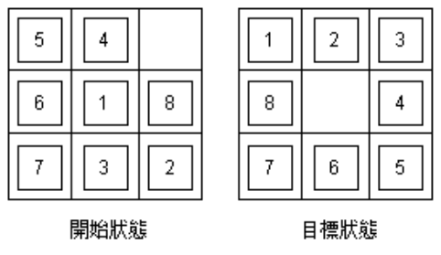
- Reasoning: (30%)
  - Express the following English sentence in First-Order Logic
Jack owns a dog.
Every dog owner is an animal lover.
No animal lover kills an animal.
Either Jack or Ben killed the cat, who is named Tuna.

  - Assume we have the following logical rules, please use the forward chaining and backward chaining to infer Faster(Bob, Steve), respectively.
Buffalo(x) ∧ Pig(y) ⇒ Faster(x, y)
Pig(y) ∧ Slug(z) ⇒ Faster(y, z)
Faster(x, y) ∧ Faster(y, z) ⇒Faster(x, z)
Buffalo(Bob)
Pig(Pat)
Slug(Steve)

- Learning: (20%)
  - Please give a brief explanation about inductive learning and bias in inductive learning
  - Construct a decision tree induced from the following 12-example training set by using the attributes Pat, Type, Hun and Fri.
