Chapter 1
Introduction

1.1 Motivation

The importance of Chinese character recognition is that it can provide the convenience of Chinese electronic data processing. Although there are many key-in methods, such as Changjei [Shen 93], Dayi [Kao 92], Wuhsiami, Mandarin phonetic, etc., for Chinese characters, the key-in speed is still slow. The main problem of all key-in methods for Chinese characters is that they are not friendly enough. Hence, many researchers focus on the recognition of Chinese characters [Cheng & Hsu 91].

The difficulties of Chinese character recognition are: large character sets of characters (at least 5401s for daily use), very complex in structure, different writing styles, and many similar characters in shape [Cheng & Hsu 91] [Chuang & Tseng 95a] [Chuang & Tseng 95b]. Because of the writing habit, the handwritten Chinese character recognition (HCCR) is more difficult. In addition, since we can easily extract the strokes and know the sequence of them, the on-line HCCR is easier than the off-line HCCR. In 1970s, the research of Chinese character recognition is focused on printed and on-line handwritten characters [Mori & Masuda 80] [Stallings 76]. Recently, more and more researchers have a deep concern about the off-line handwritten Chinese character recognition [Hildebrandt & Liu 93].

In order to overcome the difficult problems of HCCR that we mentioned above, the researchers often use these following methods [Cheng & Hsu 91]:
(1) Using preclassification technique to reduce the candidate characters, and
then select a character from them. This can relieve the problem of large
character sets.
(2) Since a Chinese character is composed of several components － radicals,
deassemble a character to many radicals may reduce the problem of vary
complex in Chinese character structure.
(3) Using neural network model and fuzzy concept to lighten the problem of
various writing styles.
(4) Induce the structure about the shape of Chinese characters can reduce the
difficulty of the recognition of similar characters.

Our method proposed in this thesis belongs to the method (1) mentioned above. In order to reduce the candidates of input character, we try to propose a model that can create the preclassification classes via the fuzzy concept and SEART classifier [Lee & Lai 96] [Lee & Lai 93]. This model can distribute the input character into the corresponding preclassification class. Besides, we allow these classes to overlap each other. This can improve the preclassification rate, but the overlap degree must be set appropriately. If the overlap degree between classes is high, the class size becomes large. That will conflict with the purpose of preclassification.

1.2 Overview of a Character Recognition System

The typical character recognition system is shown in Fig. 1.1 [Hildebrandt & Liu 93]. Generally speaking, the process of Chinese character recognition can be separated into four parts: preprocessing, feature extraction, classification and postprocessing. In what follows, we discuss these four parts, respectively.

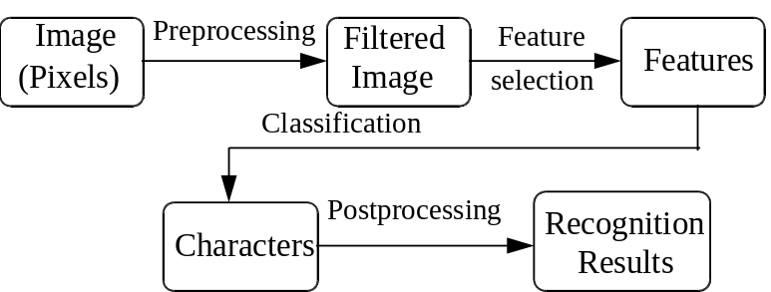
Fig. 1.1. Overview of a character recognition system.

1.2.1 Preprocessing

The major purpose of preprocessing is to bring the source image of a character into the form that the feature extraction can easily accept. Noise deletion, segmentation, normalization, and thinning can help us to achieve this goal. Noise deletion is to remove the isolated pixels in the source image. Segmentation is to separate the whole text into characters. This is a difficult problem, for example, "木木" is "林", or "木" and "木" ?

The purpose of normalization is to adjust the source image into a suitable size, for example, N×N. Jeng et al. [Jeng et al. 90] used a simple method to normalize the size of source image into N×N. At first, they clear P(i, j) into 0, where i and j are the integers between 1 and N. The normalization process can be formulated as:
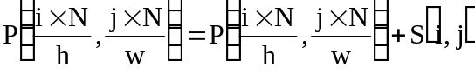 (1.1)
Where P(i, j) is the normalized pixel value at location (i, j) of a N×N image, and S(i, j) is the pixel value at location (i, j) of the source image with h in high and w in width. ＋ is the OR operator of two pixels. In general, both h and w are larger than N.

The width of strokes is not uniform in both printed and handwritten Chinese characters. There are many fonts, such as Kai, Li, Shing, Ming, and Black font in printed Chinese characters. Also, various tools, such as ball point pen and Chinese writing brush are used to write Chinese characters. That is why many researchers use thinning method to find the skeletons of characters. This makes it convenient for feature extraction. Ogawa and Taniguchi [Ogawa & Taniguchi 82] proposed a thinning technique in 1982. They use a two-stage method to achieve the thinning. At the first stage, the width of strokes is reduced to two or three pixels in part by repeating the deletion of boundary pixels. The final result at the second stage is a 2×2 pixels square by tracking the strokes obtained at the first stage.

Since using thinning method can simplify the feature extraction process, many researchers adopted it in preprocessing process, for examples, Chang et al. [Chang et al. 94], Lee and Huang [Lee & Huang 94], Wang et al. [Wang et al. 94], Chang and Wang [Chang & Wang 93], Liao et al. [Liao et al. 92], Cheng et al. [Cheng et al. 89a], Cheng et al. [Cheng et al. 89b], and Wang et al. [Wang et al. 88]. The thinned strokes may be accompanied with distortions, such as damage of the stroke shape, broken stroke, and reduction of the stroke length. Therefore, some researchers do not stand for using thinning method in preprocessing process, such as Tseng and Chuang [Chuang & Tseng 95a] [Chuang & Tseng 95b] [Tseng & Chuang 92] [Tseng & Chuang 91], Tseng and Huang [Tseng & Huang 91], Yen et al. [Yen et al. 91], Jeng et al. [Jeng et al. 90], Tsukumo and Asai [Tsukumo & Asai 86]. For example, Tseng and Chuang derived some knowledge about strokes by studying the structure of Chinese characters. They then converted this knowledge into some parameters, and incorporated these parameters in their stroke extraction procedure instead of using the thinning technique.

1.2.2 Feature extraction

Although the preprocessing method is used to process the raw image of Chinese characters, the image still contains much redundant information. Due to the redundant information, the dimension of the features is large and many unstable features exist. If we directly use them to do classification, the result may be not good enough and it may spend much time. Thus, the goal of feature extraction is to condense the raw image, that is, to extract the important and stable features for the input character.

Generally speaking, there are three types of features that we frequently use in Chinese character recognition: global feature, local feature, and structural feature [Hildebrandt & Liu 93] [Cheng & Hsu 91]. Global features are extracted via the transformation approach by mapping the character image from x-y domain into a new domain. Several orthogonal transformations such as the Fourier transform and Walsh function have been used. Local feature is the feature that is related to the geometrical and topological properties of characters, such as stroke direction, stroke density, stroke length, and stroke position, etc. Structural feature is based on the structure of a character. In what follows, we discuss the three types of features, respectively.

A. Global feature methods
This category contains methods that use a global transformation to integrate the information in the image of an input character. These methods ignore the inherent structure of characters. By considering the image as a whole, they treat the input character more abstractly. Because these methods tolerate the local variations, the transformation may lose many features that are needed to distinguish a similar pair [Hildebrandt & Liu 93]. We will give three global feature methods below.

(1) Projections
These methods compress the data through projection. Projections transfer the data from 2D to 1D. Cheng and Xia [Cheng & Xia 96] employed projection to recognize the printed Chinese characters. They use VH2D (Vertical-Horizontal-2Diagonal) method to extract the features from input characters. In the VH2D method, projections on character images are made from four directions: vertical, horizontal, and two diagonals (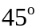 and 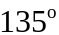).

(2) Walsh function
Walsh function is an orthogonal function. By this property, Yen et al. [Yen et al. 91] employed the Walsh function for feature extraction. At first, they divide the whole character into 9 blocks, and then calculate the Walsh coefficients for each block, respectively. Fig. 1.2 shows the example.

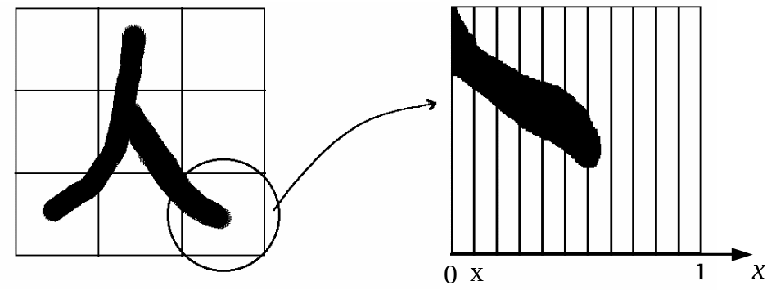
Fig. 1.2. Find the Walsh coefficients. (In this example, N=11)

The general equation is of the form:
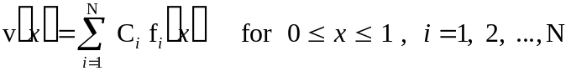 (1.2)
Where 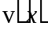 is the projection intensity distribution function of the character image (for example, if we draw a vertical line in , and there are 10 black pixels of character image through this line, then v(0.5) = 10); 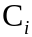 is Walsh coefficient; 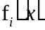 is Walsh function. Because Walsh function is an orthogonal function, it has the following properties:

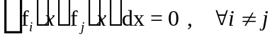 (1.3)
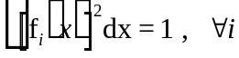 (1.4)
From these, we can find the Walsh coefficients easily.
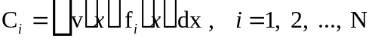 (1.5)
The (i = 1, 2, ..., N) are the features that we extract from the character.

(3) Hough transform
Cheng et al. [Cheng et al. 89b] employed the modified Hough transform (MHT) to extract the straight lines as features. Hough transform can transfer the character image from () space to (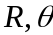) space. Fig. 1.3 shows the transform.

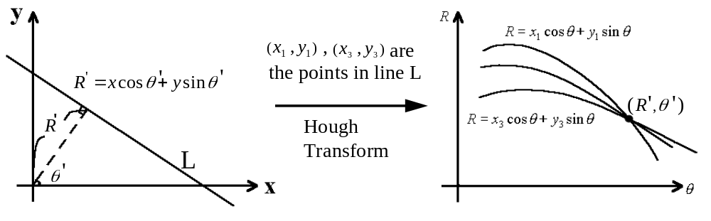
Fig. 1.3. Hough transform transfers the character image from () space to () space.

We adopt the parametric equation below.
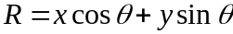 (1.6)
Where is the normal distance between the straight line and the origin; is the inclined angle of the straight line relative to the X axis. According to equation (1.6), each point () of the straight line can be transformed into a curve in the () space. If (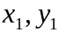), (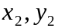), ..., (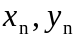) are in the same line L, then 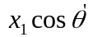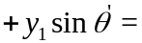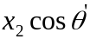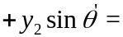...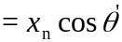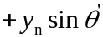. Therefore, the intersection point of many curves in the () space denotes a collinear line in the () space. According to the theory, if we use the following algorithm to detect all the pixels in () space of a character image, then the element value of accumulative matrix 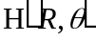 shows that there is a straight line in the character.
FOR each (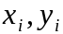) in P DO
FOR 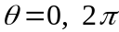 STEP BY 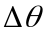 DO (note: 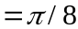)
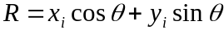
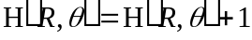
END
END
Suppose P is a set of points in the image of a character, where 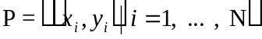. For example, If 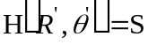, and threshold, it shows that there is a straight line with length , position 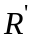, and direction in the image of the character.

There are some disadvantages in the original Hough transform. For example, we can not detect the line with short length (i.e., 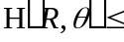 threshold). If there are two lines with the same position and direction, we can not recognize them correctly. Therefore, Cheng et al. used MHT to overcome this drawback. They define some rules; and in order to speed up the processing, they compute 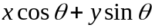 only in the direction that may have the strokes. Moreover, in the above algorithm, 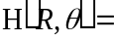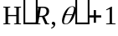 is replaced by 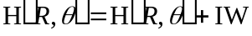. The value of IW depends on the probability of the change of direction for different types of points. In order to recognize the two short lines that have the same position and direction, they separate the character image into left and right parts. They then employ MHT to analyze the two parts, respectively. Finally, structure code is used to detect whether there is a stroke near the center of the character image. They use feature vector 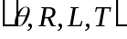 instead of the original vector 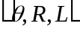, where is the structure code.

B. Local feature methods
Both global and local feature methods ignore the inherent structure of characters, but local feature methods extract the features from limited region of a character. Local feature methods are more suitable to recognize the similar pair than global feature methods are.

Tsukumo and Asai [Tsukumo & Asai 86] used Four Direction Positions Feature (FD Positions Feature) to recognize Chinese characters. The FD Positions Feature is shown in Fig. 1.4.

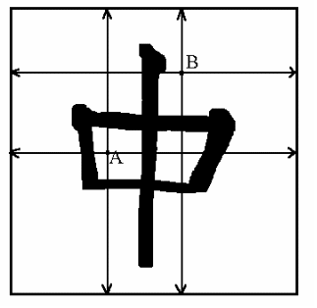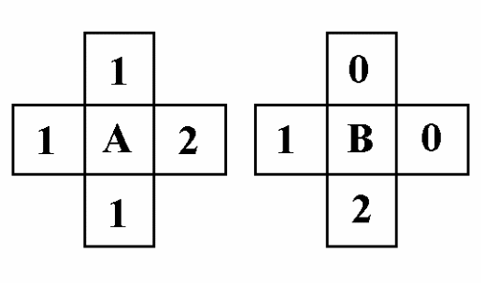
Fig. 1.4. The FD Positions Features of white pixels A and B.

For every white pixel of a character image, scanning lines are derived in four directions: top, down, left, and right. In each scanning, the number of crossings between the scanning line and strokes is counted. Therefore, we can obtain 4 values from each white pixel. The FD Positions Feature is composed of these 4 values. Because of the varieties of handwritten characters, the FD Positions Feature is not very suitable for HCCR.

Jeng et al. [Jeng et al. 90] extracted the features from the contour pixels of the character image. They define the orientations (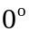, , 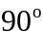, ) of the contour pixels, and then divide the character into N×N blocks. In each block, they compute the numbers of , , , contour pixels, respectively, and then use these numbers as features.

C. Structural feature methods
Structural feature methods are developed based on the structure that exists in characters. Since Chinese characters are composed of strokes, the feature in recognition that the researchers can consider firstly is stroke.

Lee and Huang [Lee & Huang 94] employed strokes as fuzzy objects to recognize the radical of the character. They use a two-pass fast stroke extraction strategy instead of a window-oriented tracing approach, e.g., [Ogawa & Taniguchi 82] which causes the time-consuming problem. In pass I, they extract the vertical strokes and slanting ones. In pass II, they extract the horizontal strokes. They then use a combining phase to combine the proper strokes into corner strokes. Also they use the fuzzy concept to define the membership functions of five stroke types (horizontal, vertical, left-slanting, right-slanting, corner), and the five degrees of different stroke type for each stroke are computed, respectively.

Tseng and Chuang [Chuang & Tseng 95a] [Chuang & Tseng 95b] [Tseng & Chuang 92] [Tseng & Chuang 91] proposed a stroke extraction strategy without the thinning. They examine the structure of Chinese characters, and then the knowledge was derived into about 20 parameters. They incorporate these parameters into their stroke extraction strategy. After extracting the strokes, they convert the strokes into stroke sequence codes.

Liao et al. [Liao et al. 92] extracted strokes after thinning. They calculate the length of each stroke and derive the coordinate of its centroid. They employ the length and centroid as the features.

Chang et al. [Chang et al. 94] proposed a feature to recognize the similar Chinese characters (i.e., the characters with the same number of straight strokes and cross-points). The numbers and the distributions of four primitive (horizontal, vertical, left-slanting, and right-slanting) extracted strokes of the character are used to construct a 12-dimensional feature vector. The distributions represent the average position and average length of the primitive strokes. In order to increase the recognition accuracy, a subsidiary feature, i.e., the four-corner-code, is used.

Wang et al. [Wang et al. 94] extracted the line segments from the thinning character. In order to reduce the complexity of classification, they proposed a method that combines the line segments into the full strokes as possible as they can.

Shao and Wu [Shao & Wu 90] treated the Chinese characters as graphs. They define the vector (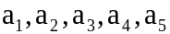) as the code of a Chinese character, where is the number of Kdv (K5; Kdv means that the degree of vertex is K); is the number of 4dv; is the number of 3dv; is the number of components; and is the number of cycle. An example is given in Fig. 1.5. If

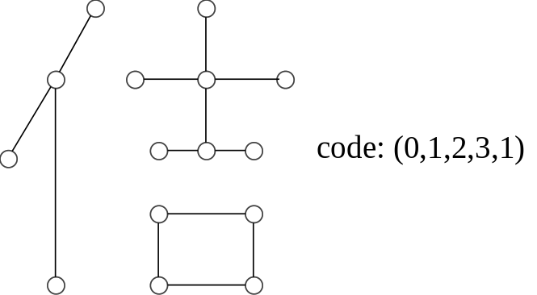
Fig. 1.5. Associated graph of the Chinese character "佶" and its code.
more than two codes of templates in database are the same to the input character, we must compare their similarity. The template with large similarity is the result. They use the fuzzy concept in the comparison of similarity between input character and the templates.

Cheng et al. [Cheng et al. 89a] employed the fuzzy concept in the process of stroke extraction. A stroke can be defined by its slope (stroke type) and middle point (stroke location). They define two fuzzy sets, "location" and "type", and assign to the stroke a degree of membership. We will obtain two membership values in the interval 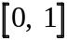; 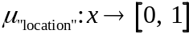, 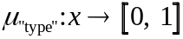. Then the similarity measure of two strokes is considered as 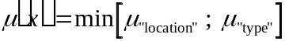. We will have the similarity 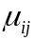 between the strokes , which belong to the input and template character, respectively.

1.2.3 Classification

The purpose of classification is to compare the similarity of the input character with the templates in database. If the similarities of all templates with the input character are lower than a certain threshold, output "reject" or "can't find" as the recognition result. If the recognition result is neither "reject" nor "can't find" and the output is the character that we do not expect, a recognition error occurs. A good matching method must have excellent accuracy, low matching time, and little memory space needed.

Some matching methods that we frequently use to compare the similarity of the input character with the templates are linear programming and dynamic programming [Cheng & Hsu 91]. Recently, some researchers use neural network model and fuzzy theory in Chinese character recognition [Chi & Yan 95] [Chi et al. 95] [Yeung & Fong 95] [Chang et al. 94] [Lee & Huang 94] [Liao et al. 92] [Xu & Ding 92] [Tseng & Chuang 91] [Tseng & Huang 91] [Yen et al. 91] [Jeng et al. 90] [Wang & Pan 90]. The theory of neural network model is based on the biological neurons of human brain. Since through "learning - failure - relearning," human can get the powerful ability of pattern recognition. Some researchers [Chang et al. 94] [Liao et al. 92] [Xu & Ding 92] [Tseng & Chuang 91] [Tseng & Huang 91] [Yen et al. 91] [Jeng et al. 90] [Wang & Pan 90] believe persistently that neural network model is the best choice of Chinese character recognition. The advantages of neural network model [Lippmann 87] include: flexibility, learning capability, fault tolerance, simple architecture of processing element (PE), and using parallel processing to speed up the calculating ability, etc. Because of the advantages of neural network model, it is suitable for HCCR. The purpose of fuzzy theory is to make the fuzzy things clearly. If we crisply determine that the slope of extracted stroke between 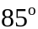- is a vertical stroke, then a stroke with slope 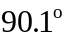 is not vertical. If we adopt fuzzy concept in stroke types, a stroke may have various degrees of different stroke types. For example, the slope of one extracted stroke is , it may get degree 0 for horizontal type and degree 1 for vertical type; the slope of one extracted stroke is 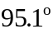, it may get degree 0.09 for horizontal type and degree 0.91 for vertical type. This makes the process of recognition more flexibly and reasonably. Moreover, some researchers [Lee & Huang 94] [Chi & Yan 95] [Chi et al. 95] [Yeung & Fong 95] define fuzzy rules and use fuzzy inference to get the recognition result.

A. Dynamic programming matching
Cheng et al. [Cheng et al. 89b] used DP (Dynamic Programming) to match the characters. In Section 1.2.2, we have mentioned how they used modified Hough transform to extract the features from characters. Now we introduce the DP method that they used to match the input with template characters.

In order to reduce the complexity of DP matching, they divide the set of feature vectors 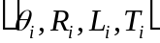 into eight categories according to the eight directions 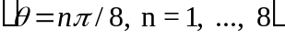. By sorting the feature vectors in each category according to its normal distance , we have eight ordered sequences of feature vectors for a character. Let and 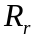 be the sequences of feature vectors with direction 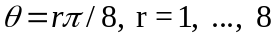, for the input and the reference pattern, respectively, where
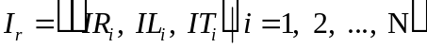 (1.7)
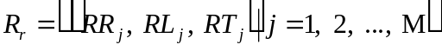 (1.8)
Then the algorithm of DP matching for each sequence of feature vectors is listed below.
STEP 1: sim(0, 0) = 0
STEP 2: FOR i = 1, N DO
sim(i, 0) = 0
END
FOR j = 1, M DO
sim(0, j) = 0
END
STEP 3: FOR i = 1, N DO
FOR j = 1, M DO
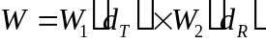
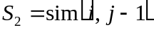
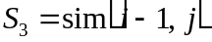
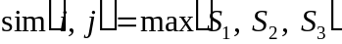
END
END
STEP 4: 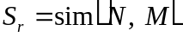
Where sim(i, j) is a matrix used to count the similarity between and , and 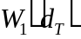 and 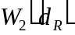 are weighting functions, 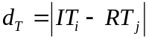, 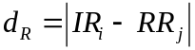.

Apply the above algorithm, we can obtain the similarity 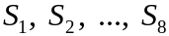. The final simialrity can be computed as: 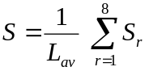, where 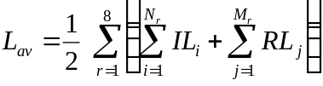.

B. Linear programmimg method
Cheng et al. [Cheng et al. 89a] used linear programming to match characters. In Section 1.2.2, we have mentioned how they used fuzzy concept to extract the features from characters. Now we give the linear programming that they used to match the input with template characters. Suppose the input character and template one have (i.e. 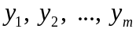), and (i.e. 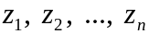) strokes, respectively. In order to find the optimal one-to-one matches between 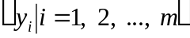 and 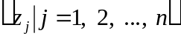, they construct a matching matrix 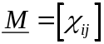 as shown in Table 1.1 (a).

Table 1.1 (a) Matching matrix; (b) Scoring matrix used in linear programming
method.
stroke no. 1 2 . . . m stroke no. 1 2 . . . m
1 0 1 . . . 0 1 0.5 0.9 . . . 0.4
2 1 0 . . . 0 2 0.8 0.1 . . . 0.3
.
.
. .
.
. .
.
. . . .
. . .
. . . .
.
. .
.
. .
.
. .
.
. . . .
. . .
. . . .
.
.
0 0 . . . 1 0.6 0.3 . . . 1.0
(a) (b)

Let denotes the similarity of the match 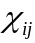, then a scoring matrix 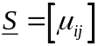 is constructed as shown in Table 1.1 (b). Now, the problem is to select the optimal matches in  such that the maximum score of similarity in is achieved. It is noted that there is only one match (i.e. element 1) in each row or column of , because a stroke can be matched with only one line segment . This problem can be formalized as follows:
Select to maximize 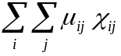
subject to 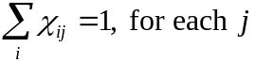
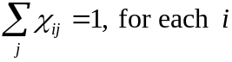
where .
C. Fuzzy rules
Because that the purpose of fuzzy theory is to make the fuzzy things clearly, the fuzzy concept is suitable for HCCR. Since the writing style of handwritten character varies a lot in stroke type, length, and distance, it completely meet the fuzzy characteristics.

Lee and Huang [Lee & Huang 94] used fuzzy concept in HCCR. In Section 1.2.2, we have mentioned how they defined the membership functions of five stroke types. In the classification process, they defined some fuzzy rules to determine whether two strokes can be combined or not. Using fuzzy rules to combine the strokes until there are no strokes or radicals can be combined. Output the final combined radical as the result. This method takes advantage of needless to compare the information of inputs with built-in prototypes. Furthermore, because there are many common sub-structures in Chinese characters, many fuzzy rules can be sharable.

Chi et al. [Chi & Yan 95] [Chi et al. 95] employed the fuzzy rules with optimized defuzzification parameters to recognize the handwritten numeral. They use Kohonen Self-Organizing Map (SOM) algorithm to create the prototypes. Then fuzzy rules are generated by learning from the SOM prototypes and the defuzzification parameters are determined by training a three-layer feedforward network.

D. Neural networks
Neural network model is based on the biological neurons of human brain. Because humans have the powerful ability of pattern recognition, some researchers believe that using the neural network is the best choice of Chinese character recognition. The main difference between neural networks and the other classification methods is that neural networks need not to built the large prototypes' database in advance. Besides, neural networks do not need to spend much time for matching the input character with template ones. In the training process, neural network model adjusts the weight values between PEs (processing elements) to achieve the goal of learning. But the main disadvantage of neural network is the large training time. The more the training patterns have, the larger the training time is. Furthermore, in the training process, the neural network may not achieve the convergence that we satisfy. But once the training process ends, the recognition speed is faster than other classification methods need.

(1) Backpropagation neural network
Tseng et al. [Tseng & Chuang 91] [Tseng & Huang 91] used one hidden layer of backpropagation neural network to recognize the Chinese characters. They use the sequence of strokes as the input to the neural network model, and the output of the neural network model is the Mandarin phonetic transcriptions. Thirty Chinese characters are chosen to test the proposed system. The experimental result shows that the backpropagation neural network with 28 hidden nodes has the best convergence rate.

Yen et al. [Yen et al. 91] proposed a backpropagation neural network with one hidden layer to recognize 30 printed Chinese characters. The network has 30 output nodes. They use the Walsh coefficients that we have mentioned in Section 1.2.2 as the input of the neural network model, and only one corresponding output node shows "1".

Jeng et al. [Jeng et al. 90] proposed a backpropagation neural network with no hidden layer to recognize handwritten and printed Chinese characters. They use the local features that we have mentioned in Section 1.2.2 as the inputs, and only one corresponding output node of neural network shows "1".

(2) Hopfield network
Liao et al. [Liao et al. 92] employed a two-dimensional Hopfield network to perform the classification of handwritten Chinese characters. They calculate the length of each stroke and derive the coordinate of its centroid. They adopt the length and centroid as the features. They put the input character into the rows of network, and put the template characters into the columns of network. Then the network will compute the similarity between input and template characters. They choose 20 handwritten Chinese characters－"你" (you) to evaluate the proposed system. The result shows that only two characters of them are failed.

(3) Neocognitron
Neocognitron was be used in alphanumeric character recognition previously by Fukushima et al. [Fukushima & Miyake 82] [Fukushima & Wake 91]. Some researchers employ Neocognitron in Chinese character recognition recently.

Wang and Pan [Wang & Pan 90] proposed a Neocognitron system to recognize 50 Chinese characters. Furthermore, Yeung and Fong [Yeung & Fong 95] proposed a rule-mapped modified-Neocognitron system to recognize a small set of Chinese characters. They suggest a tool called "knowledge matrix" that generates symbolic interpretation of the network's response to an input.

(4) Bayesian neural network
Chang et al. [Chang et al. 94] used Bayesian neural network to recognize the similar Chinese characters with the same number of straight strokes and cross-points. They employ ILVQ (incremental learning vector quantization) algorithm to train the network. In Section 1.2.2, we have mentioned the features they used.

(5) Cooperative block neural network (CBNN)
Xu and Ding [Xu & Ding 92] proposed CBNN (cooperative block neural network) to recognize printed Chinese characters. CBNN is composed of three main cooperative blocks: the feature extraction neural network, the clustering neural network, and the individual recognition neural network. Feature extraction neural network is responsible for the feature extraction, including the rough and the detail features. Clustering neural network uses the rough feature to do the rough classification and it enables the corresponding individual recognition neural network finishing the fine classification. The feature extraction neural network is a three-layer feedforward network. The clustering neural network is ART [Carpenter & Grossberg 87]. The individual recognition neural network is a backpropagation network.

E. Other methods
Besides the method we have mentioned above, some researchers use correlation matching and relaxation methods to do the classification. The correlation matching is a method that compares with the feature vector of input character and the template characters. Tsukumo and Asai [Tsukumo & Asai 86], Shao and Wu [Shao & Wu 90] employed this method. Wang et al. [Wang et al. 94] used the modified relaxation method to do the matching process.

1.2.4 Postprocessing

In order to improve the recognition rate of the overall system, some researchers used the contextual processing technique after the recognition of individual characters [Hildebrandt & Liu 93]. With a dictionary of allowable digraphs, for example, and a table of characters that are frequently confused, a system can correct many single-character classification errors. By adding the contextual processing after the recognition of individual characters, the accuracy of the recognition system can be improved to a great deal.

1.3 Proposed Approach

In Section 1.1, we have listed the major difficulties of Chinese character recognition. One of them is the large number of categories. Since the scale of Chinese character recognition system is large, we cannot examine each topic of the system and process it nicely. Therefore, in this thesis, we focus on the preclassification of off-line HCCR.

We use a 2-stage method to accomplish the preclassification. In stage I, we try to extract the first primitive features from handwritten Chinese characters and use the fuzzy rules to create the four preclassification groups. The first primitive features are a kind of statistical feature and they are easy to be extracted. The reasons we adopt the fuzzy concept in stage I to create the four preclassification groups are: fast preclassification speed and overlapping preclassification groups. The purpose in stage I is to reduce the candidates roughly, so we can not spend much time in stage I. Furthermore, in order to make sure the high preclassification rate in stage I, we allow the preclassification groups to overlap each other. If the four preclassification groups are not allowed to overlap each other, the preclassification rate of stage I might be low. The fuzzy concept can help us to achieve these goals. In stage II, we extract the second primitive features from handwritten Chinese characters and then use the supervised extended ART (SEART) [Lee & Lai 96] [Lee & Lai 93] as the classifier to generate the preclassification classes for each preclassification group that we create in stage I. The second primitive features have the properties of local and structural features. We also allow the preclassification classes to overlap each other, but we set the overlap degree appropriately to control the preclassification class size. The number of preclassification classes should be large and the class size ought to be small. These two factors are the performance measure of the preclassification system [Cheng et al. 95]. Our proposed system will produce a good preclassification result in terms of the above two factors. In our experiment, when we control each preclassification class below 25 character categories, the preclassification rate is acceptable. The preclassification rate that characters of testing set can be distributed into correct preclassification classes is 98.11%.

1.4 Overview of the Thesis

Following this introduction is a detailed description of the proposed system. Chapter 3 shows the experimental results. Chapter 4 includes the advantages and the major reasons for preclassification errors of our proposed system. Some problems we met during the development of proposed system are also discussed in Chapter 4. The comparisons for some related works and the proposed system are given in Chapter 5. The final chapter contains the conclusions of this thesis.

