Chapter 3
Experimental Results

In order to evaluate the proposed system, we use the 605 Chinese character categories in the text books of elementary school as our training and testing data. The database used is CCL/HCCR3 of HCCRBASE provided by Computer and Communication Research Laboratories of Industrial Technology Research Institute, Taiwan (CCL, ITRI, Taiwan). HCCRBASE contains 5401 categories commonly used handwritten Chinese characters. They are written by about 2600 persons and each character category collects 214 to 284 writing samples. All the samples are reordered in script regularity for each category. That is, the first one third samples of each category are written in a regular manner, and the last one third samples are written in more cursive approach. In the following experiments, the net parameters: choice parameters, vigilance parameters, and nest parameters used in SEART, are set to 0.3, 0.6, 0.5, respectively. Fig. 3.1 shows the 605 character categories we used in printed font.

丁 了 人 力 十 又 丈 上 凡 久 也 兀 千 口 土 士 大 女 子 小 山 已 干 才 不 中 之 井 互 仁 仍 今 介 元 內 公 切 化 匹 午 友 反 壬 天 夫 太 孔 少 巴 心 戶 手 扎 方 日 木 欠 歹 比 水 火 父 片 牛 王 丙 且 丘 乍 以 仔 他 代 仙 充 冬 出 功 北 半 卡 去 可 只 史 台 外 奴 它 巧 市 布 幼 本 末 正 汁 氾 犯 瓜 生 用 田 由 甲 白 目 石 禾 立 休 伏 仲 件 仰 企 光 先 全 共 冰 印 同 向 合 吃 后 因 回 地 在 多 奸 好 如 存 安 寺 尖 帆 年 式 早 旨 曲 曳 朽 朱 朵 汗 污 灰 米 羊 而 耳 肉 自 艾 行 衣 住 何 但 作 你 伯 冷 利 吞 吧 呆 呈 君 吩 告 吶 呀 吱 含 吟 坎 壯 夾 宋 宏 局 尾 形 彷 快 我 找 批 扯 折 改 攻 更 材 村 沒 災 牠 狂 罕 肚 良 芒 見 言 豆 足 車 巡 邦 那 酉 里 防 乖 京 依 侍 例 併 兒 其 典 刺 到 制 卸 叔 受 味 咐 和 周 命 坡 奔 妻 定 尚 居 岡 岩 往 征 彿 忽 怪 怕 拌 招 披 拓 拍 抵 拘 放 昌 明 服 朋 果 枝 林 板 枉 析 杵 武 泥 河 沾 油 況 沿 治 泡 泛 炎 炒 炙 狀 玩 玫 的 直 社 空 糾 芽 花 芬 虎 初 表 返 采 金 長 附 雨 青 亮 信 便 保 促 俘 俗 侮 係 前 南 卻 品 哄 咱 垢 姿 娃 姪 宣 室 屏 巷 思 恰 扁 挑 政 故 既 春 昭 映 是 柿 架 枯 柚 查 洋 流 津 洞 活 炭 玻 珍 畏 省 盾 砌 砍 秋 穿 突 竿 紅 缸 美 羿 胃 胡 茅 苛 若 茉 英 苔 衍 要 迪 郊 郁 限 降 面 革 風 食 首 香 候 倘 修 倉 凌 凋 原 哼 員 埋 夏 害 容 座 步 汽 恩 悟 悅 捕 捆 捉 捐 挫 效 根 桂 梳 桌 浙 浴 烈 狹 班 珠 益 砲 神 秧 秘 站 笑 粉 紗 索 紛 缺 能 般 荒 荊 草 貢 送 迷 追 酒 閃 馬 高 做 務 啦 堆 婦 寄 崩 常 悉 悠 情 惜 捷 掛 推 排 掏 捨 斬 曹 梯 梅 梨 涼 淡 清 淒 深 爽 球 產 略 皎 祥 笨 笙 粒 紹 細 習 莉 荷 蛋 袍 覓 訝 許 逍 通 造 透 釣 閉 陪 雀 章 魚 麻 傍 喧 喘 單 喚 場 富 就 復 悲 惠 提 揚 斯 晶 曾 期 棕 椅 棧 湧 湯 焚 煮 番 登 稍 策 給 菁 萎 菜 視 詞 詐 買 開 間 閒 飲 黃 傲 慈 慎 新 暗 椰 楊 楓 滑 滔 溪 煩 瑜 當 睜 碎 碌 罪 腸 葵 裡 試 話 資 路 漆 熔 瑰 監 瞄 碧 稱 綿 蒙 語 說 遙 價 瘦 稻 箱 蓮 諸 調 賣 賜 質 憶 曆 磨 糖 螢 謀 諾 檢 濫 璧 決

Fig. 3.1. The 605 Chinese character categories in the text books of elementary school, which are shown in printed font.

3.1 The Experiments with Stage II

In this experiment, we just employ stage II to evaluate the proposed system. That is, instead of creating the preclassification groups, we generate the preclassification classes directly. We select the samples 1－50 (except the samples 10, 20, 30, 40, 50) of CCL/HCCR3 as the training set, and the samples 10, 20, 30, 40, 50 as the testing set. After the training phase, we have 605 preclassification classes. In the following experiments, we will observe that when the "top 10" categories that have the smallest choice function values are kept to generate the preclassification classes and the preclassification class size is less than 25 character categories then we will have the better result.

We control the size of each preclassification class to be less than 25 character categories. The preclassification results are shown in Table 3.1. In Table 3.1, the first row indicates that we input the training pattern to the SEART, and the top N categories that have the smallest choice function values are kept. We use these top N categories to generate the preclassification classes. From Table 3.1, we observe that "top 10" have the best result among them. In the following experiments of this chapter, we keep the top 10 categories that have the smallest choice function values for each input training pattern to generate the preclassification classes.

Table 3.1. The preclassification results after training samples 1－50 (except the
samples 10, 20, 30, 40, 50), and adopting samples 10, 20, 30, 40,
50 as the testing set. We just use the stage II to create the
preclassification classes. The size of each preclassification class
is less than 25 character categories.

Top 6Top 7Top 8Top 9Top 10Top 11Top 12
preclassificationrate
92.46%
93.74%
95.17%
96.36%
97.09%
96.86%
96.52%

Table 3.2 lists the preclassification rates of various preclassification class sizes. The purpose of preclassification is to reduce the candidates of input character. Although using large character categories in each preclassification class has good preclassification rate, that will conflict with the purpose of preclassification. We consider both preclassification class size and preclassification rate, the character categories of each preclassification class less than 25 seems to be the best choice in this experiment. If we control the preclassification class size below 25 character categories, the experimental result shows that the preclassification class size is between 7 and 25 character categories, and 24.53 categories in average. In this case, the preclassification rate is 97.09%.

Table 3.2. The preclassification rates of various preclassification class sizes.

N character categories in each preclassification classpreclassification rate
20098.64%
15098.64%
10098.64%
5098.47%
3597.98%
2597.09%
2096.63%
1595.87%
1094.81%

3.2 The Experiments with Stages I and II

In the following experiments, we adopt both stages I and II to evaluate the proposed system. The samples 1－50 and the samples 1－100 of CCL/HCCR3 are our training and testing data.

3.2.1 The experiment of samples 1－50

In this experiment, we choose the samples 1－50 (except the samples 10, 20, 30, 40, 50) of CCL/HCCR3 as the training set, and the samples 10, 20, 30, 40, 50 as the testing set.

(1) Stage I
In stage I, we use the training set to create the membership functions, defined in Section 2.4.1, and preclassification groups. We sort horizontal density H of all training patterns ascendently by their values. Since the size of training set is 27225 characters, 20% of them is 5445 characters. The value of the 5445th sorted horizontal density H is 0.34, therefore, we can determine the membership function of fuzzy set Low for horizontal density H easily. Similarly, we can obtain the other membership functions of fuzzy sets for horizontal density H and vertical density V. The membership functions of fuzzy sets Low and High for horizontal density H and vertical density V are illustrated in Fig. 3.2 and Fig. 3.3, respectively.
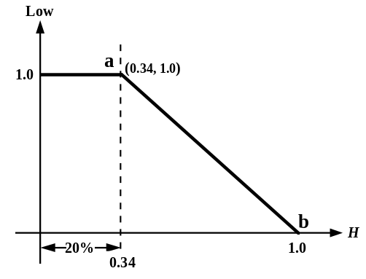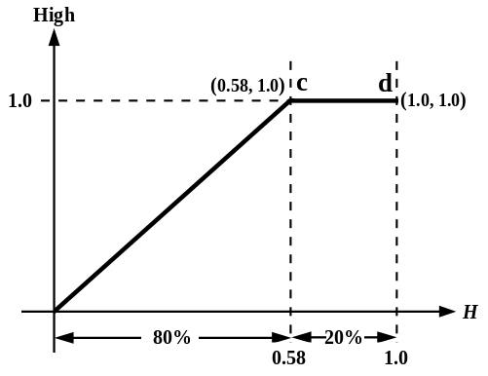

Fig. 3.2 (a) The membership Fig. 3.2 (b) The membership
function of fuzzy set Low function of fuzzy set High
for horizontal density H. for horizontal density H.

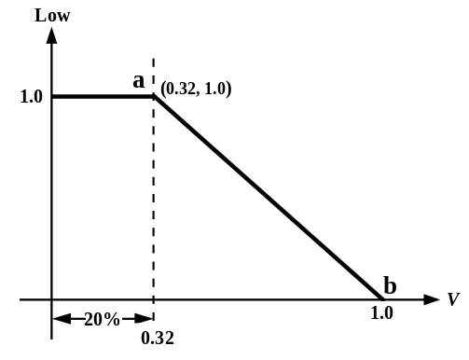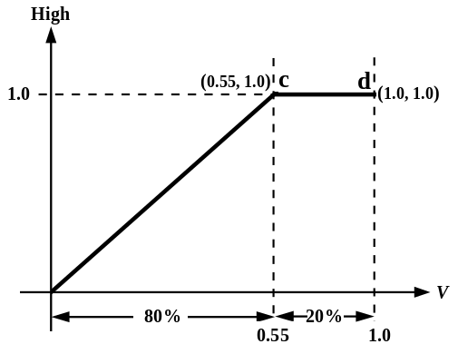

Fig. 3.3 (a) The membership Fig. 3.3 (b) The membership
function of fuzzy set Low function of fuzzy set High
for vertical density V. for vertical density V.

The value of the level has the effect on the size and overlap degree of preclassification groups. The lower value of the level is, the larger size and overlap degree of preclassification groups have. Table 3.3 lists the different values and their effect on each preclassification group. Large preclassification group size makes the preclassification rate higher in stage I, but it may lead to the bad total result in stage II. The 0.8 for value seems to be the best choice in this experiment.

Table 3.3. The experiment of samples 1－50. The different values and their effect on each preclassification group.

value0.60.70.80.850.9
the size (characterGroup 1581490228460
categories) ofGroup 2589544445394327
preclassificationGroup 3592535447398356
groupsGroup 459753337017159
preclassification rate in stage I100%100%100%95.24%88.50%

(2) Stage II
In stage II, the second primitive features of the training patterns that belong to each preclassification group are sent to the corresponding SEART neural net model. Table 3.4 lists the preclassification rates of various preclassification class sizes in each preclassification group (the level is set to be 0.8). From Table 3.4, we can find that the character categories of each preclassification class less than 25 seems to be the best choice. Table 3.5 lists the detailed experimental results when we control the character categories of each preclassification class less than 25 in each preclassification group. With both stages I and II strategies, the total preclassification rate is 98.38%. That is, the preclassification rate is promoted about 1.3% than just adopting stage II strategy.

Table 3.4. The experiment of samples 1－50. The preclassification rates of
various preclassification class sizes in each preclassification group
(the level is set to be 0.8).

preclassification ratepreclassification groups
îGroup 1Group 2Group 3Group 4
N5098.46%99.08%98.98%99.10%
character4098.46%98.77%98.69%99.10%
categories3098.46%98.54%98.47%98.64%
in each2598.46%98.54%98.25%98.19%
preclassification2098.46%96.93%96.72%94.12%
class1095.38%95.01%95.11%92.76%

Table 3.5. The experiment of samples 1－50. The detailed experimental
results of each preclassification group in stage II (we control the
preclassification class size below 25 character categories).

Group 1Group 2Group 3Group 4
the number of classes228445447370
the size of the smallest class6667
the size of the largest class25252525
the average size of class23.8024.4324.4324.48
the number of testing patterns that are distributed into corresponding group
130
1303
1371
221
the number of testing patterns that are not distributed into the proper group
0
0
0
0
the number of testing patterns that cannot be distributed into correct class
2
19
24
4
preclassification rate98.46%98.54%98.25%98.19%
total preclassification rate98.38%
3.2.2 The experiment of samples 1－100

In this experiment, we select the samples 1－100 of CCL/HCCR3 to evaluate the proposed system. We adopt the even samples as the training set, and the odd samples as the testing set.

(1) Stage I
In stage I, we use the training set to create the membership functions and preclassification groups. We have introduced how we define the membership functions in Section 2.4.1. Since the size of training set is 30250 characters, 20% of them is 6050 characters. We can use the method that is similar to Section 3.2.1 to define the membership functions of fuzzy sets for horizontal density H and vertical density V. Fig. 3.4 and Fig. 3.5 show these membership

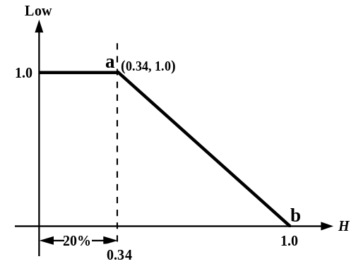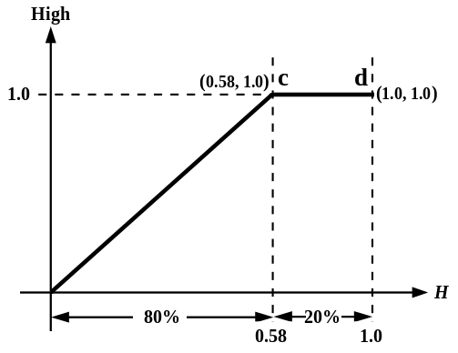

Fig. 3.4 (a) The membership Fig. 3.4 (b) The membership
function of fuzzy set Low function of fuzzy set High
for horizontal density H. for horizontal density H.
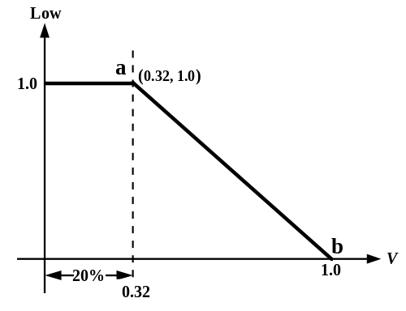

Fig. 3.5 (a) The membership Fig. 3.5 (b) The membership
function of fuzzy set Low function of fuzzy set High
for vertical density V. for vertical density V.

functions. Fortuitously, these membership functions are the same as the experiment in Section 3.2.1. Table 3.6 lists the different values and their effect on each preclassification group. In this experiment, the 0.8 for value seems to be the best choice.

Table 3.6. The experiment of samples 1－100. The different values and their effect on each preclassification group.

value0.60.70.80.850.9
the size (characterGroup 1578496278480
categories) ofGroup 2583550475407341
preclassificationGroup 3596542480411368
groupsGroup 459554541117857
preclassification rate in stage I100%99.99%99.99%95.22%89.21%

(2) Stage II
In stage II, the second primitive features of the training patterns that belong to each preclassification group are sent to the corresponding SEART neural net model. Table 3.7 lists the preclassification rates of various preclassification class sizes in each preclassification group (the level is set to be 0.8). From Table 3.7, we can find that the character categories of each preclassification class less than 25 seems to be the best choice. Table 3.8 lists the detailed experimental results when we control the character categories of each preclassification class less than 25 in each preclassification group. With both stages I and II strategies, the total preclassification rate is 98.11%. From the experiments in Section 3.2.1 and Section 3.2.2, we observe that the proposed system is stable and has good generalization ability. The total preclassification rate does not change to a great deal according to the different training and testing samples.

Table 3.7. The experiment of samples 1－100. The preclassification rates
of various preclassification class sizes in each preclassification
group (the level is set to be 0.8).

preclassification ratepreclassification groups
îGroup 1Group 2Group 3Group 4
N5098.13%99.16%98.91%99.42%
character4098.82%98.91%98.83%99.21%
categories3098.58%98.62%98.20%99.01%
in each2598.26%98.32%97.76%98.92%
preclassification2098.10%96.96%96.89%98.38%
class1096.05%94.36%94.57%95.85%

Table 3.8. The experiment of samples 1－100. The detailed experimental
results of each preclassification group in stage II (we control the
preclassification class size below 25 character categories).

Group 1Group 2Group 3Group 4
the number of classes278475480411
the size of the smallest class6745
the size of the largest class25252525
the average size of class24.4524.6724.6824.78
the number of testing patterns that are distributed into corresponding group
1266
13098
13669
2217
the number of testing patterns that are not distributed into the proper group
1
0
2
1
the number of testing patterns that cannot be distributed into correct class
21
220
304
23
preclassification rate98.26%98.32%97.76%98.92%
total preclassification rate98.11%

